The International Observation Campaign
“Photometry and Spectroscopy of P Cygni”
A Cooperative Project of AAVSO, ASPA, and BAV

The International Observation Campaign “Photometry and Spectroscopy of P Cygni” as a joint project of AAVSO, ASPA and BAV has, from November 2008 until now, resulted in very encouraging findings. The objective of this campaign is the investigation of an anti-correlation between the equivalent width (EW) of the Hα Emission and the star’s photometric V-brightness in the context of short-time changes with amplitudes up to 10 Ǻ (EW) and a temporal duration of 40-60 days. A direct comparison in these investigations of photometric and spectroscopic data revealed the existence of a close relationship between the variabilities of the Hα EW and V in the sense that if the Hα EW decreases, the star becomes brighter in V and vice versa. Fig. 5 of the investigation (see fig. 1 in this paper) could mean, that the observed variabilities of the line strengths are caused either by changes in the photospheric continuum or by change in the wind density. For this reason the influence of a variable continuum has to be taken to account if studies of the wind and the mass loss rate are performed.
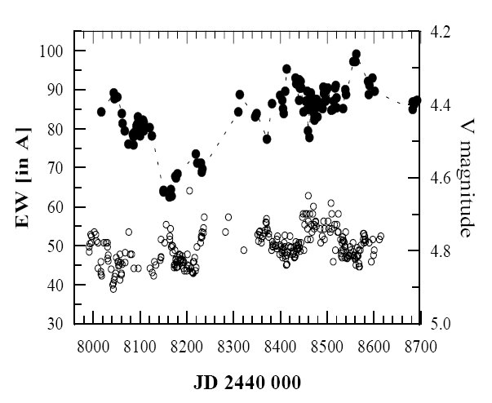

Fig. 1: Comparison between variations of the Hα equivalent width und the V brightness. Clearly to see is the inverse behavior of both to each other.

The anti-correlation in fig. 2 (received by observers of ASPA and BAV) compares well with results by Markova et al. (2001) in fig.1. An anti-correlation may be expected if variations in the continuum and line flux are independent. If flux is constant, an increase or decrease of the continuum must produce smaller or larger EW, respectively.

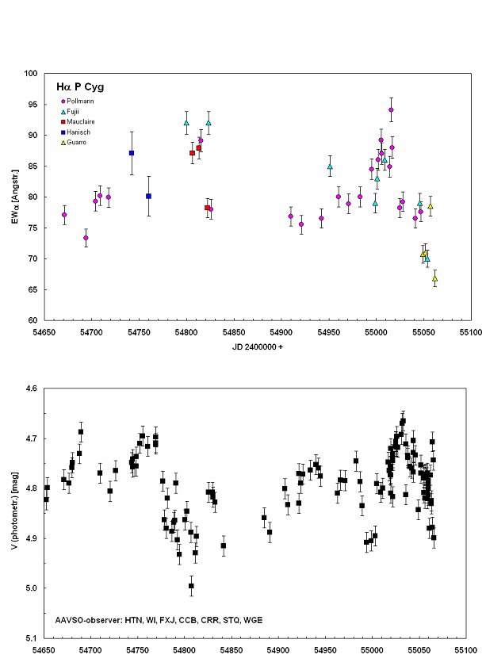

Fig. 2: In analogy to the results in the investigations of Markova et al. (in fig. 1) the comparison of the behavior of EW and V during our campaign.

Observation of absolute line flux is important because its variations are to due to a variable mass loss rate, variations of the wind density, and changes in the ionization structure. In order to see whether and how the absolute line flux can be obtained from EW, the measured EW must be corrected by removal of the continuum standardisation. From the definition of EW (flux/continuum) and the definition of star brightness we have:

F ~ EW*10^ (-0.4*Vphot)

Strictly speaking, differences in the continuum flux at λ = 6563 Ǻ should be used, but the colour indices of P Cygni do not vary greatly. To correct continuum variations the measured EW is divided by 10^ (0.4*Vphot). So far we have only 18 simultaneous measurements of EW and V.

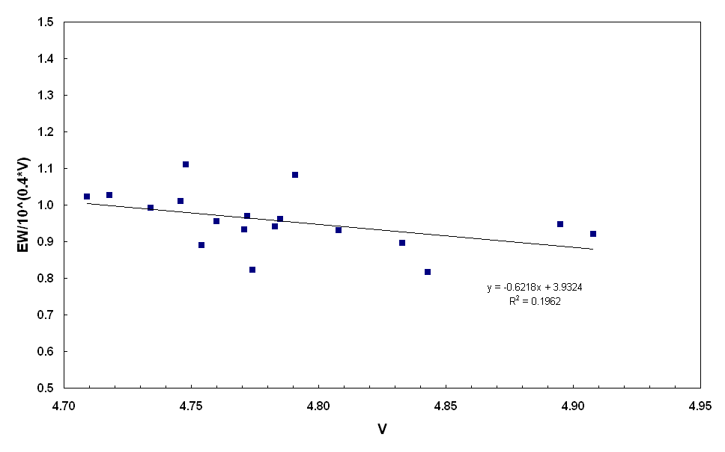

Fig. 3: Attempt to find out sign of independence of the intrinsic line flux to V. Further explanations in the following text below

The correlation coefficient of 0,28 for fig. 3 seems to confirm the independence of the intrinsic line flux from V, and that the uncorrected EW variations in fig. 2 are caused by changes in V. Markova et al. (2001) argues that the wind is probably sufficiently optically thick for the star to have a permanent pseudo-photosphere. Hence changes of the order 0,2 visual magnitude could be caused by mass-loss rate variations. Our campaign does not yet have enough simultaneous measurements of V and EW/10^(0.4*Vphot) to conclude anything yet. The determination of this will obviously require further contemporaneous observations and data possibly covering several years.

Many variable stars eject mass either continuously or sporadically from their surfaces into the surrounding space. The velocity of such ejections from P Cyg-type stars is in the range 200-500 km/s. Most of the spectral lines show two clearly separated components, one moderately red- shifted emission paired with a remarkably wide and deeply blue-shifted absorption. This is the characteristic P Cyg profile. With bright stars like P Cyg this profile on hydrogen lines indicates the existence of an expanding shell. Absorption on the shorter wavelength shows the velocity of expansion. The emission on the red side points towards a strongly agitated and widely expanded atmosphere. It arises from more distant parts of the atmosphere than the absorption component.

Absorption components of P Cyg-profiles show the highest expansion velocities. Absorption increases in cooler regions of the outer shell of the star where the level of excitation and ionization is reduced, and consequentially the gas is accelerated outward. The star will lose mass when the expansion velocity exceeds escape velocity.

The rate of loss is the amount of matter crossing the outer shell’s border in a certain time. For a shell radius of about 16 solar radii, a velocity of 1000 km/s, and a density of 10⁻¹² g/cm⁻³ (typical values for variable blue supergiants like P Cyg), the rate of loss is around 10⁻⁵ solar masses per year.

Variations of mass loss should be reflected not only in the EW of the Hα emission but also in the blue-shifted absorption component. This Hα absorption, however, is so strongly saturated that even big variations of the mass loss rate produce very low changes of the intensity of absorption. Stahl et al. writes in A&A, 326, 1997: “Only a recombined wind is capable of producing the saturated P Cyg absorption on the Hα-profile.” Due to the high wind density in P Cyg no static photosphere is visible. The blue-shifted absorption line on HeI 6678 emission is more sensitive to variations in mass loss because it arises from a region of lower optical density.

Changes in the rate of mass loss and variations in the structure of the stellar wind's ionization can cause emission and absorption line widths to vary. Fig. 4 compares changes on the blue side of H6678 absorption to changes in Hα emission.
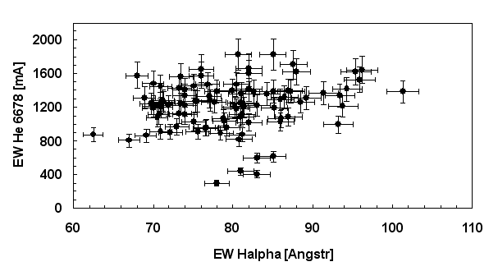

Fig. 4: : Investigation to find out any correlations between the HeI6678-absorption component and the Hα-emission

Since JD 2452730 He6678 absorption EW is not correlated with Hα emission EW. There are several relevant considerations. First, EWs of the single components of He6678 (absorption and emission) are difficult to determine. Secondly, absorption in He6678 depends strongly on temperature and ionization structures in the stellar wind. Does this lack of correlation hint at non-spherical mass loss? Thirdly, Hα emission EW measures mainly the mass of the shell. By contrast, He 6678 absorption EW measures only mass in front of the star. Fourthly, a time-related shift cannot be excluded as Hα emission is generated farther outside in the shell. Then it is no surprise that Hα emission and He6678 absorption show no correlation.

References:

Stahl O. et al., 1997, A&A 326, 1117-1134
Markova N. et al., 2001, A&A 366, 935-944

