OBSERVED MINIMA TIMINGS
OF ECLIPSING BINARIES

NUMBER 8

Prepared by:

Marvin E. Baldwin
Chairman, AAVSO
Eclipsing Binary
Committee

Gerard Samolyk
AAVSO Eclipsing
Binary Committee

August 2003

Funds for publication were provided by
The Harold S. Martin Fund.

ISBN 1-878174-67-3

COPYRIGHT 2003
The American Association of Variable Star Observers
25 Birch Street
Cambridge, MA 02138
USA

All rights reserved. No part of this book may be reproduced by any mechanical, photographic, or electronic process, nor may it be stored on an information retrieval system, transmitted, or otherwise copied for public or private use, without the written permission of the American Association of Variable Star Observers.

TABLE OF CONTENTS

Introduction v

References vi

Table 1. Publications Containing Previous AAVSO Minima for Each Star in this Monograph vii

Table 2. Information on O-C Minima and Linear Elements viii

Table 3. Observers Contributing to this Monograph ix

Compilation of Times of Minima and O-C Diagrams 1

INTRODUCTION

This compilation contains 800 minima timings of 50 eclipsing binary stars. It represents a portion of the stars observed by participants in the AAVSO's eclipsing binary program since 1976, and continues the listing of minima published in Observed Minima Timings of Eclipsing Binaries Nos. 1 through 7. Except where otherwise specified, all minima are determined from visual observations reduced by the authors using a computerized tracing paper method. Ron Baldwin and Gerard Samolyk wrote the tracing paper software specifically for this purpose.

Some CCD observations were reduced by the observers using the method of Kwee and Van Worden (1957). The standard error is included in each of these cases.

In instances where fragments of eclipses are observed during different cycles, the data points are reduced to heliocentric phase and combined into a single light curve for the tracing paper process. In these cases, the listed time of minimum is the eclipse nearest to the midpoint of the observing interval that corresponds to the calculated phase of minimum light. A footnote is added to these listings indicating the observing interval in JD.

In most cases, the linear elements in the General Catalogue of Variable Stars (Kholopov et al. 1985) were used to compute the cycle and O-C for each time of minimum. For the following stars the light elements from the sources indicated are used:

CW Cas JAAVSO (Samolyk 1992) Z Dra SAC 68 (Kurpinska-Winiarksa M., et al.1997)
DF Hya JAAVSO (Samolyk 1992) DK Hya JAAVSO (Samolyk 1990)
GU Ori JAAVSO (Samolyk 1985)

All elements used in this publication are listed in Table 2. The number of observations used for determination of each time of minimum is given under N. This work is sponsored by the AAVSO, with Marvin Baldwin acting as program coordinator.

The O-C diagrams accompanying the minima listings represent not only the minima tabulated here but also all previously published minima associated with the AAVSO program. Times of minimum obtained electronically that have four-place accuracy are circled on the O-C diagrams. The years spanned by these diagrams are listed by star in Table 2, with the second column giving the year of the earliest observation appearing in the diagram and the third and fourth columns listing the earliest and latest year of the minima tabulated in this publication.

The material in this monograph may be accessed electronically via the AAVSO web site home page (http://www.aavso.org) or the AAVSO ftp site (ftp.aavso.org in /pub/monographs).

Observers contributing data used in this publication are listed in Table 3. Their dedicated efforts are greatly appreciated.

Marvin E. Baldwin Gerard Samolyk
8655 N Co. Rd. 775E 9504 W Barnard Ave.
Butlerville, IN 47223 Greenfield, WI 53228
USA USA
REFERENCES

1 Ashbrook, J. 1963, Sky & Telescope, 26, 3,153.
2 Ashbrook, J. 1964, Sky & Telescope, 27,1, 58.
3 Ashbrook, J. 1964, Sky & Telescope, 27, 5, 317.
4 Ashbrook, J. 1965, Sky & Telescope, 29, 4, 254.
5 Robinson, L. J. 1965, Inf. Bull. Var. Stars, No. 111.
6 Robinson, L. J. 1965, Inf. Bull. Var. Stars, No. 114.
7 Robinson, L. J. 1965, Inf. Bull. Var. Stars, No. 119.
8 Robinson, L. J. 1966, Inf. Bull. Var. Stars, No. 129.
9 Robinson, L. J. 1966, Inf. Bull. Var. Stars, No. 154.
10 Robinson, L. J. 1967, Inf. Bull. Var. Stars, No. 180.
11 Robinson, L. J. 1967, Inf. Bull. Var. Stars, No. 221.
12 Robinson, L. J., and Ashbrook, J. 1968, Inf. Bull. Var. Stars, No. 247.
13 Baldwin, M. E. 1973, Inf. Bull. Var. Stars, No. 795.
14 Baldwin, M. E. 1974, J. Amer. Assoc. Var. Star Obs., 3, 60.
15 Baldwin, M. E. 1975, J. Amer. Assoc. Var. Star Obs., 4, 86.
16 Baldwin, M. E. 1976, J. Amer. Assoc. Var. Star Obs., 5, 29.
17 Baldwin, M. E. 1976, J. Amer. Assoc. Var. Star Obs., 5, 84.
18 Baldwin, M. E. 1977, J. Amer. Assoc. Var. Star Obs., 6, 24.
19 Baldwin, M. E. 1978, J. Amer. Assoc. Var. Star Obs., 7, 28.
20 Samolyk, G. 1985, J. Amer. Assoc. Var. Star Obs., 14, 12.
21 Samolyk, G. 1990, J. Amer. Assoc. Var. Star Obs., 19, 5.
22 Samolyk, G. 1992, J. Amer. Assoc. Var. Star Obs., 21, 34.
23 Samolyk, G. 1992, J. Amer. Assoc. Var. Star Obs., 21, 111.
24 Baldwin, M. E., and Samolyk, G. 1993, Observed Minima Timings of Eclipsing Binaries No. 1,
AAVSO, Cambridge, MA.
25 Baldwin, M. E., and Samolyk, G. 1995, Observed Minima Timings of Eclipsing Binaries No. 2,
AAVSO, Cambridge, MA.
26 Baldwin, M. E., and Samolyk, G. 1996, Observed Minima Timings of Eclipsing Binaries No. 3,
AAVSO, Cambridge, MA.
27 Baldwin, M. E., and Samolyk, G. 1997, Observed Minima Timings of Eclipsing Binaries No. 4,
AAVSO, Cambridge, MA.
28 Baldwin, M. E., and Samolyk, G. 1999, Observed Minima Timings of Eclipsing Binaries No. 5,
AAVSO, Cambridge, MA.
29 Baldwin, M. E., and Samolyk, G. 2000, Observed Minima Timings of Eclipsing Binaries No. 6,
AAVSO, Cambridge, MA.
30 Baldwin, M. E., and Samolyk, G. 2002, Observed Minima Timings of Eclipsing Binaries No. 7,
AAVSO, Cambridge, MA.
31 Kholopov, P. N., et al. 1985, General Catalogue of Variable Stars, Fourth Edition, Moscow.
32 Kwee K. K., and Van Worden, H. 1957, Bull. Astron. Inst. Netherlands, 12, 327.
33 Kurpinska-Winiarksa M., et al.1997, SAC68 (Rocznik Astron. Obserwat. Krakowskiego, Suppl.
Ann. Cracoviense No. 68)

TABLE 1

1 2 3 4 5 6 7 8 9 10 11 12 13 14 15 16 17 18 19 20 21 22 23 24 25 26 27 28 29 30
UU And X
WZ And X X X X X X X X
AB And X X X X X X X X X X X X X X X
KO Aql X
V346 Aql X X X X X X X X X X X X X X X
RX Ari X
AP Aur
HP Aur
TU Boo X
TY Boo X X
TZ Boo X
R CMa X X X X X X X X X X X X
SX CMa
XZ CMi X
RZ Cas X X X X X X X X X X X X X X X X X X X X X X X X
AB Cas X X X X X X X X X X X X X X X
CW Cas X X
XX Cep X X X X X X X X X X X
DL Cep
BR Cyg X X X X X
CG Cyg X X
DK Cyg X
KR Cyg X X
FZ Del X X X X X X X X X
Z Dra X X X X X X X X X X X X X X X
RZ Dra X X X
TU Her X X X
DF Hya X
DK Hya X
SW Lac X X X X X X X X X X X X X X X X X X
CM Lac X X X X X X X X
CO Lac
VZ Leo
Z Lep X
FL Lyr X X X X X X X X X X X X
U Oph X X X X X X X X X X
V1010 Oph X
GU Ori X X
BB Peg X X
DI Peg X
GP Peg X
Y Psc X X X X X X
UZ Pup X
AV Pup X
V Tri X X X X
W UMa X X X X X X X X X X X
XZ UMa X X X X X X X X
W UMi X X X
RU UMi X X X X
AZ Vir X X

This table identifies publications in which previous AAVSO minima for each star have been published.
The numbers across the top of the table correspond to those given at the beginning of each entry in the
References.
TABLE 2

Earliest Earliest Latest Epoch Period
Minimum Listing Listing 2400000 + (Days)

UU And 1976 1994 2002 41650.340 1.486296
WZ And 1966 1999 2003 40872.290 0.6956576
AB And 1966 2001 2002 36109.57928 0.33189215
KO Aql 1965 1976 2002 41887.4724 2.864055
V346 Aql 1965 2000 2003 41918.384 1.106363
RX Ari 1973 1976 2003 38398.5697 1.029626
AP Aur 1976 1976 2003 42443.609 0.5693125
HP Aur 1976 1976 2003 42756.3475 1.4228132
TU Boo 1976 1997 2003 33066.404 0.3242868
TY Boo 1977 1999 2003 34480.425 0.3171477
TZ Boo 1977 2000 2003 39632.8418 0.297162
R CMa 1963 2000 2003 44289.361 1.1359405
SX CMa 1977 1977 2003 28095.400 1.62425838
XZ CMi 1976 1995 2003 42444.4017 0.5788095
RZ Cas 1961 2002 2003 43200.3063 1.195247
AB Cas 1965 2000 2002 42714.4627 1.3668738
CW Cas 1977 1999 2003 41632.185 0.3188641
XX Cep 1964 1994 2002 44839.8022 2.3373266
DL Cep 1976 1976 2002 33946.608 1.630481
BR Cyg 1968 1999 2001 41539.4654 1.33256415
CG Cyg 1976 1999 2003 39425.1221 0.63114100
DK Cyg 1976 1995 2002 37999.5838 0.47069055
KR Cyg 1987 1999 2002 29106.413 0.8451517
FZ Del 1968 2000 2002 31324.329 0.7832126
Z Dra 1965 2000 2002 49844.401 1.3574357
RZ Dra 1975 1999 2003 44177.5555 0.5508738
TU Her 1971 1995 2003 44061.462 2.2670005
DF Hya 1976 1993 2003 42787.777 0.33060521
DK Hya 1976 1991 2003 42843.718 0.5219207
SW Lac 1965 2001 2002 45275.3477 0.3207209
CM Lac 1966 2000 2002 27026.316 1.6046916
CO Lac 1976 1976 2003 27534.0728 1.5422075
VZ Leo 1980 1980 2003 31164.316 1.089906
Z Lep 1977 1993 2003 27424.311 0.993715
FL Lyr 1963 1995 2002 38221.55250 2.1781544
U Oph 1956 1995 2000 44416.3864 1.67734617
V1010 Oph 1987 2000 2002 38937.7690 0.66142613
GU Ori 1976 1999 2003 43069.903 0.470681
BB Peg 1977 1999 2002 43764.3334 0.3615021
DI Peg 1976 1995 2001 45196.488 0.7118168
GP Peg 1987 1994 2000 41238.328 0.9756179
Y Psc 1969 1996 2002 45635.241 3.765767
UZ Pup 1976 1997 2003 44613.69829 0.79485120
AV Pup 1976 1996 2001 31178.131 0.5563389
V Tri 1975 2000 2002 24474.305 0.5852057
W UMa 1966 1999 2003 45765.7385 0.33363749
XZ UMa 1967 2001 2003 46168.426 1.22232
W UMi 1957 1996 2002 33682.323 1.7011576
RU UMi 1972 2001 2002 41596.3365 0.52492618
AZ Vir 1975 2000 2003 43976.540 0.34966511

The O-C diagrams for each star contain the minima spanning the years in columns two and four. The listing of new minima spans the years in columns three and four. The fifth and sixth columns contain the linear elements used to calculate the O-C values in this publication. All of these elements are from the General Catalogue of Variable Stars (Kholopov et al. 1985) except where noted.
TABLE 3

P. Atwood 1 P. Kuebler (CCD) 1
1) Bal-Mai (CCD) 6 R. Lee 1
M. Baldwin 73 G. Lubcke (CCD) 18
R. Berg 5 B. Manske 14
J. Blackwell (CCD) 1 D. Matsnev 2
G. Chaple 3 J. McKenna 3
L. Cook (CCD) 1 M. Nicholas (CCD) 6
S. Cook (CCD) 14 D. Ruokonen 4
M. Csukas 1 G. Samolyk 211
S. Dvorak (CCD) 105 G. Samolyk (CCD) 106
2) FBAC GRB team (CCD) 1 G. Sarty 5
S. Foglia 16 R. Schmude 6
E. Halbach 2 N. Simmons 2
G. Hanson 4 N. Simmons (CCD) 1
R. Hays 31 M. Simonsen 9
C. Hesseltine 2 C. Stephan 60
C. Hesseltine (CCD) 11 G. Stecher (CCD) 2
R. Hill 16 J. Virtanen 1
J. A. Howell 1 G. Wedemayer 3
J. A. Howell (CCD) 12 D. Weier 3
S. Jamieson (CCD) 3 D. Williams 33

38 Observers Total 800

1) CCD observations by the team of L. Baldinelli and A. Maitan
2) Team members Len Casady, Alex Cruz, Joe Dellinger, Bill Dillon, and Terry Hiserodt

This table lists the observers and the number of minima contributed by each. CCD stands for Charge-Coupled Device.

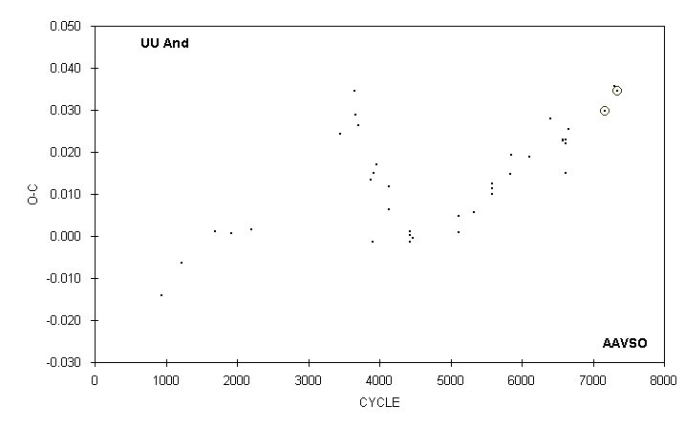

 | JD(min) |  |  |  |  |  |  | STANDARD
 | HEL. |  | CYCLE | O-C | N |  | OBSERVER | ERROR
 | 2400000 +
 | 49570.817 |  | 5329 | 0.006 | 16 |  | M. Baldwin
 | 50337.755 |  | 5845 | 0.015 | 18 |  | M. Baldwin
 | 50340.732 |  | 5847 | 0.019 | 17 |  | M. Baldwin
 | 50719.737 |  | 6102 | 0.019 | 15 |  | M. Baldwin
 | 51165.635 |  | 6402 | 0.028 | 15 |  | M. Baldwin
 | 51428.704 |  | 6579 | 0.023 | 16 |  | M. Baldwin
 | 51431.677 |  | 6581 | 0.023 | 19 |  | M. Baldwin
 | 51486.669 |  | 6618 | 0.022 | 17 |  | M. Baldwin
 | 51492.607 |  | 6622 | 0.015 | 17 |  | R. Hill
 | 51492.615 |  | 6622 | 0.023 | 25 |  | M. Baldwin
 | 51544.638 |  | 6657 | 0.026 | 14 |  | M. Baldwin
 | 52311.5709 |  | 7173 | 0.0297 | 53 |  | G. Samolyk (CCD) | 0.0002
 | 52507.768 |  | 7305 | 0.036 | 20 |  | M. Simonsen
 | 52568.7049 |  | 7346 | 0.0344 | 279 |  | L. Cook (CCD) | 0.0001

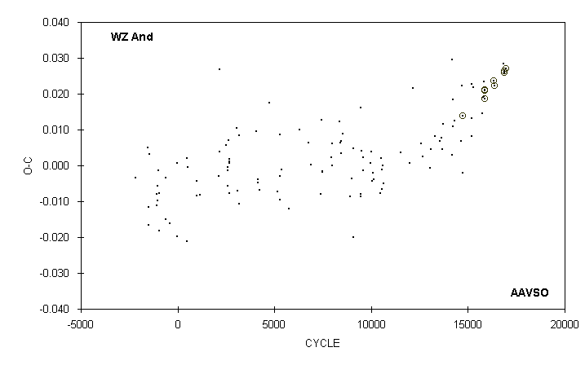

 | JD(min) |  |  |  |  |  |  | STANDARD
 | HEL. |  | CYCLE | O-C | N |  | OBSERVER | ERROR
 | 2400000 +
 | 51431.685 |  | 15179 | 0.008 | 15 |  | M. Baldwin
 | 51431.690 |  | 15179 | 0.013 | 14 |  | R. Berg
 | 51438.656 |  | 15189 | 0.023 | 19 |  | M. Baldwin
 | 51493.612 |  | 15268 | 0.022 | 16 |  | M. Baldwin
 | 51836.564 |  | 15761 | 0.014 | 14 |  | M. Baldwin
 | 51849.786 |  | 15780 | 0.019 | 17 |  | R. Hill
 | 51868.573 |  | 15807 | 0.023 | 16 |  | C. Stephan
 | 51872.743 |  | 15813 | 0.019 | 16 |  | R. Hill
 | 51909.6143 |  | 15866 | 0.0208 | 53 |  | S. Dvorak (CCD) | 0.0003
 | 51916.5713 |  | 15876 | 0.0212 | 32 |  | S. Dvorak (CCD) | 0.0004
 | 51923.5253 |  | 15886 | 0.0187 | 33 |  | S. Dvorak (CCD) | 0.0006
 | 52224.7501 |  | 16319 | 0.0237 | 27 |  | S. Dvorak (CCD) | 0.0001
 | 52259.5316 |  | 16369 | 0.0223 | 76 |  | J. A. Howell (CCD) | 0.0001
 | 52585.801 |  | 16838 | 0.028 | 19 |  | R. Hill
 | 52604.5813 |  | 16865 | 0.0259 | 63 |  | J. A. Howell (CCD) | 0.0001
 | 52611.5383 |  | 16875 | 0.0263 | 42 |  | S. Dvorak (CCD) | 0.0001
 | 52684.5830 |  | 16980 | 0.0270 | 43 |  | S. Jamieson (CCD) | 0.0002

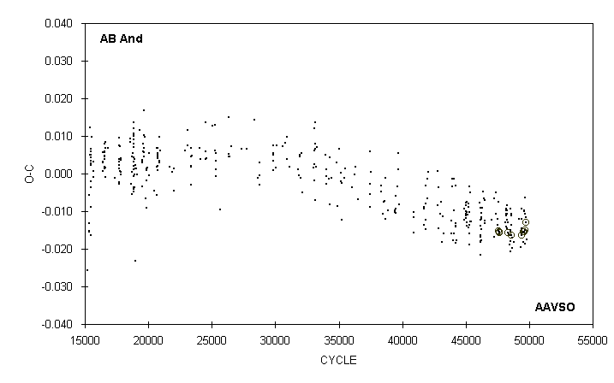

 | JD(min) |  |  |  |  |  |  | STANDARD
 | HEL. |  | CYCLE | O-C | N |  | OBSERVER | ERROR
 | 2400000 +
 | 52236.540 |  | 48591 | -0.011 | 13 |  | C. Stephan
 | 52254.619 |  | 48645.5 | -0.020 | 18 |  | G. Samolyk
 | 52263.583 |  | 48672.5 | -0.017 | 16 |  | G. Samolyk
 | 52299.592 |  | 48781 | -0.018 | 15 |  | G. Samolyk
 | 52441.814 |  | 49209.5 | -0.012 | 16 |  | G. Samolyk
 | 52489.765 |  | 49354 | -0.019 | 13 |  | B. Manske
 | 52497.734 |  | 49378 | -0.016 | 13 |  | D. Williams
 | 52503.3757 |  | 49395 | -0.0163 | 25 |  | Bal-Mai (CCD) | 0.0002
 | 52506.699 |  | 49405 | -0.012 | 19 |  | M. Simonsen
 | 52507.692 |  | 49408 | -0.015 | 11 |  | M. Simonsen
 | 52511.680 |  | 49420 | -0.009 | 11 |  | M. Simonsen
 | 52525.779 |  | 49462.5 | -0.016 | 15 |  | G. Samolyk
 | 52557.8068 |  | 49559 | -0.0155 | 58 |  | S. Dvorak (CCD) | 0.0001
 | 52558.634 |  | 49561.5 | -0.018 | 16 |  | G. Samolyk
 | 52568.765 |  | 49592 | -0.010 | 9 |  | G. Sarty
 | 52574.7335 |  | 49610 | -0.0153 | 237 |  | M. Nicholas (CCD) | 0.0001
 | 52576.7247 |  | 49616 | -0.0155 | 94 |  | M. Nicholas (CCD) | 0.0001
 | 52580.713 |  | 49628 | -0.010 | 13 |  | G. Sarty
 | 52585.695 |  | 49643 | -0.006 | 16 |  | R. Hill
 | 52587.674 |  | 49649 | -0.019 | 11 |  | C. Stephan
 | 52601.617 |  | 49691 | -0.015 | 89 |  | J. A. Howell (CCD)
 | 52602.617 |  | 49694 | -0.011 | 19 |  | C. Stephan
 | 52609.586 |  | 49715 | -0.012 | 18 |  | C. Stephan
 | 52616.5544 |  | 49736 | -0.0129 | 31 |  | G. Samolyk (CCD) | 0.0002
 | 52637.625 |  | 49799.5 | -0.017 | 17 |  | G. Samolyk

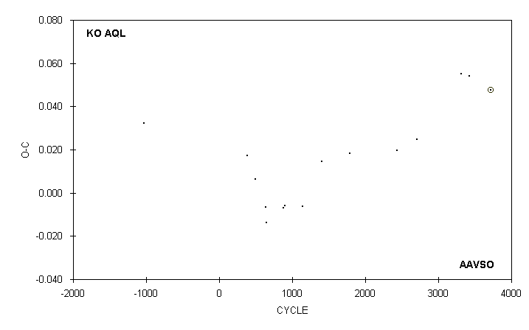

 | JD(min) |  |  |  |  |  |  | STANDARD
 | HEL. |  | CYCLE | O-C | N |  | OBSERVER | ERROR
 | 2400000 +
 | 42998.743 |  | 388 | 0.017 | 12 |  | D. Ruokonen
 | 43313.778 |  | 498 | 0.006 | 17 |  | D. Ruokonen
 | 43714.733 |  | 638 | -0.006 | 13 |  | G. Samolyk
 | 43734.774 |  | 645 | -0.014 | 14 |  | C. Hesseltine
 | 44410.698 |  | 881 | -0.007 | 16 |  | G. Hanson
 | 44410.698 |  | 881 | -0.007 | 13 |  | G. Samolyk
 | 44473.708 |  | 903 | -0.006 | 20 |  | G. Hanson
 | 45166.809 |  | 1145 | -0.006 | 11 |  | E. Halbach
 | 45905.756 |  | 1403 | 0.014 | 15 |  | D. Williams
 | 46999.829 |  | 1785 | 0.018 | 19 |  | P. Atwood
 | 48855.738 |  | 2433 | 0.020 | 21 |  | G. Samolyk
 | 49637.630 |  | 2706 | 0.025 | 17 |  | G. Samolyk
 | 51384.734 |  | 3316 | 0.055 | 17 |  | G. Samolyk
 | 51699.779 |  | 3426 | 0.054 | 17 |  | D. Williams
 | 52524.6203 |  | 3714 | 0.0476 | 67 |  | G. Samolyk (CCD) | 0.0005

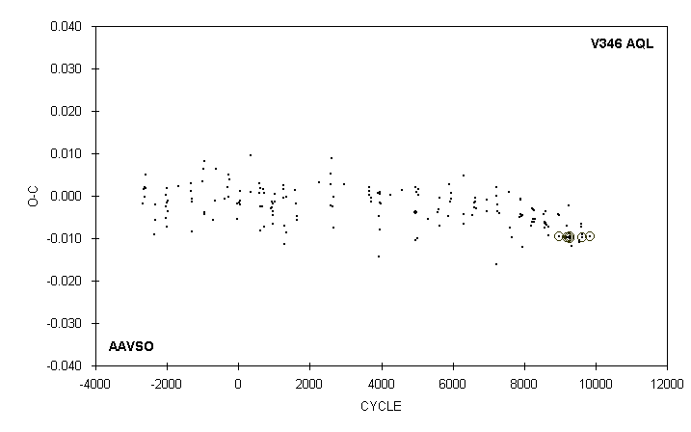

 | JD(min) |  |  |  |  |  |  | STANDARD
 | HEL. |  | CYCLE | O-C | N |  | OBSERVER | ERROR
 | 2400000 +
 | 51812.584 |  | 8943 | -0.004 | 18 |  | C. Stephan
 | 51843.562 |  | 8971 | -0.004 | 14 |  | R. Hays
 | 51864.5779 |  | 8990 | -0.0095 | 37 |  | S. Dvorak (CCD) | 0.0005
 | 52094.7011 |  | 9198 | -0.0098 | 109 |  | S. Dvorak (CCD) | 0.0001
 | 52104.661 |  | 9207 | -0.007 | 10 |  | B. Manske
 | 52135.644 |  | 9235 | -0.002 | 13 |  | R. Hays
 | 52145.5937 |  | 9244 | -0.0099 | 119 |  | S. Dvorak (CCD) | 0.0001
 | 52176.5717 |  | 9272 | -0.0100 | 85 |  | S. Dvorak (CCD) | 0.0001
 | 52186.5294 |  | 9281 | -0.0097 | 72 |  | S. Dvorak (CCD) | 0.0001
 | 52228.569 |  | 9319 | -0.012 | 11 |  | M. Baldwin
 | 52469.757 |  | 9537 | -0.011 | 17 |  | D. Williams
 | 52489.672 |  | 9555 | -0.010 | 8 |  | B. Manske
 | 52489.672 |  | 9555 | -0.010 | 7 |  | D. Weier
 | 52531.717 |  | 9593 | -0.007 | 6 |  | G. Sarty
 | 52541.675 |  | 9602 | -0.007 | 12 |  | R. Hays
 | 52561.5862 |  | 9620 | -0.0099 | 53 |  | G. Samolyk (CCD) | 0.0001
 | 52561.587 |  | 9620 | -0.009 | 14 |  | R. Hays
 | 52812.7309 |  | 9847 | -0.0096 | 40 |  | G. Samolyk (CCD) | 0.0003

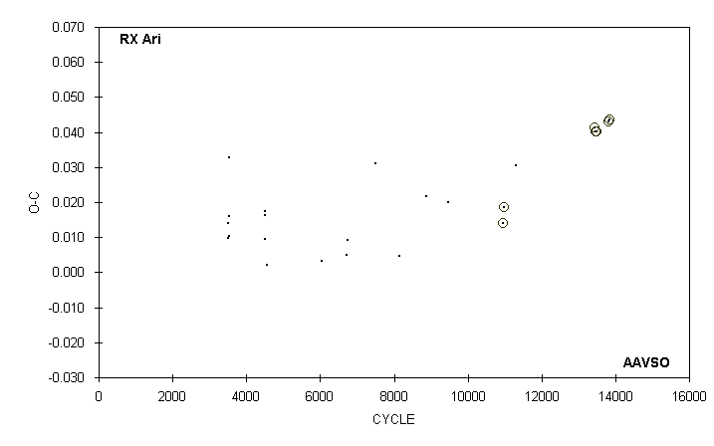

 | JD(min) |  |  |  |  |  |  | STANDARD
 | HEL. |  | CYCLE | O-C | N |  | OBSERVER | ERROR
 | 2400000 +
 | 43026.748 |  | 4495 | 0.009 | 9 |  | D. Ruokonen
 | 43026.756 |  | 4495 | 0.017 | 10 |  | G. Wedemayer
 | 43028.814 |  | 4497 | 0.016 | 15 |  | G. Samolyk
 | 43094.696 |  | 4561 | 0.002 | 15 |  | G. Samolyk
 | 44622.662 |  | 6045 | 0.003 | 18 |  | G. Hanson
 | 45315.602 |  | 6718 | 0.005 | 19 |  | G. Samolyk
 | 45352.673 |  | 6754 | 0.009 | 20 |  | G. Samolyk
 | 46114.618 |  | 7494 | 0.031 | 17 |  | G. Samolyk
 | 46774.582 |  | 8135 | 0.005 | 16 |  | G. Samolyk
 | 47539.611 |  | 8878 | 0.022 | 16 |  | G. Samolyk
 | 48137.822 |  | 9459 | 0.020 | 12 |  | G. Samolyk
 | 49666.8107 |  | 10944 | 0.0141 | 196 |  | G. Lubcke (CCD) | 0.0006
 | 49696.6745 |  | 10973 | 0.0187 | 94 |  | G. Lubcke (CCD) | 0.0002
 | 50041.611 |  | 11308 | 0.030 | 17 |  | S. Cook (CCD)
 | 52235.7547 |  | 13439 | 0.0412 | 108 |  | S. Dvorak (CCD) | 0.0001
 | 52265.6128 |  | 13468 | 0.0401 | 57 |  | S. Dvorak (CCD) | 0.0002
 | 52299.5906 |  | 13501 | 0.0403 | 53 |  | G. Samolyk (CCD) | 0.0005
 | 52616.7182 |  | 13809 | 0.0431 | 49 |  | G. Samolyk (CCD) | 0.0003
 | 52644.5186 |  | 13836 | 0.0436 | 51 |  | S. Dvorak (CCD) | 0.0002

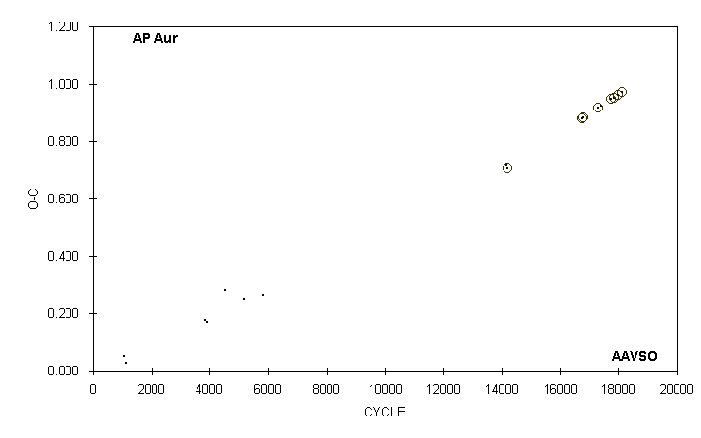

 | JD(min) |  |  |  |  |  |  | STANDARD
 | HEL. |  | CYCLE | O-C | N |  | OBSERVER | ERROR
 | 2400000 +
 | 43050.833 |  | 1066.5 | 0.052 | 7 |  | G. Samolyk
 | 43100.908 |  | 1154.5 | 0.028 | 11 |  | G. Samolyk
 | 44629.660 |  | 3839.5 | 0.176 | 19 |  | G. Samolyk
 | 44670.646 |  | 3911.5 | 0.171 | 16 |  | G. Samolyk
 | 45026.574 |  | 4536.5 | 0.279 | 10 |  | G. Samolyk
 | 45405.707 |  | 5202.5 | 0.250 | 14 |  | G. Samolyk
 | 45762.678 |  | 5829.5 | 0.262 | 21 |  | G. Samolyk
 | 50503.798 |  | 14156.5 | 0.717 | 32 |  | G. Stecher (CCD) | 0.012
 | 50529.6924 |  | 14202 | 0.7073 | 24 |  | G. Stecher (CCD) | 0.0014
 | 51976.7739 |  | 16743.5 | 0.8811 | 103 |  | S. Dvorak (CCD) | 0.0007
 | 51996.7001 |  | 16778.5 | 0.8814 | 35 |  | G. Lubcke (CCD) | 0.0003
 | 52312.7036 |  | 17333.5 | 0.9164 | 15 |  | G. Samolyk (CCD) | 0.0008
 | 52365.658 |  | 17426.5 | 0.9247 | 52 |  | S. Dvorak (CCD) | 0.001
 | 52559.8158 |  | 17767.5 | 0.9470 | 48 |  | G. Samolyk (CCD) | 0.0004
 | 52609.6354 |  | 17855 | 0.9517 | 58 |  | G. Samolyk (CCD) | 0.0006
 | 52616.7529 |  | 17867.5 | 0.9528 | 30 |  | S. Jamieson (CCD) | 0.0004
 | 52689.6346 |  | 17995.5 | 0.9625 | 51 |  | S. Dvorak (CCD) | 0.0004
 | 52755.6823 |  | 18111.5 | 0.9700 | 105 |  | C. Hesseltine (CCD) | 0.0003

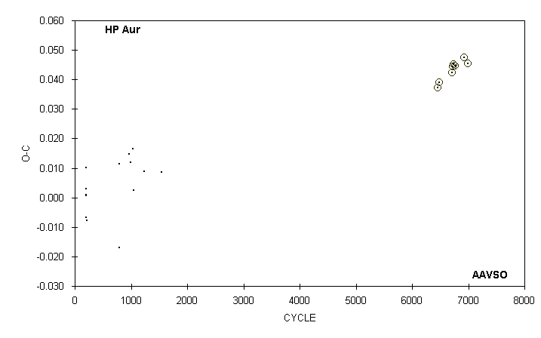

 | JD(min) |  |  |  |  |  |  | STANDARD
 | HEL. |  | CYCLE | O-C | N |  | OBSERVER | ERROR
 | 2400000 +
 | 43035.931 |  | 196.5 | 0.001 | 9 |  | G. Samolyk
 | 43043.766 |  | 202 | 0.010 | 7 |  | G. Samolyk
 | 43045.891 |  | 203.5 | 0.001 | 21 |  | G. Wedemayer
 | 43045.893 |  | 203.5 | 0.003 | 22 |  | G. Samolyk
 | 43050.863 |  | 207 | -0.007 | 13 |  | G. Samolyk
 | 43055.842 |  | 210.5 | -0.008 | 9 |  | G. Samolyk
 | 43876.796 |  | 787.5 | -0.017 | 12 |  | G. Samolyk
 | 43879.670 |  | 789.5 | 0.011 | 17 |  | G. Samolyk
 | 44132.934 : |  | 967.5 | 0.015 | 26 |  | G. Samolyk
 | 44160.676 |  | 987 | 0.012 | 17 |  | G. Samolyk
 | 44222.573 |  | 1030.5 | 0.016 | 9 |  | G. Samolyk
 | 44236.787 |  | 1040.5 | 0.002 | 26 |  | G. Samolyk
 | 44522.779 |  | 1241.5 | 0.009 | 18 |  | G. Samolyk
 | 44958.871 |  | 1548 | 0.009 | 19 |  | G. Samolyk
 | 51937.7984 |  | 6453 | 0.0373 | 45 |  | G. Samolyk (CCD) | 0.0001
 | 51987.5985 |  | 6488 | 0.0390 | 37 |  | G. Lubcke (CCD) | 0.0002
 | 52300.6208 |  | 6708 | 0.0424 | 62 |  | C. Hesseltine (CCD) | 0.0008
 | 52320.5422 |  | 6722 | 0.0444 | 37 |  | S. Dvorak (CCD) | 0.0001
 | 52337.6167 |  | 6734 | 0.0451 | 40 |  | G. Samolyk (CCD) | 0.0002
 | 52374.6094 |  | 6760 | 0.0447 | 43 |  | G. Samolyk (CCD) | 0.0001
 | 52618.6247 |  | 6931.5 | 0.0475 | 42 |  | G. Samolyk (CCD) | 0.0005
 | 52714.6626 |  | 6999 | 0.0455 | 64 |  | C. Hesseltine (CCD) | 0.0002

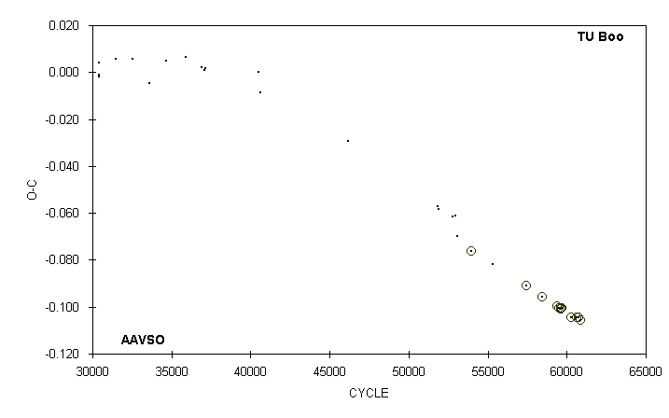

 | JD(min) |  |  |  |  |  |  | STANDARD
 | HEL. |  | CYCLE | O-C | N |  | OBSERVER | ERROR
 | 2400000 +
 | 50574.8962 |  | 53991 | -0.0764 | 59 |  | P. Kuebler (CCD) | 0.0006
 | 51012.678 |  | 55341 | -0.082 | 14 |  | G. Samolyk
 | 51693.6711 |  | 57441 | -0.0910 | 36 |  | G. Samolyk (CCD) | 0.0003
 | 52028.6545 |  | 58474 | -0.0958 | 94 |  | G. Samolyk (CCD) | 0.0002
 | 52323.7518 |  | 59384 | -0.0995 | 33 |  | S. Dvorak (CCD) | 0.0001
 | 52373.6909 |  | 59538 | -0.1006 | 16 |  | S. Dvorak (CCD) | 0.0002
 | 52398.8230 |  | 59615.5 | -0.1007 | 34 |  | G. Samolyk (CCD) | 0.0003
 | 52405.635 |  | 59636.5 | -0.099 | 13 |  | C. Stephan
 | 52407.5791 |  | 59642.5 | -0.1004 | 17 |  | S. Dvorak (CCD) | 0.0001
 | 52426.7118 |  | 59701.5 | -0.1006 | 36 |  | N. Simmons (CCD) | 0.0002
 | 52615.9292 |  | 60285 | -0.1045 | 38 |  | G. Samolyk (CCD) | 0.0005
 | 52728.7812 |  | 60633 | -0.1043 | 38 |  | G. Samolyk (CCD) | 0.0002
 | 52796.7179 |  | 60842.5 | -0.1057 | 57 |  | G. Samolyk (CCD) | 0.0001
 | 52769.6410 |  | 60759 | -0.1047 | 30 |  | G. Samolyk (CCD) | 0.0003

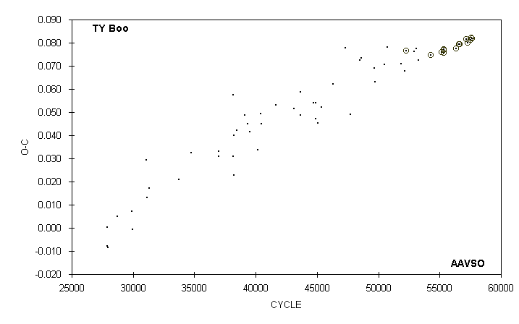

 | JD(min) |  |  |  |  |  |  | STANDARD
 | HEL. |  | CYCLE | O-C | N |  | OBSERVER | ERROR
 | 2400000 +
 | 51370.674 |  | 53256.5 | 0.073 | 12 |  | G. Samolyk
 | 51685.7623 |  | 54250 | 0.0746 | 45 |  | G. Samolyk (CCD) | 0.0002
 | 51690.6782 |  | 54265.5 | 0.0746 | 43 |  | G. Lubcke (CCD) | 0.0002
 | 51974.6853 |  | 55161 | 0.0760 | 25 |  | S. Dvorak (CCD) | 0.0003
 | 52021.6229 |  | 55309 | 0.0758 | 39 |  | S. Dvorak (CCD) | 0.0002
 | 52025.5885 |  | 55321.5 | 0.0770 | 31 |  | G. Samolyk (CCD) | 0.0002
 | 52037.6403 |  | 55359.5 | 0.0772 | 36 |  | G. Samolyk (CCD) | 0.0002
 | 52349.8726 |  | 56344 | 0.0776 | 48 |  | S. Dvorak (CCD) | 0.0001
 | 52416.6339 |  | 56554.5 | 0.0793 | 37 |  | G. Samolyk (CCD) | 0.0002
 | 52448.6660 |  | 56655.5 | 0.0795 | 40 |  | G. Samolyk (CCD) | 0.0005
 | 52615.9635 |  | 57183 | 0.0816 | 42 |  | G. Samolyk (CCD) | 0.0004
 | 52651.9583 |  | 57296.5 | 0.0801 | 51 |  | G. Samolyk (CCD) | 0.0002
 | 52728.8678 |  | 57539 | 0.0813 | 29 |  | G. Samolyk (CCD) | 0.0002
 | 52740.6031 |  | 57576 | 0.0821 | 32 |  | G. Samolyk (CCD) | 0.0003
 | 52762.6445 |  | 57645.5 | 0.0818 | 76 |  | C. Hesseltine (CCD) | 0.0001

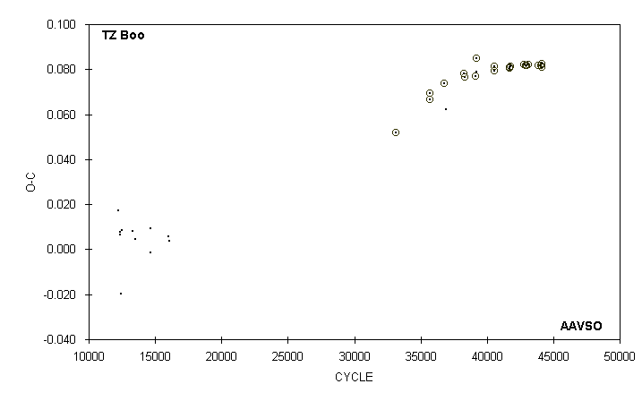

 | JD(min) |  |  |  |  |  |  | STANDARD
 | HEL. |  | CYCLE | O-C | N |  | OBSERVER | ERROR
 | 2400000 +
 | 51678.6800 |  | 40536 | 0.0793 | 27 |  | G. Lubcke (CCD) | 0.0006
 | 51685.6651 |  | 40559.5 | 0.0812 | 68 |  | G. Lubcke (CCD) | 0.0002
 | 51693.6887 |  | 40586.5 | 0.0814 | 70 |  | G. Samolyk (CCD) | 0.0002
 | 52015.6632 |  | 41670 | 0.0809 | 64 |  | S. Dvorak (CCD) | 0.0002
 | 52021.6062 |  | 41690 | 0.0806 | 39 |  | G. Samolyk (CCD) | 0.0002
 | 52028.740 |  | 41714 | 0.083 | 10 |  | B. Manske
 | 52047.7572 |  | 41778 | 0.0814 | 55 |  | S. Dvorak (CCD) | 0.0002
 | 52353.6862 |  | 42807.5 | 0.0821 | 33 |  | S. Dvorak (CCD) | 0.0002
 | 52384.8877 |  | 42912.5 | 0.0816 | 37 |  | S. Dvorak (CCD) | 0.0003
 | 52404.6493 |  | 42979 | 0.0819 | 156 |  | G. Lubcke (CCD) | 0.0003
 | 52448.6296 |  | 43127 | 0.0822 | 27 |  | G. Samolyk (CCD) | 0.0008
 | 52659.9114 |  | 43838 | 0.0818 | 46 |  | S. Dvorak (CCD) | 0.0002
 | 52728.8527 |  | 44070 | 0.0816 | 32 |  | G. Samolyk (CCD) | 0.0002
 | 52742.6700 |  | 44116.5 | 0.0808 | 66 |  | G. Samolyk (CCD) | 0.0003
 | 52752.6266 |  | 44150 | 0.0825 | 51 |  | S. Dvorak (CCD) | 0.0003

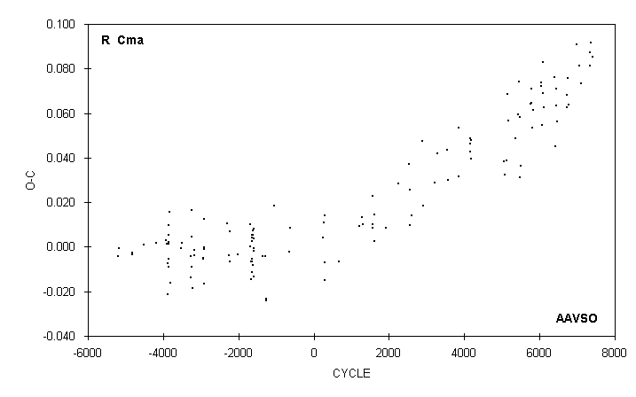

 | JD(min) |  |  |  |  |  |  | STANDARD
 | HEL. |  | CYCLE | O-C | N |  | OBSERVER | ERROR
 | 2400000 +
 | 51544.689 |  | 6387 | 0.076 | 22 |  | G. Samolyk
 | 51586.688 |  | 6424 | 0.045 | 23 |  | G. Samolyk
 | 51602.617 |  | 6438 | 0.071 | 16 |  | G. Samolyk
 | 51610.561 |  | 6445 | 0.063 | 13 |  | G. Samolyk
 | 51644.632 |  | 6475 | 0.056 | 8 |  | R. Schmude
 | 51928.629 |  | 6725 | 0.068 | 11 |  | C. Stephan
 | 51937.711 |  | 6733 | 0.063 | 18 |  | G. Samolyk
 | 51961.579 |  | 6754 | 0.076 | 15 |  | G. Samolyk
 | 51978.606 |  | 6769 | 0.064 | 12 |  | G. Samolyk
 | 52230.812 |  | 6991 | 0.091 | 14 |  | G. Samolyk
 | 52312.590 |  | 7063 | 0.081 | 16 |  | G. Samolyk
 | 52354.612 |  | 7100 | 0.073 | 20 |  | C. Stephan
 | 52615.886 |  | 7330 | 0.081 | 22 |  | G. Samolyk
 | 52639.747 |  | 7351 | 0.087 | 18 |  | G. Samolyk
 | 52663.606 |  | 7372 | 0.092 | 16 |  | G. Samolyk
 | 52713.581 |  | 7416 | 0.085 | 13 |  | G. Samolyk

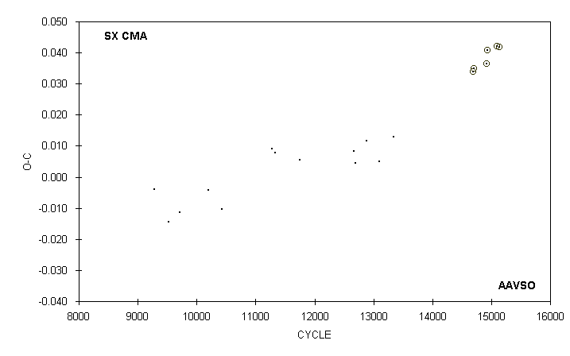

 | JD(min) |  |  |  |  |  |  | STANDARD
 | HEL. |  | CYCLE | O-C | N |  | OBSERVER | ERROR
 | 2400000 +
 | 43176.635 |  | 9285 | -0.004 | 13 |  | G. Samolyk
 | 43556.701 |  | 9519 | -0.015 | 17 |  | G. Samolyk
 | 43876.683 |  | 9716 | -0.011 | 17 |  | G. Samolyk
 | 44654.710 |  | 10195 | -0.004 | 16 |  | G. Samolyk
 | 45026.659 |  | 10424 | -0.010 | 19 |  | G. Samolyk
 | 46413.795 |  | 11278 | 0.009 | 23 |  | G. Samolyk
 | 46496.631 |  | 11329 | 0.008 | 16 |  | G. Samolyk
 | 47170.696 |  | 11744 | 0.006 | 20 |  | G. Samolyk
 | 48661.768 |  | 12662 | 0.008 | 15 |  | G. Samolyk
 | 48705.619 |  | 12689 | 0.004 | 13 |  | G. Samolyk
 | 49012.611 |  | 12878 | 0.012 | 15 |  | G. Samolyk
 | 49374.814 |  | 13101 | 0.005 | 16 |  | R. Hill
 | 49777.638 |  | 13349 | 0.013 | 13 |  | G. Samolyk
 | 51947.6682 |  | 14685 | 0.0339 | 82 |  | S. Dvorak (CCD) | 0.0001
 | 51986.6515 |  | 14709 | 0.0350 | 96 |  | G. Samolyk (CCD) | 0.0002
 | 52319.6260 |  | 14914 | 0.0365 | 62 |  | G. Samolyk (CCD) | 0.0008
 | 52358.6124 |  | 14938 | 0.0407 | 52 |  | S. Dvorak (CCD) | 0.0002
 | 52616.8708 |  | 15097 | 0.0420 | 44 |  | G. Samolyk (CCD) | 0.0004
 | 52678.5925 |  | 15135 | 0.0419 | 117 |  | C. Hesseltine (CCD) | 0.0001

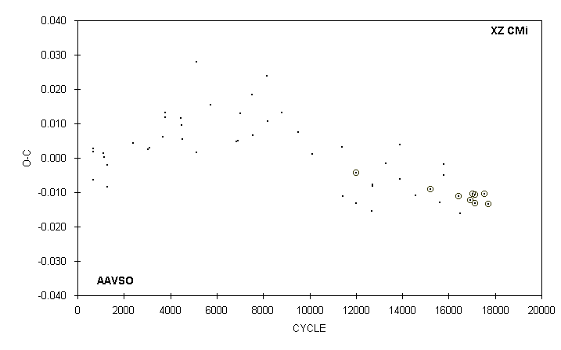

 | JD(min) |  |  |  |  |  |  | STANDARD
 | HEL. |  | CYCLE | O-C | N |  | OBSERVER | ERROR
 | 2400000 +
 | 49779.639 |  | 12673 | -0.015 | 13 |  | G. Samolyk
 | 49801.641 |  | 12711 | -0.008 | 13 |  | G. Samolyk
 | 49812.639 |  | 12730 | -0.008 | 15 |  | G. Samolyk
 | 50131.569 : |  | 13281 | -0.002 | 10 |  | S. Cook (CCD)
 | 50488.700 |  | 13898 | 0.004 | 12 |  | G. Samolyk
 | 50491.584 |  | 13903 | -0.006 | 16 |  | S. Cook (CCD)
 | 50884.591 |  | 14582 | -0.011 | 15 |  | G. Samolyk
 | 51244.6122 |  | 15204 | -0.0092 | 65 |  | G. Lubcke (CCD) | 0.0005
 | 51488.866 |  | 15626 | -0.013 | 14 |  | G. Samolyk
 | 51579.747 |  | 15783 | -0.005 | 13 |  | G. Samolyk
 | 51586.696 |  | 15795 | -0.002 | 12 |  | G. Samolyk
 | 51957.7035 |  | 16436 | -0.0111 | 43 |  | C. Hesseltine (CCD) | 0.0002
 | 51986.639 |  | 16486 | -0.016 | 14 |  | G. Samolyk
 | 52244.7918 |  | 16932 | -0.0124 | 34 |  | S. Dvorak (CCD) | 0.0001
 | 52307.5945 |  | 17040.5 | -0.0105 | 38 |  | S. Dvorak (CCD) | 0.0004
 | 52362.5786 |  | 17135.5 | -0.0133 | 43 |  | S. Dvorak (CCD) | 0.0005
 | 52366.6329 |  | 17142.5 | -0.0107 | 19 |  | S. Dvorak (CCD) | 0.0005
 | 52602.7874 |  | 17550.5 | -0.0104 | 31 |  | S. Dvorak (CCD) | 0.0003
 | 52698.5773 |  | 17716 | -0.0135 | 42 |  | G. Samolyk (CCD) | 0.0003

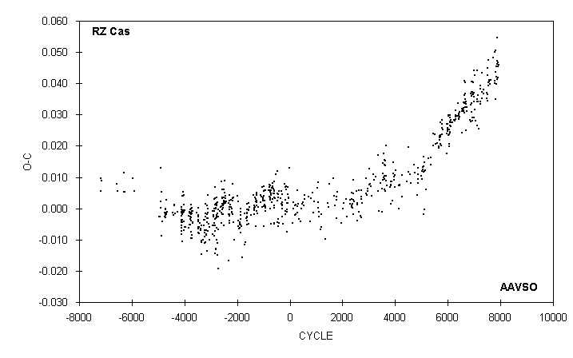

 | JD(min)
 | HEL. |  | CYCLE | O-C | N |  | OBSERVER
 | 2400000 +
 | 52415.709 |  | 7710 | 0.048 | 13 |  | N. Simmons
 | 52489.806 |  | 7772 | 0.040 | 19 |  | B. Manske
 | 52489.816 |  | 7772 | 0.050 | 15 |  | G. Samolyk
 | 52505.345 |  | 7785 | 0.041 | 13 |  | S. Foglia
 | 52525.667 |  | 7802 | 0.044 | 17 |  | G. Samolyk
 | 52548.368 |  | 7821 | 0.035 | 27 |  | S. Foglia
 | 52555.555 |  | 7827 | 0.050 | 21 |  | G. Chaple
 | 52560.331 |  | 7831 | 0.045 | 18 |  | S. Foglia
 | 52568.692 |  | 7838 | 0.040 | 11 |  | G. Sarty
 | 52586.623 |  | 7853 | 0.042 | 16 |  | C. Stephan
 | 52604.551 |  | 7868 | 0.041 | 21 |  | J. A. Howell
 | 52609.338 |  | 7872 | 0.047 | 22 |  | S. Foglia
 | 52610.532 |  | 7873 | 0.046 | 16 |  | C. Stephan
 | 52617.712 |  | 7879 | 0.055 | 11 |  | G. Sarty
 | 52641.609 |  | 7899 | 0.047 | 18 |  | G. Samolyk
 | 52652.365 |  | 7908 | 0.045 | 24 |  | S. Foglia
 | 52664.314 |  | 7918 | 0.042 | 10 |  | S. Foglia
 | 52678.661 |  | 7930 | 0.046 | 18 |  | G. Samolyk

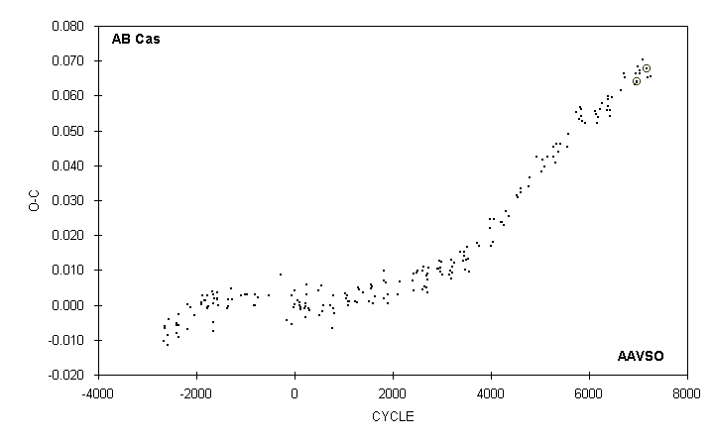

 | JD(min) |  |  |  |  |  |  | STANDARD
 | HEL. |  | CYCLE | O-C | N |  | OBSERVER | ERROR
 | 2400000 +
 | 51805.602 |  | 6651 | 0.062 | 14 |  | G. Samolyk
 | 51887.619 |  | 6711 | 0.066 | 25 |  | C. Stephan
 | 51898.553 |  | 6719 | 0.065 | 15 |  | R. Hays
 | 52189.695 |  | 6932 | 0.063 | 18 |  | G. Samolyk
 | 52226.604 |  | 6959 | 0.066 | 15 |  | M. Baldwin
 | 52230.702 |  | 6962 | 0.064 | 39 |  | M. Simonsen
 | 52230.7022 |  | 6962 | 0.0641 | 98 |  | S. Dvorak (CCD) | 0.0001
 | 52278.547 |  | 6997 | 0.068 | 14 |  | R. Hays
 | 52319.552 |  | 7027 | 0.067 | 11 |  | M. Baldwin
 | 52323.652 |  | 7030 | 0.066 | 14 |  | M. Baldwin
 | 52398.834 |  | 7085 | 0.070 | 18 |  | B. Manske
 | 52524.5838 |  | 7177 | 0.0678 | 36 |  | G. Samolyk (CCD) | 0.0002
 | 52547.818 |  | 7194 | 0.065 | 13 |  | R. Hays
 | 52617.529 |  | 7245 | 0.066 | 11 |  | R. Hays

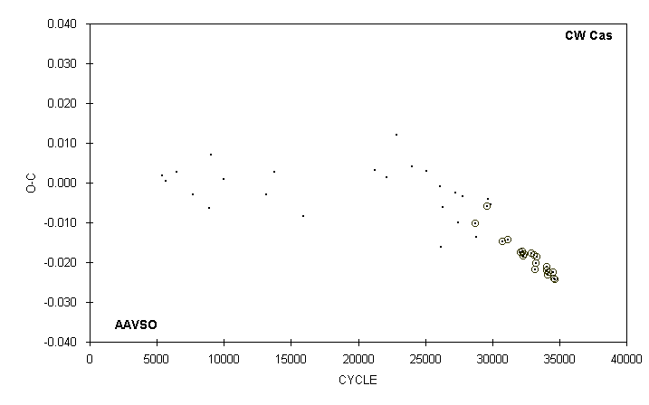

 | JD(min) |  |  |  |  |  |  | STANDARD
 | HEL. |  | CYCLE | O-C | N |  | OBSERVER | ERROR
 | 2400000 +
 | 51443.6186 |  | 30770 | -0.0148 | 35 |  | G. Lubcke (CCD) | 0.0003
 | 51576.5853 |  | 31187 | -0.0144 | 28 |  | G. Samolyk (CCD) | 0.0003
 | 51870.5749 |  | 32109 | -0.0175 | 56 |  | G. Samolyk (CCD) | 0.0001
 | 51919.5208 |  | 32262.5 | -0.0172 | 38 |  | G. Samolyk (CCD) | 0.0001
 | 51933.5496 |  | 32306.5 | -0.0184 | 35 |  | S. Dvorak (CCD) | 0.0003
 | 51948.5368 |  | 32353.5 | -0.0179 | 39 |  | S. Dvorak (CCD) | 0.0004
 | 52125.8253 |  | 32909.5 | -0.0178 | 70 |  | G. Samolyk (CCD) | 0.0002
 | 52185.7713 |  | 33097.5 | -0.0182 | 65 |  | S. Dvorak (CCD) | 0.0001
 | 52215.5816 |  | 33191 | -0.0217 | 33 |  | S. Dvorak (CCD) | 0.0003
 | 52230.5698 |  | 33238 | -0.0202 | 72 |  | G. Samolyk (CCD) | 0.0002
 | 52257.5154 |  | 33322.5 | -0.0186 | 29 |  | S. Dvorak (CCD) | 0.0002
 | 52489.8054 |  | 34051 | -0.0211 | 10 |  | G. Samolyk (CCD) | 0.0007
 | 52496.8194 |  | 34073 | -0.0221 | 27 |  | S. Dvorak (CCD) | 0.0003
 | 52518.6605 |  | 34141.5 | -0.0232 | 61 |  | G. Samolyk (CCD) | 0.0003
 | 52527.9082 |  | 34170.5 | -0.0225 | 30 |  | S. Dvorak (CCD) | 0.0003
 | 52639.5107 |  | 34520.5 | -0.0225 | 15 |  | G. Lubcke (CCD) | 0.0002
 | 52663.5834 |  | 34596 | -0.0240 | 52 |  | G. Samolyk (CCD) | 0.0003
 | 52678.5698 |  | 34643 | -0.0242 | 49 |  | G. Samolyk (CCD) | 0.0003

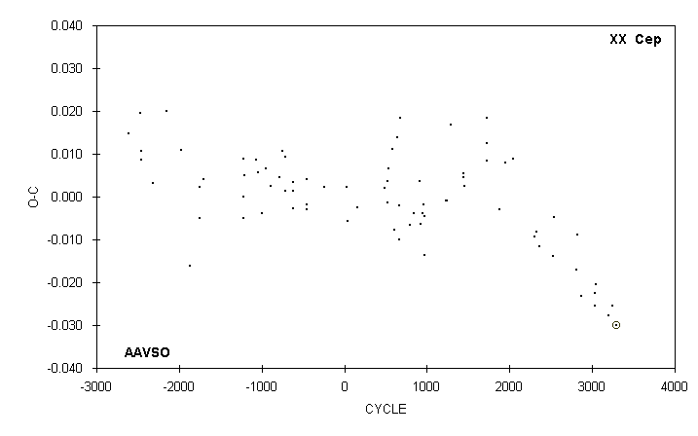

 | JD(min) |  |  |  |  |  |  | STANDARD
 | HEL. |  | CYCLE | O-C | N |  | OBSERVER | ERROR
 | 2400000 +
 | 49605.620 |  | 2039 | 0.009 | 13 |  | S. Cook (CCD)
 | 50222.656 |  | 2303 | -0.009 | 12 |  | M. Baldwin
 | 50264.729 |  | 2321 | -0.008 | 10 |  | S. Cook (CCD)
 | 50367.568 |  | 2365 | -0.012 | 13 |  | G. Samolyk
 | 50755.562 |  | 2531 | -0.014 | 18 |  | C. Stephan
 | 50769.595 |  | 2537 | -0.005 | 11 |  | R. Hays
 | 51407.673 |  | 2810 | -0.017 | 13 |  | M. Baldwin
 | 51421.705 |  | 2816 | -0.009 | 11 |  | R. Hays
 | 51538.557 |  | 2866 | -0.023 | 12 |  | R. Hays
 | 51919.539 |  | 3029 | -0.025 | 12 |  | R. Hays
 | 51933.566 |  | 3035 | -0.022 | 13 |  | R. Hays
 | 51947.592 |  | 3041 | -0.020 | 12 |  | R. Hays
 | 52307.533 |  | 3195 | -0.028 | 22 |  | S. Dvorak (CCD) | 0.002
 | 52426.739 |  | 3246 | -0.025 | 14 |  | B. Manske
 | 52529.5768 |  | 3290 | -0.0299 | 39 |  | G. Samolyk (CCD) | 0.0005

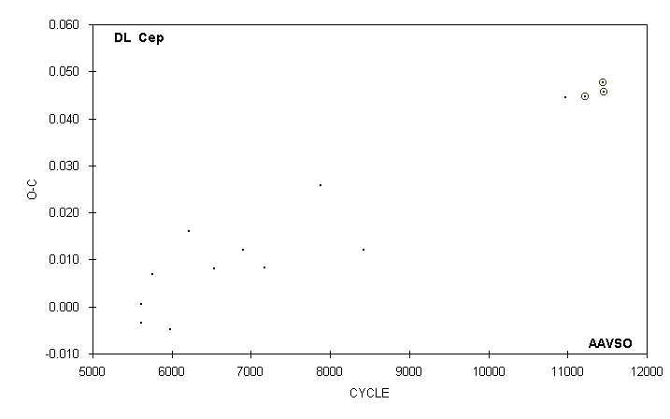

 | JD(min) |  |  |  |  |  |  | STANDARD
 | HEL. |  | CYCLE | O-C | N |  | OBSERVER | ERROR
 | 2400000 +
 | 43096.864 |  | 5612 | -0.003 | 14 |  | D. Ruokonen
 | 43096.868 |  | 5612 | 0.001 | 14 |  | G. Wedemayer
 | 43326.772 |  | 5753 | 0.007 | 17 |  | G. Samolyk
 | 43701.771 |  | 5983 | -0.005 | 17 |  | G. Samolyk
 | 44081.694 |  | 6216 | 0.016 | 16 |  | G. Samolyk
 | 44593.657 |  | 6530 | 0.008 | 23 |  | G. Samolyk
 | 45193.678 |  | 6898 | 0.012 | 17 |  | G. Samolyk
 | 45643.687 |  | 7174 | 0.008 | 16 |  | G. Samolyk
 | 46804.607 |  | 7886 | 0.026 | 20 |  | G. Samolyk
 | 47681.792 |  | 8424 | 0.012 | 17 |  | G. Samolyk
 | 51842.812 : |  | 10976 | 0.045 | 9 |  | R. Hill
 | 52245.5409 |  | 11223 | 0.0446 | 51 |  | G. Samolyk (CCD) | 0.0003
 | 52602.6192 |  | 11442 | 0.0476 | 36 |  | S. Dvorak (CCD) | 0.0003
 | 52620.5526 |  | 11453 | 0.0458 | 30 |  | G. Lubcke (CCD) | 0.0002

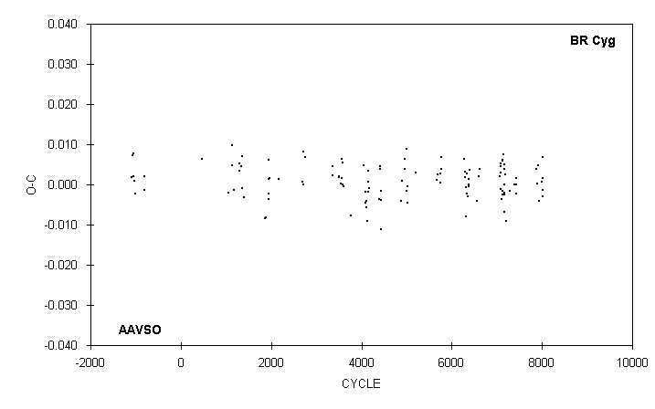

 | JD(min)
 | HEL. |  | CYCLE | O-C | N |  | OBSERVER
 | 2400000 +
 | 51397.775 |  | 7398 | 0.000 | 15 |  | M. Baldwin
 | 51429.758 |  | 7422 | 0.001 | 14 |  | R. Berg
 | 51433.752 |  | 7425 | -0.002 | 19 |  | M. Baldwin
 | 51437.752 |  | 7428 | 0.000 | 20 |  | M. Baldwin
 | 52042.740 |  | 7882 | 0.004 | 12 |  | D. Williams
 | 52070.720 |  | 7903 | 0.000 | 13 |  | D. Williams
 | 52086.715 |  | 7915 | 0.005 | 13 |  | M. Baldwin
 | 52118.688 |  | 7939 | -0.004 | 13 |  | C. Stephan
 | 52182.656 |  | 7987 | 0.001 | 14 |  | D. Williams
 | 52210.646 |  | 8008 | 0.007 | 14 |  | G. Samolyk
 | 52226.627 |  | 8020 | -0.003 | 17 |  | R. Hays
 | 52226.629 |  | 8020 | -0.001 | 12 |  | M. Baldwin
 | 52230.629 |  | 8023 | 0.001 | 15 |  | M. Baldwin

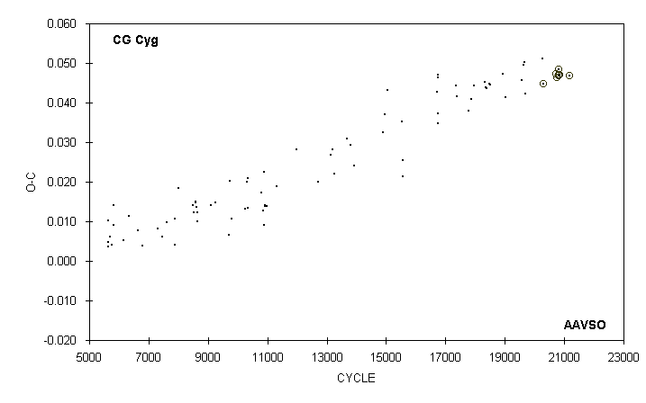

 | JD(min) |  |  |  |  |  |  | STANDARD
 | HEL. |  | CYCLE | O-C | N |  | OBSERVER | ERROR
 | 2400000 +
 | 51370.775 |  | 18927 | 0.047 | 11 |  | G. Samolyk
 | 51432.621 |  | 19025 | 0.041 | 12 |  | R. Berg
 | 51784.802 |  | 19583 | 0.046 | 9 |  | R. Berg
 | 51812.576 |  | 19627 | 0.049 | 10 |  | C. Stephan
 | 51836.560 |  | 19665 | 0.050 | 11 |  | G. Samolyk
 | 51853.593 |  | 19692 | 0.042 | 7 |  | R. Berg
 | 52221.557 |  | 20275 | 0.051 | 12 |  | C. Stephan
 | 52240.4848 |  | 20305 | 0.0447 | 33 |  | S. Dvorak (CCD) | 0.0001
 | 52502.4108 |  | 20720 | 0.0472 | 15 |  | Bal-Mai (CCD) | 0.0006
 | 52522.6065 |  | 20752 | 0.0464 | 46 |  | G. Samolyk (CCD) | 0.0002
 | 52563.6311 |  | 20817 | 0.0468 |  |  | FBAC GRB team (CCD) | 0.0001
 | 52563.6327 |  | 20817 | 0.0484 | 141 |  | M. Nicholas (CCD) | 0.0001
 | 52566.7871 |  | 20822 | 0.0471 | 100 |  | M. Nicholas (CCD) | 0.0001
 | 52589.5082 |  | 20858 | 0.0471 | 26 |  | S. Dvorak (CCD) | 0.0001
 | 52785.7927 |  | 21169 | 0.0468 | 34 |  | G. Samolyk (CCD) | 0.0002

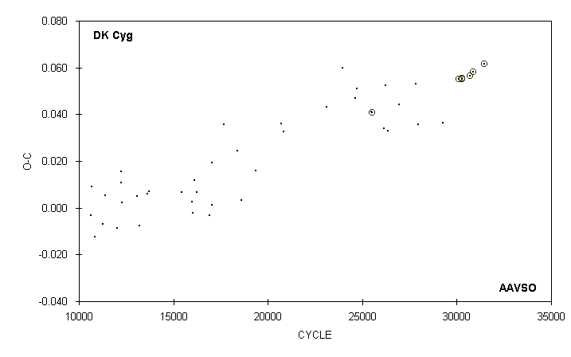

 | JD(min) |  |  |  |  |  |  | STANDARD
 | HEL. |  | CYCLE | O-C | N |  | OBSERVER | ERROR
 | 2400000 +
 | 49988.584 |  | 25471 | 0.041 | 15 |  | G. Samolyk
 | 50003.6456 |  | 25503 | 0.0407 | 88 |  | G. Lubcke (CCD) | 0.0002
 | 50313.824 |  | 26162 | 0.034 | 15 |  | G. Samolyk
 | 50341.613 |  | 26221 | 0.052 | 11 |  | J. McKenna
 | 50397.606 |  | 26340 | 0.033 | 12 |  | J. McKenna
 | 50692.740 |  | 26967 | 0.044 | 20 |  | G. Samolyk
 | 51095.660 |  | 27823 | 0.053 | 18 |  | G. Samolyk
 | 51160.598 |  | 27961 | 0.036 | 21 |  | G. Samolyk
 | 51777.674 |  | 29272 | 0.036 | 19 |  | G. Samolyk
 | 52163.6590 |  | 30092 | 0.0552 | 88 |  | G. Samolyk (CCD) | 0.0002
 | 52245.5592 |  | 30266 | 0.0552 | 44 |  | S. Dvorak (CCD) | 0.0001
 | 52253.5613 |  | 30283 | 0.0556 | 75 |  | G. Samolyk (CCD) | 0.0002
 | 52441.8384 |  | 30683 | 0.0565 | 33 |  | G. Samolyk (CCD) | 0.0003
 | 52525.6231 |  | 30861 | 0.0582 | 45 |  | G. Samolyk (CCD) | 0.0003
 | 52811.8062 |  | 31469 | 0.0615 | 57 |  | G. Samolyk (CCD) | 0.0002
 | 52526.5644 |  | 30863 | 0.0582 | 26 |  | S. Dvorak (CCD) | 0.0003

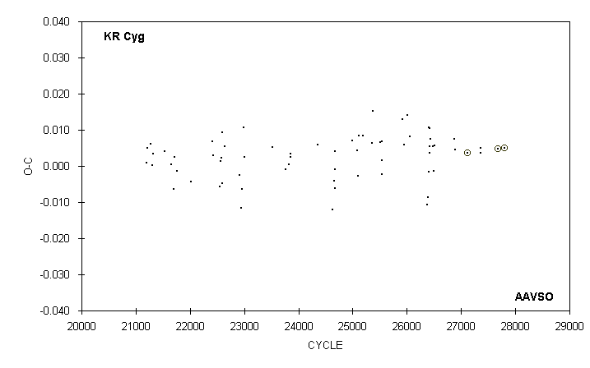

 | JD(min) |  |  |  |  |  |  | STANDARD
 | HEL. |  | CYCLE | O-C | N |  | OBSERVER | ERROR
 | 2400000 +
 | 51400.659 |  | 26379 | -0.011 | 12 |  | M. Baldwin
 | 51411.648 |  | 26392 | -0.009 | 15 |  | M. Baldwin
 | 51426.880 |  | 26410 | 0.011 | 14 |  | M. Baldwin
 | 51427.713 |  | 26411 | -0.002 | 12 |  | M. Baldwin
 | 51432.789 |  | 26417 | 0.004 | 13 |  | M. Baldwin
 | 51433.641 |  | 26418 | 0.010 | 11 |  | M. Baldwin
 | 51438.707 |  | 26424 | 0.005 | 17 |  | M. Baldwin
 | 51444.625 |  | 26431 | 0.007 | 12 |  | S. Cook (CCD)
 | 51488.571 |  | 26483 | 0.006 | 18 |  | M. Baldwin
 | 51493.635 |  | 26489 | -0.001 | 17 |  | M. Baldwin
 | 51510.545 |  | 26509 | 0.006 | 17 |  | M. Baldwin
 | 51815.647 |  | 26870 | 0.008 | 10 |  | M. Baldwin
 | 51837.618 |  | 26896 | 0.005 | 14 |  | M. Baldwin
 | 52027.7760 |  | 27121 | 0.0037 | 63 |  | S. Dvorak (CCD) | 0.0001
 | 52225.543 |  | 27355 | 0.005 | 11 |  | M. Baldwin
 | 52230.612 |  | 27361 | 0.004 | 19 |  | M. Baldwin
 | 52499.3716 |  | 27679 | 0.0047 | 30 |  | Bal-Mai (CCD) | 0.0003
 | 52596.5643 |  | 27794 | 0.0050 | 73 |  | S. Dvorak (CCD) | 0.0001

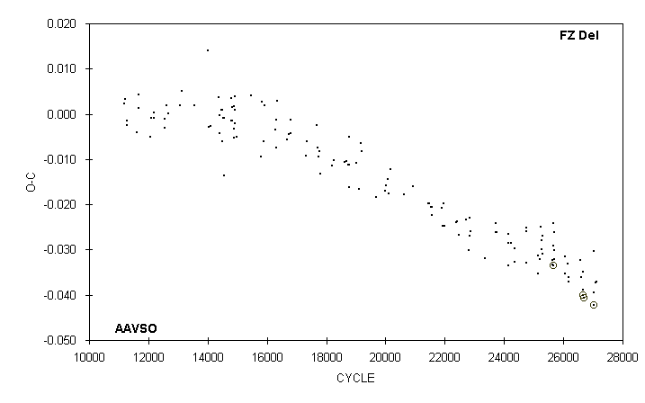

 | JD(min) |  |  |  |  |  |  | STANDARD
 | HEL. |  | CYCLE | O-C | N |  | OBSERVER | ERROR
 | 2400000 +
 | 51734.814 |  | 26060 | -0.035 | 11 |  | D. Williams
 | 51792.774 |  | 26134 | -0.033 | 16 |  | R. Hays
 | 51818.617 |  | 26167 | -0.036 | 8 |  | D. Williams
 | 51836.630 |  | 26190 | -0.037 | 15 |  | R. Hays
 | 52132.689 |  | 26568 | -0.032 | 16 |  | R. Hays
 | 52168.713 |  | 26614 | -0.036 | 8 |  | D. Williams
 | 52205.5200 |  | 26661 | -0.0401 | 22 |  | J. Blackwell (CCD)
 | 52219.619 |  | 26679 | -0.039 | 13 |  | G. Samolyk
 | 52219.623 |  | 26679 | -0.035 | 14 |  | R. Hays
 | 52241.5473 |  | 26707 | -0.0406 | 60 |  | S. Dvorak (CCD) | 0.0001
 | 52493.752 |  | 27029 | -0.030 | 15 |  | R. Hays
 | 52497.659 |  | 27034 | -0.039 | 8 |  | D. Williams
 | 52502.3555 |  | 27040 | -0.0422 | 13 |  | Bal-Mai (CCD) | 0.0006
 | 52548.570 |  | 27099 | -0.037 | 15 |  | C. Stephan
 | 52555.619 |  | 27108 | -0.037 | 13 |  | R. Hays
 | 52566.584 |  | 27122 | -0.037 | 22 |  | C. Stephan

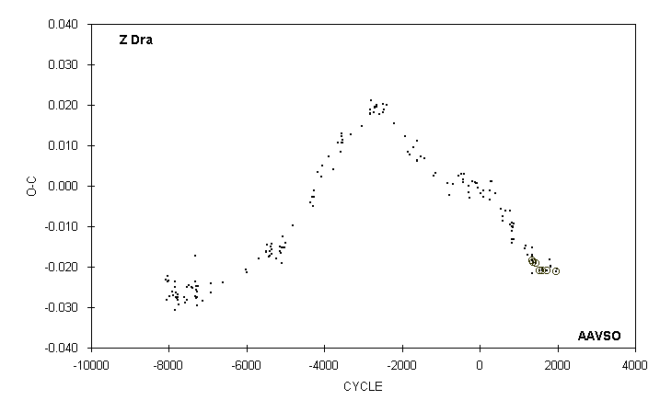

 | JD(min) |  |  |  |  |  |  | STANDARD
 | HEL. |  | CYCLE | O-C | N |  | OBSERVER | ERROR
 | 2400000 +
 | 51660.633 |  | 1338 | -0.017 | 9 |  | M. Baldwin
 | 51664.704 |  | 1341 | -0.018 | 16 |  | M. Baldwin
 | 51698.6392 |  | 1366 | -0.0190 |  |  | J. A. Howell (CCD) | 0.0003
 | 51937.5460 |  | 1542 | -0.0208 | 70 |  | G. Samolyk (CCD) | 0.0001
 | 52017.635 |  | 1601 | -0.021 | 17 |  | G. Samolyk
 | 52021.7069 |  | 1604 | -0.0210 | 98 |  | S. Dvorak (CCD) | 0.0001
 | 52021.707 |  | 1604 | -0.021 | 18 |  | G. Samolyk
 | 52184.5992 |  | 1724 | -0.0209 | 81 |  | G. Samolyk (CCD) | 0.0001
 | 52287.767 |  | 1800 | -0.018 | 17 |  | G. Samolyk
 | 52314.914 |  | 1820 | -0.020 | 13 |  | D. Williams
 | 52329.846 |  | 1831 | -0.020 | 13 |  | D. Williams
 | 52522.6006 |  | 1973 | -0.0210 | 46 |  | G. Samolyk (CCD) | 0.0001
 | 52556.537 |  | 1998 | -0.021 | 18 |  | G. Chaple

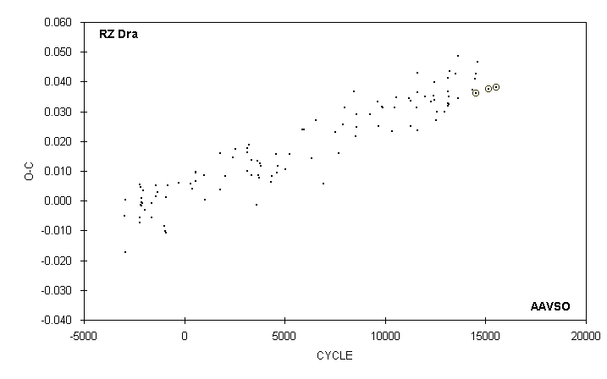

 | JD(min) |  |  |  |  |  |  | STANDARD
 | HEL. |  | CYCLE | O-C | N |  | OBSERVER | ERROR
 | 2400000 +
 | 51400.654 |  | 13112 | 0.041 | 15 |  | M. Baldwin
 | 51406.709 |  | 13123 | 0.037 | 16 |  | M. Baldwin
 | 51407.806 |  | 13125 | 0.032 | 12 |  | M. Baldwin
 | 51411.663 |  | 13132 | 0.033 | 18 |  | M. Baldwin
 | 51427.638 |  | 13161 | 0.032 | 17 |  | M. Baldwin
 | 51438.658 |  | 13181 | 0.035 | 14 |  | M. Baldwin
 | 51454.642 |  | 13210 | 0.044 | 13 |  | G. Samolyk
 | 51629.819 |  | 13528 | 0.043 | 15 |  | G. Samolyk
 | 51693.712 |  | 13644 | 0.034 | 14 |  | G. Samolyk
 | 51698.684 |  | 13653 | 0.049 | 17 |  | G. Samolyk
 | 52077.674 |  | 14341 | 0.037 | 12 |  | D. Williams
 | 52163.614 |  | 14497 | 0.041 | 14 |  | G. Samolyk
 | 52179.591 |  | 14526 | 0.043 | 15 |  | G. Samolyk
 | 52184.5422 |  | 14535 | 0.0360 | 73 |  | S. Dvorak (CCD) | 0.0001
 | 52223.665 |  | 14606 | 0.047 | 11 |  | B. Manske
 | 52515.6188 |  | 15136 | 0.0375 | 42 |  | G. Samolyk (CCD) | 0.0002
 | 52729.9094 |  | 15525 | 0.0382 | 47 |  | S. Dvorak (CCD) | 0.0001

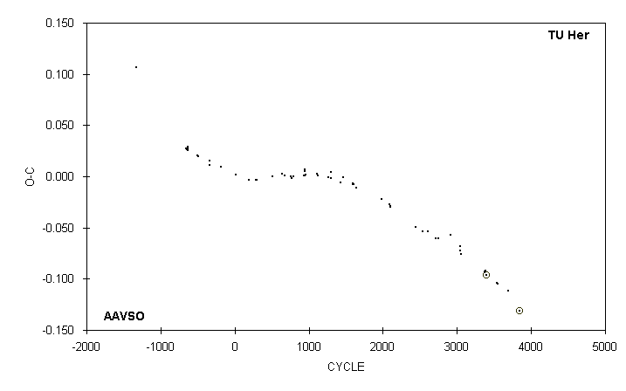

 | JD(min) |  |  |  |  |  |  | STANDARD
 | HEL. |  | CYCLE | O-C | N |  | OBSERVER | ERROR
 | 2400000 +
 | 49812.789 |  | 2537 | -0.053 | 17 |  | M. Baldwin
 | 49960.144 | 3) | 2602 | -0.053 | 21 |  | G. Samolyk
 | 50211.774 |  | 2713 | -0.060 | 16 |  | R. Hill
 | 50304.721 |  | 2754 | -0.060 | 21 |  | M. Baldwin
 | 50669.711 |  | 2915 | -0.057 | 22 |  | G. Samolyk
 | 50950.804 |  | 3039 | -0.073 | 17 |  | C. Hesseltine
 | 50950.808 |  | 3039 | -0.069 | 22 |  | G. Samolyk
 | 50984.806 |  | 3054 | -0.076 | 22 |  | R. Hill
 | 51705.694 |  | 3372 | -0.094 | 11 |  | D. Williams
 | 51705.695 |  | 3372 | -0.093 | 21 |  | G. Samolyk
 | 51748.769 |  | 3391 | -0.092 | 16 |  | G. Samolyk
 | 51773.7012 |  | 3402 | -0.0965 |  |  | J. A. Howell (CCD) | 0.0001
 | 52070.671 |  | 3533 | -0.104 | 14 |  | D. Williams
 | 52104.675 |  | 3548 | -0.105 | 17 |  | G. Samolyk
 | 52435.650 |  | 3694 | -0.112 | 23 |  | C. Stephan
 | 52775.6804 |  | 3844 | -0.1315 | 61 |  | G. Samolyk (CCD) | 0.0002
 | 3) | Observations combined from 49955 to 49964

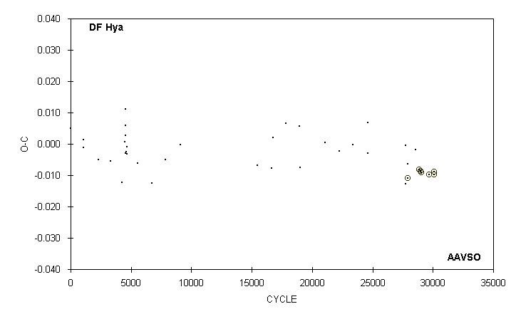

 | JD(min) |  |  |  |  |  |  | STANDARD
 | HEL. |  | CYCLE | O-C | N |  | OBSERVER | ERROR
 | 2400000 +
 | 49060.686 |  | 18974 | 0.006 | 12 |  | G. Samolyk
 | 49064.640 |  | 18986 | -0.008 | 17 |  | G. Samolyk
 | 49754.621 |  | 21073 | 0.000 | 14 |  | G. Samolyk
 | 50152.667 |  | 22277 | -0.002 | 12 |  | G. Samolyk
 | 50523.608 |  | 23399 | 0.000 | 13 |  | G. Samolyk
 | 50921.654 |  | 24603 | -0.003 | 11 |  | G. Samolyk
 | 50926.623 |  | 24618 | 0.007 | 14 |  | G. Samolyk
 | 51957.761 |  | 27737 | -0.013 | 14 |  | G. Samolyk
 | 51958.765 |  | 27740 | -0.001 | 13 |  | G. Samolyk
 | 52017.607 |  | 27918 | -0.006 | 14 |  | G. Samolyk
 | 52021.5697 |  | 27930 | -0.0108 | 47 |  | S. Dvorak (CCD) | 0.0001
 | 52223.909 |  | 28542 | -0.002 | 13 |  | B. Manske
 | 52334.6555 |  | 28877 | -0.0082 | 66 |  | S. Dvorak (CCD) | 0.0001
 | 52370.6911 |  | 28986 | -0.0085 | 38 |  | G. Samolyk (CCD) | 0.0002
 | 52386.5595 |  | 29034 | -0.0092 | 22 |  | S. Dvorak (CCD) | 0.0001
 | 52607.8992 |  | 29703.5 | -0.0097 | 48 |  | S. Dvorak (CCD) | 0.0001
 | 52732.7036 |  | 30081 | -0.0088 | 35 |  | S. Dvorak (CCD) | 0.0003
 | 52735.6780 |  | 30090 | -0.0098 | 44 |  | G. Samolyk (CCD) | 0.0002

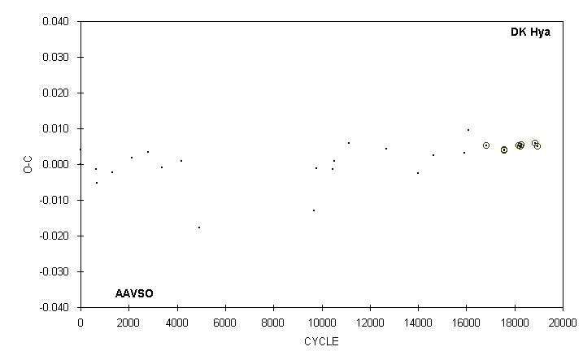

 | JD(min) |  |  |  |  |  |  | STANDARD
 | HEL. |  | CYCLE | O-C | N |  | OBSERVER | ERROR
 | 2400000 +
 | 48297.788 |  | 10450 | -0.001 | 17 |  | G. Samolyk
 | 48331.715 |  | 10515 | 0.001 | 16 |  | G. Samolyk
 | 48654.789 |  | 11134 | 0.006 | 16 |  | G. Samolyk
 | 49460.633 |  | 12678 | 0.004 | 15 |  | G. Samolyk
 | 50152.693 |  | 14004 | -0.002 | 16 |  | G. Samolyk
 | 50488.815 |  | 14648 | 0.003 | 16 |  | G. Samolyk
 | 51144.870 |  | 15905 | 0.003 | 16 |  | G. Samolyk
 | 51245.607 |  | 16098 | 0.010 | 19 |  | G. Samolyk
 | 51629.7363 |  | 16834 | 0.0052 | 107 |  | C. Hesseltine (CCD) | 0.0001
 | 52006.5618 |  | 17556 | 0.0040 | 47 |  | S. Dvorak (CCD) | 0.0001
 | 52007.6055 |  | 17558 | 0.0038 | 56 |  | G. Samolyk (CCD) | 0.0002
 | 52018.5660 |  | 17579 | 0.0040 | 32 |  | S. Dvorak (CCD) | 0.0001
 | 52330.6758 |  | 18177 | 0.0052 | 30 |  | S. Dvorak (CCD) | 0.0001
 | 52364.6004 |  | 18242 | 0.0050 | 46 |  | G. Samolyk (CCD) | 0.0002
 | 52389.6531 |  | 18290 | 0.0055 | 42 |  | G. Samolyk (CCD) | 0.0004
 | 52678.7976 |  | 18844 | 0.0059 | 44 |  | G. Samolyk (CCD) | 0.0003
 | 52735.6860 |  | 18953 | 0.0050 | 40 |  | G. Samolyk (CCD) | 0.0004

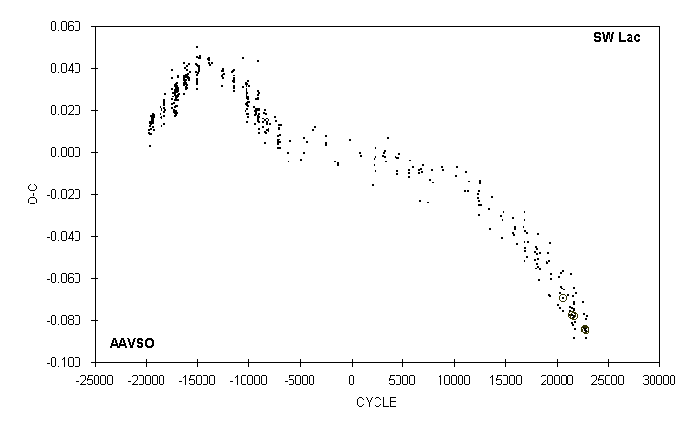

 | JD(min) |  |  |  |  |  |  | STANDARD
 | HEL. |  | CYCLE | O-C | N |  | OBSERVER | ERROR
 | 2400000 +
 | 52254.644 |  | 21761.5 | -0.072 | 20 |  | G. Samolyk
 | 52256.556 |  | 21767.5 | -0.084 | 14 |  | C. Stephan
 | 52263.619 |  | 21789.5 | -0.077 | 15 |  | G. Samolyk
 | 52265.539 |  | 21795.5 | -0.081 | 13 |  | C. Stephan
 | 52286.560 |  | 21861 | -0.067 | 14 |  | G. Samolyk
 | 52506.719 : |  | 22547.5 | -0.083 | 16 |  | M. Simonsen
 | 52511.702 : |  | 22563 | -0.071 | 12 |  | M. Simonsen
 | 52525.808 |  | 22607 | -0.077 | 14 |  | G. Samolyk
 | 52552.582 |  | 22690.5 | -0.083 | 14 |  | C. Stephan
 | 52558.6744 |  | 22709.5 | -0.0846 | 114 |  | M. Nicholas (CCD) | 0.0003
 | 52564.7681 |  | 22728.5 | -0.0846 | 28 |  | S. Dvorak (CCD) | 0.0001
 | 52566.6928 |  | 22734.5 | -0.0842 | 123 |  | M. Nicholas (CCD) | 0.0001
 | 52586.5769 |  | 22796.5 | -0.0848 | 60 |  | S. Dvorak (CCD) | 0.0001
 | 52586.582 |  | 22796.5 | -0.080 | 13 |  | C. Stephan
 | 52587.540 |  | 22799.5 | -0.084 | 13 |  | C. Stephan
 | 52602.609 |  | 22846.5 | -0.089 | 16 |  | C. Stephan
 | 52637.578 |  | 22955.5 | -0.078 | 12 |  | G. Samolyk

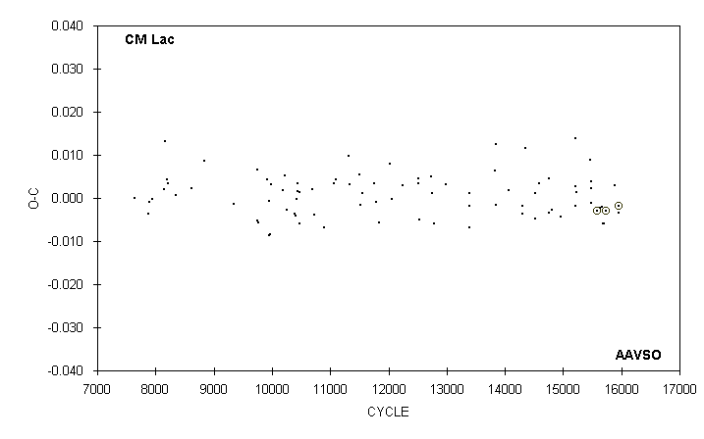

 | JD(min) |  |  |  |  |  |  | STANDARD
 | HEL. |  | CYCLE | O-C | N |  | OBSERVER | ERROR
 | 2400000 +
 | 51839.671 |  | 15463 | 0.009 | 11 |  | G. Samolyk
 | 51868.549 |  | 15481 | 0.002 | 16 |  | C. Stephan
 | 51871.760 |  | 15483 | 0.004 | 14 |  | R. Hill
 | 51876.569 |  | 15486 | -0.001 | 20 |  | C. Stephan
 | 52041.8504 |  | 15589 | -0.0030 | 98 |  | S. Dvorak (CCD) | 0.0001
 | 52115.667 |  | 15635 | -0.002 | 15 |  | C. Stephan
 | 52168.622 |  | 15668 | -0.002 | 13 |  | D. Williams
 | 52184.665 |  | 15678 | -0.006 | 12 |  | R. Hays
 | 52221.573 |  | 15701 | -0.006 | 15 |  | C. Stephan
 | 52266.5073 |  | 15729 | -0.0029 | 52 |  | S. Dvorak (CCD) | 0.0001
 | 52521.659 |  | 15888 | 0.003 | 13 |  | R. Hays
 | 52619.539 |  | 15949 | -0.003 | 12 |  | R. Hays
 | 52627.5640 |  | 15954 | -0.0018 | 106 |  | S. Dvorak (CCD) | 0.0001

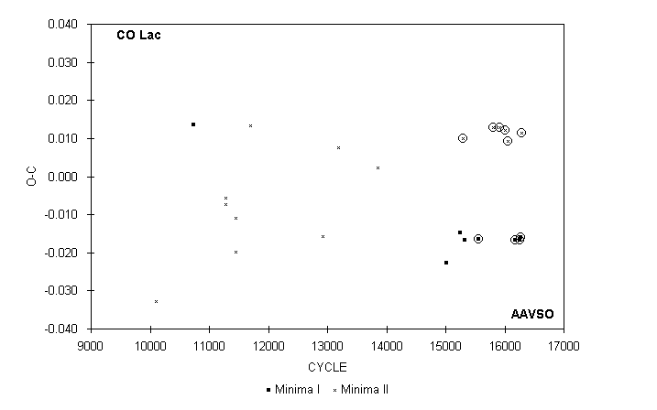

 | JD(min) |  |  |  |  |  |  | STANDARD
 | HEL. |  | CYCLE | O-C | N |  | OBSERVER | ERROR
 | 2400000 +
 | 43112.649 |  | 10101.5 | -0.033 | 11 |  | G. Samolyk
 | 44089.684 |  | 10735 | 0.014 | 15 |  | G. Samolyk
 | 44921.684 |  | 11274.5 | -0.007 | 14 |  | G. Samolyk
 | 44938.650 |  | 11285.5 | -0.006 | 15 |  | G. Samolyk
 | 45200.811 |  | 11455.5 | -0.020 | 16 |  | R. Lee
 | 45200.820 |  | 11455.5 | -0.011 | 16 |  | E. Halbach
 | 45578.685 |  | 11700.5 | 0.013 | 20 |  | G. Samolyk
 | 47466.318 |  | 12924.5 | -0.016 | 17 |  | G. Samolyk
 | 47859.604 |  | 13179.5 | 0.007 | 18 |  | G. Samolyk
 | 48900.589 |  | 13854.5 | 0.002 | 16 |  | G. Samolyk
 | 50685.669 |  | 15012 | -0.023 | 14 |  | S. Cook (CCD)
 | 51049.638 |  | 15248 | -0.015 | 14 |  | S. Cook (CCD)
 | 51130.6287 |  | 15300.5 | 0.0100 | 82 |  | G. Samolyk (CCD) | 0.0006
 | 51160.675 |  | 15320 | -0.017 | 52 |  | G. Samolyk (CCD) | 0.002
 | 51538.5161 |  | 15565 | -0.0164 | 63 |  | G. Samolyk (CCD) | 0.0002
 | 51915.6152 |  | 15809.5 | 0.0129 | 63 |  | G. Samolyk (CCD) | 0.0003
 | 52069.8359 |  | 15909.5 | 0.0129 | 69 |  | G. Samolyk (CCD) | 0.0004
 | 52225.5982 |  | 16010.5 | 0.0122 | 82 |  | G. Samolyk (CCD) | 0.0003
 | 52299.6211 |  | 16058.5 | 0.0092 | 31 |  | G. Samolyk (CCD) | 0.0008
 | 52494.6846 |  | 16185 | -0.0166 | 59 |  | S. Dvorak (CCD) | 0.0002
 | 52602.6391 |  | 16255 | -0.0166 | 35 |  | G. Samolyk (CCD) | 0.0002
 | 52616.5195 |  | 16264 | -0.0161 | 36 |  | G. Samolyk (CCD) | 0.0003
 | 52663.5844 |  | 16294.5 | 0.0115 | 51 |  | G. Samolyk (CCD) | 0.0005

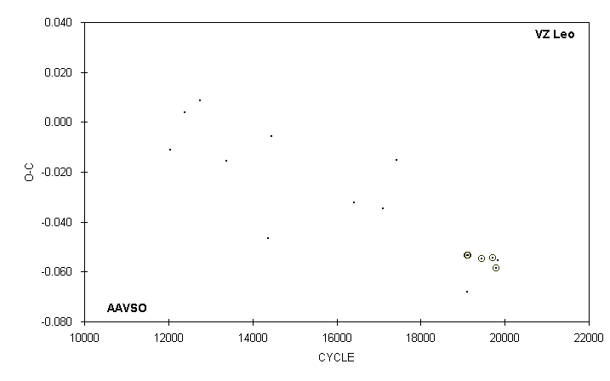

 | JD(min) |  |  |  |  |  |  | STANDARD
 | HEL. |  | CYCLE | O-C | N |  | OBSERVER | ERROR
 | 2400000 +
 | 44286.773 |  | 12040 | -0.011 | 12 |  | G. Hanson
 | 44660.626 |  | 12383 | 0.004 | 15 |  | G. Samolyk
 | 45060.626 |  | 12750 | 0.008 | 14 |  | G. Samolyk
 | 45753.782 |  | 13386 | -0.016 | 11 |  | G. Samolyk
 | 46820.769 |  | 14365 | -0.047 | 13 |  | G. Samolyk
 | 46915.632 |  | 14452 | -0.006 | 9 |  | G. Samolyk
 | 49061.630 |  | 16421 | -0.032 | 11 |  | G. Samolyk
 | 49801.674 |  | 17100 | -0.035 | 15 |  | G. Samolyk
 | 50164.632 : |  | 17433 | -0.015 | 11 |  | S. Cook (CCD)
 | 51995.6359 |  | 19113 | -0.0535 | 25 |  | G. Lubcke (CCD) | 0.0004
 | 51997.801 : |  | 19115 | -0.068 | 19 |  | R. Hill
 | 52007.6248 |  | 19124 | -0.0535 | 61 |  | C. Hesseltine (CCD) | 0.0005
 | 52371.6521 |  | 19458 | -0.0548 | 25 |  | S. Dvorak (CCD) | 0.0004
 | 52651.7583 |  | 19715 | -0.0545 | 15 |  | G. Samolyk (CCD) | 0.0010
 | 52735.6770 |  | 19792 | -0.0586 | 36 |  | G. Lubcke (CCD) | 0.0003
 | 52783.636 |  | 19836 | -0.055 | 60 |  | G. Samolyk (CCD) | 0.001

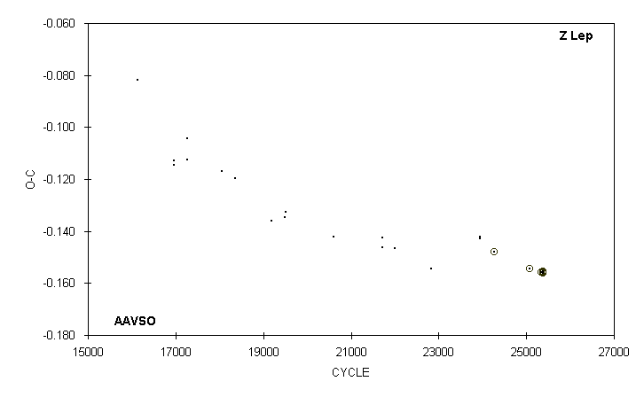

 | JD(min) |  |  |  |  |  |  | STANDARD
 | HEL. |  | CYCLE | O-C | N |  | OBSERVER | ERROR
 | 2400000 +
 | 49005.667 |  | 21718 | -0.146 | 19 |  | G. Samolyk
 | 49012.627 |  | 21725 | -0.142 | 19 |  | G. Samolyk
 | 49283.907 |  | 21998 | -0.147 | 13 |  | G. Samolyk
 | 50110.670 |  | 22830 | -0.154 | 15 |  | G. Samolyk
 | 50113.651 |  | 22833 | -0.155 | 14 |  | G. Samolyk
 | 51223.643 |  | 23950 | -0.142 | 17 |  | G. Samolyk
 | 51224.636 |  | 23951 | -0.143 | 19 |  | G. Samolyk
 | 51530.6951 |  | 24259 | -0.1481 | 50 |  | G. Samolyk (CCD) | 0.0002
 | 52337.5854 |  | 25071 | -0.1544 | 48 |  | G. Samolyk (CCD) | 0.0003
 | 52609.8619 |  | 25345 | -0.1558 | 33 |  | G. Samolyk (CCD) | 0.0003
 | 52637.6860 |  | 25373 | -0.1557 | 43 |  | S. Dvorak (CCD) | 0.0001
 | 52646.6291 |  | 25382 | -0.1560 | 38 |  | S. Dvorak (CCD) | 0.0002
 | 52650.6047 |  | 25386 | -0.1553 | 37 |  | G. Samolyk (CCD) | 0.0003

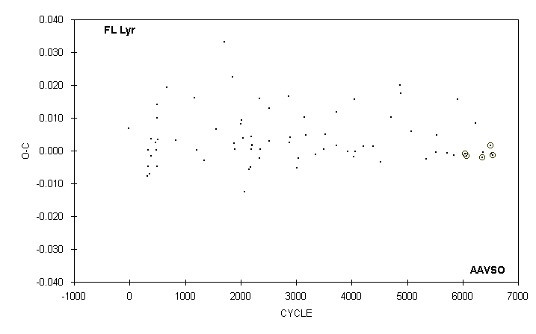

 | JD(min) |  |  |  |  |  |  | STANDARD
 | HEL. |  | CYCLE | O-C | N |  | OBSERVER | ERROR
 | 2400000 +
 | 49874.676 |  | 5350 | -0.003 | 9 |  | R. Hays
 | 50253.677 |  | 5524 | 0.000 | 15 |  | S. Cook (CCD)
 | 50266.751 |  | 5530 | 0.005 | 12 |  | R. Hays
 | 50693.664 |  | 5726 | -0.001 | 15 |  | R. Hays
 | 50959.398 |  | 5848 | -0.001 | 12 |  | D. Matsnev
 | 51085.748 |  | 5906 | 0.016 | 13 |  | R. Hill
 | 51390.6732 |  | 6046 | -0.0008 |  |  | J. A. Howell (CCD) | 0.0018
 | 51438.5917 |  | 6068 | -0.0017 |  |  | J. A. Howell (CCD) | 0.0003
 | 51793.641 |  | 6231 | 0.008 | 13 |  | R. Hays
 | 52063.7217 |  | 6355 | -0.0020 | 50 |  | S. Dvorak (CCD) | 0.0001
 | 52087.683 |  | 6366 | 0.000 | 13 |  | R. Hays
 | 52370.8451 |  | 6496 | 0.0016 | 26 |  | S. Jamieson (CCD) | 0.0003
 | 52405.693 |  | 6512 | -0.001 | 20 |  | C. Stephan
 | 52466.6808 |  | 6540 | -0.0015 | 47 |  | S. Dvorak (CCD) | 0.0001

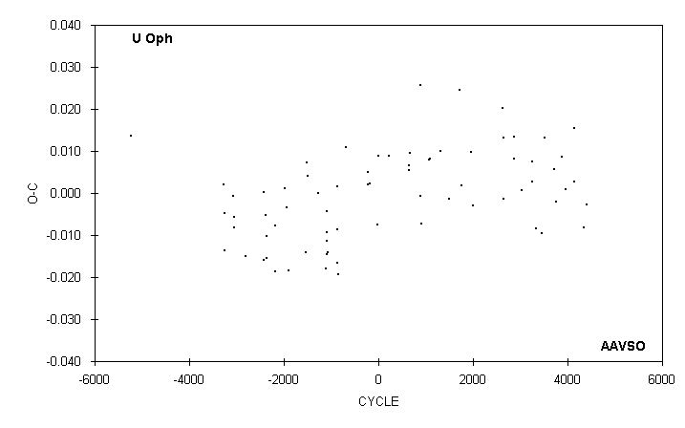

 | JD(min)
 | HEL. |  | CYCLE | O-C | N |  | OBSERVER
 | 2400000 +
 | 49857.700 |  | 3244 | 0.003 | 17 |  | S. Cook (CCD)
 | 49872.801 |  | 3253 | 0.008 | 13 |  | G. Samolyk
 | 49998.586 |  | 3328 | -0.008 | 10 |  | R. Schmude
 | 50221.672 |  | 3461 | -0.009 | 9 |  | R. Schmude
 | 50320.658 |  | 3520 | 0.013 | 10 |  | N. Simmons
 | 50642.701 : |  | 3712 | 0.006 | 7 |  | R. Schmude
 | 50733.270 : |  | 3766 | -0.002 | 18 |  | S. Foglia
 | 50914.434 : |  | 3874 | 0.009 | 8 |  | D. Matsnev
 | 51048.614 |  | 3954 | 0.001 | 10 |  | R. Schmude
 | 51361.441 |  | 4140.5 | 0.003 | 16 |  | S. Foglia
 | 51370.679 |  | 4146 | 0.015 | 15 |  | G. Samolyk
 | 51702.770 |  | 4344 | -0.008 | 11 |  | R. Schmude
 | 51809.287 |  | 4407.5 | -0.003 | 9 |  | S. Foglia

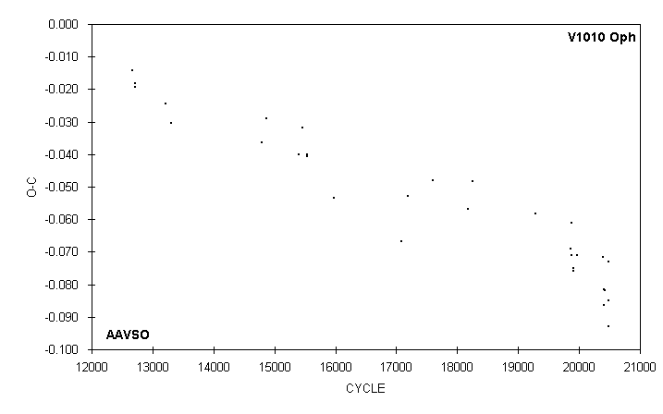

 | JD(min)
 | HEL. |  | CYCLE | O-C | N |  | OBSERVER
 | 2400000 +
 | 51690.668 |  | 19281 | -0.058 | 14 |  | G. Samolyk
 | 52078.253 |  | 19867 | -0.069 | 16 |  | G. Samolyk
 | 52081.558 |  | 19872 | -0.071 | 17 |  | G. Samolyk
 | 52089.505 |  | 19884 | -0.061 | 19 |  | G. Samolyk
 | 52104.703 |  | 19907 | -0.076 | 13 |  | B. Manske
 | 52104.704 |  | 19907 | -0.075 | 15 |  | G. Samolyk
 | 52149.685 |  | 19975 | -0.071 | 17 |  | G. Samolyk
 | 52426.822 |  | 20394 | -0.071 | 13 |  | B. Manske
 | 52434.749 |  | 20406 | -0.082 | 13 |  | D. Williams
 | 52440.697 |  | 20415 | -0.086 | 9 |  | D. Weier
 | 52442.686 |  | 20418 | -0.082 | 11 |  | D. Williams
 | 52489.636 |  | 20489 | -0.093 | 11 |  | B. Manske
 | 52489.644 |  | 20489 | -0.085 | 9 |  | D. Weier
 | 52489.656 |  | 20489 | -0.073 | 12 |  | G. Samolyk

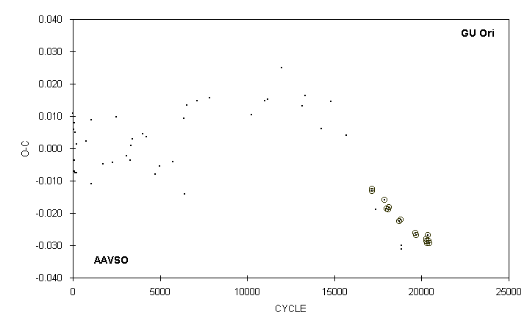

 | JD(min) |  |  |  |  |  |  | STANDARD
 | HEL. |  | CYCLE | O-C | N |  | OBSERVER | ERROR
 | 2400000 +
 | 51488.7227 |  | 17886.5 | -0.0160 | 47 |  | G. Samolyk (CCD) | 0.0002
 | 51544.7311 |  | 18005.5 | -0.0186 | 82 |  | G. Samolyk (CCD) | 0.0002
 | 51586.6216 |  | 18094.5 | -0.0188 | 29 |  | G. Lubcke (CCD) | 0.0002
 | 51602.6253 |  | 18128.5 | -0.0182 | 64 |  | C. Hesseltine (CCD) | 0.0002
 | 51881.7348 |  | 18721.5 | -0.0225 | 21 |  | G. Samolyk (CCD) | 0.0003
 | 51912.5648 |  | 18787 | -0.0221 | 75 |  | G. Samolyk (CCD) | 0.0004
 | 51930.677 |  | 18825.5 | -0.031 | 15 |  | R. Hill
 | 51939.621 : |  | 18844.5 | -0.030 | 13 |  | R. Hill
 | 52312.6396 |  | 19637 | -0.0262 | 66 |  | G. Samolyk (CCD) | 0.0005
 | 52337.5850 |  | 19690 | -0.0269 | 54 |  | G. Samolyk (CCD) | 0.0004
 | 52609.8730 |  | 20268.5 | -0.0278 | 43 |  | G. Samolyk (CCD) | 0.0003
 | 52610.8135 |  | 20270.5 | -0.0287 | 41 |  | S. Dvorak (CCD) | 0.0002
 | 52625.8747 |  | 20302.5 | -0.0293 | 24 |  | S. Dvorak (CCD) | 0.0004
 | 52662.5902 |  | 20380.5 | -0.0269 | 70 |  | G. Samolyk (CCD) | 0.0005
 | 52669.6486 |  | 20395.5 | -0.0287 | 57 |  | G. Samolyk (CCD) | 0.0005
 | 52701.6544 |  | 20463.5 | -0.0292 | 29 |  | G. Lubcke (CCD) | 0.0002

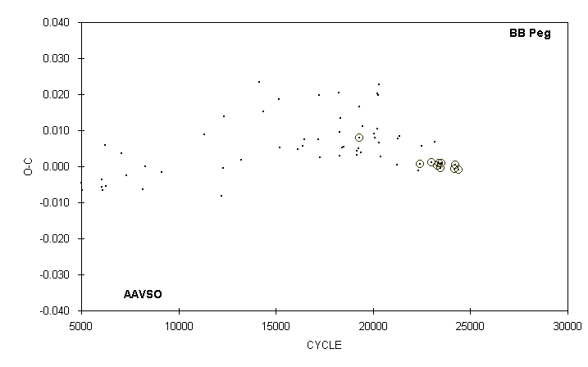

 | JD(min) |  |  |  |  |  |  | STANDARD
 | HEL. |  | CYCLE | O-C | N |  | OBSERVER | ERROR
 | 2400000 +
 | 51433.601 |  | 21215 | 0.001 | 12 |  | G. Samolyk
 | 51452.587 |  | 21267.5 | 0.008 | 15 |  | G. Samolyk
 | 51486.569 |  | 21361.5 | 0.008 | 12 |  | G. Samolyk
 | 51837.578 |  | 22332.5 | -0.001 | 15 |  | G. Samolyk
 | 51873.5492 |  | 22432 | 0.0007 | 42 |  | G. Samolyk (CCD) | 0.0002
 | 51897.594 |  | 22498.5 | 0.006 | 16 |  | G. Samolyk
 | 52075.8100 |  | 22991.5 | 0.0011 | 61 |  | S. Dvorak (CCD) | 0.0002
 | 52133.656 |  | 23151.5 | 0.007 | 14 |  | G. Samolyk
 | 52183.5368 |  | 23289.5 | 0.0003 | 58 |  | S. Dvorak (CCD) | 0.0001
 | 52215.5305 |  | 23378 | 0.0010 | 30 |  | S. Dvorak (CCD) | 0.0005
 | 52254.5713 |  | 23486 | -0.0004 | 82 |  | G. Samolyk (CCD) | 0.0001
 | 52264.5139 |  | 23513.5 | 0.0009 | 31 |  | S. Dvorak (CCD) | 0.0002
 | 52504.3689 |  | 24177 | -0.0008 | 24 |  | Bal-Mai (CCD) | 0.0004
 | 52525.6987 |  | 24236 | 0.0004 | 31 |  | G. Samolyk (CCD) | 0.0006
 | 52584.6223 |  | 24399 | -0.0008 | 29 |  | S. Dvorak (CCD) | 0.0002

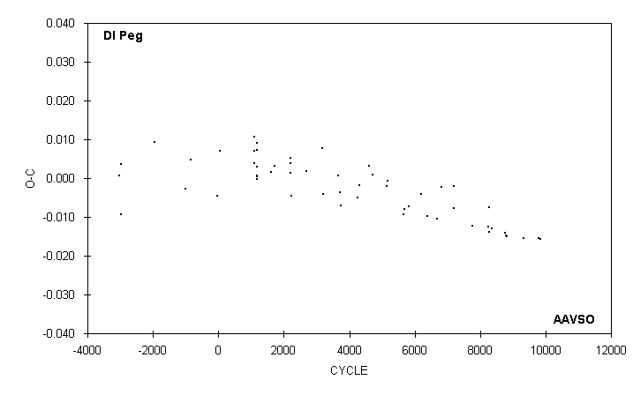

 | JD(min)
 | HEL. |  | CYCLE | O-C | N |  | OBSERVER
 | 2400000 +
 | 49743.564 |  | 6388 | -0.010 | 12 |  | G. Samolyk
 | 49950.702 |  | 6679 | -0.010 | 11 |  | S. Cook (CCD)
 | 50044.670 |  | 6811 | -0.002 | 15 |  | G. Samolyk
 | 50313.737 |  | 7189 | -0.002 | 12 |  | G. Samolyk
 | 50318.714 |  | 7196 | -0.008 | 10 |  | S. Cook (CCD)
 | 50716.615 |  | 7755 | -0.012 | 15 |  | G. Samolyk
 | 51076.794 |  | 8261 | -0.013 | 12 |  | D. Williams
 | 51079.640 |  | 8265 | -0.014 | 12 |  | D. Williams
 | 51084.629 |  | 8272 | -0.008 | 15 |  | G. Samolyk
 | 51141.569 |  | 8352 | -0.013 | 16 |  | G. Samolyk
 | 51432.701 |  | 8761 | -0.014 | 14 |  | D. Williams
 | 51452.631 |  | 8789 | -0.015 | 16 |  | G. Samolyk
 | 51467.579 |  | 8810 | -0.015 | 12 |  | D. Williams
 | 51842.706 |  | 9337 | -0.015 | 10 |  | R. Hill
 | 52168.718 |  | 9795 | -0.016 | 11 |  | D. Williams
 | 52203.597 |  | 9844 | -0.016 | 10 |  | D. Williams

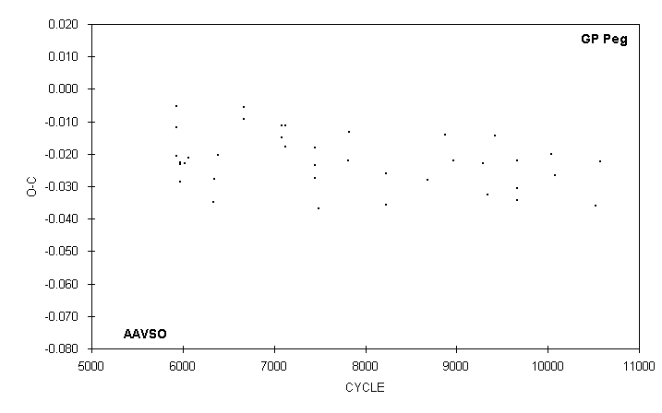

 | JD(min)
 | HEL. |  | CYCLE | O-C | N |  | OBSERVER
 | 2400000 +
 | 49712.517 : |  | 8686 | -0.028 | 9 |  | M. Baldwin
 | 49901.801 |  | 8880 | -0.014 | 13 |  | M. Baldwin
 | 49988.623 |  | 8969 | -0.022 | 12 |  | M. Baldwin
 | 50305.698 |  | 9294 | -0.023 | 12 |  | M. Baldwin
 | 50349.591 |  | 9339 | -0.033 | 18 |  | M. Baldwin
 | 50431.561 |  | 9423 | -0.014 | 8 |  | M. Baldwin
 | 50662.775 |  | 9660 | -0.022 | 13 |  | M. Baldwin
 | 50666.665 |  | 9664 | -0.034 | 10 |  | M. Baldwin
 | 50668.620 |  | 9666 | -0.031 | 7 |  | M. Baldwin
 | 51027.658 |  | 10034 | -0.020 | 12 |  | M. Baldwin
 | 51069.603 |  | 10077 | -0.027 | 10 |  | M. Baldwin
 | 51510.573 |  | 10529 | -0.036 | 16 |  | M. Baldwin
 | 51551.562 |  | 10571 | -0.022 | 15 |  | M. Baldwin

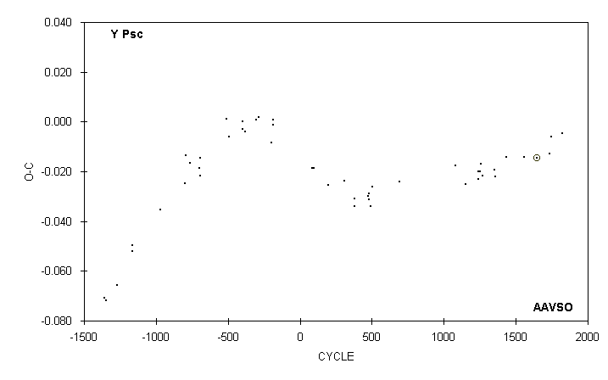

 | JD(min) |  |  |  |  |  |  | STANDARD
 | HEL. |  | CYCLE | O-C | N |  | OBSERVER | ERROR
 | 2400000 +
 | 50304.769 |  | 1240 | -0.023 | 19 |  | M. Baldwin
 | 50304.772 |  | 1240 | -0.020 | 14 |  | G. Samolyk
 | 50338.664 |  | 1249 | -0.020 | 19 |  | M. Baldwin
 | 50372.559 |  | 1258 | -0.017 | 11 |  | M. Baldwin
 | 50410.212 | 4) | 1268 | -0.022 | 20 |  | J. McKenna
 | 50722.773 |  | 1351 | -0.019 | 15 |  | M. Baldwin
 | 50741.599 |  | 1356 | -0.022 | 20 |  | M. Baldwin
 | 51027.805 |  | 1432 | -0.014 | 11 |  | M. Baldwin
 | 51513.589 |  | 1561 | -0.014 | 17 |  | M. Baldwin
 | 51833.6789 |  | 1646 | -0.0146 |  |  | J. A. Howell (CCD) | 0.0001
 | 52168.834 |  | 1735 | -0.013 | 17 |  | G. Samolyk
 | 52221.561 |  | 1749 | -0.006 | 15 |  | M. Baldwin
 | 52507.761 |  | 1825 | -0.005 | 19 |  | M. Simonsen
 | 4) |  | Observations combined from 50402 to 50421

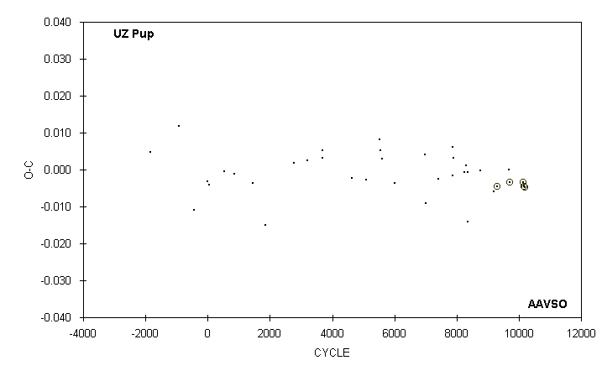

 | JD(min) |  |  |  |  |  |  | STANDARD
 | HEL. |  | CYCLE | O-C | N |  | OBSERVER | ERROR
 | 2400000 +
 | 50498.774 : | 5) | 7404 | -0.003 | 18 |  | C. Stephan
 | 50867.586 |  | 7868 | -0.002 | 15 |  | G. Samolyk
 | 50871.568 |  | 7873 | 0.006 | 13 |  | C. Stephan
 | 50898.590 |  | 7907 | 0.003 | 15 |  | C. Stephan
 | 51160.887 |  | 8237 | -0.001 | 18 |  | G. Samolyk
 | 51223.682 |  | 8316 | 0.001 | 18 |  | G. Samolyk
 | 51256.653 |  | 8357.5 | -0.014 | 13 |  | G. Samolyk
 | 51262.628 |  | 8365 | -0.001 | 13 |  | C. Stephan
 | 51579.774 |  | 8764 | 0.000 | 16 |  | G. Samolyk
 | 51930.695 |  | 9205.5 | -0.006 | 13 |  | G. Samolyk
 | 52010.5790 |  | 9306 | -0.0046 | 41 |  | S. Dvorak (CCD) | 0.0001
 | 52312.627 |  | 9686 | 0.000 | 17 |  | G. Samolyk
 | 52322.5592 |  | 9698.5 | -0.0035 | 41 |  | S. Dvorak (CCD) | 0.0002
 | 52678.6526 |  | 10146.5 | -0.0034 | 23 |  | G. Samolyk (CCD) | 0.0007
 | 52694.5485 |  | 10166.5 | -0.0045 | 19 |  | S. Dvorak (CCD) | 0.0003
 | 52713.6247 |  | 10190.5 | -0.0047 | 63 |  | G. Samolyk (CCD) | 0.0004
 | 5) |  | Observations combined from 50461 to 50536

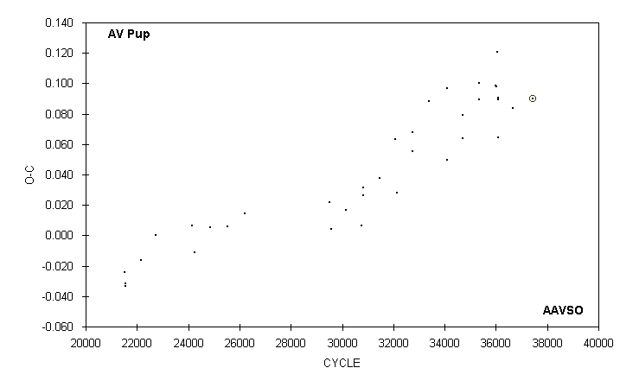

 | JD(min) |  |  |  |  |  |  | STANDARD
 | HEL. |  | CYCLE | O-C | N |  | OBSERVER | ERROR
 | 2400000 +
 | 50140.483 | 6) | 34084 | 0.097 | 51 |  | C. Stephan
 | 50488.718 |  | 34710 | 0.064 | 13 |  | G. Samolyk
 | 50492.628 |  | 34717 | 0.079 | 17 |  | G. Samolyk
 | 50845.646 |  | 35351.5 | 0.100 | 14 |  | C. Stephan
 | 50850.642 |  | 35360.5 | 0.089 | 18 |  | C. Stephan
 | 51201.701 |  | 35991.5 | 0.098 | 18 |  | C. Stephan
 | 51215.609 |  | 36016.5 | 0.098 | 10 |  | C. Stephan
 | 51229.540 |  | 36041.5 | 0.121 | 15 |  | C. Stephan
 | 51257.604 |  | 36092 | 0.089 | 18 |  | C. Stephan
 | 51260.639 |  | 36097.5 | 0.065 | 27 |  | C. Stephan
 | 51262.612 |  | 36101 | 0.090 | 22 |  | C. Stephan
 | 51581.666 |  | 36674.5 | 0.084 | 22 |  | C. Stephan
 | 52002.5424 |  | 37431 | 0.0900 | 22 |  | S. Dvorak (CCD) | 0.0004
 | 6) |  | Observations combined from 50095 to 50185

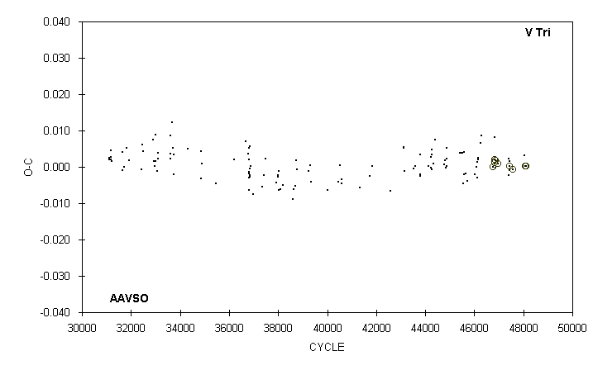

 | JD(min) |  |  |  |  |  |  | STANDARD
 | HEL. |  | CYCLE | O-C | N |  | OBSERVER | ERROR
 | 2400000 +
 | 51835.5974 |  | 46755 | -0.0001 | 77 |  | S. Dvorak (CCD) | 0.0004
 | 51869.5414 |  | 46813 | 0.0020 |  |  | J. A. Howell (CCD) | 0.0001
 | 51870.7109 |  | 46815 | 0.0011 | 31 |  | S. Dvorak (CCD) | 0.0009
 | 51873.637 |  | 46820 | 0.001 | 14 |  | G. Samolyk
 | 51876.570 |  | 46825 | 0.008 | 14 |  | C. Stephan
 | 51897.629 |  | 46861 | 0.000 | 14 |  | C. Stephan
 | 51897.6312 |  | 46861 | 0.0019 | 40 |  | S. Dvorak (CCD) | 0.0002
 | 51948.5432 |  | 46948 | 0.0010 |  |  | J. A. Howell (CCD) | 0.0002
 | 52207.786 |  | 47391 | -0.002 | 15 |  | R. Hill
 | 52223.591 |  | 47418 | 0.002 | 16 |  | M. Baldwin
 | 52230.610 |  | 47430 | -0.001 | 15 |  | M. Baldwin
 | 52230.6117 |  | 47430 | 0.0003 | 56 |  | S. Dvorak (CCD) | 0.0001
 | 52230.613 |  | 47430 | 0.002 | 16 |  | C. Stephan
 | 52305.5171 |  | 47558 | -0.0006 | 25 |  | S. Dvorak (CCD) | 0.0002
 | 52587.590 |  | 48040 | 0.003 | 18 |  | C. Stephan
 | 52618.6029 |  | 48093 | 0.0002 | 48 |  | G. Samolyk (CCD) | 0.0002
 | 52628.5515 |  | 48110 | 0.0003 | 34 |  | S. Dvorak (CCD) | 0.0001
 | 52635.574 |  | 48122 | 0.000 | 23 |  | G. Chaple

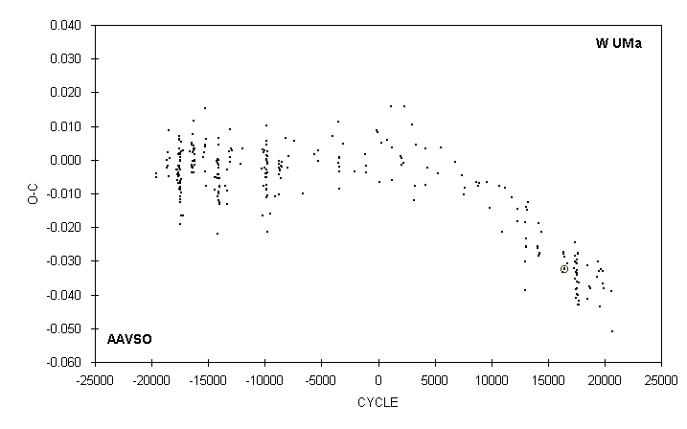

 | JD(min) |  |  |  |  |  |  | STANDARD
 | HEL. |  | CYCLE | O-C | N |  | OBSERVER | ERROR
 | 2400000 +
 | 51250.7065 |  | 16440 | -0.0323 | 82 |  | G. Lubcke (CCD) | 0.0001
 | 51937.834 |  | 18499.5 | -0.031 | 15 |  | G. Samolyk
 | 51943.329 : |  | 18516 | -0.041 | 6 |  | S. Foglia
 | 51993.712 |  | 18667 | -0.038 | 13 |  | D. Williams
 | 52021.737 |  | 18751 | -0.038 | 14 |  | G. Samolyk
 | 52223.758 |  | 19356.5 | -0.035 | 8 |  | B. Manske
 | 52252.789 |  | 19443.5 | -0.030 | 17 |  | G. Samolyk
 | 52268.467 |  | 19490.5 | -0.033 | 14 |  | S. Foglia
 | 52307.659 |  | 19608 | -0.043 | 14 |  | G. Samolyk
 | 52329.690 |  | 19674 | -0.032 | 12 |  | D. Williams
 | 52370.727 |  | 19797 | -0.033 | 13 |  | G. Samolyk
 | 52398.415 |  | 19880 | -0.037 | 10 |  | M. Csukas
 | 52426.773 |  | 19965 | -0.038 | 12 |  | B. Manske
 | 52652.311 |  | 20641 | -0.039 | 11 |  | S. Foglia
 | 52664.310 |  | 20677 | -0.051 | 9 |  | S. Foglia

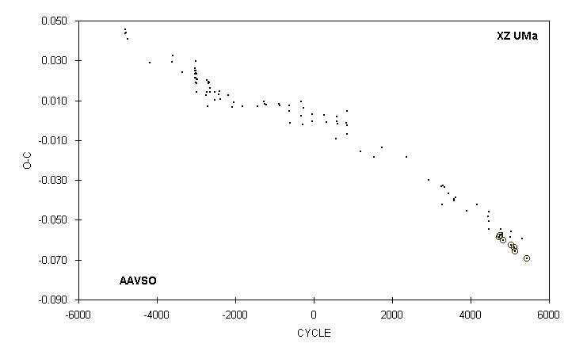

 | JD(min) |  |  |  |  |  |  | STANDARD
 | HEL. |  | CYCLE | O-C | N |  | OBSERVER | ERROR
 | 2400000 +
 | 51937.7179 |  | 4720 | -0.0585 | 72 |  | C. Hesseltine (CCD) | 0.0001
 | 51964.6098 |  | 4742 | -0.0576 |  |  | J. A. Howell (CCD) | 0.0001
 | 51992.726 |  | 4765 | -0.055 | 11 |  | C. Stephan
 | 52025.726 |  | 4792 | -0.057 | 15 |  | R. Hays
 | 52041.617 |  | 4805 | -0.057 | 16 |  | C. Stephan
 | 52063.6151 |  | 4823 | -0.0603 | 83 |  | S. Dvorak (CCD) | 0.0001
 | 52300.747 |  | 5017 | -0.058 | 10 |  | M. Simonsen
 | 52305.6323 |  | 5021 | -0.0624 | 45 |  | S. Dvorak (CCD) | 0.0001
 | 52316.640 |  | 5030 | -0.056 | 14 |  | G. Samolyk
 | 52404.6390 |  | 5102 | -0.0636 | 31 |  | S. Dvorak (CCD) | 0.0001
 | 52404.639 |  | 5102 | -0.064 | 15 |  | R. Hays
 | 52448.6404 |  | 5138 | -0.0658 | 25 |  | C. Hesseltine (CCD) | 0.0005
 | 52656.441 |  | 5308 | -0.060 | 15 |  | J. Virtanen
 | 52811.6658 |  | 5435 | -0.0694 | 35 |  | G. Samolyk (CCD) | 0.0002

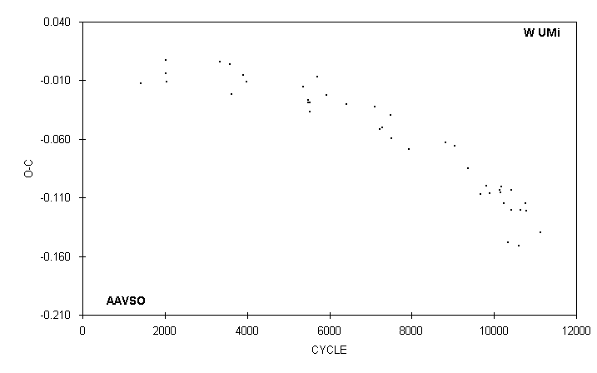

 | JD(min)
 | HEL. |  | CYCLE | O-C | N |  | OBSERVER
 | 2400000 +
 | 50151.123 | 7) | 9681 | -0.107 | 21 |  | S. Cook (CCD)
 | 50387.591 |  | 9820 | -0.100 | 21 |  | G. Samolyk
 | 50523.677 |  | 9900 | -0.106 | 28 |  | G. Samolyk
 | 50921.751 |  | 10134 | -0.103 | 23 |  | G. Samolyk
 | 50950.668 |  | 10151 | -0.106 | 11 |  | D. Williams
 | 50984.696 |  | 10171 | -0.101 | 9 |  | D. Williams
 | 51110.568 |  | 10245 | -0.115 | 12 |  | D. Williams
 | 51282.351 |  | 10346 | -0.149 | 13 |  | S. Foglia
 | 51411.667 |  | 10422 | -0.121 | 15 |  | D. Williams
 | 51411.684 |  | 10422 | -0.104 | 21 |  | G. Samolyk
 | 51731.454 |  | 10610 | -0.151 | 14 |  | S. Foglia
 | 51789.324 | 8) | 10644 | -0.120 | 17 |  | G. Samolyk
 | 51986.664 |  | 10760 | -0.115 | 23 |  | G. Samolyk
 | 52042.796 |  | 10793 | -0.121 | 12 |  | D. Williams
 | 52609.263 |  | 11126 | -0.139 | 14 |  | S. Foglia
 | 7) |  | Observations combined from 50142 to 50159
 | 8) |  | Observations combined from 51775 to 51804

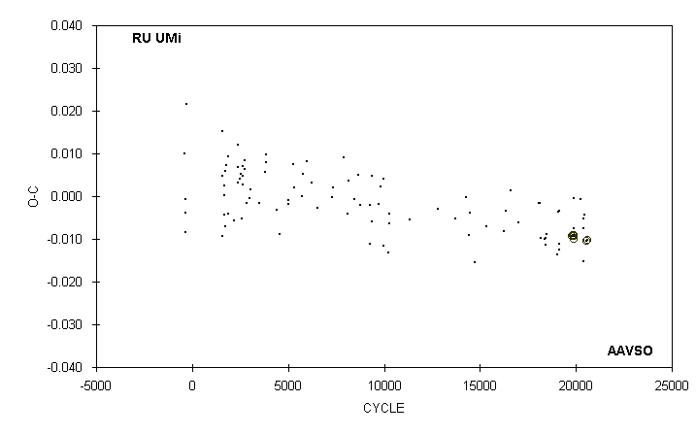

 | JD(min) |  |  |  |  |  |  | STANDARD
 | HEL. |  | CYCLE | O-C | N |  | OBSERVER | ERROR
 | 2400000 +
 | 51995.6398 |  | 19811 | -0.0093 |  |  | J. A. Howell (CCD) | 0.0001
 | 52006.6633 |  | 19832 | -0.0092 | 76 |  | S. Dvorak (CCD) | 0.0001
 | 52027.6602 |  | 19872 | -0.0093 | 72 |  | S. Dvorak (CCD) | 0.0001
 | 52027.669 |  | 19872 | -0.001 | 17 |  | C. Stephan
 | 52036.5842 |  | 19889 | -0.0091 | 74 |  | S. Dvorak (CCD) | 0.0001
 | 52047.6068 |  | 19910 | -0.0099 | 63 |  | S. Dvorak (CCD) | 0.0004
 | 52048.659 |  | 19912 | -0.008 | 16 |  | C. Stephan
 | 52225.566 |  | 20249 | -0.001 | 19 |  | G. Samolyk
 | 52299.566 |  | 20390 | -0.015 | 17 |  | G. Samolyk
 | 52311.647 |  | 20413 | -0.008 | 21 |  | G. Samolyk
 | 52314.799 |  | 20419 | -0.005 | 15 |  | D. Williams
 | 52342.621 |  | 20472 | -0.004 | 13 |  | C. Stephan
 | 52383.5591 |  | 20550 | -0.0104 | 19 |  | S. Dvorak (CCD) | 0.0004
 | 52396.6825 |  | 20575 | -0.0102 | 18 |  | S. Dvorak (CCD) | 0.0001

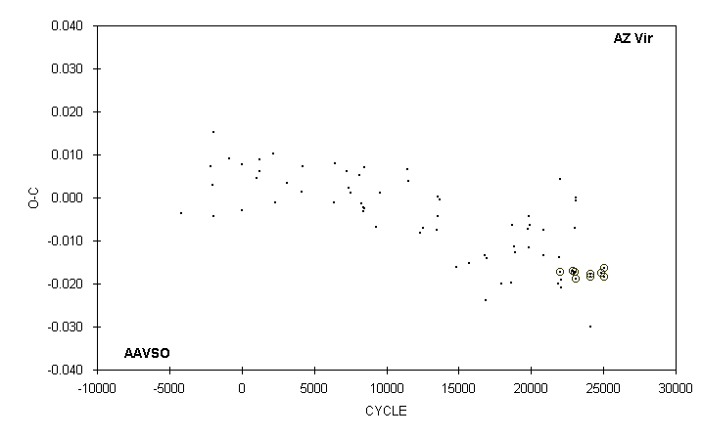

 | JD(min) |  |  |  |  |  |  | STANDARD
 | HEL. |  | CYCLE | O-C | N |  | OBSERVER | ERROR
 | 2400000 +
 | 51663.582 |  | 21984 | 0.004 | 12 |  | C. Stephan
 | 51693.628 |  | 22070 | -0.021 | 18 |  | C. Stephan
 | 51971.7906 |  | 22865.5 | -0.0170 | 39 |  | G. Samolyk (CCD) | 0.0002
 | 52015.673 |  | 22991 | -0.018 | 18 |  | C. Stephan
 | 52021.6176 |  | 23008 | -0.0173 | 33 |  | G. Samolyk (CCD) | 0.0003
 | 52027.572 |  | 23025 | -0.007 | 11 |  | C. Stephan
 | 52041.565 |  | 23065 | -0.001 | 10 |  | C. Stephan
 | 52046.6171 |  | 23079.5 | -0.0188 | 48 |  | S. Dvorak (CCD) | 0.0007
 | 52048.559 : |  | 23085 | 0.000 | 6 |  | C. Stephan
 | 52398.7309 |  | 24086.5 | -0.0178 | 44 |  | G. Samolyk (CCD) | 0.0002
 | 52402.5766 |  | 24097.5 | -0.0184 | 26 |  | S. Dvorak (CCD) | 0.0002
 | 52405.712 |  | 24106.5 | -0.030 | 15 |  | C. Stephan
 | 52678.8129 |  | 24887.5 | -0.0175 | 28 |  | G. Samolyk (CCD) | 0.0002
 | 52731.7862 |  | 25039 | -0.0185 | 14 |  | S. Dvorak (CCD) | 0.0005
 | 52739.6559 |  | 25061.5 | -0.0163 | 63 |  | G. Samolyk (CCD) | 0.0003

