OBSERVED MINIMA TIMINGS
OF ECLIPSING BINARIES

NUMBER 7

Prepared by:

Marvin E. Baldwin
Chairman, AAVSO
Eclipsing Binary
Committee

Gerard Samolyk
AAVSO Eclipsing
Binary Committee

October 2002

Funds for publication were provided by
The Harold S. Martin Fund.

ISBN 1-878174-64-9

COPYRIGHT 2002
The American Association of Variable Star Observers
25 Birch Street
Cambridge, MA 02138
USA

All rights reserved. No part of this book may be reproduced by any mechanical, photographic, or electronic process, nor may it be stored on an information retrieval system, transmitted, or otherwise copied for public or private use, without the written permission of the American Association of Variable Star Observers.

TABLE OF CONTENTS

Introduction v

References vi

Table 1. Publications Containing Previous AAVSO Minima for Each Star in this Monograph vii

Table 2. Information on O-C Minima and Linear Elements viii

Table 3. Observers Contributing to this Monograph ix

Compilation of Times of Minima and O-C Diagrams 1

INTRODUCTION

This compilation contains 1,072 minima timings of 50 eclipsing binary stars. It represents a portion of the stars observed by participants in the AAVSO's eclipsing binary program since 1976, and continues the listing of minima published in Observed Minima Timings of Eclipsing Binaries Nos. 1 through 6. Except where otherwise specified, all minima are determined from visual observations reduced by the authors using a computerized tracing paper method. Ron Baldwin and Gerard Samolyk wrote the tracing paper software specifically for this purpose.

Some CCD observations were reduced by the observers using the method of Kwee and Van Worden (1957). The standard error is included in each of these cases. CCD data obtained by Ronald Zissell of EX Dra were reduced by the observer using the mean chord method.

In instances where fragments of eclipses are observed during different cycles, the data points are reduced to heliocentric phase and combined into a single light curve for the tracing paper process. In these cases, the listed time of minimum is the eclipse nearest to the midpoint of the observing interval that corresponds to the calculated phase of minimum light. A footnote is added to these listings indicating the observing interval in JD.

With the exception of EX Dra, linear elements in the General Catalogue of Variable Stars (Kholopov et al. 1985) were used to compute the O-C's. In the case of EX Dra, the linear elements were calculated by linear regression using the times of minima listed in this publication. All elements used in this publication are listed in Table 2. The number of observations used for determination of each time of minimum is given under N. This work is sponsored by the AAVSO, with Marvin Baldwin acting as program coordinator.

The O-C diagrams accompanying the minima listings represent not only the minima tabulated here but also all previously published minima associated with the AAVSO program. Times of minimum obtained electronically that have four place accuracy are circled on the O-C diagrams. The years spanned by these diagrams are listed by star in Table 2, with the second column giving the year of the earliest observation appearing in the diagram and the third and fourth columns listing the earliest and latest year of the minima tabulated in this publication.

The material in this monograph may be accessed electronically via the AAVSO web site home page (http://www.aavso.org) or the AAVSO ftp site (ftp.aavso.org in /pub/monographs).

Observers contributing data used in this publication are listed in Table 3. Their dedicated efforts are greatly appreciated.

Marvin E. Baldwin Gerard Samolyk
8655 N Co. Rd. 775E 9504 W Barnard Ave.
Butlerville, IN 47223 Greenfield, WI 53228
USA USA

REFERENCES

1 Ashbrook, J. 1963, Sky & Telescope, 25, 5,277.
2 Ashbrook, J. 1963, Sky & Telescope, 26, 3,153.
3 Ashbrook, J. 1964, Sky & Telescope, 27,1, 58.
4 Ashbrook, J. 1964, Sky & Telescope, 27, 5, 317.
5 Ashbrook, J. 1964, Sky & Telescope, 28, 10, 244.
6 Ashbrook, J. 1965, Sky & Telescope, 29, 4, 254.
7 Robinson, L. J. 1965, Inf. Bull. Var. Stars, No. 111.
8 Robinson, L. J. 1965, Inf. Bull. Var. Stars, No. 114.
9 Robinson, L. J. 1965, Inf. Bull. Var. Stars, No. 119.
10 Robinson, L. J. 1966, Inf. Bull. Var. Stars, No. 129.
11 Robinson, L. J. 1966, Inf. Bull. Var. Stars, No. 154.
12 Robinson, L. J. 1967, Inf. Bull. Var. Stars, No. 180.
13 Robinson, L. J. 1967, Inf. Bull. Var. Stars, No. 221.
14 Robinson, L. J., and Ashbrook, J. 1968, Inf. Bull. Var. Stars, No. 247.
15 Baldwin, M. E. 1973, Inf. Bull. Var. Stars, No. 795.
16 Baldwin, M. E. 1974, J. Amer. Assoc. Var. Star Obs., 3, 60.
17 Baldwin, M. E. 1975, J. Amer. Assoc. Var. Star Obs., 4, 86.
18 Baldwin, M. E. 1976, J. Amer. Assoc. Var. Star Obs., 5, 29.
19 Baldwin, M. E. 1976, J. Amer. Assoc. Var. Star Obs., 5, 84.
20 Baldwin, M. E. 1977, J. Amer. Assoc. Var. Star Obs., 6, 24.
21 Baldwin, M. E. 1978, J. Amer. Assoc. Var. Star Obs., 7, 28.
22 Samolyk, G. 1992, J. Amer. Assoc. Var. Star Obs., 21, 111.
23 Baldwin, M. E., and Samolyk, G. 1993, Observed Minima Timings of Eclipsing Binaries No. 1,
AAVSO, Cambridge, MA.
24 Baldwin, M. E., and Samolyk, G. 1995, Observed Minima Timings of Eclipsing Binaries No. 2,
AAVSO, Cambridge, MA.
25 Baldwin, M. E., and Samolyk, G. 1996, Observed Minima Timings of Eclipsing Binaries No. 3,
AAVSO, Cambridge, MA.
26 Baldwin, M. E., and Samolyk, G. 1997, Observed Minima Timings of Eclipsing Binaries No. 4,
AAVSO, Cambridge, MA.
27 Baldwin, M. E., and Samolyk, G. 1999, Observed Minima Timings of Eclipsing Binaries No. 5,
AAVSO, Cambridge, MA.
28 Baldwin, M. E., and Samolyk, G. 2000, Observed Minima Timings of Eclipsing Binaries No. 6,
AAVSO, Cambridge, MA.
29 Kholopov, P. N., et al. 1985, General Catalogue of Variable Stars, Fourth Edition, Moscow.
30 Kwee K. K., and Van Worden, H. 1957, Bull. Astron. Inst. Netherlands, 12, 327.

TABLE 1

1 2 3 4 5 6 7 8 9 10 11 12 13 14 15 16 17 18 19 20 21 22 23 24 25 26 27 28

RT AND X X X X X X X X X X X X X X X X X X X X
AB AND X X X X X X X X X X X X X X
BX AND X X
DS AND
CX AQR X X X X X X X X X X X X X
OO AQL X X X X X X X X X X X X X X X X X X X X
SS ARI X X
SV CAM X X X X X X X X X X X X X X X X X X
RZ CAS X X X X X X X X X X X X X X X X X X X X X X X
TV CAS X X X X X X X X X X X X X X
DZ CAS
U CEP X X X X X X X X X X X X
VW CEP
EG CEP X X X X X X X X X X X
TW CET
RW COM X X X
RZ COM X X X
CC COM X X
W CRV X X X X X
Y CYG X X X X X X
V387 CYG X X
V388 CYG
TY DEL X X X X X X X X
UZ DRA X X X
AI DRA X X X X X X X X X X X X X X
EX DRA
YY ERI X X X X X X X X X X X
SZ HER X X X X X X X X X X X X X X X X X X X X X
CT HER X X X X X X X X
WY HYA
SW LAC X X X X X X X X X X X X X X X X X
VX LAC X X X X X X X X X X X
UV LEO X X X X X X X X
UZ LYR X
BETA LYR X X X X X
EQ ORI X X X
ER ORI X X X X X X X X X
FL ORI X X X X X
U PEG X X X X X X X X
ST PER X X X X X X X X X
XZ PER X X X X X X X X X
BETA PER X X X X X X X X X X X X X X
RZ TAU X
EQ TAU X X X
X TRI X X X X X X X X X X X X X X X X
TY UMA X X
UX UMA X X
VV UMA X X X X X X X X
AH VIR X
BU VUL X X X X X X X X X X X X

This table identifies publications in which previous AAVSO minima for each star have been published.
The numbers across the top of the table correspond to those given at the beginning of each entry in the
References.

TABLE 2

Earliest Earliest Latest Epoch Period
Minimum Listing Listing 2400000 + (days)

RT AND 1963 2000 2001 41141.88902 0.628929513
AB AND 1966 2000 2001 36109.57928 0.33189215
BX AND 1960 1993 2002 36528.7777 0.61011534
DS AND 1976 1976 2002 36142.401 1.010519
CX AQR 1964 2000 2001 36453.555 0.5559862
OO AQL 1960 2000 2001 38613.2222 0.50678848
SS ARI 1976 1997 2001 39028.395 0.4059936
SV CAM 1964 1999 2002 42594.61518 0.59306995
RZ CAS 1961 2000 2002 43200.3063 1.195247
TV CAS 1952 1996 2001 44602.4534 1.8125956
DZ CAS 1976 1976 2001 28434.556 0.7848916
U CEP 1964 1993 2001 44541.6031 2.4930475
VW CEP 1997 1997 2001 44157.4131 0.2783146
EG CEP 1966 1999 2001 42594.3825 0.54462183
TW CET 1997 1997 2002 42373.378 0.3168519
RW COM 1974 2000 2002 40022.4163 0.2373459
RZ COM 1969 2000 2001 34837.4198 0.33850604
CC COM 1977 2000 2002 39533.583 0.22068628
W CRV 1971 1998 2002 39647.766 0.38808083
Y CYG 1965 1977 2002 09453.4192 2.9963328
V387 CYG 1976 1999 2001 27985.461 0.6405964
V388 CYG 1976 1976 2001 41953.3373 0.8590372
TY DEL 1965 1999 2001 42959.445 1.19112689
UZ DRA 1969 1981 2000 41570.283 3.2613024
AI DRA 1964 1997 2001 43291.627 1.1988146
EX DRA 1996 1996 2001 50241.7022 0.209937094
YY ERI 1968 2000 2002 41581.624 0.32149415
SZ HER 1959 1998 2001 41864.30517 0.81809828
CT HER 1965 1995 2001 42522.932 1.7863748
WY HYA 1978 1978 2002 40570.9755 0.7160065
SW LAC 1965 1999 2001 45275.3477 0.3207209
VX LAC 1966 1999 2001 45258.466 1.0744942
UV LEO 1964 1996 2002 38440.72633 0.60008478
UZ LYR 1966 1977 2001 43689.9415 1.8912727
BETA LYR 1936 1999 2001 48990.54 12.93784
EQ ORI 1972 1995 2002 31438.743 1.746057
ER ORI 1968 1999 2002 41626.415 0.4233987
FL ORI 1966 1995 2002 45347.464 1.550971
U PEG 1968 1997 2001 36511.66823 0.374781439
ST PER 1965 1995 2001 42436.508 2.648315
XZ PER 1966 1997 2001 43507.47742 1.15163412
BETA PER 1963 1999 2002 45641.5135 2.8673043
RZ TAU 1976 1995 2001 37676.567 0.4156747
EQ TAU 1976 2000 2002 40213.325 0.34134848
X TRI 1960 1999 2002 42502.721 0.9715352
TY UMA 1976 1999 2002 39532.4965 0.3545386
UX UMA 1976 1999 2002 37432.8204 0.19667128
VV UMA 1969 1999 2002 45815.3365 0.68738
AH VIR 1977 1997 2001 45814.385 0.407521
BU VUL 1966 2000 2001 33533.683 0.5689930

The O-C diagrams for each star contain the minima spanning the years in columns two and four. The listing of new minima spans the years in columns three and four. The fifth and sixth columns contain the linear elements used to calculate the O-C values in this publication. All of these elements are from the General Catalogue of Variable Stars (Kholopov et al. 1985) except where noted.
TABLE 3

P. Atwood 7 G. Lubcke (CCD) 10
M. Baldwin 73 B. Lux 2
R. Berg 23 R. Manske 16
J. Blackwell (CCD) 1 D. Matsnev 11
G. Chaple 4 J. McKenna 8
E. Colombo 1 G. Pozzi 2
S. Cook 4 C. Pullen (CCD) 1
S. Cook (CCD) 6 G. Samolyk 330
R. Crumrine 2 G. Samolyk (CCD) 45
M. Csukas 2 R. Schmude 9
S. Dvorak (CCD) 108 L. Shaw 2
S. Foglia 57 N. Simmons 3
M. Glennon 1 N. Simmons (CCD) 1
I. Gomez 1 M. Simonsen 5
P. Guilbault 3 M. Smith 3
E. Halbach 5 B. Sonka 4
G. Hanson 3 C. Stephan 124
R. Hays 35 M. Suarez 1
C. Hesseltine (CCD) 8 R. Tucker (PEP) 1
R. Hill 34 G. Wedemayer 3
A. Howell (CCD) 27 D. Weier 4
S. Jamieson (CCD) 3 D. Williams 51
D. Kaiser (CCD) 1 R. Williams (CCD) 1
P. Kuebler (CCD) 1 R. Zissell (CCD) 24
T. Lubbers 1

Total 1072

This table lists the observers and the number of minima contributed by each. CCD stands for Charge-Coupled Device; PEP stands for Photoelectric Photometry (V).

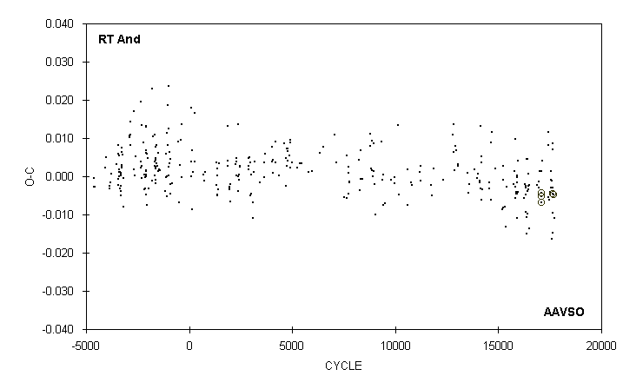
 | JD(min) |  |  |  |  |  |  | STANDARD
 | HEL. |  | CYCLE | O-C | N |  | OBSERVER | ERROR
 | 2400000 +
 | 51748.783 |  | 16865 | -0.002 | 12 |  | G. Samolyk
 | 51813.562 |  | 16968 | -0.003 | 12 |  | C. Stephan
 | 51818.595 |  | 16976 | -0.001 | 14 |  | D. Williams
 | 51835.579 |  | 17003 | 0.001 | 12 |  | C. Stephan
 | 51879.5974 |  | 17073 | -0.0052 | 44 |  | S. Dvorak (CCD) | 0.0002
 | 51884.6271 |  | 17081 | -0.0069 | 55 |  | S. Dvorak (CCD) | 0.0002
 | 51896.585 |  | 17100 | 0.001 | 15 |  | G. Samolyk
 | 51901.6109 |  | 17108 | -0.0042 | 52 |  | S. Dvorak (CCD) | 0.0001
 | 51930.550 |  | 17154 | 0.004 | 15 |  | G. Samolyk
 | 52104.754 |  | 17431 | -0.005 | 14 |  | G. Samolyk
 | 52104.771 : |  | 17431 | 0.012 | 5 |  | B. Manske
 | 52110.428 |  | 17440 | 0.008 | 8 |  | D. Matsnev
 | 52133.684 |  | 17477 | -0.006 | 20 |  | G. Samolyk
 | 52143.749 |  | 17493 | -0.004 | 14 |  | G. Samolyk
 | 52179.601 |  | 17550 | -0.001 | 14 |  | G. Samolyk
 | 52189.662 |  | 17566 | -0.003 | 14 |  | G. Samolyk
 | 52191.553 |  | 17569 | 0.001 | 17 |  | J. McKenna
 | 52196.582 |  | 17577 | -0.001 | 17 |  | C. Stephan
 | 52211.661 |  | 17601 | -0.016 | 19 |  | R. Hill
 | 52223.618 |  | 17620 | -0.009 | 16 |  | M. Baldwin
 | 52223.624 |  | 17620 | -0.003 | 16 |  | G. Samolyk
 | 52223.634 |  | 17620 | 0.007 | 11 |  | R. Berg
 | 52230.554 |  | 17631 | 0.009 | 19 |  | C. Stephan
 | 52235.562 |  | 17639 | -0.015 | 17 |  | G. Samolyk
 | 52245.6350 |  | 17655 | -0.0045 | 29 |  | S. Dvorak (CCD) | 0.0001
 | 52257.5844 |  | 17674 | -0.0048 | 100 |  | S. Dvorak (CCD) | 0.0001
 | 52296.572 |  | 17736 | -0.011 | 18 |  | G. Samolyk

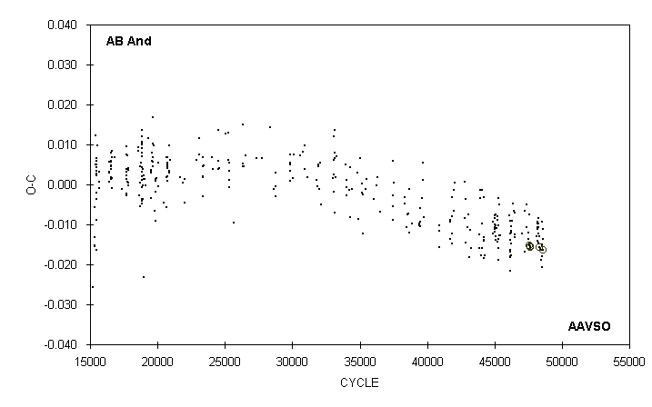

 | JD(min) |  |  |  |  |  |  | STANDARD
 | HEL. |  | CYCLE | O-C | N |  | OBSERVER | ERROR
 | 2400000 +
 | 51783.667 |  | 47226.5 | -0.017 | 13 |  | G. Samolyk
 | 51793.634 |  | 47256.5 | -0.007 | 15 |  | G. Samolyk
 | 51836.610 |  | 47386 | -0.011 | 16 |  | G. Samolyk
 | 51841.594 |  | 47401 | -0.005 | 15 |  | C. Stephan
 | 51870.626 |  | 47488.5 | -0.014 | 16 |  | G. Samolyk
 | 51881.746 |  | 47522 | -0.012 | 24 |  | B. Manske
 | 51895.690 |  | 47564 | -0.008 | 15 |  | G. Samolyk
 | 51904.6434 |  | 47591 | -0.0152 | 43 |  | S. Dvorak (CCD) | 0.0003
 | 51906.635 |  | 47597 | -0.015 | 22 |  | G. Samolyk
 | 51919.5781 |  | 47636 | -0.0156 | 57 |  | S. Dvorak (CCD) | 0.0001
 | 51932.5221 |  | 47675 | -0.0154 | 24 |  | S. Dvorak (CCD) | 0.0001
 | 52069.762 |  | 48088.5 | -0.013 | 15 |  | G. Samolyk
 | 52108.431 |  | 48205 | -0.009 | 13 |  | D. Matsnev
 | 52109.425 |  | 48208 | -0.011 | 18 |  | D. Matsnev
 | 52110.421 |  | 48211 | -0.011 | 12 |  | D. Matsnev
 | 52111.418 |  | 48214 | -0.009 | 11 |  | D. Matsnev
 | 52112.409 |  | 48217 | -0.014 | 11 |  | D. Matsnev
 | 52113.409 |  | 48220 | -0.010 | 12 |  | D. Matsnev
 | 52114.406 |  | 48223 | -0.008 | 11 |  | D. Matsnev
 | 52116.391 |  | 48229 | -0.015 | 10 |  | D. Matsnev
 | 52117.387 |  | 48232 | -0.014 | 15 |  | D. Matsnev
 | 52121.372 |  | 48244 | -0.012 | 9 |  | D. Matsnev
 | 52125.688 |  | 48257 | -0.011 | 12 |  | B. Manske
 | 52125.689 |  | 48257 | -0.010 | 14 |  | G. Samolyk
 | 52136.6355 |  | 48290 | -0.0157 | 129 |  | S. Dvorak (CCD) | 0.0001
 | 52146.761 |  | 48320.5 | -0.013 | 18 |  | G. Samolyk
 | 52179.615 |  | 48419.5 | -0.016 | 14 |  | G. Samolyk
 | 52189.735 |  | 48450 | -0.019 | 15 |  | G. Samolyk
 | 52210.648 |  | 48513 | -0.015 | 17 |  | G. Samolyk
 | 52219.615 |  | 48540 | -0.009 | 15 |  | G. Samolyk
 | 52221.595 |  | 48546 | -0.021 | 15 |  | C. Stephan
 | 52223.589 |  | 48552 | -0.018 | 17 |  | C. Stephan
 | 52223.592 |  | 48552 | -0.015 | 9 |  | R. Berg
 | 52225.582 |  | 48558 | -0.016 | 11 |  | R. Berg
 | 52226.5777 |  | 48561 | -0.0163 | 84 |  | S. Dvorak (CCD) | 0.0001
 | 52230.563 |  | 48573 | -0.014 | 16 |  | C. Stephan
 | 52235.544 |  | 48588 | -0.011 | 18 |  | G. Samolyk

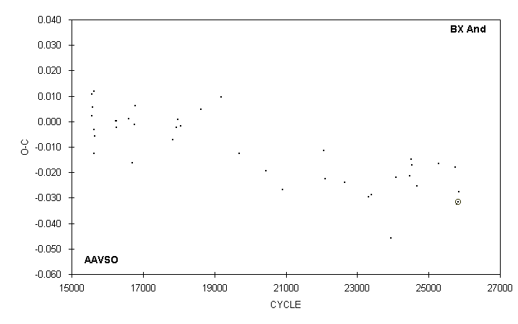

 | JD(min) |  |  |  |  |  |  | STANDARD
 | HEL. |  | CYCLE | O-C | N |  | OBSERVER | ERROR
 | 2400000 +
 | 49282.602 |  | 20904 | -0.027 | 16 |  | G. Samolyk
 | 49983.640 |  | 22053 | -0.011 | 16 |  | G. Samolyk
 | 50016.575 |  | 22107 | -0.023 | 17 |  | G. Samolyk
 | 50341.765 |  | 22640 | -0.024 | 11 |  | D. Williams
 | 50751.757 |  | 23312 | -0.030 | 21 |  | R. Hill
 | 50800.567 |  | 23392 | -0.029 | 12 |  | D. Williams
 | 51133.673 |  | 23938 | -0.046 | 14 |  | R. Hill
 | 51224.604 |  | 24087 | -0.022 | 19 |  | G. Samolyk
 | 51454.618 |  | 24464 | -0.021 | 16 |  | G. Samolyk
 | 51488.791 |  | 24520 | -0.015 | 16 |  | G. Samolyk
 | 51490.619 |  | 24523 | -0.017 | 19 |  | G. Samolyk
 | 51576.637 |  | 24664 | -0.025 | 15 |  | G. Samolyk
 | 51958.578 |  | 25290 | -0.017 | 13 |  | G. Samolyk
 | 52235.569 |  | 25744 | -0.018 | 22 |  | G. Samolyk
 | 52263.620 |  | 25790 | -0.032 | 19 |  | G. Samolyk
 | 52285.5850 |  | 25826 | -0.0315 | 66 |  | S. Dvorak (CCD) | 0.0001
 | 52296.571 |  | 25844 | -0.028 | 20 |  | G. Samolyk

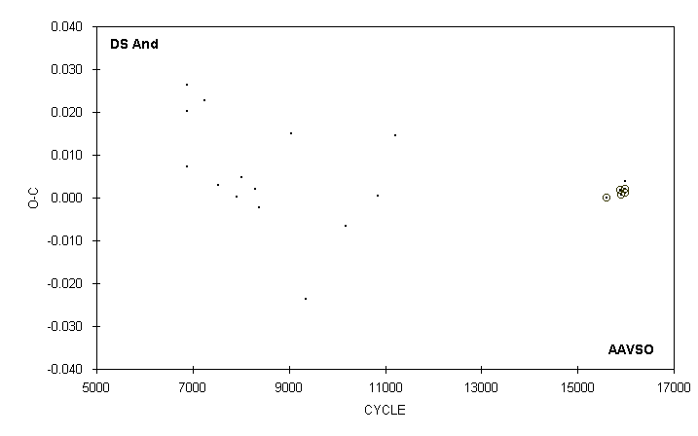

 | JD(min) |  |  |  |  |  |  | STANDARD
 | HEL. |  | CYCLE | O-C | N |  | OBSERVER | ERROR
 | 2400000 +
 | 43094.792 |  | 6880 | 0.020 | 17 |  | G. Wedemayer
 | 43094.798 |  | 6880 | 0.026 | 19 |  | G. Samolyk
 | 43098.821 |  | 6884 | 0.007 | 13 |  | G. Wedemayer
 | 43098.821 |  | 6884 | 0.007 | 13 |  | G. Samolyk
 | 43469.697 |  | 7251 | 0.023 | 11 |  | G. Samolyk
 | 43755.654 |  | 7534 | 0.003 | 11 |  | G. Samolyk
 | 44138.638 |  | 7913 | 0.000 | 13 |  | G. Samolyk
 | 44236.663 |  | 8010 | 0.005 | 15 |  | G. Samolyk
 | 44520.616 |  | 8291 | 0.002 | 15 |  | G. Samolyk
 | 44522.637 |  | 8293 | 0.002 | 13 |  | G. Samolyk
 | 44614.590 |  | 8384 | -0.002 | 16 |  | G. Samolyk
 | 45291.655 |  | 9054 | 0.015 | 14 |  | G. Samolyk
 | 45584.667 |  | 9344 | -0.024 | 11 |  | G. Samolyk
 | 46437.562 |  | 10188 | -0.007 | 12 |  | G. Samolyk
 | 47105.522 |  | 10849 | 0.000 | 10 |  | G. Samolyk
 | 47465.281 |  | 11205 | 0.015 | 11 |  | G. Samolyk
 | 51915.5920 |  | 15609 | -0.0001 | 39 |  | G. Samolyk (CCD) | 0.0006
 | 52200.5603 |  | 15891 | 0.0019 | 92 |  | S. Dvorak (CCD) | 0.0002
 | 52210.6643 |  | 15901 | 0.0007 | 103 |  | G. Samolyk (CCD) | 0.0001
 | 52295.551 |  | 15985 | 0.004 | 12 |  | C. Stephan
 | 52296.5588 |  | 15986 | 0.0011 | 82 |  | G. Samolyk (CCD) | 0.0003
 | 52298.5808 |  | 15988 | 0.0020 | 59 |  | S. Dvorak (CCD) | 0.0002

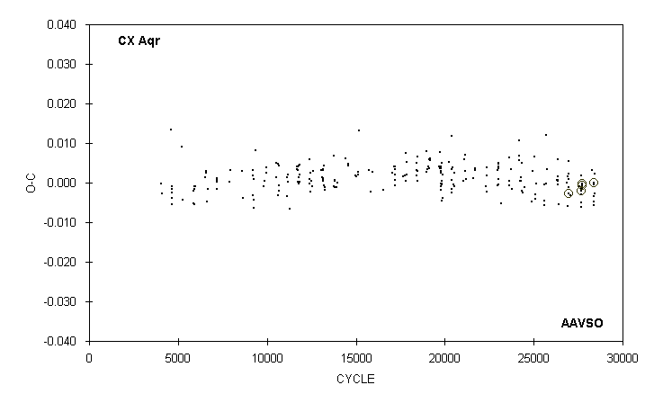

 | JD(min) |  |  |  |  |  |  | STANDARD
 | HEL. |  | CYCLE | O-C | N |  | OBSERVER | ERROR
 | 2400000 +
 | 51769.862 |  | 27548 | -0.001 | 12 |  | D. Williams
 | 51836.580 |  | 27668 | -0.001 | 18 |  | M. Baldwin
 | 51836.580 |  | 27668 | -0.001 | 13 |  | G. Samolyk
 | 51837.695 |  | 27670 | 0.002 | 15 |  | R. Hays
 | 51841.582 |  | 27677 | -0.003 | 13 |  | C. Stephan
 | 51842.691 |  | 27679 | -0.006 | 17 |  | R. Hill
 | 51846.584 |  | 27686 | -0.005 | 15 |  | R. Hays
 | 51846.5869 |  | 27686 | -0.0020 |  |  | A. Howell (CCD) | 0.0001
 | 51871.607 |  | 27731 | -0.001 | 14 |  | R. Hays
 | 51871.6077 |  | 27731 | -0.0006 | 45 |  | S. Dvorak (CCD) | 0.0001
 | 51876.6119 |  | 27740 | -0.0003 | 30 |  | S. Dvorak (CCD) | 0.0002
 | 51876.612 |  | 27740 | 0.000 | 15 |  | C. Stephan
 | 52175.736 |  | 28278 | 0.003 | 8 |  | D. Williams
 | 52219.651 |  | 28357 | -0.005 | 15 |  | G. Samolyk
 | 52219.65 |  | 28357 | -0.006 | 15 |  | R. Hays
 | 52223.5472 |  | 28364 | 0.000 | 11 |  | M. Baldwin
 | 52224.6595 |  | 28366 | 0.0000 | 58 |  | S. Dvorak (CCD) | 0.0001
 | 52228.548 |  | 28373 | -0.003 | 14 |  | M. Baldwin
 | 52253.568 |  | 28418 | -0.003 | 17 |  | G. Samolyk
 | 52253.573 : |  | 28418 | 0.002 | 8 |  | M. Simonsen

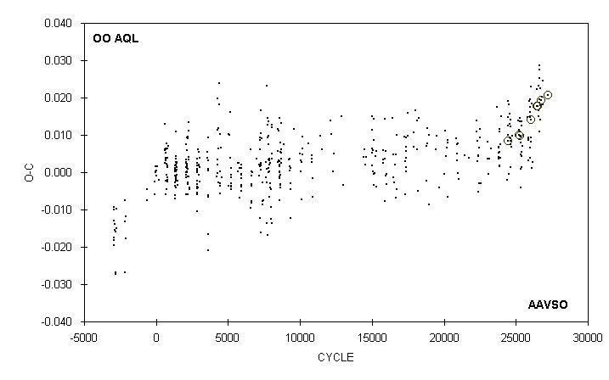

 | JD(min) |  |  |  |  |  |  | STANDARD
 | HEL. |  | CYCLE | O-C | N |  | OBSERVER | ERROR
 | 2400000 +
 | 51711.427 |  | 25845.5 | 0.003 | 14 |  | S. Foglia
 | 51731.451 |  | 25885 | 0.009 | 8 |  | S. Foglia
 | 51732.465 |  | 25887 | 0.009 | 11 |  | S. Foglia
 | 51748.692 |  | 25919 | 0.019 | 11 |  | D. Williams
 | 51781.618 |  | 25984 | 0.004 | 7 |  | R. Crumrine
 | 51783.656 |  | 25988 | 0.015 | 15 |  | G. Samolyk
 | 51784.671 |  | 25990 | 0.016 | 16 |  | R. Berg
 | 51785.675 |  | 25992 | 0.007 | 14 |  | R. Berg
 | 51787.715 |  | 25996 | 0.019 | 13 |  | R. Berg
 | 51792.781 |  | 26006 | 0.018 | 16 |  | R. Hays
 | 51804.696 |  | 26029.5 | 0.023 | 15 |  | G. Samolyk
 | 51813.550 |  | 26047 | 0.008 | 15 |  | C. Stephan
 | 51816.5965 |  | 26053 | 0.0140 |  |  | A. Howell (CCD) | 0.0002
 | 51820.646 |  | 26061 | 0.009 | 16 |  | R. Hays
 | 51836.619 |  | 26092.5 | 0.018 | 13 |  | G. Samolyk
 | 51850.285 |  | 26119.5 | 0.001 | 11 |  | S. Foglia
 | 51867.264 |  | 26153 | 0.003 | 8 |  | S. Foglia
 | 52021.8496 |  | 26458 | 0.0178 | 87 |  | S. Dvorak (CCD) | 0.0001
 | 52021.854 |  | 26458 | 0.022 | 16 |  | G. Samolyk
 | 52057.8315 |  | 26529 | 0.0177 | 62 |  | S. Dvorak (CCD) | 0.0001
 | 52069.740 |  | 26552.5 | 0.017 | 17 |  | G. Samolyk
 | 52077.855 |  | 26568.5 | 0.023 | 11 |  | B. Manske
 | 52089.503 |  | 26591.5 | 0.015 | 18 |  | G. Samolyk
 | 52104.717 |  | 26621.5 | 0.025 | 16 |  | G. Samolyk
 | 52118.648 |  | 26649 | 0.020 | 14 |  | C. Stephan
 | 52121.680 |  | 26655 | 0.011 | 15 |  | R. Hays
 | 52125.742 |  | 26663 | 0.019 | 17 |  | G. Samolyk
 | 52125.751 |  | 26663 | 0.028 | 17 |  | D. Weier
 | 52125.752 |  | 26663 | 0.029 | 18 |  | B. Manske
 | 52143.737 |  | 26698.5 | 0.023 | 16 |  | G. Samolyk
 | 52144.742 |  | 26700.5 | 0.014 | 16 |  | R. Hill
 | 52155.642 |  | 26722 | 0.018 | 15 |  | R. Hays
 | 52185.5439 |  | 26781 | 0.0194 | 55 |  | S. Dvorak (CCD) | 0.0001
 | 52189.599 |  | 26789 | 0.020 | 21 |  | C. Stephan
 | 52221.531 |  | 26852 | 0.025 | 14 |  | C. Stephan
 | 52225.579 |  | 26860 | 0.018 | 15 |  | R. Hays
 | 52396.8759 |  | 27198 | 0.0206 | 26 |  | S. Dvorak (CCD) | 0.0001

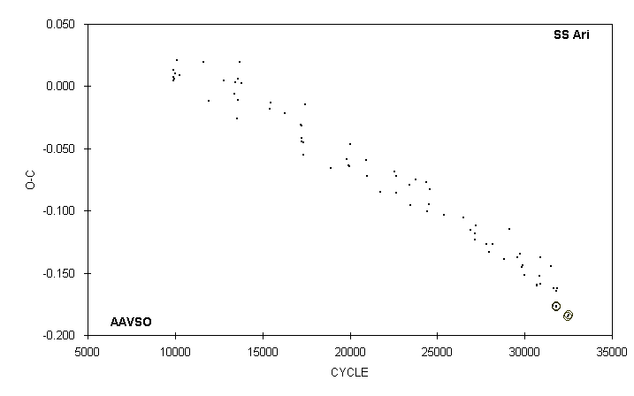

 | JD(min) |  |  |  |  |  |  | STANDARD
 | HEL. |  | CYCLE | O-C | N |  | OBSERVER | ERROR
 | 2400000 +
 | 50726.759 |  | 28814.5 | -0.139 | 12 |  | G. Samolyk
 | 50845.536 |  | 29107 | -0.115 | 9 |  | M. Baldwin
 | 51041.811 |  | 29590.5 | -0.138 | 11 |  | G. Samolyk
 | 51109.615 |  | 29757.5 | -0.135 | 14 |  | G. Samolyk
 | 51144.723 |  | 29844 | -0.145 | 11 |  | G. Samolyk
 | 51160.558 |  | 29883 | -0.144 | 13 |  | G. Samolyk
 | 51214.547 |  | 30016 | -0.152 | 9 |  | R. Berg
 | 51486.555 |  | 30686 | -0.160 | 11 |  | G. Samolyk
 | 51488.787 |  | 30691.5 | -0.161 | 11 |  | G. Samolyk
 | 51544.619 |  | 30829 | -0.153 | 11 |  | G. Samolyk
 | 51567.573 |  | 30885.5 | -0.137 | 15 |  | G. Samolyk
 | 51582.573 |  | 30922.5 | -0.159 | 13 |  | G. Samolyk
 | 51813.598 |  | 31491.5 | -0.144 | 11 |  | G. Samolyk
 | 51870.608 |  | 31632 | -0.177 | 11 |  | G. Samolyk
 | 51873.667 |  | 31639.5 | -0.163 | 10 |  | G. Samolyk
 | 51937.609 |  | 31797 | -0.164 | 12 |  | G. Samolyk
 | 51946.5289 |  | 31819 | -0.1765 | 31 |  | S. Dvorak (CCD) | 0.0004
 | 51951.6029 |  | 31831.5 | -0.1774 | 46 |  | C. Hesseltine (CCD) | 0.0002
 | 51961.565 |  | 31856 | -0.162 | 12 |  | G. Samolyk
 | 52220.5662 |  | 32494 | -0.1848 | 72 |  | S. Dvorak (CCD) | 0.0001
 | 52225.6423 |  | 32506.5 | -0.1837 | 81 |  | G. Samolyk (CCD) | 0.0004

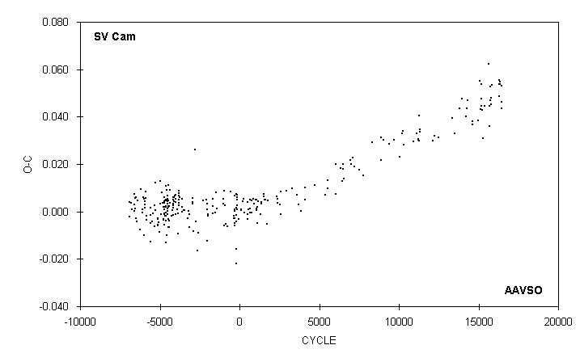

 | JD(min)
 | HEL. |  | CYCLE | O-C | N |  | OBSERVER
 | 2400000 +
 | 51467.573 |  | 14961 | 0.038 | 12 |  | D. Williams
 | 51544.689 |  | 15091 | 0.055 | 23 |  | G. Samolyk
 | 51553.573 |  | 15106 | 0.043 | 21 |  | C. Stephan
 | 51582.644 |  | 15155 | 0.054 | 20 |  | G. Samolyk
 | 51601.616 |  | 15187 | 0.047 | 17 |  | C. Stephan
 | 51608.730 |  | 15199 | 0.045 | 12 |  | D. Williams
 | 51633.637 |  | 15241 | 0.043 | 17 |  | G. Samolyk
 | 51657.348 |  | 15281 | 0.031 | 13 |  | S. Foglia
 | 51720.820 |  | 15388 | 0.044 | 13 |  | G. Samolyk
 | 51867.326 |  | 15635 | 0.062 | 7 |  | S. Foglia
 | 51897.555 |  | 15686 | 0.045 | 14 |  | C. Stephan
 | 51902.291 |  | 15694 | 0.036 | 7 |  | S. Foglia
 | 51929.583 |  | 15740 | 0.047 | 17 |  | C. Stephan
 | 51930.775 |  | 15742 | 0.053 | 13 |  | G. Samolyk
 | 51958.642 |  | 15789 | 0.045 | 15 |  | G. Samolyk
 | 51961.610 |  | 15794 | 0.048 | 17 |  | G. Samolyk
 | 51993.641 |  | 15848 | 0.053 | 12 |  | D. Williams
 | 52252.808 |  | 16285 | 0.049 | 18 |  | G. Samolyk
 | 52254.594 |  | 16288 | 0.055 | 16 |  | G. Samolyk
 | 52270.605 |  | 16315 | 0.054 | 16 |  | G. Samolyk
 | 52276.536 |  | 16325 | 0.054 | 10 |  | C. Stephan
 | 52295.515 |  | 16357 | 0.055 | 6 |  | C. Stephan
 | 52350.662 |  | 16450 | 0.046 | 15 |  | G. Samolyk
 | 52350.669 |  | 16450 | 0.053 | 12 |  | N. Simmons
 | 52356.590 |  | 16460 | 0.043 | 13 |  | C. Stephan

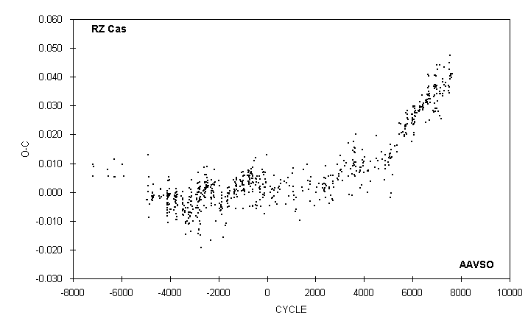

 | JD(min)
 | HEL. |  | CYCLE | O-C | N |  | OBSERVER
 | 2400000 +
 | 51699.742 |  | 7111 | 0.034 | 10 |  | D. Williams
 | 51705.719 |  | 7116 | 0.035 | 15 |  | D. Williams
 | 51722.444 |  | 7130 | 0.027 | 16 |  | S. Foglia
 | 51748.747 |  | 7152 | 0.034 | 11 |  | D. Williams
 | 51748.749 |  | 7152 | 0.036 | 15 |  | G. Samolyk
 | 51771.448 |  | 7171 | 0.025 | 18 |  | S. Foglia
 | 51839.585 |  | 7228 | 0.033 | 13 |  | G. Samolyk
 | 51844.372 |  | 7232 | 0.039 | 12 |  | S. Foglia
 | 51845.566 |  | 7233 | 0.038 | 14 |  | R. Schmude
 | 51850.343 |  | 7237 | 0.034 | 9 |  | S. Foglia
 | 51931.629 |  | 7305 | 0.043 | 16 |  | G. Samolyk
 | 51937.597 |  | 7310 | 0.035 | 14 |  | G. Samolyk
 | 51937.599 |  | 7310 | 0.037 | 14 |  | D. Williams
 | 51986.605 |  | 7351 | 0.038 | 14 |  | G. Samolyk
 | 51992.580 |  | 7356 | 0.037 | 14 |  | C. Stephan
 | 52145.570 |  | 7484 | 0.035 | 7 |  | M. Glennon
 | 52146.767 |  | 7485 | 0.037 | 18 |  | G. Samolyk
 | 52182.622 |  | 7515 | 0.034 | 15 |  | G. Samolyk
 | 52182.624 |  | 7515 | 0.036 | 11 |  | B. Manske
 | 52182.630 |  | 7515 | 0.042 | 14 |  | D. Williams
 | 52194.585 |  | 7525 | 0.045 | 12 |  | T. Lubbers
 | 52217.290 |  | 7544 | 0.040 | 14 |  | S. Foglia
 | 52231.632 |  | 7556 | 0.039 | 22 |  | C. Stephan
 | 52231.640 |  | 7556 | 0.047 | 22 |  | J. McKenna
 | 52249.562 |  | 7571 | 0.041 | 14 |  | J. McKenna
 | 52261.515 |  | 7581 | 0.041 | 15 |  | C. Stephan
 | 52292.590 |  | 7607 | 0.040 | 17 |  | J. McKenna
 | 52329.644 |  | 7638 | 0.041 | 14 |  | D. Williams

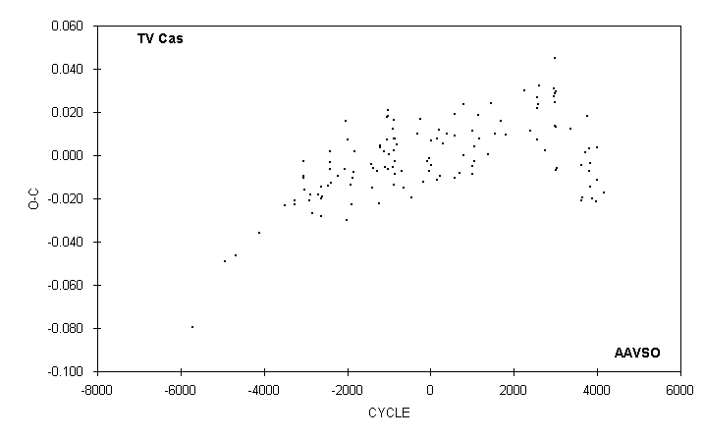

 | JD(min)
 | HEL. |  | CYCLE | O-C | N |  | OBSERVER
 | 2400000 +
 | 50085.549 : |  | 3025 | -0.006 | 6 |  | R. Schmude
 | 50674.661 |  | 3350 | 0.012 | 14 |  | R. Hays
 | 51149.544 |  | 3612 | -0.005 | 16 |  | R. Berg
 | 51158.591 |  | 3617 | -0.021 | 12 |  | R. Hays
 | 51216.595 |  | 3649 | -0.020 | 14 |  | R. Schmude
 | 51334.435 |  | 3714 | 0.002 | 9 |  | S. Foglia
 | 51432.332 |  | 3768 | 0.018 | 10 |  | S. Foglia
 | 51490.320 |  | 3800 | 0.003 | 18 |  | S. Foglia
 | 51519.311 |  | 3816 | -0.007 | 17 |  | S. Foglia
 | 51544.680 |  | 3830 | -0.015 | 15 |  | R. Hays
 | 51548.316 |  | 3832 | -0.004 | 10 |  | S. Foglia
 | 51615.366 |  | 3869 | -0.020 | 13 |  | S. Foglia
 | 51809.312 |  | 3976 | -0.022 | 8 |  | S. Foglia
 | 51845.574 |  | 3996 | -0.011 | 16 |  | R. Schmude
 | 51867.340 |  | 4008 | 0.003 | 6 |  | S. Foglia
 | 52133.771 |  | 4155 | -0.017 | 7 |  | B. Manske

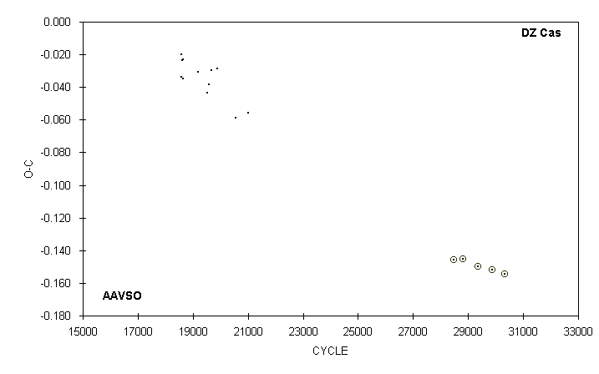

 | JD(min) |  |  |  |  |  |  | STANDARD
 | HEL. |  | CYCLE | O-C | N |  | OBSERVER | ERROR
 | 2400000 +
 | 43017.808 |  | 18580 | -0.034 | 8 |  | G. Wedemayer
 | 43017.822 |  | 18580 | -0.020 | 9 |  | G. Samolyk
 | 43050.784 |  | 18622 | -0.023 | 10 |  | G. Samolyk
 | 43069.610 |  | 18646 | -0.035 | 7 |  | E. Halbach
 | 43069.622 |  | 18646 | -0.023 | 14 |  | G. Samolyk
 | 43503.659 |  | 19199 | -0.031 | 16 |  | G. Samolyk
 | 43751.672 |  | 19515 | -0.044 | 14 |  | G. Samolyk
 | 43802.695 |  | 19580 | -0.039 | 17 |  | G. Samolyk
 | 43879.623 |  | 19678 | -0.030 | 17 |  | G. Samolyk
 | 44046.806 |  | 19891 | -0.029 | 17 |  | G. Samolyk
 | 44576.578 |  | 20566 | -0.059 | 11 |  | G. Samolyk
 | 44915.654 |  | 20998 | -0.056 | 14 |  | G. Samolyk
 | 50797.5419 |  | 28492 | -0.1456 | 84 |  | G. Lubcke (CCD) | 0.0005
 | 51055.7714 |  | 28821 | -0.1454 | 26 |  | G. Lubcke (CCD) | 0.0015
 | 51468.6202 |  | 29347 | -0.1496 | 35 |  | G. Lubcke (CCD) | 0.0007
 | 51873.6221 |  | 29863 | -0.1518 | 87 |  | G. Samolyk (CCD) | 0.0006
 | 52230.7453 |  | 30318 | -0.1542 | 66 |  | G. Samolyk (CCD) | 0.0005

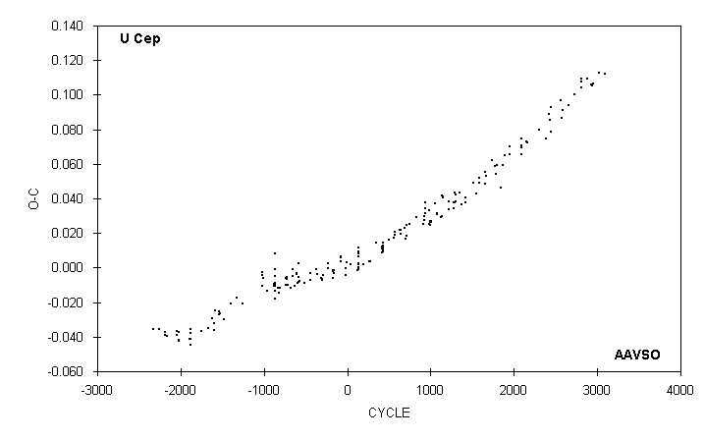

 | JD(min)
 | HEL. |  | CYCLE | O-C | N |  | OBSERVER
 | 2400000 +
 | 49188.703 |  | 1864 | 0.059 | 23 |  | M. Baldwin
 | 50579.853 |  | 2422 | 0.089 | 17 |  | M. Baldwin
 | 50938.860 |  | 2566 | 0.097 | 18 |  | M. Baldwin
 | 50963.780 |  | 2576 | 0.087 | 19 |  | G. Samolyk
 | 50988.715 |  | 2586 | 0.091 | 21 |  | M. Baldwin
 | 51160.738 |  | 2655 | 0.094 | 20 |  | G. Samolyk
 | 51347.723 |  | 2730 | 0.100 | 23 |  | M. Baldwin
 | 51544.678 |  | 2809 | 0.104 | 19 |  | M. Baldwin
 | 51544.681 |  | 2809 | 0.107 | 22 |  | G. Samolyk
 | 51544.683 |  | 2809 | 0.109 | 18 |  | D. Williams
 | 51721.689 |  | 2880 | 0.109 | 20 |  | M. Baldwin
 | 51836.366 |  | 2926 | 0.106 | 27 |  | S. Foglia
 | 51868.775 |  | 2939 | 0.105 | 16 |  | R. Hill
 | 51898.693 |  | 2951 | 0.107 | 26 |  | G. Samolyk
 | 52070.719 |  | 3020 | 0.112 | 18 |  | D. Williams
 | 52252.711 |  | 3093 | 0.112 | 22 |  | G. Samolyk

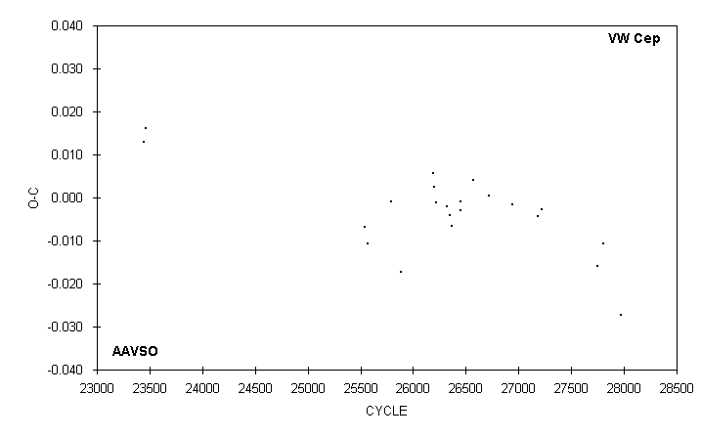

 | JD(min)
 | HEL. |  | CYCLE | O-C | N |  | OBSERVER
 | 2400000 +
 | 50681.677 |  | 23442 | 0.013 | 24 |  | S. Cook (CCD)
 | 50688.638 |  | 23467 | 0.016 | 22 |  | S. Cook (CCD)
 | 51266.396 : |  | 25543 | -0.007 | 9 |  | S. Foglia
 | 51273.350 : |  | 25568 | -0.011 | 7 |  | S. Foglia
 | 51334.450 |  | 25787.5 | -0.001 | 9 |  | S. Foglia
 | 51361.430 |  | 25884.5 | -0.017 | 16 |  | S. Foglia
 | 51446.339 |  | 26189.5 | 0.006 | 11 |  | S. Foglia
 | 51448.284 |  | 26196.5 | 0.002 | 9 |  | S. Foglia
 | 51453.290 |  | 26214.5 | -0.001 | 12 |  | S. Foglia
 | 51483.347 |  | 26322.5 | -0.002 | 29 |  | S. Foglia
 | 51490.303 |  | 26347.5 | -0.004 | 15 |  | S. Foglia
 | 51495.310 |  | 26365.5 | -0.007 | 15 |  | S. Foglia
 | 51518.416 |  | 26448.5 | -0.001 | 21 |  | S. Foglia
 | 51519.388 |  | 26452 | -0.003 | 28 |  | S. Foglia
 | 51551.262 |  | 26566.5 | 0.004 | 12 |  | S. Foglia
 | 51594.258 |  | 26721 | 0.000 | 12 |  | S. Foglia
 | 51655.346 |  | 26940.5 | -0.002 | 10 |  | S. Foglia
 | 51722.417 |  | 27181.5 | -0.004 | 14 |  | S. Foglia
 | 51732.438 |  | 27217.5 | -0.003 | 16 |  | S. Foglia
 | 51879.375 |  | 27745.5 | -0.016 | 6 |  | S. Foglia
 | 51895.244 : |  | 27802.5 | -0.011 | 10 |  | S. Foglia
 | 51943.376 |  | 27975.5 | -0.027 | 8 |  | S. Foglia

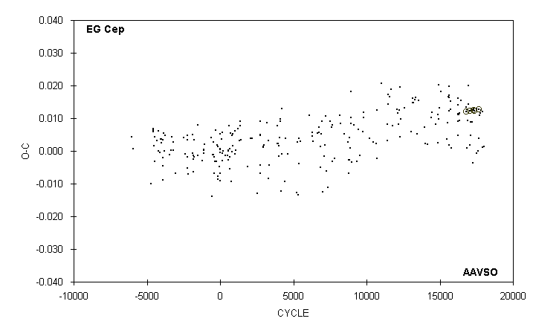

 | JD(min) |  |  |  |  |  |  | STANDARD
 | HEL. |  | CYCLE | O-C | N |  | OBSERVER | ERROR
 | 2400000 +
 | 51427.613 |  | 16219 | 0.009 | 14 |  | M. Baldwin
 | 51428.698 |  | 16221 | 0.005 | 10 |  | M. Baldwin
 | 51433.606 |  | 16230 | 0.011 | 10 |  | M. Baldwin
 | 51433.609 |  | 16230 | 0.014 | 15 |  | G. Samolyk
 | 51433.611 |  | 16230 | 0.016 | 12 |  | R. Berg
 | 51439.597 |  | 16241 | 0.011 | 11 |  | M. Baldwin
 | 51469.551 |  | 16296 | 0.011 | 15 |  | C. Stephan
 | 51487.524 |  | 16329 | 0.012 | 12 |  | G. Chaple
 | 51488.611 |  | 16331 | 0.009 | 14 |  | G. Samolyk
 | 51544.713 |  | 16434 | 0.015 | 18 |  | G. Samolyk
 | 51734.784 |  | 16783 | 0.013 | 12 |  | D. Williams
 | 51739.6844 |  | 16792 | 0.0121 | 60 |  | G. Lubcke (CCD) | 0.0001
 | 51775.630 |  | 16858 | 0.013 | 14 |  | D. Williams
 | 51781.609 |  | 16869 | 0.001 | 7 |  | R. Crumrine
 | 51799.590 |  | 16902 | 0.009 | 16 |  | C. Stephan
 | 51835.540 |  | 16968 | 0.014 | 14 |  | C. Stephan
 | 51836.635 |  | 16970 | 0.020 | 13 |  | G. Samolyk
 | 51873.651 |  | 17038 | 0.002 | 15 |  | G. Samolyk
 | 51896.5356 |  | 17080 | 0.0122 | 31 |  | S. Dvorak (CCD) | 0.0004
 | 51909.599 |  | 17104 | 0.005 | 17 |  | C. Stephan
 | 51915.594 |  | 17115 | 0.009 | 21 |  | G. Samolyk
 | 51958.619 |  | 17194 | 0.009 | 18 |  | G. Samolyk
 | 51989.650 |  | 17251 | -0.004 | 17 |  | G. Samolyk
 | 52015.8080 |  | 17299 | 0.0125 | 78 |  | S. Dvorak (CCD) | 0.0001
 | 52021.799 |  | 17310 | 0.013 | 15 |  | G. Samolyk
 | 52057.7438 |  | 17376 | 0.0124 | 96 |  | S. Dvorak (CCD) | 0.0001
 | 52125.822 |  | 17501 | 0.013 | 13 |  | G. Samolyk
 | 52143.781 |  | 17534 | -0.001 | 15 |  | R. Hill
 | 52196.610 |  | 17631 | 0.000 | 18 |  | C. Stephan
 | 52201.5242 |  | 17640 | 0.0126 | 60 |  | S. Dvorak (CCD) | 0.0001
 | 52223.845 |  | 17681 | 0.004 | 12 |  | B. Manske
 | 52252.717 |  | 17734 | 0.011 | 18 |  | G. Samolyk
 | 52263.610 |  | 17754 | 0.012 | 18 |  | G. Samolyk
 | 52299.556 |  | 17820 | 0.012 | 16 |  | G. Samolyk
 | 52350.739 |  | 17914 | 0.001 | 15 |  | N. Simmons
 | 52350.750 |  | 17914 | 0.012 | 17 |  | G. Samolyk
 | 52398.666 |  | 18002 | 0.001 | 14 |  | D. Weier

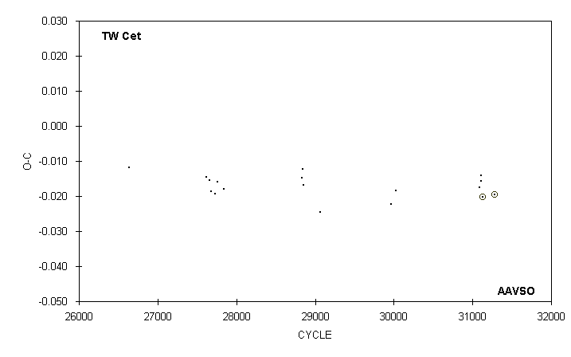

 | JD(min) |  |  |  |  |  |  | STANDARD
 | HEL. |  | CYCLE | O-C | N |  | OBSERVER | ERROR
 | 2400000 +
 | 50812.558 |  | 26634.5 | -0.012 | 9 |  | C. Stephan
 | 51125.605 |  | 27622.5 | -0.015 | 13 |  | C. Stephan
 | 51138.595 |  | 27663.5 | -0.016 | 10 |  | C. Stephan
 | 51144.612 |  | 27682.5 | -0.019 | 12 |  | C. Stephan
 | 51158.553 |  | 27726.5 | -0.019 | 13 |  | C. Stephan
 | 51169.646 |  | 27761.5 | -0.016 | 13 |  | C. Stephan
 | 51195.626 |  | 27843.5 | -0.018 | 10 |  | C. Stephan
 | 51510.580 |  | 28837.5 | -0.015 | 14 |  | C. Stephan
 | 51511.533 |  | 28840.5 | -0.012 | 8 |  | C. Stephan
 | 51516.598 |  | 28856.5 | -0.017 | 14 |  | C. Stephan
 | 51581.545 |  | 29061.5 | -0.024 | 11 |  | C. Stephan
 | 51868.615 |  | 29967.5 | -0.022 | 14 |  | C. Stephan
 | 51887.630 |  | 30027.5 | -0.018 | 13 |  | C. Stephan
 | 52224.603 |  | 31091 | -0.017 | 11 |  | C. Stephan
 | 52230.625 |  | 31110 | -0.016 | 14 |  | C. Stephan
 | 52231.577 |  | 31113 | -0.014 | 16 |  | C. Stephan
 | 52236.6407 |  | 31129 | -0.0201 | 19 |  | S. Dvorak (CCD) | 0.0001
 | 52283.5353 |  | 31277 | -0.0196 | 46 |  | S. Dvorak (CCD) | 0.0001

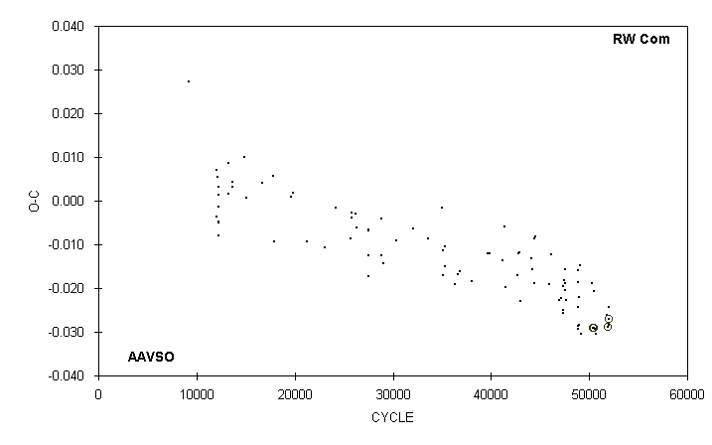

 | JD(min) |  |  |  |  |  |  | STANDARD
 | HEL. |  | CYCLE | O-C | N |  | OBSERVER | ERROR
 | 2400000 +
 | 51611.755 |  | 48829 | -0.024 | 7 |  | R. Berg
 | 51627.652 |  | 48896 | -0.029 | 8 |  | R. Berg
 | 51629.683 |  | 48904.5 | -0.016 | 13 |  | G. Samolyk
 | 51629.789 |  | 48905 | -0.029 | 7 |  | R. Berg
 | 51629.799 |  | 48905 | -0.019 | 11 |  | G. Samolyk
 | 51633.824 |  | 48922 | -0.028 | 9 |  | R. Berg
 | 51639.764 |  | 48947 | -0.022 | 8 |  | R. Berg
 | 51657.691 |  | 49022.5 | -0.015 | 8 |  | D. Williams
 | 51685.682 |  | 49140.5 | -0.030 | 14 |  | G. Samolyk
 | 51958.760 |  | 50291 | -0.019 | 16 |  | G. Samolyk
 | 51986.6381 |  | 50408.5 | -0.0290 | 80 |  | C. Hesseltine (CCD) | 0.0002
 | 52015.5942 |  | 50530.5 | -0.0291 | 62 |  | S. Dvorak (CCD) | 0.0001
 | 52017.620 |  | 50539 | -0.021 | 13 |  | G. Samolyk
 | 52028.648 |  | 50585.5 | -0.029 | 14 |  | G. Samolyk
 | 52042.769 |  | 50645 | -0.030 | 11 |  | B. Manske
 | 52316.789 |  | 51799.5 | -0.026 | 14 |  | G. Samolyk
 | 52341.7076 |  | 51904.5 | -0.0290 | 34 |  | S. Dvorak (CCD) | 0.0002
 | 52356.665 |  | 51967.5 | -0.024 | 14 |  | G. Samolyk
 | 52370.783 |  | 52027 | -0.028 | 15 |  | G. Samolyk
 | 52373.6325 |  | 52039 | -0.0271 | 32 |  | S. Dvorak (CCD) | 0.0002

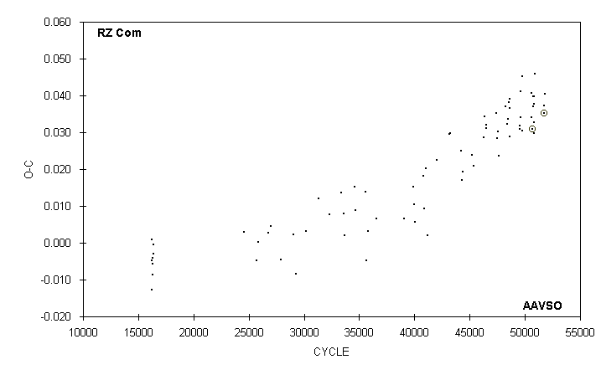

 | JD(min) |  |  |  |  |  |  | STANDARD
 | HEL. |  | CYCLE | O-C | N |  | OBSERVER | ERROR
 | 2400000 +
 | 51609.749 |  | 49548 | 0.032 | 11 |  | R. Berg
 | 51611.779 |  | 49554 | 0.031 | 11 |  | R. Berg
 | 51629.723 |  | 49607 | 0.034 | 13 |  | G. Samolyk
 | 51629.730 |  | 49607 | 0.041 | 8 |  | R. Berg
 | 51685.757 |  | 49772.5 | 0.045 | 19 |  | G. Samolyk
 | 51693.697 |  | 49796 | 0.030 | 13 |  | G. Samolyk
 | 51957.742 |  | 50576 | 0.041 | 13 |  | G. Samolyk
 | 51958.751 |  | 50579 | 0.034 | 14 |  | G. Samolyk
 | 51994.6294 |  | 50685 | 0.0310 | 28 |  | S. Dvorak (CCD) | 0.0008
 | 52017.654 |  | 50753 | 0.037 | 15 |  | G. Samolyk
 | 52028.658 |  | 50785.5 | 0.040 | 14 |  | G. Samolyk
 | 52038.644 |  | 50815 | 0.040 | 15 |  | G. Samolyk
 | 52042.696 |  | 50827 | 0.030 | 9 |  | B. Manske
 | 52042.699 |  | 50827 | 0.033 | 8 |  | D. Weier
 | 52042.704 |  | 50827 | 0.038 | 16 |  | G. Samolyk
 | 52076.732 |  | 50927.5 | 0.046 | 15 |  | B. Manske
 | 52349.7264 |  | 51734 | 0.0351 | 33 |  | S. Dvorak (CCD) | 0.0002
 | 52356.668 |  | 51754.5 | 0.037 | 15 |  | G. Samolyk
 | 52362.7590 |  | 51772.5 | 0.0352 | 28 |  | S. Dvorak (CCD) | 0.0001
 | 52370.719 |  | 51796 | 0.040 | 14 |  | G. Samolyk

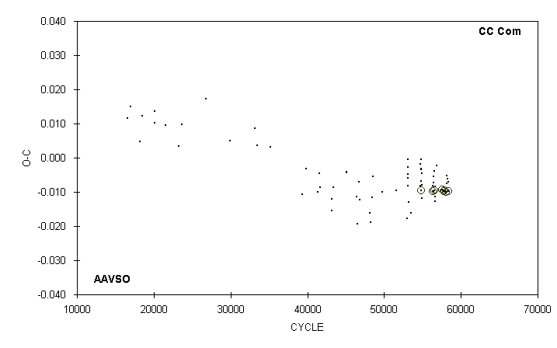

 | JD(min) |  |  |  |  |  |  | STANDARD
 | HEL. |  | CYCLE | O-C | N |  | OBSERVER | ERROR
 | 2400000 +
 | 51640.6436 |  | 54861 | -0.0095 | 52 |  | G. Lubcke (CCD) | 0.0001
 | 51956.6659 |  | 56293 | -0.0099 | 58 |  | S. Dvorak (CCD) | 0.0001
 | 51958.764 |  | 56302.5 | -0.008 | 19 |  | G. Samolyk
 | 51977.6311 |  | 56388 | -0.0099 | 25 |  | S. Dvorak (CCD) | 0.0001
 | 51986.794 |  | 56429.5 | -0.005 | 14 |  | G. Samolyk
 | 51989.661 |  | 56442.5 | -0.007 | 14 |  | G. Samolyk
 | 51996.610 |  | 56474 | -0.010 | 15 |  | G. Samolyk
 | 52013.609 |  | 56551 | -0.004 | 16 |  | G. Samolyk
 | 52019.5618 |  | 56578 | -0.0095 | 31 |  | S. Dvorak (CCD) | 0.0002
 | 52038.648 |  | 56664.5 | -0.013 | 16 |  | G. Samolyk
 | 52042.732 |  | 56683 | -0.011 | 15 |  | G. Samolyk
 | 52042.733 |  | 56683 | -0.010 | 6 |  | B. Manske
 | 52042.735 |  | 56683 | -0.008 | 6 |  | D. Weier
 | 52077.720 |  | 56841.5 | -0.002 | 14 |  | B. Manske
 | 52244.8827 |  | 57599 | -0.0093 | 28 |  | S. Dvorak (CCD) | 0.0002
 | 52279.8610 |  | 57757.5 | -0.0098 | 37 |  | S. Dvorak (CCD) | 0.0001
 | 52307.7781 |  | 57884 | -0.0095 | 31 |  | S. Dvorak | 0.0001
 | 52345.6253 |  | 58055.5 | -0.0100 | 30 |  | S. Dvorak | 0.0001
 | 52370.678 |  | 58169 | -0.005 | 13 |  | G. Samolyk
 | 52370.786 |  | 58169.5 | -0.008 | 15 |  | G. Samolyk
 | 52380.608 |  | 58214 | -0.006 | 15 |  | G. Samolyk
 | 52405.655 |  | 58327.5 | -0.007 | 9 |  | C. Stephan
 | 52416.576 |  | 58377 | -0.0098 | 19 |  | S. Dvorak (CCD) | 0.0002

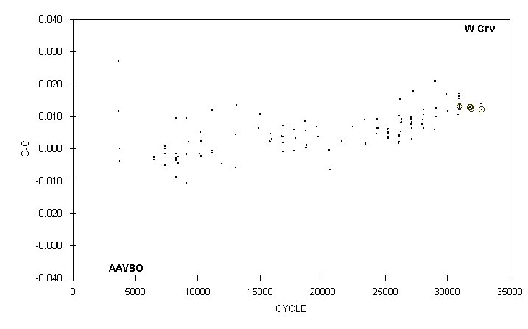

 | JD(min) |  |  |  |  |  |  | STANDARD
 | HEL. |  | CYCLE | O-C | N |  | OBSERVER | ERROR
 | 2400000 +
 | 50902.698 |  | 29001.5 | 0.006 | 13 |  | M. Baldwin
 | 50921.729 |  | 29050.5 | 0.021 | 20 |  | G. Samolyk
 | 50928.706 |  | 29068.5 | 0.012 | 10 |  | M. Baldwin
 | 50950.630 |  | 29125 | 0.010 | 11 |  | M. Baldwin
 | 51257.803 |  | 29916.5 | 0.017 | 15 |  | G. Samolyk
 | 51308.636 |  | 30047.5 | 0.012 | 13 |  | M. Baldwin
 | 51629.772 |  | 30875 | 0.010 | 13 |  | G. Samolyk
 | 51640.644 |  | 30903 | 0.016 | 14 |  | M. Baldwin
 | 51643.748 |  | 30911 | 0.015 | 16 |  | M. Baldwin
 | 51657.717 |  | 30947 | 0.014 | 12 |  | M. Baldwin
 | 51660.631 |  | 30954.5 | 0.017 | 12 |  | M. Baldwin
 | 51664.7016 |  | 30965 | 0.0127 | 29 |  | S. Dvorak (CCD) | 0.0002
 | 51664.7021 |  | 30965 | 0.0132 | 42 |  | C. Hesseltine (CCD) | 0.0002
 | 51664.705 |  | 30965 | 0.016 | 14 |  | M. Baldwin
 | 51664.706 |  | 30965 | 0.017 | 14 |  | D. Williams
 | 51986.8087 |  | 31795 | 0.0127 | 39 |  | G. Samolyk (CCD) | 0.0002
 | 52012.616 |  | 31861.5 | 0.013 | 13 |  | C. Stephan
 | 52020.5717 |  | 31882 | 0.0127 | 29 |  | S. Dvorak (CCD) | 0.0002
 | 52028.722 |  | 31903 | 0.013 | 10 |  | D. Williams
 | 52044.6323 |  | 31944 | 0.0123 |  |  | A. Howell (CCD) | 0.0002
 | 52342.680 |  | 32712 | 0.014 | 14 |  | C. Stephan
 | 52356.6490 |  | 32748 | 0.0120 | 43 |  | S. Dvorak (CCD) | 0.0001

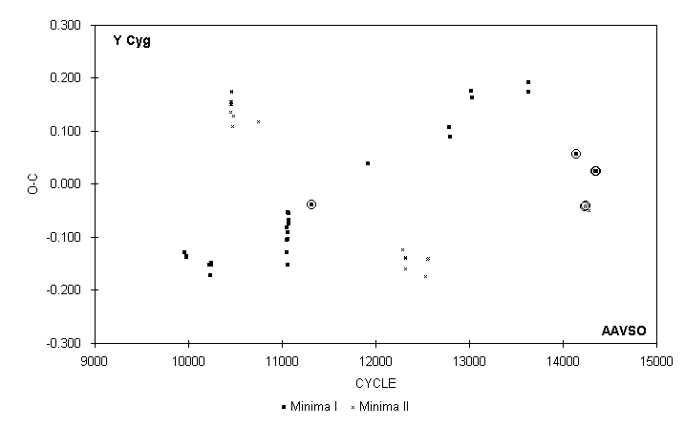

 | JD(min) |  |  |  |  |  |  | STANDARD
 | HEL. |  | CYCLE | O-C | N |  | OBSERVER | ERROR
 | 2400000 +
 | 43362.8795 |  | 11317 | -0.0380 | 20 |  | R. Tucker (PEP)
 | 45166.749 |  | 11919 | 0.039 | 9 |  | E. Halbach
 | 46258.749 |  | 12283.5 | -0.124 | 12 |  | S. Cook
 | 46342.611 |  | 12311.5 | -0.159 | 10 |  | S. Cook
 | 46345.628 |  | 12312.5 | -0.139 | 13 |  | S. Cook
 | 46354.618 |  | 12315.5 | -0.138 | 15 |  | S. Cook
 | 47004.787 |  | 12532.5 | -0.173 | 10 |  | P. Atwood
 | 47058.753 |  | 12550.5 | -0.141 | 8 |  | P. Atwood
 | 47085.721 |  | 12559.5 | -0.140 | 9 |  | P. Atwood
 | 47776.623 : |  | 12790 | 0.107 | 6 |  | B. Lux
 | 47791.587 : |  | 12795 | 0.090 | 8 |  | B. Lux
 | 48480.829 |  | 13025 | 0.175 | 16 |  | G. Samolyk
 | 48501.792 |  | 13032 | 0.164 | 13 |  | G. Samolyk
 | 50290.631 : |  | 13629 | 0.192 | 10 |  | M. Baldwin
 | 50299.601 : |  | 13632 | 0.173 | 10 |  | S. Cook (CCD)
 | 51839.5994 |  | 14146 | 0.0564 | 47 |  | G. Samolyk (CCD) | 0.0007
 | 52098.6835 |  | 14232.5 | -0.0423 | 70 |  | G. Samolyk (CCD) | 0.0006
 | 52125.6520 |  | 14241.5 | -0.0408 | 69 |  | G. Samolyk (CCD) | 0.0006
 | 52230.516 |  | 14276.5 | -0.049 | 25 |  | G. Samolyk (CCD) | 0.002
 | 52441.8308 |  | 14347 | 0.0249 | 62 |  | G. Samolyk (CCD) | 0.0004
 | 52468.7970 |  | 14356 | 0.0241 | 65 |  | G. Samolyk (CCD) | 0.0004

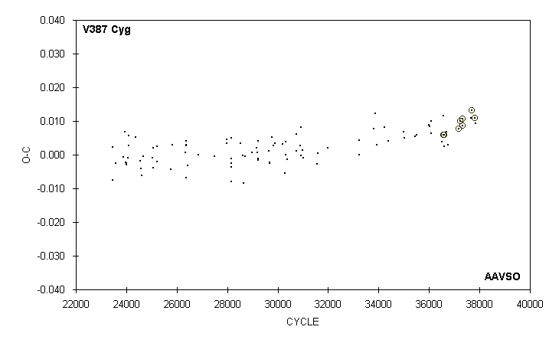

 | JD(min) |  |  |  |  |  |  | STANDARD
 | HEL. |  | CYCLE | O-C | N |  | OBSERVER | ERROR
 | 2400000 +
 | 51380.686 |  | 36521 | 0.004 | 23 |  | C. Stephan
 | 51405.6712 |  | 36560 | 0.0058 |  |  | A. Howell (CCD) | 0.0005
 | 51408.880 |  | 36565 | 0.012 | 13 |  | M. Baldwin
 | 51435.776 |  | 36607 | 0.003 | 11 |  | M. Baldwin
 | 51439.6228 |  | 36613 | 0.0058 |  |  | A. Howell (CCD) | 0.0008
 | 51496.637 |  | 36702 | 0.007 | 15 |  | M. Baldwin
 | 51523.538 |  | 36744 | 0.003 | 10 |  | M. Baldwin
 | 51799.6398 |  | 37175 | 0.0076 |  |  | A. Howell (CCD) | 0.0001
 | 51838.7186 |  | 37236 | 0.0100 | 54 |  | C. Hesseltine (CCD) | 0.0002
 | 51892.5272 |  | 37320 | 0.0086 | 36 |  | S. Dvorak (CCD) | 0.0003
 | 51899.5760 |  | 37331 | 0.0108 | 47 |  | S. Dvorak (CCD) | 0.0005
 | 52118.660 |  | 37673 | 0.011 | 12 |  | C. Stephan
 | 52125.7089 |  | 37684 | 0.0132 | 69 |  | G. Samolyk (CCD) | 0.0001
 | 52209.6247 |  | 37815 | 0.0108 | 28 |  | S. Dvorak (CCD) | 0.0002
 | 52225.638 |  | 37840 | 0.009 | 19 |  | G. Samolyk

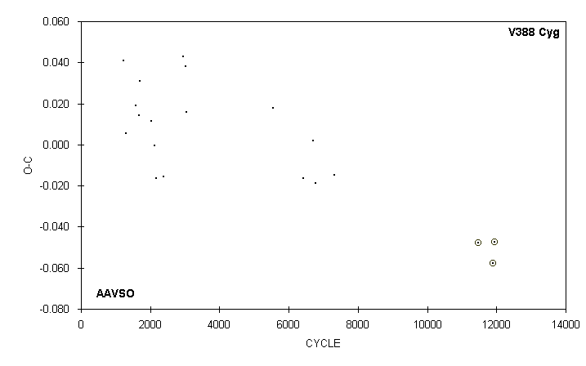

 | JD(min) |  |  |  |  |  |  | STANDARD
 | HEL. |  | CYCLE | O-C | N |  | OBSERVER | ERROR
 | 2400000 +
 | 43011.712 |  | 1232 | 0.041 | 13 |  | G. Samolyk
 | 43066.655 |  | 1296 | 0.005 | 9 |  | G. Samolyk
 | 43309.776 |  | 1579 | 0.019 | 11 |  | G. Samolyk
 | 43395.675 |  | 1679 | 0.014 | 11 |  | G. Samolyk
 | 43420.604 |  | 1708 | 0.031 | 10 |  | G. Samolyk
 | 43687.745 |  | 2019 | 0.012 | 11 |  | G. Samolyk
 | 43779.650 |  | 2126 | 0.000 | 13 |  | G. Samolyk
 | 43822.586 |  | 2176 | -0.016 | 12 |  | G. Samolyk
 | 44010.716 |  | 2395 | -0.015 | 12 |  | G. Samolyk
 | 44492.694 |  | 2956 | 0.043 | 10 |  | G. Samolyk
 | 44554.540 |  | 3028 | 0.038 | 9 |  | G. Hanson
 | 44560.531 |  | 3035 | 0.016 | 14 |  | G. Hanson
 | 46714.569 : |  | 5542.5 | 0.018 | 22 |  | G. Samolyk
 | 47465.333 |  | 6416.5 | -0.016 | 19 |  | G. Samolyk
 | 47706.741 |  | 6697.5 | 0.002 | 21 |  | G. Samolyk
 | 47772.866 |  | 6774.5 | -0.019 | 13 |  | G. Samolyk
 | 48237.609 |  | 7315.5 | -0.015 | 17 |  | G. Samolyk
 | 51805.5873 |  | 11469 | -0.0476 | 67 |  | G. Samolyk (CCD) | 0.0002
 | 52182.6946 |  | 11908 | -0.0577 | 80 |  | C. Hesseltine (CCD) | 0.0005
 | 52219.6433 |  | 11951 | -0.0476 | 52 |  | G. Samolyk (CCD) | 0.0003

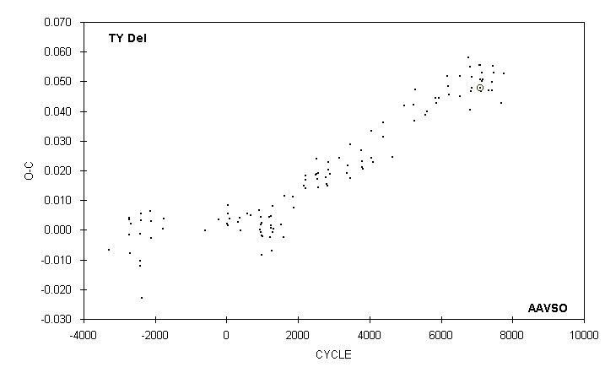

 | JD(min) |  |  |  |  |  |  | STANDARD
 | HEL. |  | CYCLE | O-C | N |  | OBSERVER | ERROR
 | 2400000 +
 | 51392.679 |  | 7080 | 0.056 | 13 |  | R. Hays
 | 51398.6269 |  | 7085 | 0.0479 |  |  | A. Howell (CCD) | 0.0004
 | 51411.732 |  | 7096 | 0.051 | 16 |  | D. Williams
 | 51411.737 |  | 7096 | 0.056 | 14 |  | G. Samolyk
 | 51429.595 |  | 7111 | 0.047 | 12 |  | D. Williams
 | 51454.612 |  | 7132 | 0.050 | 16 |  | G. Samolyk
 | 51454.615 |  | 7132 | 0.053 | 14 |  | R. Hays
 | 51485.582 |  | 7158 | 0.051 | 16 |  | R. Hays
 | 51698.790 |  | 7337 | 0.047 | 16 |  | G. Samolyk
 | 51791.698 |  | 7415 | 0.047 | 21 |  | R. Hill
 | 51803.612 |  | 7425 | 0.050 | 14 |  | D. Williams
 | 51828.631 |  | 7446 | 0.055 | 13 |  | R. Hays
 | 51859.598 |  | 7472 | 0.053 | 12 |  | R. Hays
 | 52115.680 |  | 7687 | 0.043 | 18 |  | C. Stephan
 | 52189.540 |  | 7749 | 0.053 | 13 |  | C. Stephan

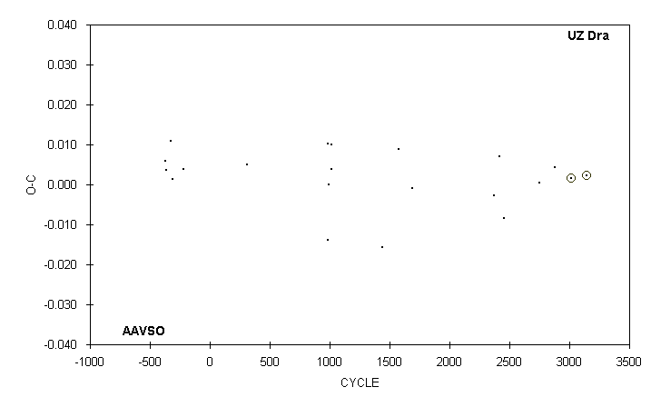

 | JD(min) |  |  |  |  |  |  | STANDARD
 | HEL. |  | CYCLE | O-C | N |  | OBSERVER | ERROR
 | 2400000 +
 | 44772.868 |  | 982 | -0.014 | 8 |  | E. Halbach
 | 44782.676 |  | 985 | 0.010 | 11 |  | D. Williams
 | 44795.711 |  | 989 | 0.000 | 18 |  | D. Williams
 | 44870.725 |  | 1012 | 0.004 | 11 |  | E. Halbach
 | 44870.731 |  | 1012 | 0.010 | 10 |  | D. Williams
 | 46269.804 |  | 1441 | -0.016 | 6 |  | P. Atwood
 | 46711.735 |  | 1576.5 | 0.009 | 11 |  | P. Atwood
 | 47086.775 |  | 1691.5 | -0.001 | 19 |  | P. Atwood
 | 49299.567 |  | 2370 | -0.003 | 11 |  | M. Baldwin
 | 49457.750 |  | 2418.5 | 0.007 | 18 |  | M. Baldwin
 | 49581.664 |  | 2456.5 | -0.008 | 15 |  | M. Baldwin
 | 50548.649 |  | 2753 | 0.000 | 13 |  | M. Baldwin
 | 50949.793 |  | 2876 | 0.004 | 19 |  | R. Hill
 | 51409.6340 |  | 3017 | 0.0017 |  |  | A. Howell (CCD) | 0.0004
 | 51820.5587 |  | 3143 | 0.0023 |  |  | D. Kaiser (CCD) | 0.0001

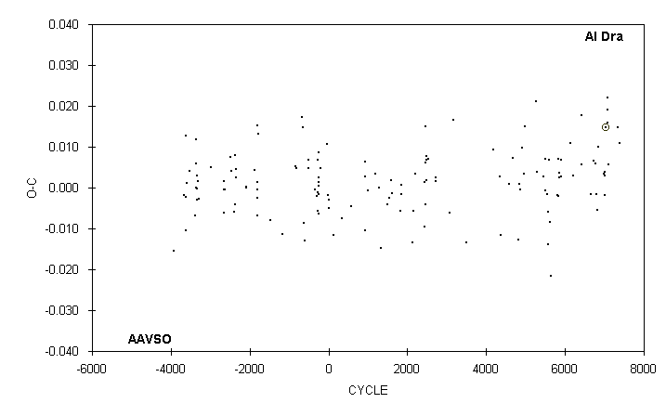

 | JD(min) |  |  |  |  |  |  | STANDARD
 | HEL. |  | CYCLE | O-C | N |  | OBSERVER | ERROR
 | 2400000 +
 | 50726.678 |  | 6202 | 0.003 | 23 |  | G. Samolyk
 | 50984.426 |  | 6417 | 0.006 | 25 |  | G. Pozzi
 | 50990.432 |  | 6422 | 0.018 | 22 |  | G. Pozzi
 | 51273.333 |  | 6658 | -0.002 | 10 |  | S. Foglia
 | 51358.457 |  | 6729 | 0.007 | 14 |  | S. Foglia
 | 51425.590 |  | 6785 | 0.006 | 17 |  | C. Stephan
 | 51448.360 |  | 6804 | -0.002 | 10 |  | S. Foglia
 | 51480.724 |  | 6831 | -0.006 | 16 |  | L. Shaw
 | 51490.330 |  | 6839 | 0.010 | 13 |  | S. Foglia
 | 51667.748 |  | 6987 | 0.003 | 11 |  | R. Berg
 | 51685.725 |  | 7002 | -0.002 | 20 |  | G. Samolyk
 | 51697.718 |  | 7012 | 0.003 | 15 |  | R. Schmude
 | 51703.713 |  | 7017 | 0.004 | 15 |  | R. Schmude
 | 51727.7001 |  | 7037 | 0.0148 |  |  | A. Howell (CCD) | 0.0002
 | 51769.663 |  | 7072 | 0.019 | 14 |  | D. Williams
 | 51775.660 |  | 7077 | 0.022 | 15 |  | D. Williams
 | 51793.636 |  | 7092 | 0.016 | 16 |  | G. Samolyk
 | 51805.614 |  | 7102 | 0.006 | 17 |  | G. Samolyk
 | 52077.754 |  | 7329 | 0.015 | 16 |  | D. Williams
 | 52155.673 |  | 7394 | 0.011 | 12 |  | R. Hays

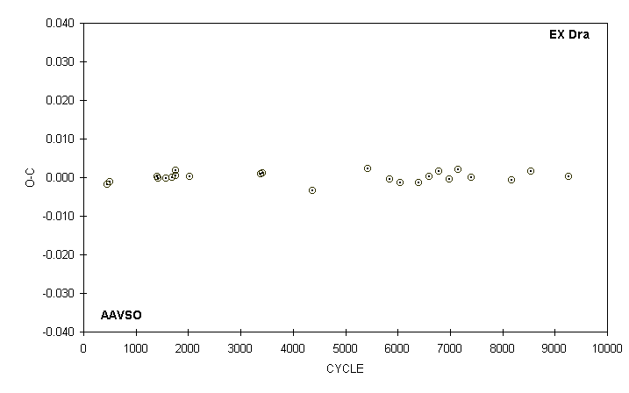

 | JD(min)
 | HEL. |  | CYCLE | O-C |  |  | OBSERVER
 | 2400000 +
 | 50337.6417 |  | 457 | -0.0018 |  |  | R.Zissell (CCD)
 | 50347.5094 |  | 504 | -0.0011 |  |  | R.Zissell (CCD)
 | 50535.8242 |  | 1401 | 0.0001 |  |  | R.Zissell (CCD)
 | 50541.7021 |  | 1429 | -0.0002 |  |  | R.Zissell (CCD)
 | 50573.8224 |  | 1582 | -0.0003 |  |  | R.Zissell (CCD)
 | 50595.6562 |  | 1686 | 0.0001 |  |  | R.Zissell (CCD)
 | 50609.7237 |  | 1753 | 0.0018 |  |  | R.Zissell (CCD)
 | 50610.7721 |  | 1758 | 0.0005 |  |  | R.Zissell (CCD)
 | 50667.6648 |  | 2029 | 0.0002 |  |  | R.Zissell (CCD)
 | 50951.7104 |  | 3382 | 0.0009 |  |  | R.Zissell (CCD)
 | 50958.6384 |  | 3415 | 0.0010 |  |  | R.Zissell (CCD)
 | 51159.5437 |  | 4372 | -0.0035 |  |  | R.Zissell (CCD)
 | 51380.6131 |  | 5425 | 0.0022 |  |  | R.Zissell (CCD)
 | 51468.5742 |  | 5844 | -0.0004 |  |  | R.Zissell (CCD)
 | 51512.6599 |  | 6054 | -0.0015 |  |  | R.Zissell (CCD)
 | 51583.8287 |  | 6393 | -0.0013 |  |  | R.Zissell (CCD)
 | 51628.7568 |  | 6607 | 0.0002 |  |  | R.Zissell (CCD)
 | 51665.7071 |  | 6783 | 0.0016 |  |  | R.Zissell (CCD)
 | 51706.6428 |  | 6978 | -0.0004 |  |  | R.Zissell (CCD)
 | 51744.6439 |  | 7159 | 0.0020 |  |  | R.Zissell (CCD)
 | 51795.6565 |  | 7402 | -0.0001 |  |  | R.Zissell (CCD)
 | 51958.7769 |  | 8179 | -0.0008 |  |  | R.Zissell (CCD)
 | 52035.6163 |  | 8545 | 0.0016 |  |  | R.Zissell (CCD)
 | 52185.7199 |  | 9260 | 0.0002 |  |  | R.Zissell (CCD)

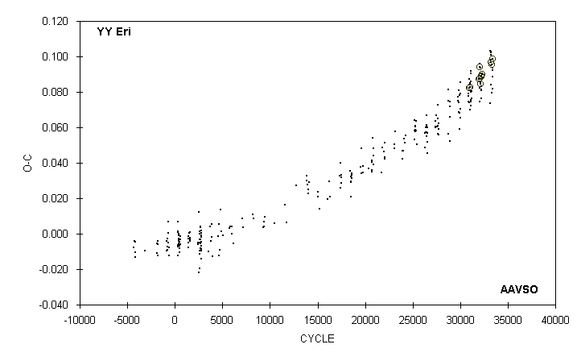

 | JD(min) |  |  |  |  |  |  | STANDARD
 | HEL. |  | CYCLE | O-C | N |  | OBSERVER | ERROR
 | 2400000 +
 | 51870.6493 |  | 32003.5 | 0.0873 | 47 |  | S. Dvorak (CCD) | 0.0001
 | 51881.7476 |  | 32038 | 0.0940 | 40 |  | S. Dvorak (CCD) | 0.0003
 | 51887.697 |  | 32056.5 | 0.096 | 11 |  | C. Stephan
 | 51888.6536 |  | 32059.5 | 0.0879 | 34 |  | S. Dvorak (CCD) | 0.0002
 | 51895.713 |  | 32081.5 | 0.074 | 17 |  | G. Samolyk
 | 51897.650 |  | 32087.5 | 0.082 | 19 |  | G. Samolyk
 | 51906.654 |  | 32115.5 | 0.085 | 20 |  | G. Samolyk
 | 51911.638 |  | 32131 | 0.085 | 17 |  | C. Stephan
 | 51921.6035 |  | 32162 | 0.0846 | 40 |  | S. Dvorak (CCD) | 0.0001
 | 51922.577 |  | 32165 | 0.094 | 15 |  | C. Stephan
 | 51929.637 |  | 32187 | 0.081 | 17 |  | C. Stephan
 | 51930.597 |  | 32190 | 0.076 | 18 |  | G. Samolyk
 | 51930.604 |  | 32190 | 0.083 | 16 |  | C. Stephan
 | 51930.6096 |  | 32190 | 0.0889 | 75 |  | S. Dvorak (CCD) | 0.0001
 | 51935.5924 |  | 32205.5 | 0.0886 | 75 |  | S. Dvorak (CCD) | 0.0001
 | 51937.675 |  | 32212 | 0.081 | 16 |  | G. Samolyk
 | 51957.616 |  | 32274 | 0.090 | 15 |  | G. Samolyk
 | 51959.5451 |  | 32280 | 0.0899 | 53 |  | S. Dvorak (CCD) | 0.0003
 | 52224.791 |  | 33105 | 0.103 | 7 |  | B. Manske
 | 52230.709 |  | 33123.5 | 0.074 | 15 |  | C. Stephan
 | 52252.742 |  | 33192 | 0.084 | 19 |  | G. Samolyk
 | 52256.614 |  | 33204 | 0.098 | 14 |  | C. Stephan
 | 52261.594 |  | 33219.5 | 0.095 | 17 |  | C. Stephan
 | 52265.620 |  | 33232 | 0.102 | 19 |  | C. Stephan
 | 52269.637 |  | 33244.5 | 0.101 | 22 |  | G. Samolyk
 | 52276.551 |  | 33266 | 0.103 | 14 |  | C. Stephan
 | 52278.6348 |  | 33272.5 | 0.0967 | 95 |  | S. Dvorak (CCD) | 0.0001
 | 52283.6168 |  | 33288 | 0.0956 | 65 |  | S. Dvorak (CCD) | 0.0001
 | 52295.657 |  | 33325.5 | 0.080 | 16 |  | C. Stephan
 | 52311.585 |  | 33375 | 0.094 | 21 |  | G. Samolyk
 | 52319.621 |  | 33400 | 0.092 | 19 |  | G. Samolyk
 | 52323.629 |  | 33412.5 | 0.082 | 15 |  | C. Stephan
 | 52323.6458 |  | 33412.5 | 0.0985 | 29 |  | S. Jamieson (CCD) | 0.0004
 | 52330.548 |  | 33434 | 0.089 | 13 |  | C. Stephan

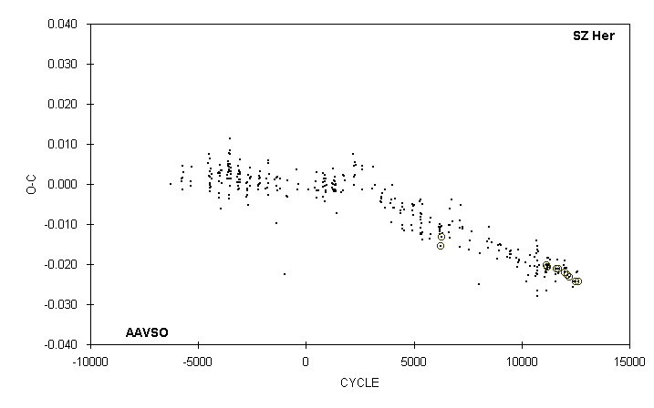

 | JD(min) |  |  |  |  |  |  | STANDARD
 | HEL. |  | CYCLE | O-C | N |  | OBSERVER | ERROR
 | 2400000 +
 | 51005.7147 |  | 11174 | -0.0207 | 23 |  | S. Dvorak (CCD) | 0.0006
 | 51347.676 |  | 11592 | -0.024 | 12 |  | R. Hays
 | 51347.678 |  | 11592 | -0.022 | 17 |  | M. Baldwin
 | 51351.7697 |  | 11597 | -0.0212 |  |  | A. Howell (CCD) | 0.0004
 | 51392.677 |  | 11647 | -0.019 | 15 |  | R. Hays
 | 51419.672 |  | 11680 | -0.0211 | 15 |  | S. Dvorak (CCD) | 0.0010
 | 51428.671 |  | 11691 | -0.021 | 16 |  | R. Hays
 | 51437.669 |  | 11702 | -0.022 | 13 |  | M. Baldwin
 | 51629.924 |  | 11937 | -0.020 | 10 |  | D. Williams
 | 51666.737 |  | 11982 | -0.022 | 13 |  | R. Hays
 | 51689.6434 |  | 12010 | -0.0221 | 49 |  | R. Williams (CCD) | 0.0001
 | 51693.7339 |  | 12015 | -0.0221 |  |  | A. Howell (CCD) | 0.0002
 | 51693.735 |  | 12015 | -0.021 | 17 |  | G. Samolyk
 | 51693.737 |  | 12015 | -0.019 | 20 |  | C. Stephan
 | 51734.64 |  | 12065 | -0.021 | 12 |  | D. Williams
 | 51770.6345 |  | 12109 | -0.0227 |  |  | A. Howell (CCD) | 0.0001
 | 51847.5353 |  | 12203 | -0.0232 | 43 |  | S. Dvorak (CCD) | 0.0001
 | 51989.882 |  | 12377 | -0.026 | 14 |  | R. Hays
 | 52021.789 |  | 12416 | -0.024 | 13 |  | G. Samolyk
 | 52094.5998 |  | 12505 | -0.0244 | 38 |  | S. Dvorak (CCD) | 0.0001
 | 52143.688 : |  | 12565 | -0.022 | 10 |  | R. Hill
 | 52157.596 |  | 12582 | -0.022 | 14 |  | R. Hays
 | 52175.594 |  | 12604 | -0.022 | 12 |  | D. Williams
 | 52184.5907 |  | 12615 | -0.0243 | 77 |  | G. Samolyk (CCD) | 0.0001

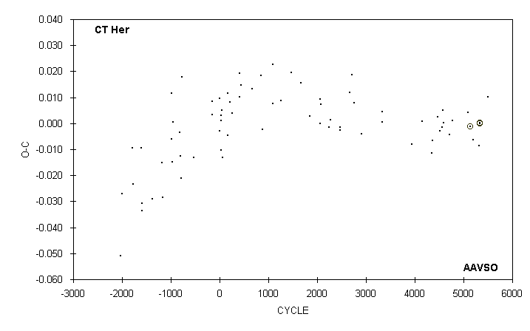

 | JD(min) |  |  |  |  |  |  | STANDARD
 | HEL. |  | CYCLE | O-C | N |  | OBSERVER | ERROR
 | 2400000 +
 | 49911.970 |  | 4136.5 | -0.301 | 7 |  | S. Cook (CCD)
 | 49925.670 : |  | 4144 | 0.001 | 8 |  | M. Baldwin
 | 50293.651 |  | 4350 | -0.011 | 19 |  | G. Chaple
 | 50327.597 |  | 4369 | -0.007 | 11 |  | M. Baldwin
 | 50518.748 |  | 4476 | 0.002 | 15 |  | M. Baldwin
 | 50577.693 |  | 4509 | -0.003 | 17 |  | C. Stephan
 | 50661.654 |  | 4556 | -0.002 | 10 |  | M. Baldwin
 | 50686.670 |  | 4570 | 0.005 | 12 |  | M. Baldwin
 | 50729.538 |  | 4594 | 0.000 | 9 |  | C. Stephan
 | 50927.821 |  | 4705 | -0.004 | 21 |  | R. Hays
 | 51054.659 |  | 4776 | 0.001 | 16 |  | C. Stephan
 | 51629.875 |  | 5098 | 0.004 | 14 |  | D. Williams
 | 51697.7517 |  | 5136 | -0.0013 |  |  | A. Howell (CCD) | 0.0003
 | 51799.570 |  | 5193 | -0.006 | 13 |  | C. Stephan
 | 52015.719 |  | 5314 | -0.009 | 20 |  | C. Stephan
 | 52047.8826 |  | 5332 | 0.0002 | 42 |  | S. Dvorak (CCD) | 0.0005
 | 52049.6687 |  | 5333 | -0.0001 | 87 |  | G. Samolyk (CCD) | 0.0002
 | 52349.790 |  | 5501 | 0.010 | 10 |  | C. Stephan

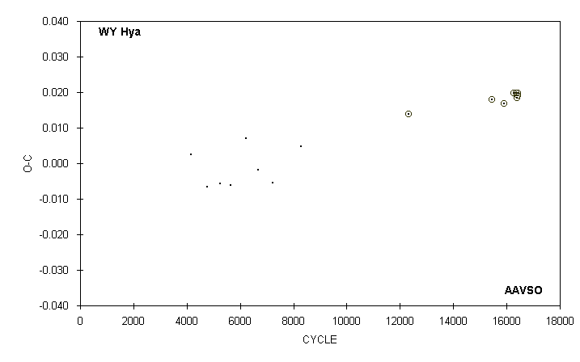

 | JD(min) |  |  |  |  |  |  | STANDARD
 | HEL. |  | CYCLE | O-C | N |  | OBSERVER | ERROR
 | 2400000 +
 | 43538.825 |  | 4145 | 0.003 | 14 |  | G. Samolyk
 | 43986.678 |  | 4770.5 | -0.007 | 15 |  | G. Samolyk
 | 44334.658 |  | 5256.5 | -0.006 | 17 |  | G. Samolyk
 | 44608.888 |  | 5639.5 | -0.006 | 13 |  | G. Samolyk
 | 45026.691 |  | 6223 | 0.007 | 21 |  | G. Samolyk
 | 45352.823 |  | 6678.5 | -0.002 | 11 |  | G. Samolyk
 | 45753.783 |  | 7238.5 | -0.006 | 17 |  | G. Samolyk
 | 46496.650 |  | 8276 | 0.005 | 15 |  | G. Samolyk
 | 49399.7076 |  | 12330.5 | 0.0140 | 70 |  | G. Lubcke (CCD) | 0.0002
 | 51633.6519 |  | 15450.5 | 0.0180 | 57 |  | G. Lubcke (CCD) | 0.0001
 | 51958.7176 |  | 15904.5 | 0.0167 | 77 |  | C. Hesseltine (CCD) | 0.0003
 | 52230.8030 |  | 16284.5 | 0.0197 | 50 |  | S. Dvorak (CCD) | 0.0001
 | 52287.7256 |  | 16364 | 0.0197 | 38 |  | G. Samolyk (CCD) | 0.0002
 | 52314.5746 |  | 16401.5 | 0.0185 | 37 |  | G. Samolyk (CCD) | 0.0007
 | 52324.5993 |  | 16415.5 | 0.0191 | 33 |  | S. Dvorak (CCD) | 0.0001
 | 52333.5502 |  | 16428 | 0.0199 | 38 |  | S. Dvorak (CCD) | 0.0001

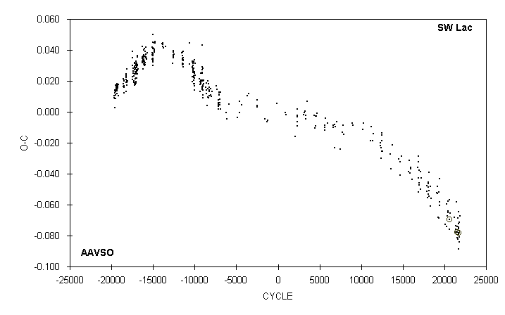

 | JD(min) |  |  |  |  |  |  | STANDARD
 | HEL. |  | CYCLE | O-C | N |  | OBSERVER | ERROR
 | 2400000 +
 | 51380.699 |  | 19036.5 | -0.052 | 19 |  | C. Stephan
 | 51411.648 |  | 19133 | -0.053 | 13 |  | G. Samolyk
 | 51425.604 |  | 19176.5 | -0.048 | 17 |  | C. Stephan
 | 51460.703 |  | 19286 | -0.068 | 17 |  | G. Samolyk
 | 51469.539 |  | 19313.5 | -0.052 | 14 |  | C. Stephan
 | 51488.605 |  | 19373 | -0.069 | 15 |  | G. Samolyk
 | 51502.582 |  | 19416.5 | -0.043 | 15 |  | C. Stephan
 | 51510.585 |  | 19441.5 | -0.058 | 14 |  | C. Stephan
 | 51511.545 |  | 19444.5 | -0.060 | 15 |  | C. Stephan
 | 51720.803 |  | 20097 | -0.073 | 13 |  | G. Samolyk
 | 51769.726 |  | 20249.5 | -0.060 | 12 |  | D. Williams
 | 51783.663 |  | 20293 | -0.074 | 13 |  | G. Samolyk
 | 51793.612 |  | 20324 | -0.067 | 14 |  | G. Samolyk
 | 51832.589 |  | 20445.5 | -0.058 | 14 |  | C. Stephan
 | 51836.592 |  | 20458 | -0.064 | 15 |  | G. Samolyk
 | 51841.562 |  | 20473.5 | -0.065 | 13 |  | C. Stephan
 | 51873.623 |  | 20573.5 | -0.076 | 16 |  | G. Samolyk
 | 51876.529 |  | 20582.5 | -0.057 | 14 |  | C. Stephan
 | 51881.6478 |  | 20598.5 | -0.0694 | 27 |  | S. Dvorak (CCD) | 0.0005
 | 51906.668 |  | 20676.5 | -0.065 | 19 |  | G. Samolyk
 | 52069.752 |  | 21185 | -0.068 | 15 |  | G. Samolyk
 | 52118.652 |  | 21337.5 | -0.078 | 10 |  | C. Stephan
 | 52125.710 |  | 21359.5 | -0.076 | 13 |  | G. Samolyk
 | 52133.730 |  | 21384.5 | -0.074 | 8 |  | B. Manske
 | 52146.735 |  | 21425 | -0.058 | 16 |  | G. Samolyk
 | 52179.593 |  | 21527.5 | -0.074 | 13 |  | G. Samolyk
 | 52185.6829 |  | 21546.5 | -0.0777 | 98 |  | S. Dvorak (CCD) | 0.0001
 | 52189.688 |  | 21559 | -0.082 | 15 |  | G. Samolyk
 | 52196.583 |  | 21580.5 | -0.082 | 17 |  | C. Stephan
 | 52210.708 |  | 21624.5 | -0.069 | 13 |  | G. Samolyk
 | 52221.602 |  | 21658.5 | -0.079 | 12 |  | C. Stephan
 | 52225.618 |  | 21671 | -0.072 | 18 |  | G. Samolyk
 | 52230.586 |  | 21686.5 | -0.075 | 12 |  | C. Stephan
 | 52231.535 |  | 21689.5 | -0.089 | 14 |  | C. Stephan
 | 52235.568 |  | 21702 | -0.065 | 17 |  | G. Samolyk
 | 52238.6012 |  | 21711.5 | -0.0783 | 80 |  | S. Dvorak (CCD) | 0.0001
 | 52239.567 |  | 21714.5 | -0.075 | 15 |  | C. Stephan

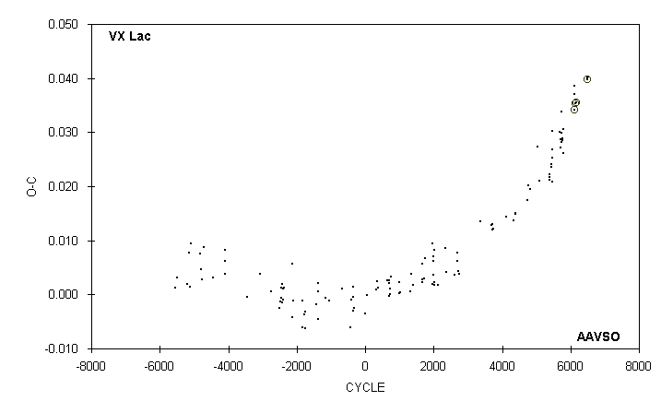

 | JD(min) |  |  |  |  |  |  | STANDARD
 | HEL. |  | CYCLE | O-C | N |  | OBSERVER | ERROR
 | 2400000 +
 | 51376.666 |  | 5694 | 0.030 | 18 |  | C. Stephan
 | 51406.749 |  | 5722 | 0.027 | 15 |  | M. Baldwin
 | 51407.825 |  | 5723 | 0.029 | 10 |  | M. Baldwin
 | 51408.899 |  | 5724 | 0.028 | 20 |  | M. Baldwin
 | 51420.719 |  | 5735 | 0.029 | 10 |  | R. Berg
 | 51433.614 |  | 5747 | 0.030 | 15 |  | M. Baldwin
 | 51433.618 |  | 5747 | 0.034 | 13 |  | G. Samolyk
 | 51450.805 |  | 5763 | 0.029 | 23 |  | R. Hill
 | 51462.624 |  | 5774 | 0.028 | 15 |  | R. Hays
 | 51491.633 |  | 5801 | 0.026 | 14 |  | M. Baldwin
 | 51492.712 |  | 5802 | 0.031 | 16 |  | M. Baldwin
 | 51822.5852 |  | 6109 | 0.0341 |  |  | A. Howell (CCD) | 0.0001
 | 51836.558 |  | 6122 | 0.039 | 13 |  | G. Samolyk
 | 51837.631 |  | 6123 | 0.037 | 14 |  | R. Hays
 | 51866.6406 |  | 6150 | 0.0353 | 40 |  | S. Dvorak (CCD) | 0.0002
 | 51880.6092 |  | 6163 | 0.0354 | 25 |  | S. Dvorak (CCD) | 0.0002
 | 52226.601 |  | 6485 | 0.040 | 17 |  | R. Hays
 | 52241.6436 |  | 6499 | 0.0398 | 40 |  | S. Dvorak (CCD) | 0.0001
 | 52254.538 |  | 6511 | 0.040 | 15 |  | R. Hays

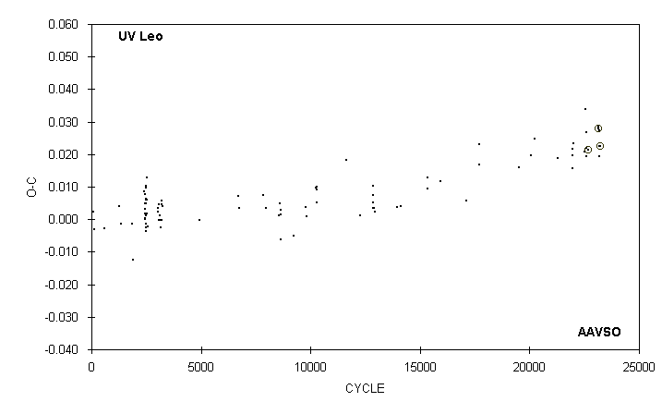

 | JD(min) |  |  |  |  |  |  | STANDARD
 | HEL. |  | CYCLE | O-C | N |  | OBSERVER | ERROR
 | 2400000 +
 | 50152.597 |  | 19517 | 0.016 | 13 |  | S. Cook (CCD)
 | 50488.648 |  | 20077 | 0.020 | 13 |  | G. Samolyk
 | 50572.665 |  | 20217 | 0.025 | 14 |  | G. Samolyk
 | 51223.751 |  | 21302 | 0.019 | 12 |  | G. Samolyk
 | 51627.609 |  | 21975 | 0.020 | 12 |  | R. Berg
 | 51633.606 |  | 21985 | 0.016 | 12 |  | R. Berg
 | 51633.612 |  | 21985 | 0.022 | 15 |  | G. Samolyk
 | 51657.617 |  | 22025 | 0.023 | 15 |  | D. Williams
 | 51937.854 |  | 22492 | 0.021 | 12 |  | G. Samolyk
 | 51986.474 |  | 22573 | 0.034 | 5 |  | B. Sonka
 | 51993.663 |  | 22585 | 0.022 | 12 |  | D. Williams
 | 51996.661 |  | 22590 | 0.019 | 14 |  | G. Samolyk
 | 52002.369 |  | 22599.5 | 0.027 | 15 |  | B. Sonka
 | 52041.6693 |  | 22665 | 0.0214 | 42 |  | S. Dvorak (CCD) | 0.0002
 | 52323.7155 |  | 23135 | 0.0278 | 44 |  | S. Jamieson (CCD) | 0.0002
 | 52329.717 |  | 23145 | 0.028 | 11 |  | D. Williams
 | 52350.711 |  | 23180 | 0.019 | 11 |  | N. Simmons
 | 52350.719 |  | 23180 | 0.027 | 15 |  | G. Samolyk
 | 52356.715 |  | 23190 | 0.023 | 17 |  | G. Samolyk
 | 52383.7186 |  | 23235 | 0.0224 | 53 |  | S. Dvorak (CCD) | 0.0002

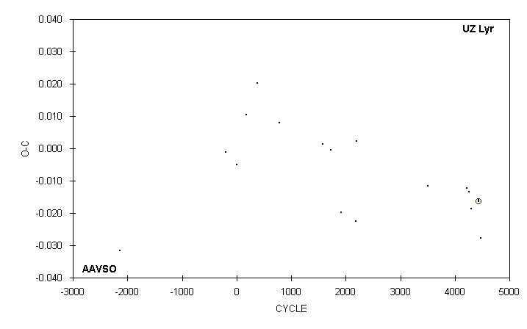

 | JD(min) |  |  |  |  |  |  | STANDARD
 | HEL. |  | CYCLE | O-C | N |  | OBSERVER | ERROR
 | 2400000 +
 | 43326.816 |  | -192 | -0.001 | 20 |  | G. Samolyk
 | 43693.719 |  | 2 | -0.005 | 13 |  | G. Samolyk
 | 44022.816 |  | 176 | 0.011 | 18 |  | G. Samolyk
 | 44406.754 |  | 379 | 0.020 | 11 |  | G. Hanson
 | 45170.816 |  | 783 | 0.008 | 16 |  | E. Halbach
 | 46666.806 |  | 1574 | 0.001 | 10 |  | P. Atwood
 | 46963.734 |  | 1731 | -0.001 | 11 |  | R. Hill
 | 47311.709 |  | 1915 | -0.020 | 10 |  | M. Smith
 | 47816.676 |  | 2182 | -0.023 | 7 |  | M. Smith
 | 47852.635 |  | 2201 | 0.002 | 11 |  | M. Smith
 | 50320.732 |  | 3506 | -0.012 | 20 |  | D. Williams
 | 51657.861 |  | 4213 | -0.012 | 14 |  | D. Williams
 | 51748.641 |  | 4261 | -0.013 | 14 |  | D. Williams
 | 51818.613 |  | 4298 | -0.019 | 12 |  | D. Williams
 | 52077.7195 |  | 4435 | -0.0164 | 95 |  | C. Hesseltine (CCD) | 0.0003
 | 52077.720 |  | 4435 | -0.016 | 14 |  | D. Williams
 | 52145.794 |  | 4471 | -0.028 | 17 |  | R. Hill

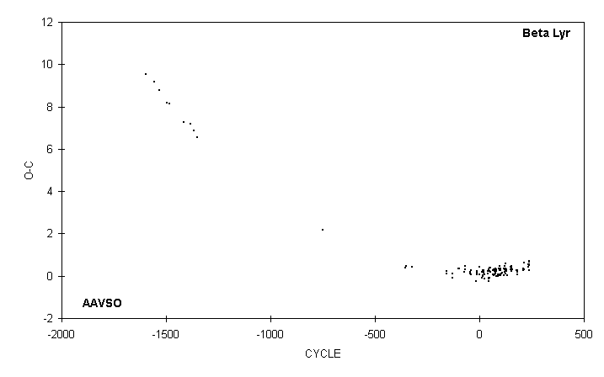

 | JD(min) |  |  |  |  |  |  | Observing
 | HEL. |  | CYCLE | O-C | N |  | OBSERVER | Interval
 | 2400000 +
 | 51306.70 |  | 179 | 0.29 | 63 |  | R. Schmude | 51126 to 51492
 | 51332.47 |  | 181 | 0.18 | 44 |  | G. Chaple | 51148 to 51509
 | 51345.44 |  | 182 | 0.21 | 20 |  | J. Mc Kenna | 51293 to 51407
 | 51345.50 |  | 182 | 0.27 | 26 |  | S. Foglia | 51183 to 51509
 | 51358.24 |  | 183 | 0.08 | 27 |  | G. Samolyk | 51285 to 51424
 | 51720.79 |  | 211 | 0.37 | 37 |  | G. Samolyk | 51629 to 51801
 | 51727.18 |  | 211.5 | 0.29 | 37 |  | G. Samolyk | 51629 to 51801
 | 51772.49 |  | 215 | 0.31 | 33 |  | J. McKenna | 51664 to 51885
 | 51779.28 |  | 215.5 | 0.64 | 32 |  | J. McKenna | 51664 to 51885
 | 52018.44 |  | 234 | 0.45 | 31 |  | R. Schmude | 51893 to 52148
 | 52025.02 |  | 234.5 | 0.56 | 31 |  | R. Schmude | 51893 to 52148
 | 52044.41 |  | 236 | 0.54 | 40 |  | G. Chaple | 51879 to 52213
 | 52057.51 |  | 237 | 0.70 | 30 |  | E. Colombo | 51850 to 52259
 | 52082.96 |  | 239 | 0.28 | 33 |  | G. Samolyk | 52017 to 52150
 | 52083.19 |  | 239 | 0.51 | 36 |  | M. Csukas | 51924 to 52251
 | 52089.82 |  | 239.5 | 0.67 | 36 |  | M. Csukas | 51924 to 52251

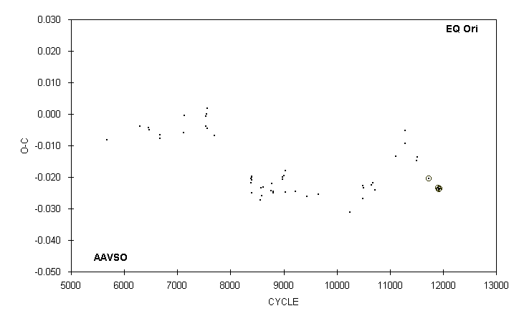

 | JD(min) |  |  |  |  |  |  | STANDARD
 | HEL. |  | CYCLE | O-C | N |  | OBSERVER | ERROR
 | 2400000 +
 | 49749.616 |  | 10487 | -0.027 | 10 |  | R. Hill
 | 49749.620 |  | 10487 | -0.023 | 24 |  | M. Baldwin
 | 49770.572 |  | 10499 | -0.023 | 12 |  | M. Baldwin
 | 50044.704 |  | 10656 | -0.022 | 20 |  | G. Samolyk
 | 50091.848 |  | 10683 | -0.022 | 19 |  | R. Hill
 | 50154.704 |  | 10719 | -0.024 | 13 |  | R. Hill
 | 50842.661 |  | 11113 | -0.013 | 16 |  | M. Baldwin
 | 51144.733 |  | 11286 | -0.009 | 10 |  | M. Baldwin
 | 51144.737 |  | 11286 | -0.005 | 16 |  | G. Samolyk
 | 51523.622 |  | 11503 | -0.015 | 13 |  | M. Baldwin
 | 51551.560 |  | 11519 | -0.014 | 14 |  | M. Baldwin
 | 51914.7330 |  | 11727 | -0.0204 | 33 |  | S. Dvorak (CCD) | 0.0004
 | 52230.7663 |  | 11908 | -0.0235 | 64 |  | G. Samolyk (CCD) | 0.0001
 | 52244.7344 |  | 11916 | -0.0238 | 34 |  | S. Dvorak (CCD) | 0.0001
 | 52265.6872 |  | 11928 | -0.0237 | 104 |  | A. Howell (CCD) | 0.0001
 | 52300.609 |  | 11948 | -0.023 | 21 |  | M. Simonsen

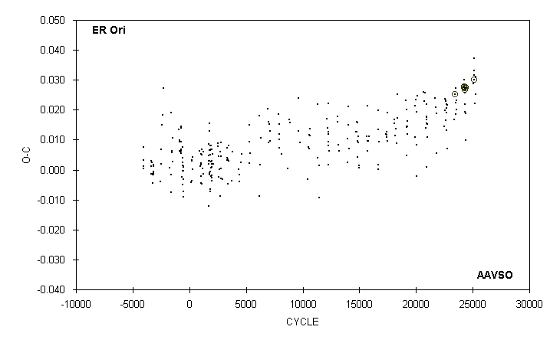

 | JD(min) |  |  |  |  |  |  | STANDARD
 | HEL. |  | CYCLE | O-C | N |  | OBSERVER | ERROR
 | 2400000 +
 | 51516.602 |  | 23359 | 0.017 | 11 |  | C. Stephan
 | 51538.6271 |  | 23411 | 0.0251 |  |  | A. Howell (CCD) | 0.0005
 | 51574.618 |  | 23496 | 0.027 | 14 |  | C. Stephan
 | 51579.694 |  | 23508 | 0.022 | 13 |  | G. Samolyk
 | 51580.537 |  | 23510 | 0.019 | 12 |  | C. Stephan
 | 51594.302 |  | 23542.5 | 0.023 | 11 |  | S. Foglia
 | 51607.636 |  | 23574 | 0.020 | 15 |  | C. Stephan
 | 51892.5909 |  | 24247 | 0.0276 | 44 |  | S. Dvorak (CCD) | 0.0002
 | 51897.674 |  | 24259 | 0.030 | 18 |  | G. Samolyk
 | 51899.7887 |  | 24264 | 0.0276 | 48 |  | S. Dvorak (CCD) | 0.0001
 | 51911.638 |  | 24292 | 0.022 | 17 |  | C. Stephan
 | 51916.7243 |  | 24304 | 0.0273 | 30 |  | S. Dvorak (CCD) | 0.0001
 | 51922.644 |  | 24318 | 0.0194 | 12 |  | C. Stephan | 0.0000
 | 51928.578 |  | 24332 | 0.026 | 10 |  | C. Stephan
 | 51930.6959 |  | 24337 | 0.0267 | 60 |  | S. Dvorak (CCD) | 0.0003
 | 51943.381 |  | 24367 | 0.010 | 13 |  | S. Foglia
 | 51947.6326 |  | 24377 | 0.0275 |  |  | A. Howell (CCD) | 0.0002
 | 51958.640 |  | 24403 | 0.027 | 17 |  | G. Samolyk
 | 51961.596 |  | 24410 | 0.019 | 17 |  | G. Samolyk
 | 52230.676 |  | 25045.5 | 0.029 | 12 |  | G. Samolyk
 | 52252.701 |  | 25097.5 | 0.037 | 19 |  | G. Samolyk
 | 52265.609 |  | 25128 | 0.031 | 15 |  | C. Stephan
 | 52276.619 |  | 25154 | 0.033 | 15 |  | C. Stephan
 | 52265.6075 |  | 25128 | 0.0300 | 81 |  | A. Howell (CCD) | 0.0003
 | 52295.661 |  | 25199 | 0.022 | 17 |  | C. Stephan
 | 52312.600 |  | 25239 | 0.025 | 21 |  | G. Samolyk
 | 52319.592 |  | 25255.5 | 0.031 | 17 |  | G. Samolyk
 | 52323.614 |  | 25265 | 0.031 | 16 |  | C. Stephan

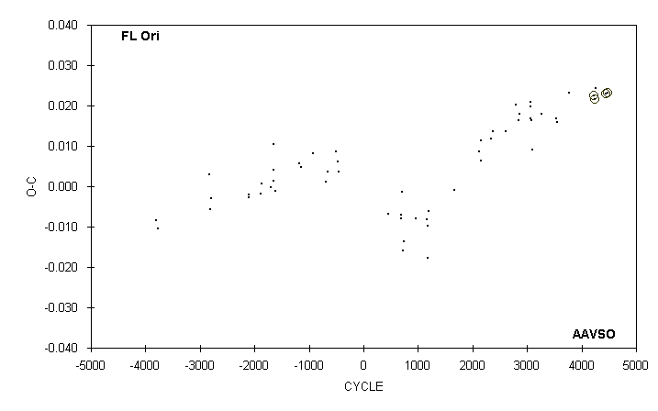

 | JD(min) |  |  |  |  |  |  | STANDARD
 | HEL. |  | CYCLE | O-C | N |  | OBSERVER | ERROR
 | 2400000 +
 | 49750.687 |  | 2839 | 0.016 | 14 |  | R. Hill
 | 49778.606 |  | 2857 | 0.018 | 10 |  | M. Baldwin
 | 50096.557 |  | 3062 | 0.020 | 16 |  | M. Suarez
 | 50096.558 |  | 3062 | 0.021 | 13 |  | I. Gomez
 | 50102.758 |  | 3066 | 0.017 | 17 |  | R. Hill
 | 50130.675 |  | 3084 | 0.016 | 17 |  | R. Hill
 | 50161.687 |  | 3104 | 0.009 | 15 |  | R. Hill
 | 50420.708 |  | 3271 | 0.018 | 11 |  | M. Baldwin
 | 50842.571 |  | 3543 | 0.017 | 14 |  | M. Baldwin
 | 50845.672 |  | 3545 | 0.016 | 13 |  | M. Baldwin
 | 51183.791 |  | 3763 | 0.023 | 22 |  | R. Hill
 | 51895.6860 |  | 4222 | 0.0224 | 36 |  | S. Dvorak (CCD) | 0.0010
 | 51937.5614 |  | 4249 | 0.0216 |  |  | A. Howell (CCD) | 0.0001
 | 51940.666 |  | 4251 | 0.024 | 13 |  | R. Hill
 | 52244.6549 |  | 4447 | 0.0229 | 41 |  | S. Dvorak (CCD) | 0.0002
 | 52286.5315 |  | 4474 | 0.0232 | 59 |  | G. Samolyk (CCD) | 0.0001

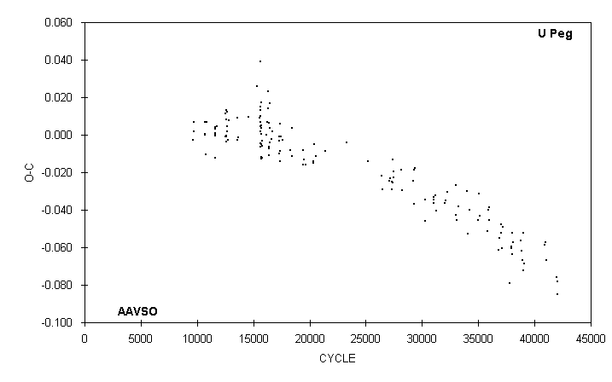

 | JD(min)
 | HEL. |  | CYCLE | O-C | N |  | OBSERVER
 | 2400000 +
 | 50684.699 |  | 37817 | -0.079 | 9 |  | S. Cook (CCD)
 | 50726.694 |  | 37929 | -0.059 | 16 |  | G. Samolyk
 | 50731.565 |  | 37942 | -0.061 | 12 |  | G. Samolyk
 | 50749.563 |  | 37990 | -0.052 | 14 |  | G. Samolyk
 | 50770.539 |  | 38046 | -0.064 | 13 |  | G. Samolyk
 | 50799.591 |  | 38123.5 | -0.057 | 16 |  | G. Samolyk
 | 51041.701 |  | 38769.5 | -0.056 | 13 |  | G. Samolyk
 | 51084.608 |  | 38884 | -0.062 | 12 |  | G. Samolyk
 | 51099.594 |  | 38924 | -0.067 | 14 |  | G. Samolyk
 | 51130.528 |  | 39006.5 | -0.052 | 13 |  | G. Samolyk
 | 51141.564 |  | 39036 | -0.072 | 14 |  | G. Samolyk
 | 51156.559 |  | 39076 | -0.069 | 12 |  | G. Samolyk
 | 51837.547 |  | 40893 | -0.059 | 14 |  | G. Samolyk
 | 51870.529 |  | 40981 | -0.057 | 12 |  | G. Samolyk
 | 51898.628 |  | 41056 | -0.067 | 20 |  | G. Samolyk
 | 52252.600 |  | 42000.5 | -0.076 | 13 |  | G. Samolyk
 | 52253.535 |  | 42003 | -0.078 | 14 |  | G. Samolyk
 | 52268.332 |  | 42042.5 | -0.085 | 15 |  | S. Foglia

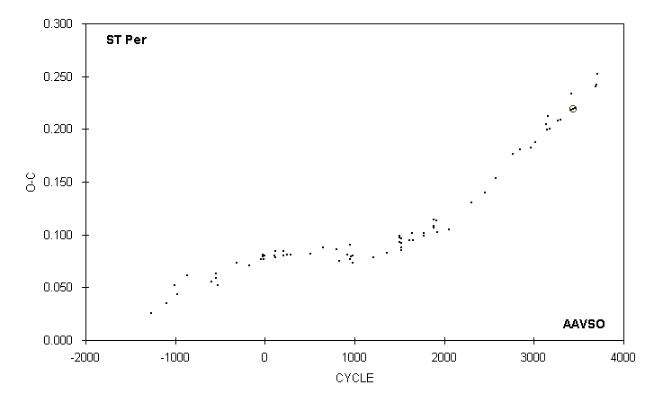

 | JD(min) |  |  |  |  |  |  | STANDARD
 | HEL. |  | CYCLE | O-C | N |  | OBSERVER | ERROR
 | 2400000 +
 | 49748.682 |  | 2761 | 0.176 | 13 |  | R. Hill
 | 49965.848 |  | 2843 | 0.180 | 16 |  | M. Baldwin
 | 50304.834 |  | 2971 | 0.182 | 11 |  | M. Baldwin
 | 50418.717 |  | 3014 | 0.188 | 17 |  | R. Hill
 | 50757.718 |  | 3142 | 0.204 | 17 |  | P. Guilbault
 | 50773.603 |  | 3148 | 0.199 | 33 |  | P. Guilbault
 | 50810.692 |  | 3162 | 0.212 | 19 |  | R. Hill
 | 50839.812 |  | 3173 | 0.201 | 29 |  | R. Hill
 | 51080.816 |  | 3264 | 0.208 | 10 |  | M. Baldwin
 | 51157.618 |  | 3293 | 0.209 | 12 |  | M. Baldwin
 | 51480.737 |  | 3415 | 0.233 | 17 |  | L. Shaw
 | 51496.612 |  | 3421 | 0.218 | 18 |  | M. Baldwin
 | 51541.6342 |  | 3438 | 0.2192 |  |  | A. Howell (CCD) | 0.0004
 | 51586.656 |  | 3455 | 0.220 | 22 |  | G. Samolyk
 | 52211.679 |  | 3691 | 0.240 | 17 |  | R. Hill
 | 52219.626 |  | 3694 | 0.242 | 22 |  | G. Samolyk
 | 52264.657 |  | 3711 | 0.252 | 6 |  | M. Simonsen

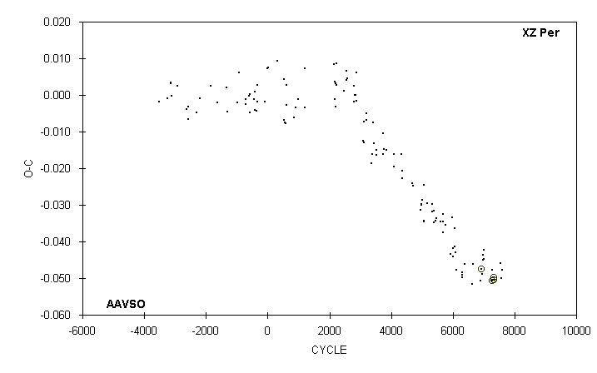

 | JD(min) |  |  |  |  |  |  | STANDARD
 | HEL. |  | CYCLE | O-C | N |  | OBSERVER | ERROR
 | 2400000 +
 | 50761.571 |  | 6299 | -0.050 | 8 |  | M. Baldwin
 | 50762.724 |  | 6300 | -0.048 | 12 |  | R. Hill
 | 50769.633 |  | 6306 | -0.049 | 20 |  | P. Guilbault
 | 50845.644 |  | 6372 | -0.046 | 11 |  | M. Baldwin
 | 51133.547 |  | 6622 | -0.052 | 14 |  | M. Baldwin
 | 51156.585 |  | 6642 | -0.046 | 18 |  | G. Samolyk
 | 51438.731 |  | 6887 | -0.051 | 16 |  | M. Baldwin
 | 51490.5576 |  | 6932 | -0.0475 | 35 |  | G. Samolyk (CCD) | 0.0003
 | 51513.589 |  | 6952 | -0.049 | 20 |  | M. Baldwin
 | 51544.687 |  | 6979 | -0.045 | 15 |  | D. Williams
 | 51551.598 |  | 6985 | -0.044 | 19 |  | M. Baldwin
 | 51581.542 |  | 7011 | -0.042 | 13 |  | C. Stephan
 | 51582.691 |  | 7012 | -0.045 | 16 |  | M. Baldwin
 | 51870.594 |  | 7262 | -0.050 | 20 |  | G. Samolyk
 | 51878.658 |  | 7269 | -0.048 | 14 |  | R. Hill
 | 51893.6265 |  | 7282 | -0.0506 |  |  | A. Howell (CCD) | 0.0001
 | 51946.6017 |  | 7328 | -0.0506 |  |  | A. Howell (CCD) | 0.0001
 | 51961.5738 |  | 7341 | -0.0497 | 54 |  | G. Samolyk (CCD) | 0.0002
 | 52205.724 |  | 7553 | -0.046 | 21 |  | R. Hill
 | 52227.601 |  | 7572 | -0.050 | 17 |  | J. McKenna
 | 52250.636 : |  | 7592 | -0.048 | 6 |  | M. Simonsen

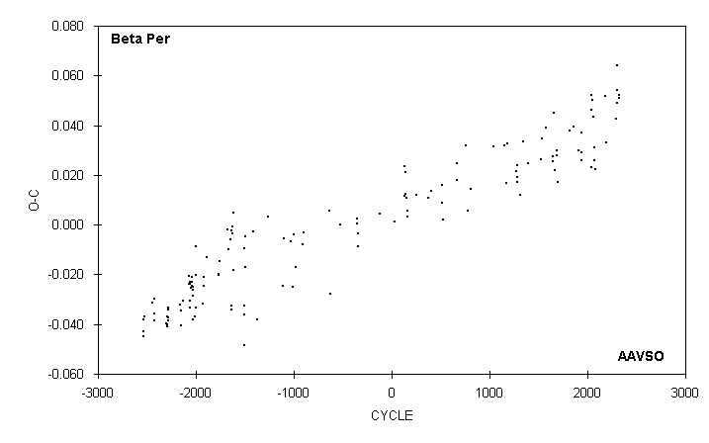

 | JD(min)
 | HEL. |  | CYCLE | O-C | N |  | OBSERVER
 | 2400000 +
 | 51479.368 |  | 2036 | 0.023 | 15 |  | S. Foglia
 | 51496.595 |  | 2042 | 0.046 | 13 |  | C. Stephan
 | 51496.601 |  | 2042 | 0.052 | 15 |  | G. Samolyk
 | 51516.670 |  | 2049 | 0.050 | 18 |  | C. Stephan
 | 51539.602 |  | 2057 | 0.044 | 16 |  | C. Stephan
 | 51565.390 |  | 2066 | 0.026 | 21 |  | S. Foglia
 | 51582.599 |  | 2072 | 0.031 | 21 |  | G. Samolyk
 | 51608.396 |  | 2081 | 0.022 | 14 |  | S. Foglia
 | 51906.625 |  | 2185 | 0.052 | 20 |  | G. Samolyk
 | 51929.545 |  | 2193 | 0.033 | 17 |  | C. Stephan
 | 52207.683 |  | 2290 | 0.043 | 9 |  | R. Hill
 | 52230.633 |  | 2298 | 0.054 | 23 |  | G. Samolyk
 | 52230.643 |  | 2298 | 0.064 | 17 |  | C. Stephan
 | 52253.566 |  | 2306 | 0.049 | 18 |  | G. Samolyk
 | 52296.579 |  | 2321 | 0.052 | 19 |  | G. Samolyk
 | 52316.649 |  | 2328 | 0.051 | 23 |  | G. Samolyk

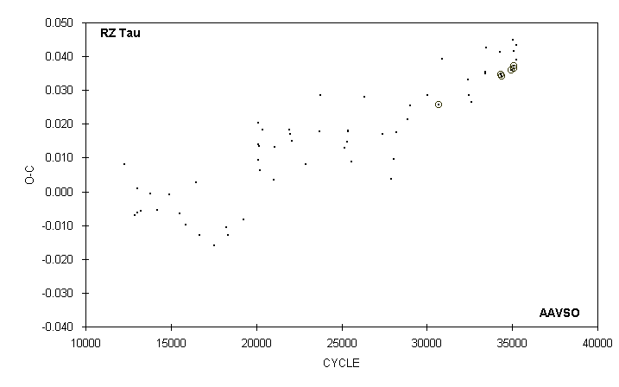

 | JD(min) |  |  |  |  |  |  | STANDARD
 | HEL. |  | CYCLE | O-C | N |  | OBSERVER | ERROR
 | 2400000 +
 | 49743.629 |  | 29030 | 0.025 | 17 |  | G. Samolyk
 | 50152.656 |  | 30014 | 0.029 | 13 |  | G. Samolyk
 | 50432.8178 |  | 30688 | 0.0256 | 198 |  | P. Kuebler (CCD) | 0.0003
 | 50517.629 |  | 30892 | 0.039 | 21 |  | G. Samolyk
 | 51144.876 |  | 32401 | 0.033 | 19 |  | G. Samolyk
 | 51160.667 |  | 32439 | 0.028 | 18 |  | G. Samolyk
 | 51224.679 |  | 32593 | 0.027 | 15 |  | G. Samolyk
 | 51567.619 |  | 33418 | 0.035 | 19 |  | G. Samolyk
 | 51579.674 |  | 33447 | 0.035 | 15 |  | G. Samolyk
 | 51582.591 |  | 33454 | 0.043 | 17 |  | G. Samolyk
 | 51937.576 |  | 34308 | 0.041 | 17 |  | G. Samolyk
 | 51947.5454 |  | 34332 | 0.0346 | 35 |  | S. Dvorak (CCD) | 0.0003
 | 51969.5757 |  | 34385 | 0.0341 | 50 |  | S. Dvorak (CCD) | 0.0002
 | 52195.7046 |  | 34929 | 0.0360 | 41 |  | S. Dvorak (CCD) | 0.0002
 | 52225.633 |  | 35001 | 0.036 | 15 |  | G. Samolyk
 | 52252.661 |  | 35066 | 0.045 | 20 |  | G. Samolyk
 | 52255.5621 |  | 35073 | 0.0363 | 43 |  | S. Dvorak (CCD) | 0.0001
 | 52265.5391 |  | 35097 | 0.0372 | 62 |  | S. Dvorak (CCD) | 0.0001
 | 52267.622 |  | 35102 | 0.042 | 17 |  | G. Samolyk
 | 52316.669 |  | 35220 | 0.039 | 17 |  | G. Samolyk
 | 52319.583 |  | 35227 | 0.043 | 18 |  | G. Samolyk

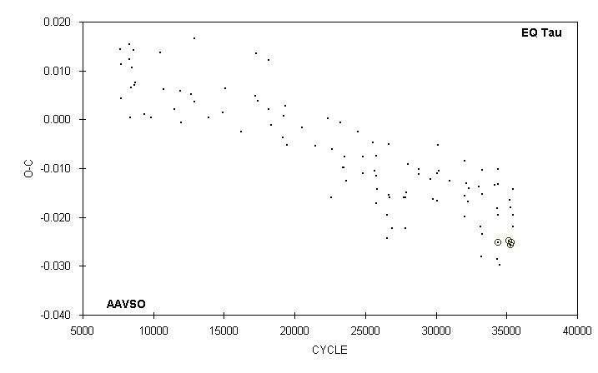

 | JD(min) |  |  |  |  |  |  | STANDARD
 | HEL. |  | CYCLE | O-C | N |  | OBSERVER | ERROR
 | 2400000 +
 | 51873.605 |  | 34159.5 | -0.013 | 13 |  | G. Samolyk
 | 51930.595 |  | 34326.5 | -0.029 | 17 |  | G. Samolyk
 | 51937.603 |  | 34347 | -0.018 | 12 |  | G. Samolyk
 | 51946.6418 |  | 34373.5 | -0.0252 | 39 |  | S. Dvorak (CCD) | 0.0002
 | 51951.597 |  | 34388 | -0.020 | 15 |  | G. Samolyk
 | 51957.580 |  | 34405.5 | -0.010 | 14 |  | G. Samolyk
 | 51958.601 |  | 34408.5 | -0.013 | 16 |  | G. Samolyk
 | 51987.599 |  | 34493.5 | -0.030 | 14 |  | G. Samolyk
 | 52224.8411 |  | 35188.5 | -0.0249 | 58 |  | S. Dvorak (CCD) | 0.0003
 | 52235.602 |  | 35220 | -0.016 | 14 |  | G. Samolyk
 | 52252.660 |  | 35270 | -0.026 | 16 |  | G. Samolyk
 | 52256.5858 |  | 35281.5 | -0.0256 | 27 |  | S. Dvorak (CCD) | 0.0002
 | 52263.591 |  | 35302 | -0.018 | 15 |  | G. Samolyk
 | 52265.8026 |  | 35308.5 | -0.0252 | 44 |  | S. Dvorak (CCD) | 0.0001
 | 52307.621 |  | 35431 | -0.022 | 15 |  | G. Samolyk
 | 52311.549 |  | 35442.5 | -0.020 | 14 |  | G. Samolyk
 | 52319.576 |  | 35466 | -0.014 | 16 |  | G. Samolyk

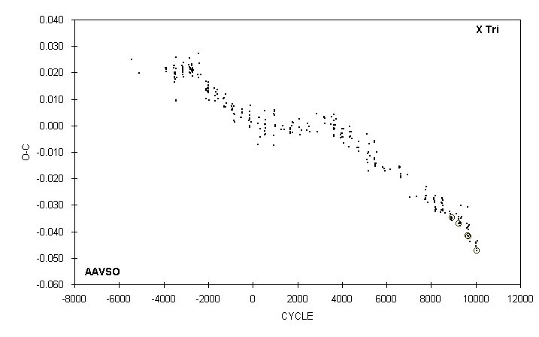

 | JD(min) |  |  |  |  |  |  | STANDARD
 | HEL. |  | CYCLE | O-C | N |  | OBSERVER | ERROR
 | 2400000 +
 | 51370.861 |  | 9128 | -0.033 | 8 |  | D. Williams
 | 51481.6122 |  | 9242 | -0.0371 |  |  | A. Howell (CCD) | 0.0001
 | 51481.615 |  | 9242 | -0.034 | 15 |  | C. Stephan
 | 51483.557 |  | 9244 | -0.035 | 13 |  | R. Hays
 | 51516.588 |  | 9278 | -0.037 | 15 |  | C. Stephan
 | 51550.592 |  | 9313 | -0.036 | 16 |  | R. Hays
 | 51551.562 |  | 9314 | -0.038 | 15 |  | D. Williams
 | 51553.506 |  | 9316 | -0.037 | 11 |  | C. Stephan
 | 51559.342 |  | 9322 | -0.030 | 13 |  | S. Foglia
 | 51586.540 |  | 9350 | -0.035 | 12 |  | C. Stephan
 | 51594.313 |  | 9358 | -0.034 | 13 |  | S. Foglia
 | 51818.735 |  | 9589 | -0.037 | 9 |  | D. Williams
 | 51819.705 |  | 9590 | -0.039 | 14 |  | R. Hill
 | 51820.678 |  | 9591 | -0.037 | 17 |  | R. Hill
 | 51853.7058 |  | 9625 | -0.0415 | 119 |  | C. Hesseltine (CCD) | 0.0002
 | 51853.709 |  | 9625 | -0.038 | 14 |  | R. Berg
 | 51859.535 |  | 9631 | -0.042 | 14 |  | R. Hays
 | 51867.318 |  | 9639 | -0.031 | 6 |  | S. Foglia
 | 51891.598 |  | 9664 | -0.039 | 14 |  | R. Hays
 | 51893.5383 |  | 9666 | -0.0419 |  |  | A. Howell (CCD) | 0.0001
 | 51902.286 |  | 9675 | -0.038 | 13 |  | S. Foglia
 | 51928.518 |  | 9702 | -0.038 | 8 |  | C. Stephan
 | 51960.575 |  | 9735 | -0.041 | 16 |  | C. Stephan
 | 51961.544 |  | 9736 | -0.044 | 13 |  | R. Hays
 | 52230.659 |  | 10013 | -0.044 | 11 |  | C. Stephan
 | 52231.630 |  | 10014 | -0.044 | 13 |  | C. Stephan
 | 52235.515 |  | 10018 | -0.046 | 14 |  | G. Samolyk
 | 52235.515 |  | 10018 | -0.046 | 14 |  | R. Hays
 | 52265.632 |  | 10049 | -0.046 | 14 |  | C. Stephan
 | 52270.4887 |  | 10054 | -0.0472 | 52 |  | A. Howell (CCD) | 0.0002
 | 52300.610 |  | 10085 | -0.043 | 9 |  | M. Simonsen

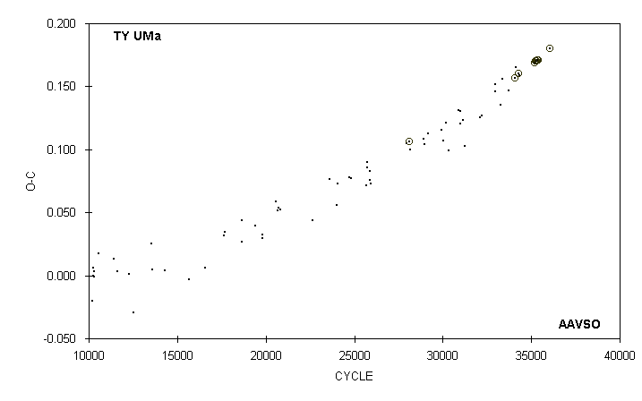

 | JD(min) |  |  |  |  |  |  | STANDARD
 | HEL. |  | CYCLE | O-C | N |  | OBSERVER | ERROR
 | 2400000 +
 | 51370.696 |  | 33390 | 0.156 | 18 |  | G. Samolyk
 | 51488.926 |  | 33723.5 | 0.147 | 16 |  | G. Samolyk
 | 51615.6835 |  | 34081 | 0.1570 | 43 |  | G. Lubcke (CCD) | 0.0001
 | 51629.696 |  | 34120.5 | 0.165 | 19 |  | G. Samolyk
 | 51690.6717 |  | 34292.5 | 0.1603 | 28 |  | G. Samolyk (CCD) | 0.0003
 | 51699.711 |  | 34318 | 0.159 | 10 |  | D. Williams
 | 51996.647 |  | 35155.5 | 0.169 | 17 |  | G. Samolyk
 | 52001.6107 |  | 35169.5 | 0.1689 | 103 |  | S. Dvorak (CCD) | 0.0001
 | 52021.8206 |  | 35226.5 | 0.1701 | 33 |  | G. Samolyk (CCD) | 0.0005
 | 52026.6070 |  | 35240 | 0.1702 | 81 |  | S. Dvorak (CCD) | 0.0002
 | 52038.6612 |  | 35274 | 0.1701 | 44 |  | G. Samolyk (CCD) | 0.0002
 | 52069.6844 |  | 35361.5 | 0.1712 | 45 |  | G. Samolyk (CCD) | 0.0002
 | 52074.6476 |  | 35375.5 | 0.1709 | 81 |  | S. Dvorak (CCD) | 0.0002
 | 52316.8064 |  | 36058.5 | 0.1798 | 38 |  | G. Samolyk (CCD) | 0.0002

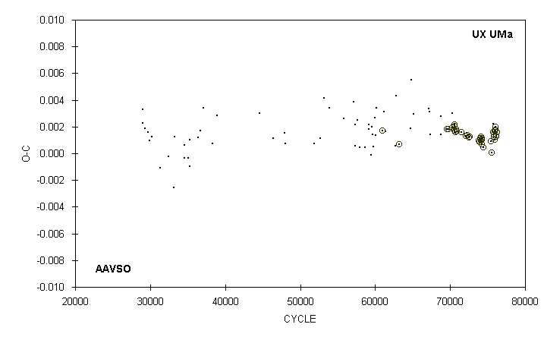

 | JD(min) |  |  |  |  |  |  | STANDARD
 | HEL. |  | CYCLE | O-C | N |  | OBSERVER | ERROR
 | 2400000 +
 | 51488.9184 |  | 71470 | 0.0016 | 21 |  | G. Samolyk (CCD) | 0.0002
 | 51610.6576 |  | 72089 | 0.0013 | 8 |  | G. Lubcke (CCD) | 0.0004
 | 51659.6288 |  | 72338 | 0.0013 | 18 |  | G. Samolyk (CCD) | 0.0001
 | 51685.7859 |  | 72471 | 0.0012 | 29 |  | G. Samolyk (CCD) | 0.0001
 | 51704.6664 |  | 72567 | 0.0012 | 15 |  | G. Samolyk (CCD) | 0.0003
 | 51706.8298 |  | 72578 | 0.0012 |  |  | C. Pullen (CCD) | 0.0002
 | 51957.7821 |  | 73854 | 0.0010 | 16 |  | G. Samolyk (CCD) | 0.0001
 | 51972.7290 |  | 73930 | 0.0009 | 32 |  | S. Dvorak (CCD) | 0.0002
 | 51995.7398 |  | 74047 | 0.0011 | 49 |  | S. Dvorak (CCD) | 0.0002
 | 52013.6370 |  | 74138 | 0.0012 | 24 |  | G. Samolyk (CCD) | 0.0002
 | 52016.5868 |  | 74153 | 0.0010 | 43 |  | S. Dvorak (CCD) | 0.0001
 | 52025.6337 |  | 74199 | 0.0010 | 12 |  | S. Jamieson (CCD) | 0.0002
 | 52028.7801 |  | 74215 | 0.0007 | 22 |  | G. Samolyk (CCD) | 0.0001
 | 52037.6308 |  | 74260 | 0.0011 | 18 |  | G. Samolyk (CCD) | 0.0002
 | 52069.6875 |  | 74423 | 0.0004 | 16 |  | G. Samolyk (CCD) | 0.0001
 | 52279.9296 |  | 75492 | 0.0009 | 30 |  | S. Dvorak (CCD) | 0.0003
 | 52287.7956 |  | 75532 | 0.0001 | 13 |  | G. Samolyk (CCD) | 0.0002
 | 52327.722 |  | 75735 | 0.002 | 7 |  | R. Hill
 | 52333.8182 |  | 75766 | 0.0016 | 35 |  | S. Dvorak (CCD) | 0.0003
 | 52347.7817 |  | 75837 | 0.0014 | 57 |  | S. Dvorak (CCD) | 0.0003
 | 52350.7316 |  | 75852 | 0.0013 | 23 |  | G. Samolyk (CCD) | 0.0001
 | 52364.6950 |  | 75923 | 0.0010 | 21 |  | G. Samolyk (CCD) | 0.0001
 | 52370.7925 |  | 75954 | 0.0017 | 35 |  | G. Samolyk (CCD) | 0.0001
 | 52380.6261 |  | 76004 | 0.0017 | 27 |  | G. Samolyk (CCD) | 0.0002
 | 52398.7201 |  | 76096 | 0.0020 | 17 |  | G. Samolyk (CCD) | 0.0003
 | 52406.7829 |  | 76137 | 0.0013 | 10 |  | S. Dvorak (CCD) | 0.0002
 | 52415.6332 |  | 76182 | 0.0013 | 24 |  | G. Samolyk (CCD) | 0.0002
 | 52426.8437 |  | 76239 | 0.0016 | 18 |  | N. Simmons (CCD) | 0.0004

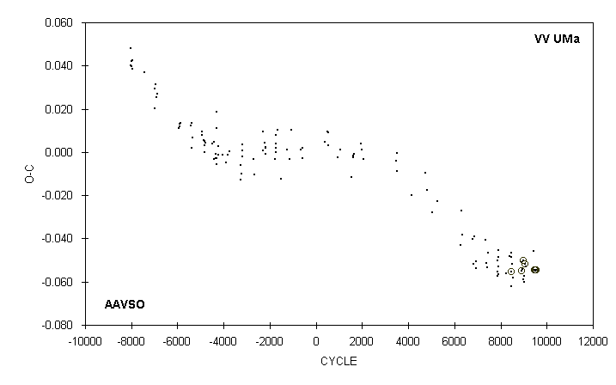

 | JD(min) |  |  |  |  |  |  |  |  |  |  |  |  |  | STANDARD
 | HEL. |  |  |  | CYCLE |  | O-C |  | N |  |  |  | OBSERVER |  | ERROR
 | 2400000 +
 | 51488.915 |  |  |  | 8254 |  | -0.056 |  | 18 |  |  |  | G. Samolyk
 | 51579.657 |  |  |  | 8386 |  | -0.048 |  | 19 |  |  |  | G. Samolyk
 | 51629.822 |  |  |  | 8459 |  | -0.062 |  | 17 |  |  |  | G. Samolyk
 | 51634.6403 |  |  |  | 8466 |  | -0.0552 |  | 39 |  |  |  | G. Lubcke (CCD) |  | 0.0002
 | 51634.648 |  |  |  | 8466 |  | -0.048 |  | 11 |  |  |  | R. Berg
 | 51667.638 |  |  |  | 8514 |  | -0.052 |  | 10 |  |  |  | M. Baldwin
 | 51693.752 |  |  |  | 8552 |  | -0.058 |  | 14 |  |  |  | G. Samolyk
 | 51935.717 |  |  |  | 8904 |  | -0.051 |  | 38 |  |  |  | S. Dvorak (CCD) |  | 0.002
 | 51946.7113 |  |  |  | 8920 |  | -0.0548 |  |  |  |  |  | A. Howell (CCD) |  | 0.0002
 | 51957.710 |  |  |  | 8936 |  | -0.054 |  | 15 |  |  |  | G. Samolyk
 | 51979.7100 |  |  |  | 8968 |  | -0.0503 |  | 48 |  |  |  | S. Dvorak (CCD) |  | 0.0008
 | 52002.385 |  |  |  | 9001 |  | -0.059 |  | 11 |  |  |  | B. Sonka
 | 52021.633 |  |  |  | 9029 |  | -0.058 |  | 16 |  |  |  | G. Samolyk
 | 52026.442 |  |  |  | 9036 |  | -0.060 |  | 11 |  |  |  | B. Sonka
 | 52054.6331 |  |  |  | 9077 |  | -0.0517 |  | 88 |  |  |  | S. Dvorak (CCD) |  | 0.0003
 | 52069.754 |  |  |  | 9099 |  | -0.053 |  | 15 |  |  |  | G. Samolyk
 | 52307.595 |  |  |  | 9445 |  | -0.046 |  | 16 |  |  |  | G. Samolyk
 | 52333.7065 |  |  |  | 9483 |  | -0.0545 |  | 44 |  |  |  | S. Dvorak (CCD) |  | 0.0001
 | 52342.642 |  |  |  | 9496 |  | -0.055 |  | 13 |  |  |  | C. Stephan
 | 52342.6426 |  |  |  | 9496 |  | -0.0544 |  | 40 |  |  |  | S. Dvorak (CCD) |  | 0.0001
 | 52384.5725 |  |  |  | 9557 |  | -0.0547 |  | 30 |  |  |  | S. Dvorak (CCD) |  | 0.0001

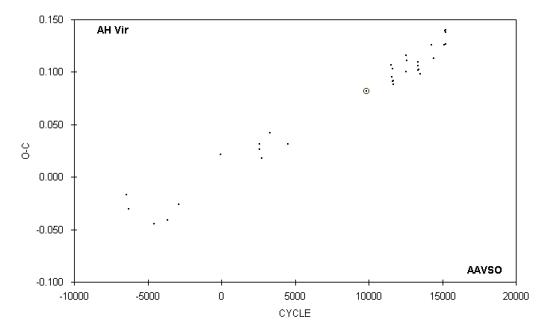

 | JD(min) |  |  |  |  |  |  | STANDARD
 | HEL. |  | CYCLE | O-C | N |  | OBSERVER | ERROR
 | 2400000 +
 | 50580.635 |  | 11695.5 | 0.088 | 9 |  | M. Baldwin
 | 50921.742 |  | 12532.5 | 0.100 | 17 |  | G. Samolyk
 | 50926.648 |  | 12544.5 | 0.116 | 17 |  | G. Samolyk
 | 50950.687 |  | 12603.5 | 0.111 | 20 |  | G. Samolyk
 | 51257.745 |  | 13357 | 0.102 | 12 |  | C. Stephan
 | 51260.605 |  | 13364 | 0.109 | 19 |  | C. Stephan
 | 51262.639 |  | 13369 | 0.106 | 15 |  | C. Stephan
 | 51271.601 |  | 13391 | 0.102 | 10 |  | C. Stephan
 | 51315.609 |  | 13499 | 0.098 | 11 |  | C. Stephan
 | 51629.632 |  | 14269.5 | 0.126 | 14 |  | G. Samolyk
 | 51698.694 |  | 14439 | 0.113 | 17 |  | G. Samolyk
 | 51987.639 |  | 15148 | 0.126 | 19 |  | G. Samolyk
 | 51996.618 |  | 15170 | 0.139 | 17 |  | G. Samolyk
 | 52015.568 |  | 15216.5 | 0.140 | 13 |  | C. Stephan
 | 52021.679 |  | 15231.5 | 0.138 | 21 |  | G. Samolyk
 | 52028.799 |  | 15249 | 0.126 | 9 |  | B. Manske

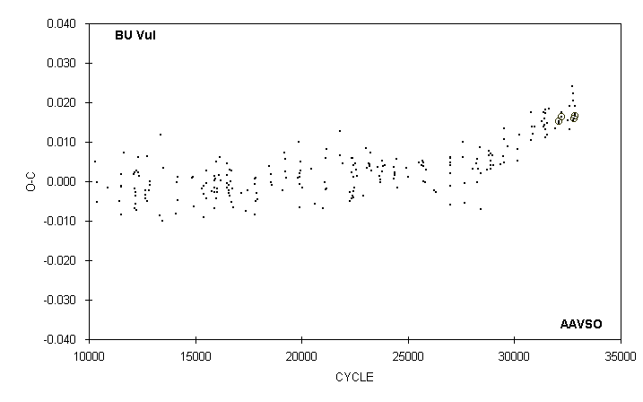

 | JD(min) |  |  |  |  |  |  | STANDARD
 | HEL. |  | CYCLE | O-C | N |  | OBSERVER | ERROR
 | 2400000 +
 | 51804.632 |  | 32111 | 0.015 | 17 |  | G. Samolyk
 | 51804.6325 |  | 32111 | 0.0153 |  |  | A. Howell (CCD) | 0.0001
 | 51861.5328 |  | 32211 | 0.0163 | 27 |  | S. Dvorak (CCD) | 0.0004
 | 51870.638 |  | 32227 | 0.018 | 15 |  | G. Samolyk
 | 52028.816 |  | 32505 | 0.016 | 17 |  | G. Samolyk
 | 52069.787 |  | 32577 | 0.019 | 14 |  | G. Samolyk
 | 52077.747 |  | 32591 | 0.013 | 14 |  | D. Williams
 | 52146.606 |  | 32712 | 0.024 | 7 |  | C. Stephan
 | 52168.795 |  | 32751 | 0.022 | 11 |  | G. Samolyk
 | 52175.621 |  | 32763 | 0.020 | 12 |  | D. Williams
 | 52179.599 |  | 32770 | 0.015 | 17 |  | G. Samolyk
 | 52191.5483 |  | 32791 | 0.0158 | 23 |  | J. Blackwell (CCD)
 | 52220.570 |  | 32842 | 0.019 | 11 |  | M. Baldwin
 | 52224.5506 |  | 32849 | 0.0165 | 122 |  | S. Dvorak (CCD) | 0.0001
 | 52224.551 |  | 32849 | 0.017 | 13 |  | M. Baldwin
 | 52253.563 |  | 32751 | 0.022 | 19 |  | G. Samolyk

