OBSERVED MINIMA TIMINGS
OF ECLIPSING BINARIES

NUMBER 11

Prepared by:

Marvin E. Baldwin
Chairman, AAVSO
Eclipsing Binary
Committee

Gerard Samolyk
AAVSO Eclipsing
Binary Committee

October 2006

Funds for publication were provided by
The Harold S. Martin Fund.

ISBN 1-878174-64-9

COPYRIGHT 2006
The American Association of Variable Star Observers
25 Birch Street
Cambridge, MA 02138
USA

All rights reserved. No part of this book may be reproduced by any mechanical, photographic, or electronic process, nor may it be stored on an information retrieval system, transmitted, or otherwise copied for public or private use, without the written permission of the American Association of Variable Star Observers.

TABLE OF CONTENTS

Introduction v

References vi

Table 1. Publications Containing Previous AAVSO Minima for Each Star in this Monograph vii

Table 2. Information on O-C Minima and Linear Elements viii

Table 3. Observers Contributing to this Monograph ix

Compilation of Times of Minima and O-C Diagrams 1

INTRODUCTION

This compilation contains 514 minima timings of 50 eclipsing binary stars. It represents a portion of the stars observed by participants in the AAVSO's eclipsing binary program since 1976, and continues the listing of minima published in Observed Minima Timings of Eclipsing Binaries Nos. 1 through 10. Except where otherwise specified, all minima are determined from visual observations reduced by the authors using a computerized tracing paper method. Ron Baldwin and Gerard Samolyk wrote the tracing paper software specifically for this purpose.

Most CCD observations were reduced by the observers using the method of Kwee and Van Worden (1957). The standard error is included in each of these cases.

In instances where fragments of eclipses are observed during different cycles, the data points are reduced to heliocentric phase and combined into a single light curve for the tracing paper process. In these cases, the listed time of minimum is the eclipse nearest to the midpoint of the observing interval that corresponds to the calculated phase of minimum light. A footnote is added to these listings indicating the observing interval in JD.

With the exception of Z Dra and GU Ori the linear elements in the 1985 General Catalog of Variable Stars (34) were used to compute the O-C values. For Z Dra the linear elements from SAC 68 (36) were used. For GU Ori the linear elements from JAAVSO Vol. 14 No. 1 (24) were used.

All elements used in this publication are listed in Table 2. The number of observations used for determination of each time of minimum is given under N. This work is sponsored by the AAVSO, with Marvin Baldwin acting as program coordinator.

The O-C diagrams accompanying the minima listings represent not only the minima tabulated here but also all previously published minima associated with the AAVSO program. Times of minimum obtained electronically that have four place accuracy are circled on the O-C diagrams. The years spanned by these diagrams are listed by star in Table 2, with the second column giving the year of the earliest observation appearing in the diagram and the third and fourth columns listing the earliest and latest year of the minima tabulated in this publication.

The material in this monograph may be accessed electronically via the AAVSO web site home page (http://www.aavso.org) or the AAVSO ftp site (ftp.aavso.org in /pub/monographs).

Observers contributing data used in this publication are listed in Table 3. Their dedicated efforts are greatly appreciated.

Marvin E. Baldwin Gerard Samolyk
8655 N Co. Rd. 775E 9504 W Barnard Ave.
Butlerville, IN 47223 Greenfield, WI 53228
USA USA
REFERENCES

1 Ashbrook, J. 1963, Sky & Telescope, 25,5,277
2 Ashbrook, J. 1963, Sky & Telescope, 26,3,153
3 Ashbrook, J. 1964, Sky & Telescope, 27,1,58
4 Ashbrook, J. 1964, Sky & Telescope, 27, 5, 317.
5 Ashbrook, J. 1964, Sky & Telescope, 28,10,244
- Ashbrook, J. 1965, Sky & Telescope, 29, 4, 254.
- Baldwin, M.E. Robinson, L.J. 1965, Inf. Bull. Var. Stars, No. 92
8 Robinson, L. J. 1965, Inf. Bull. Var. Stars, No. 111.
9 Robinson, L. J. 1965, Inf. Bull. Var. Stars, No. 114.
10 Robinson, L. J. 1965, Inf. Bull. Var. Stars, No. 119.
11 Robinson, L. J. 1966, Inf. Bull. Var. Stars, No. 129.
12 Robinson, L. J. 1966, Inf. Bull. Var. Stars, No. 154.
13 Robinson, L. J. 1967, Inf. Bull. Var. Stars, No. 180.
14 Robinson, L. J. 1967, Inf. Bull. Var. Stars, No. 221.
15 Robinson, L. J., and Ashbrook, J. 1968, Inf. Bull. Var. Stars, No. 247.
16 Baldwin, M. E. 1973, Inf. Bull. Var. Stars, No. 795.
17 Baldwin, M. E. 1974, J. Amer. Assoc. Var. Star Obs., 3, 60.
18 Baldwin, M. E. 1975, J. Amer. Assoc. Var. Star Obs., 4, 86.
19 Baldwin, M. E. 1976, J. Amer. Assoc. Var. Star Obs., 5, 29.
20 Baldwin, M. E. 1976, J. Amer. Assoc. Var. Star Obs., 5, 84.
21 Baldwin, M. E. 1977, J. Amer. Assoc. Var. Star Obs., 6, 24.
22 Baldwin, M.E. Samolyk, G. Wedemayer G.J. 1977, J. Amer. Assoc. Var. Star Obs., 6,9
23 Baldwin, M. E. 1978, J. Amer. Assoc. Var. Star Obs., 7, 28.
24 Samolyk, G. 1985, J. Amer. Assoc. Var. Star Obs., 14,1,12
25 Baldwin, M. E., and Samolyk, G. 1993, Observed Minima Timings of Eclipsing Binaries No. 1,
AAVSO, Cambridge, MA.
26 Baldwin, M. E., and Samolyk, G. 1995, Observed Minima Timings of Eclipsing Binaries No. 2,
AAVSO, Cambridge, MA.
27 Baldwin, M. E., and Samolyk, G. 1996, Observed Minima Timings of Eclipsing Binaries No. 3,
AAVSO, Cambridge, MA.
28 Baldwin, M. E., and Samolyk, G. 1997, Observed Minima Timings of Eclipsing Binaries No. 4,
AAVSO, Cambridge, MA.
29 Baldwin, M. E., and Samolyk, G. 1999, Observed Minima Timings of Eclipsing Binaries No. 5,
AAVSO, Cambridge, MA.
30 Baldwin, M. E., and Samolyk, G. 2000, Observed Minima Timings of Eclipsing Binaries No. 6,
AAVSO, Cambridge, MA.
31 Baldwin, M. E., and Samolyk, G. 2002, Observed Minima Timings of Eclipsing Binaries No. 7,
AAVSO, Cambridge, MA.
32 Baldwin, M. E., and Samolyk, G. 2003, Observed Minima Timings of Eclipsing Binaries No. 8,
AAVSO, Cambridge, MA.
33 Baldwin, M. E., and Samolyk, G. 2004, Observed Minima Timings of Eclipsing Binaries No. 9,
AAVSO, Cambridge, MA.
34 Kholopov, P. N., et al. 1985, General Catalogue of Variable Stars, Fourth Edition, Moscow.
35 Kwee K. K., and Van Worden, H. 1957, Bull. Astron. Inst. Netherlands, 12, 327.
36 Kurpinskw-Winiarska M. et. al. 1996, SAC 68

TABLE 1

1 2 3 4 5 6 7 8 9 10 11 12 13 14 15 16 17 18 19 20 21 22 23 24 25 26 27 28 29 30 31 32 33
WZ And X X X X X X X X X
CZ Aqr X
OO Aql X X X X X X X X X X X X X X X X X X X X X X
V342 Aql X X X X X X X X X X
V346 Aql X X X X X X X X X X X X X X X X
SV Cam X X X X X X X X X X X X X X X X X X X
TZ CMa
UU CMa X X
AK CMi X X
RZ Cas X X X X X X X X X X X X X X X X X X X X X X X X X X
AB Cas X X X X X X X X X X X X X X X X
IR Cas X X X X
PV Cas X
DK Cep X
EG Cep X X X X X X X X X X X X X
W Crv X X X X X X
RV Crv X X
WW Cyg X X X
BR Cyg X X X X X X
CG Cyg X X X
V387 Cyg X X X
V477 Cyg X X X X X X X X X X
TT Del X X X X X
TY Del X X X X X X X X X
FZ Del X X X X X X X X X X
Z Dra X X X X X X X X X X X X X X X X
YY Eri X X X X X X X X X X X X X
Z Her X
SZ Her X X X X X X X X X X X X X X X X X X X X X X X
CC Her X
VX Lac X X X X X X X X X X X X
Y Leo X X X X X X X X X X X X X
SS Lib X X X X
EW Lyr X X X X X X X X
RW Mon X X X X
FZ Ori
GU Ori X X X
U Peg X X X X X X X X X
DI Peg X X
IU Per
RV Psc X
V505 Sgr X X X X X X X X X
RW Tau X X X X X X X X X X
HU Tau X X X X X X X X X X X
V Tri X X X X X
X Tri X X X X X X X X X X X X X X X X X X
W UMa X X X X X X X X X X X X X
XZ UMa X X X X X X X X X
RU UMi X X X X X
VV Vir X

This table identifies publications in which previous AAVSO minima for each star have been published. The numbers across the top of the table correspond to those given at the beginning of each entry in the References.

TABLE 2

Earliest Earliest Latest Epoch Period
Minimum Listing Listing 2400000 + (Days)

WZ And 1966 2002 2005 40872.290 0.6956576
CZ Aqr 1976 1999 2005 43371.469 0.8627540
OO Aql 1960 2004 2006 38613.2222 0.50678848
V342 Aql 1965 1997 2005 39318.581 3.390882
V346 Aql 1965 2003 2005 41918.384 1.106363
SV Cam 1964 2002 2005 42594.61518 0.59306995
TZ CMa 1976 1976 2005 27124.871 1.911446
UU CMa 1976 1996 2005 44598.412 2.1664842
AK CMi 1967 1998 2006 43101.672 0.5658975
RZ Cas 1961 2004 2006 43200.3063 1.195247
AB Cas 1965 2003 2006 42714.4627 1.3668738
IR Cas 1975 2001 2006 42364.054 0.6806854
PV Cas 1976 1998 2006 40227.4044 1.75046986
DK Cep 1976 2000 2006 33590.5630 0.9859064
EG Cep 1966 2004 2006 42594.3825 0.54462183
W Crv 1971 2003 2006 39647.766 0.38808083
RV Crv 1975 2001 2005 41029.384 0.7472521
WW Cyg 1970 1995 2005 40377.886 3.3177690
BR Cyg 1968 2003 2005 41539.4654 1.33256415
CG Cyg 1976 2003 2005 39425.1221 0.63114100
V387 Cyg 1976 2002 2005 27985.461 0.6405964
V477 Cyg 1966 2000 2005 44189.2639 2.3469906
TT Del 1968 1996 2005 45232.419 2.871119
TY Del 1965 2002 2005 42959.4450 1.19112689
FZ Del 1968 2003 2006 31324.329 0.7832126
Z Dra 1965 2002 2006 43499.736 1.3574560
YY Eri 1968 2004 2006 41581.624 0.32149415
Z Her 1965 1988 2006 13086.3345 3.9928077
SZ Her 1959 2004 2005 41864.30517 0.81809828
CC Her 1976 1997 2006 39668.342 1.7340058
VX Lac 1966 2002 2005 45258.466 1.0744942
Y Leo 1963 1999 2006 45436.451 1.6861020
SS Lib 1965 2000 2006 41155.660 1.4379983
EW Lyr 1968 1999 2006 26499.697 1.948723
RW Mon 1968 2002 2005 33680.4481 1.90609412
FZ Ori 2000 2000 2006 44024.4583 0.3999866
GU Ori 1976 2003 2006 43069.903 0.470681
U Peg 1968 2002 2005 36511.66823 0.374781439
DI Peg 1976 2003 2005 45196.488 0.7118168
IU Per 1977 1977 2006 45611.436 0.8570251
RV Psc 1977 2000 2006 24381.480 0.55399145
V505 Sgr 1964 2000 2004 44461.5907 1.18287156
RW Tau 1965 2001 2006 45684.204 2.7688356
HU Tau 1964 2000 2005 41275.3219 2.0562997
V Tri 1975 2003 2005 24474.305 0.5852057
X Tri 1960 2003 2006 42502.721 0.9715352
W UMa 1966 2004 2006 45765.7385 0.33363749
XZ UMa 1967 2003 2005 46168.426 1.22232
RU UMi 1972 2003 2006 41596.3365 0.52492618
VV Vir 1977 1997 2006 31221.218 0.44613577

The O-C diagrams for each star contain the minima spanning the years in columns two and four. The listing of new minima spans the years in columns three and four. The fifth and sixth columns contain the linear elements used to calculate the O-C values in this publication. All of these elements are from the General Catalogue of Variable Stars (Kholopov et al. 1985) except for Z Dra and GU Ori (see the introduction).

TABLE 3

M. Baldwin 13 C. Hesseltine (CCD) 8
D. Beard 5 R. Hill 25
R. Berg 1 J. A. Howell (CCD) 10
J. Bialozynski (CCD) 13 S. Jamieson (CCD) 2
S. Brady (CCD) 3 V. Jani 1
N. Butterworth (CCD) 4 B. Manske (CCD) 2
G. Chaple 24 I. Megson 2
J. Coloma (CCD) 2 C. Norris (CCD) 1
S. Cook (CCD) 46 R. Papini (CCD) 4
M. Csukas 1 R. Poklar (CCD) 9
S. Dvorak (CCD) 31 G. Samolyk 63
A. Filho 1 G. Samolyk (CCD) 113
S. Foglia 3 G. Sarty 1
H. Gerner 1 T. Shoup (CCD) 1
H. Gerner (CCD) 3 M. Simonsen 2
P. Guilbault 1 C. Stephan 43
T. Hager 1 J. Virtanen 1
R. Hays 32 G. Wedemayer 2
C. Haza (CCD) 2 D. Williams 37

36 Observers 514

This table lists the observers and the number of minima contributed by each. CCD stands for Charge-Coupled Device.

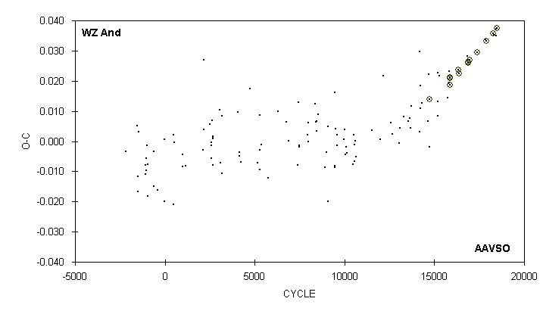

JD(min) STANDARD
HEL. CYCLE O-C N OBSERVER ERROR
2400000 +
52585.801 16838 0.028 19 R. Hill
52963.5442 17381 0.0295 60 G. Samolyk (CCD) 0.0003
52981.6312 17407 0.0294 75 S. Dvorak (CCD) 0.0001
53301.638 17867 0.034 25 S. Cook (CCD)
53331.5508 17910 0.0332 32 S. Dvorak (CCD) 0.0002
53591.7294 18284 0.0358 73 J. Bialozynski (CCD) 0.0002
53621.642 18327 0.035 17 S. Cook (CCD)
53686.338 18420 0.035 15 V. Jani
53694.688 18432 0.037 21 C. Stephan
53724.6016 18475 0.0374 106 G. Samolyk (CCD) 0.0001

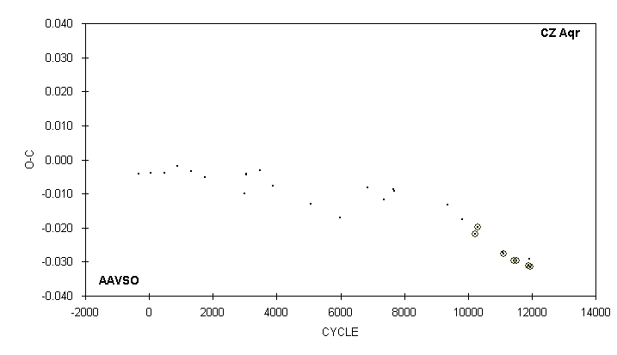

JD(min) STANDARD
HEL. CYCLE O-C N OBSERVER ERROR
2400000 +
51454.598 9369 -0.013 14 G. Samolyk
51849.735 9827 -0.018 16 R. Hill
52189.6557 10221 -0.0219 66 G. Samolyk (CCD) 0.0001
52262.5606 10305.5 -0.0197 51 S. Dvorak (CCD) 0.0008
52931.619 11081 -0.027 14 D. Williams
52963.5403 11118 -0.0277 44 G. Samolyk (CCD) 0.0002
53238.7568 11437 -0.0297 41 G. Samolyk (CCD) 0.0001
53314.6791 11525 -0.0297 48 G. Samolyk (CCD) 0.0002
53634.7595 11896 -0.0311 60 J. Bialozynski (CCD) 0.0001
53653.742 11918 -0.029 18 C. Stephan
53673.5830 11941 -0.0315 80 G. Samolyk (CCD) 0.0002

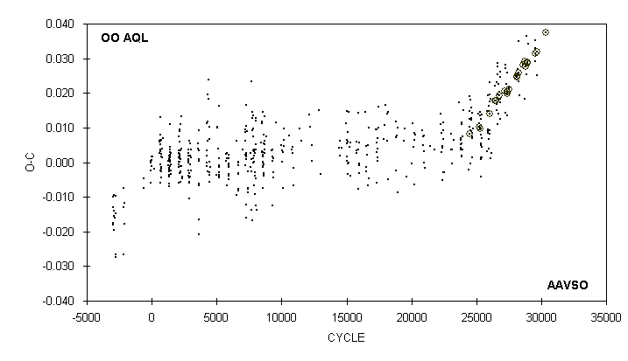

JD(min) STANDARD
HEL. CYCLE O-C N OBSERVER ERROR
2400000 +
53106.8942 28599 0.0283 60 S. Dvorak (CCD) 0.0001
53176.821 28737 0.018 16 D. Williams
53239.670 28861 0.025 13 R. Hays
53239.681 28861 0.036 10 D. Williams
53258.4244 28898 0.0287 44 R. Papini (CCD) 0.0001
53258.6779 28898.5 0.0288 55 R. Poklar (CCD) 0.0001
53274.641 28930 0.028 16 D. Williams
53292.638 28965.5 0.034 13 C. Stephan
53565.792 29504.5 0.029 17 C. Stephan
53574.6631 29522 0.0314 52 G. Samolyk (CCD) 0.0001
53581.762 29536 0.035 15 C. Stephan
53585.814 29544 0.033 17 C. Stephan
53616.726 29605 0.031 14 D. Williams
53641.5597 29654 0.0319 68 G. Samolyk (CCD) 0.0001
53643.580 29658 0.025 14 R. Hays
54000.3714 30362 0.0374 65 R. Papini (CCD) 0.0002

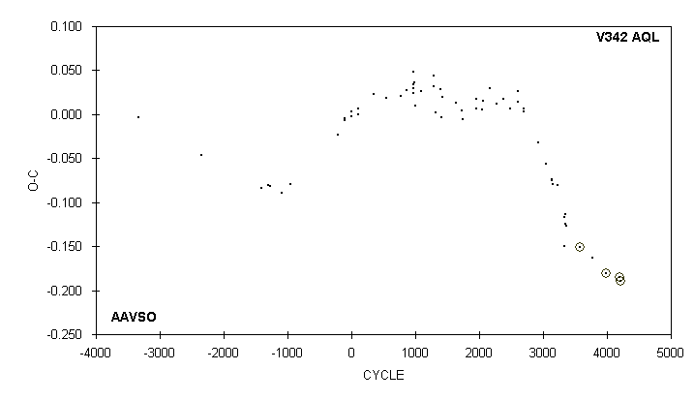

JD(min) STANDARD
HEL. CYCLE O-C N OBSERVER ERROR
2400000 +
50627.023 1) 3335 -0.149 29 D. Beard
50644.010 2) 3340 -0.117 28 D. Beard
50667.739 3347 -0.124 24 D. Beard
50684.704 3352 -0.113 29 D. Beard
50718.600 3362 -0.126 25 D. Beard
51447.6153 3577 -0.1506 J. A. Howell (CCD) 0.0017
52125.779 3777 -0.163 29 G. Samolyk
52810.7194 3979 -0.1811 59 G. Samolyk (CCD) 0.0001
53539.7550 4194 -0.1851 125 G. Samolyk (CCD) 0.0002
53621.1314 3) 4218 -0.1899 150 G. Samolyk (CCD) 0.0004

1) Observations combined from 50623 to 50633
2) Observations combined from 50640 to 50650
3) Observations combined from 53617 to 53624

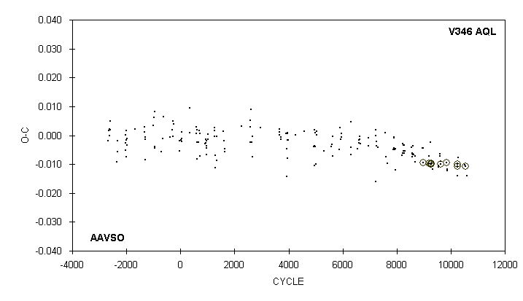

JD(min) STANDARD
HEL. CYCLE O-C N OBSERVER ERROR
2400000 +
52822.686 9856 -0.012 12 R. Hays
52833.749 9866 -0.012 13 D. Williams
53239.7867 10233 -0.0099 60 G. Samolyk (CCD) 0.0002
53258.5941 10250 -0.0106 43 G. Samolyk (CCD) 0.0004
53259.697 10251 -0.014 14 D. Williams
53279.618 10269 -0.008 26 S. Cook (CCD)
53561.738 10524 -0.010 14 D. Williams
53581.6521 10542 -0.0106 70 G. Samolyk (CCD) 0.0001
53643.605 10598 -0.014 15 R. Hays

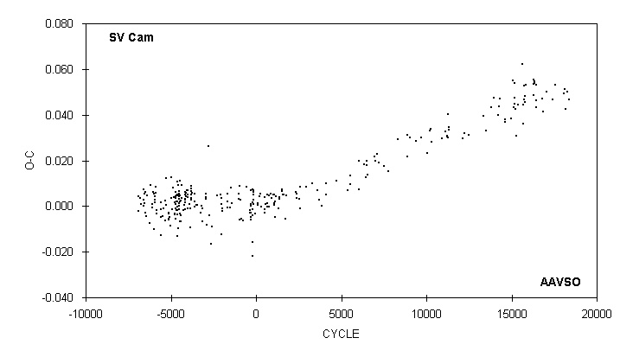

JD(min)
HEL. CYCLE O-C N OBSERVER
2400000 +
52547.562 : 16782 0.047 16 G. Chaple
52586.699 16848 0.041 18 C. Stephan
52723.707 17079 0.050 17 C. Stephan
52930.685 17428 0.047 18 C. Stephan
53003.639 17551 0.053 18 G. Samolyk
53306.694 18062 0.049 17 S. Cook (CCD)
53334.570 18109 0.051 22 S. Cook (CCD)
53373.704 18175 0.042 16 C. Stephan
53443.694 18293 0.050 16 C. Stephan
53481.647 18357 0.047 25 S. Cook (CCD)

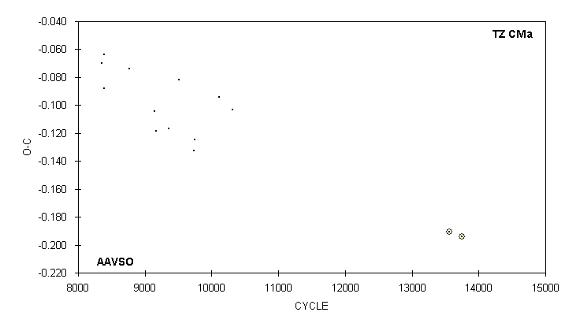

JD(min) STANDARD
HEL. CYCLE O-C N OBSERVER ERROR
2400000 +
43096.844 8356 -0.070 8 G. Wedemayer
43165.638 8392 -0.088 9 G. Samolyk
43165.662 8392 -0.064 10 G. Wedemayer
43876.710 8764 -0.074 10 G. Samolyk
44608.763 9147 -0.105 10 G. Samolyk
44654.624 9171 -0.118 12 G. Samolyk
45021.623 9363 -0.117 15 G. Samolyk
45298.818 9508 -0.082 16 G. Samolyk
45732.665 9735 -0.133 10 G. Samolyk
45753.699 9746 -0.125 22 G. Samolyk
46445.673 10108 -0.094 16 G. Samolyk
46835.599 10312 -0.103 18 G. Samolyk
53049.6222 13563 -0.1909 48 G. Samolyk (CCD) 0.0003
53393.6791 13743 -0.1943 58 G. Samolyk (CCD) 0.0005

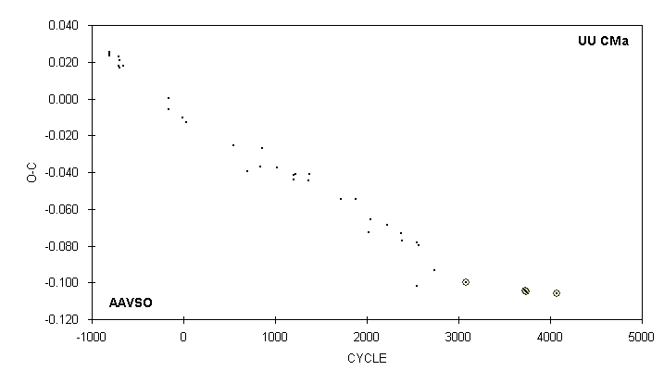

JD(min) STANDARD
HEL. CYCLE O-C N OBSERVER ERROR
2400000 +
50107.703 2543 -0.078 18 M. Baldwin
50122.845 : 2550 -0.102 13 R. Hill
50159.697 2567 -0.080 11 R. Hill
50523.653 2735 -0.093 16 G. Samolyk
51264.5838 3077 -0.1001 21 G. Samolyk (CCD) 0.0001
52683.6267 3732 -0.1043 73 G. Samolyk (CCD) 0.0003
52696.6252 3738 -0.1047 43 S. Jamieson (CCD) 0.0002
53413.7302 4069 -0.1060 71 G. Samolyk (CCD) 0.0001

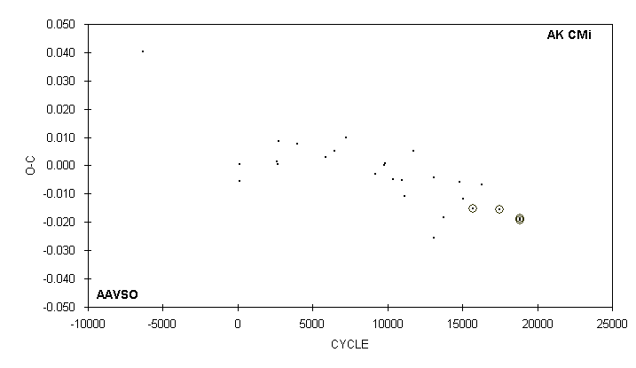

JD(min) STANDARD
HEL. CYCLE O-C N OBSERVER ERROR
2400000 +
50873.690 13734 -0.018 21 R. Hill
51488.833 14821 -0.006 18 G. Samolyk
51611.627 15038 -0.012 17 M. Baldwin
51989.6430 15706 -0.0151 49 G. Samolyk (CCD) 0.0001
52316.740 16284 -0.007 25 G. Samolyk
52986.7539 17468 -0.0156 60 C. Hesseltine (CCD) 0.0001
53763.7275 18841 -0.0193 90 R. Poklar (CCD) 0.0002
53763.7282 18841 -0.0186 88 G. Samolyk (CCD) 0.0002

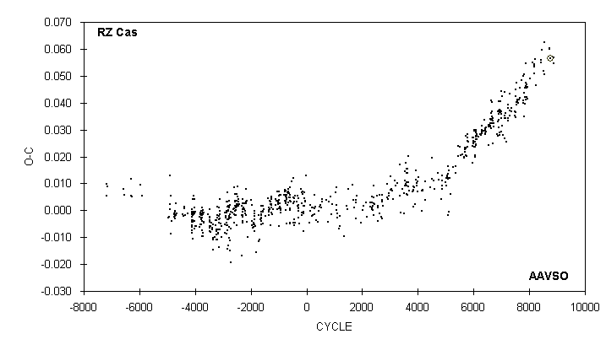

JD(min) STANDARD
HEL. CYCLE O-C N OBSERVER ERROR
2400000 +
53254.780 8412 0.056 26 C. Stephan
53259.560 8416 0.055 20 G. Chaple
53314.546 8462 0.060 16 G. Samolyk
53357.567 8498 0.052 24 G. Chaple
53406.571 8539 0.051 21 G. Chaple
53406.583 8539 0.063 16 G. Samolyk
53621.725 8719 0.060 25 S. Cook (CCD)
53645.630 8739 0.060 23 G. Samolyk
53682.6791 8770 0.0566 60 J. Bialozynski (CCD) 0.0005
53792.640 8862 0.055 17 H. Gerner
53792.642 8862 0.057 22 G. Samolyk

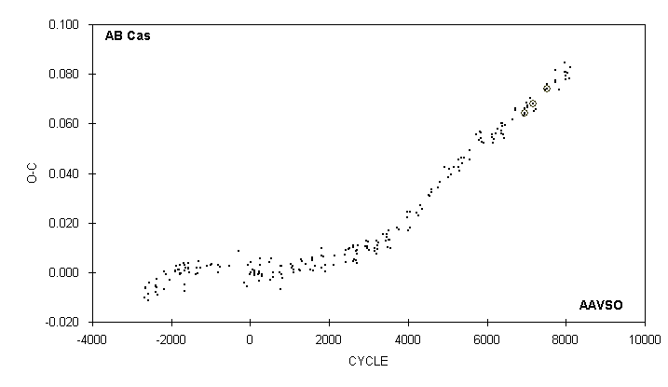

JD(min) STANDARD
HEL. CYCLE O-C N OBSERVER ERROR
2400000 +
52930.551 7474 0.074 12 M. Baldwin
52986.5932 7515 0.0739 37 G. Samolyk (CCD) 0.0001
53001.631 7526 0.076 14 D. Williams
53284.575 7733 0.077 28 G. Chaple
53288.676 7736 0.078 14 D. Williams
53288.680 7736 0.082 11 C. Stephan
53299.610 7744 0.077 24 S. Cook (CCD)
53407.590 7823 0.074 25 G. Chaple
53616.729 7976 0.081 14 D. Williams
53623.567 7981 0.085 16 G. Chaple
53627.664 7984 0.081 32 S. Cook (CCD)
53638.596 7992 0.078 27 G. Chaple
53653.633 8003 0.079 16 R. Hays
53709.676 8044 0.080 15 R. Hays
53761.615 8082 0.078 16 R. Hays
53787.590 8101 0.083 25 G. Chaple

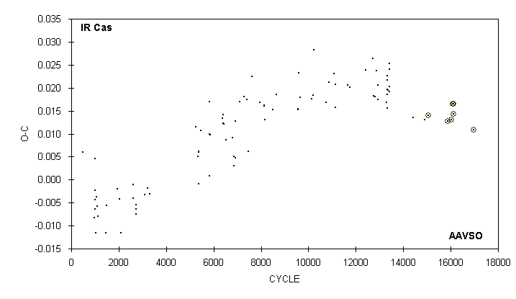

JD(min) STANDARD
HEL. CYCLE O-C N OBSERVER ERROR
2400000 +
52168.660 14404 0.013 11 G. Samolyk
52511.725 14908 0.013 18 M. Simonsen
52603.6184 15043 0.0139 47 S. Dvorak (CCD) 0.0001
53176.7543 15885 0.0127 30 G. Samolyk (CCD) 0.0002
53274.7733 16029 0.0130 40 G. Samolyk (CCD) 0.0001
53315.6179 16089 0.0165 27 S. Brady (CCD) 0.0006
53329.5719 16109.5 0.0164 38 S. Brady (CCD) 0.0005
53345.5658 16133 0.0142 27 S. Brady (CCD) 0.0005
53903.7244 16953 0.0108 97 G. Samolyk (CCD) 0.0002

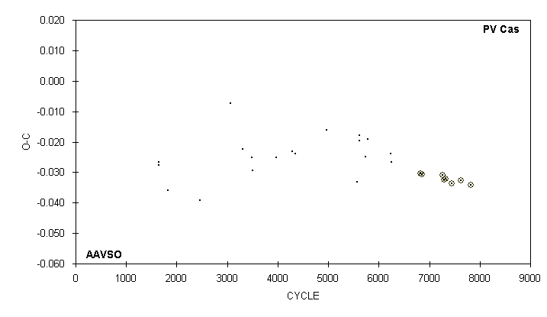

JD(min) STANDARD
HEL. CYCLE O-C N OBSERVER ERROR
2400000 +
51141.560 6235 -0.024 16 G. Samolyk
51162.563 6247 -0.027 20 G. Samolyk
52186.5840 6832 -0.0305 47 S. Dvorak (CCD) 0.0002
52235.5971 6860 -0.0305 76 S. Dvorak (CCD) 0.0002
52951.5389 7269 -0.0309 64 G. Samolyk (CCD) 0.0001
52986.5467 7289 -0.0325 59 J. Bialozynski (CCD) 0.0004
53035.5602 7317 -0.0322 52 J. Bialozynski (CCD) 0.0002
53266.6207 7449 -0.0337 41 G. Samolyk (CCD) 0.0004
53581.7064 7629 -0.0326 110 C. Hesseltine (CCD) 0.0001
53910.7931 7817 -0.0342 61 G. Samolyk (CCD) 0.0002

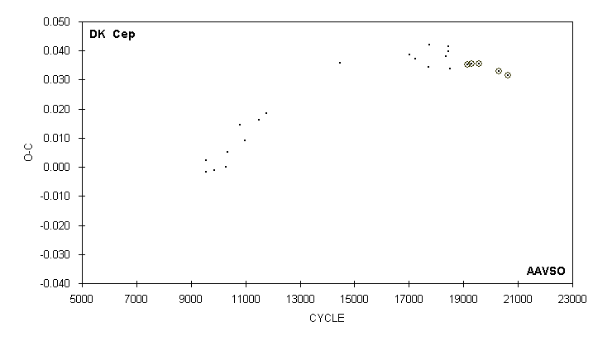

JD(min) STANDARD
HEL. CYCLE O-C N OBSERVER ERROR
2400000 +
51698.744 18367 0.038 22 G. Samolyk
51775.648 18445 0.041 10 G. Samolyk
51777.618 18447 0.040 13 G. Samolyk
51842.682 18513 0.034 11 R. Hill
52468.7340 19148 0.0353 37 G. Samolyk (CCD) 0.0002
52618.5919 19300 0.0354 30 G. Samolyk (CCD) 0.0002
52618.5921 19300 0.0356 42 S. Jamieson (CCD) 0.0002
52899.5755 19585 0.0357 49 G. Samolyk (CCD) 0.0002
53588.7213 20284 0.0329 83 G. Samolyk (CCD) 0.0001
53931.8155 20632 0.0317 50 G. Samolyk (CCD) 0.0001

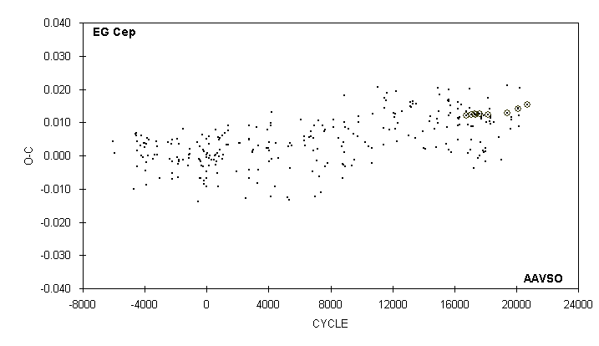

JD(min) STANDARD
HEL. CYCLE O-C N OBSERVER ERROR
2400000 +
53289.674 19638 0.008 18 C. Stephan
53307.650 19671 0.011 26 S. Cook (CCD)
53319.631 19693 0.011 20 S. Cook (CCD)
53553.822 20123 0.014 12 D. Williams
53558.7233 20132 0.0141 86 G. Samolyk (CCD) 0.0001
53565.798 20145 0.009 20 C. Stephan
53570.703 20154 0.012 30 S. Cook (CCD)
53861.5342 20688 0.0153 J. Coloma (CCD) 0.0001

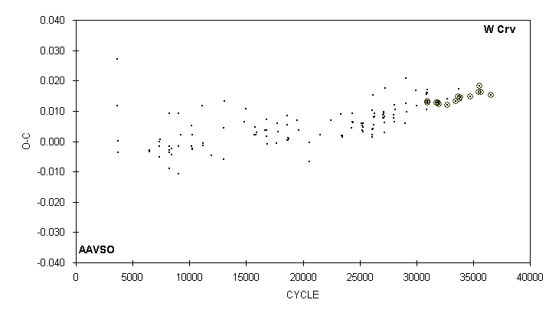

JD(min) STANDARD
HEL. CYCLE O-C N OBSERVER ERROR
2400000 +
52627.9188 33447 0.0133 30 S. Dvorak (CCD) 0.0001
52713.6862 33668 0.0148 33 G. Samolyk (CCD) 0.0003
52734.645 33722 0.017 14 C. Stephan
52762.9716 33795 0.0140 165 N. Butterworth (CCD) 0.0001
52780.6298 33840.5 0.0145 20 R. Poklar (CCD) 0.0004
53119.6186 34714 0.0147 49 G. Samolyk (CCD) 0.0002
53406.8000 35454 0.0163 40 S. Dvorak (CCD) 0.0001
53435.7141 35528.5 0.0183 75 G. Samolyk (CCD) 0.0003
53494.7003 35680.5 0.0162 50 J. Bialozynski (CCD) 0.0006
53834.6582 36556.5 0.0153 62 G. Samolyk (CCD) 0.0002

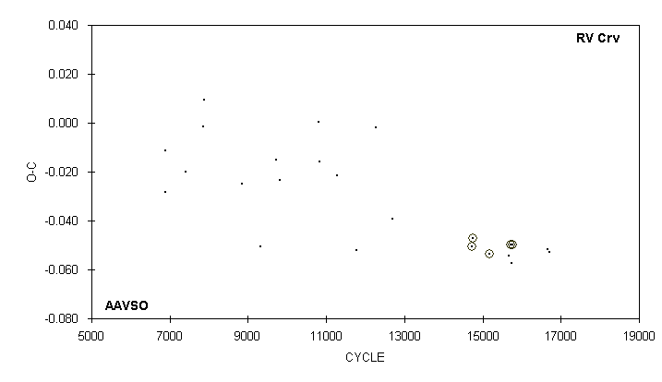

JD(min) STANDARD
HEL. CYCLE O-C N OBSERVER ERROR
2400000 +
52029.6317 14721 -0.0505 46 G. Samolyk (CCD) 0.0006
52048.6898 14746.5 -0.0473 59 G. Samolyk (CCD) 0.0011
52370.7491 15177.5 -0.0536 79 G. Samolyk (CCD) 0.0010
52734.660 15664.5 -0.055 18 C. Stephan
52780.6206 15726 -0.0499 39 G. Samolyk (CCD) 0.0007
52796.679 : 15747.5 -0.057 G. Samolyk (CCD) 0.005
52817.9834 15776 -0.0497 141 N Butterworth (CCD) 0.0002
53479.673 16661.5 -0.052 28 S. Cook (CCD)
53513.672 16707 -0.053 15 S. Cook (CCD)

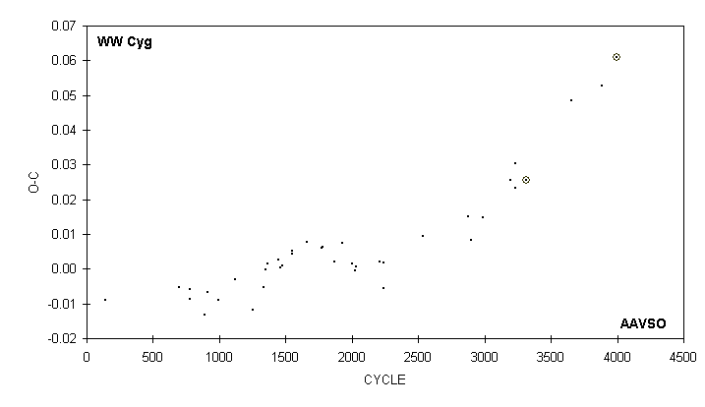

JD(min) STANDARD
HEL. CYCLE O-C N OBSERVER ERROR
2400000 +
49929.758 2879 0.015 14 M. Baldwin
49992.789 2898 0.008 17 R. Hill
50284.759 2986 0.015 17 G. Samolyk
50984.819 : 3197 0.026 19 R. Hill
51097.621 3231 0.023 20 D. Williams
51097.628 3231 0.030 24 G. Samolyk
51369.6802 3313 0.0255 J. A. Howell (CCD) 0.0008
52507.698 3656 0.049 17 M. Simonsen
53270.789 3886 0.053 26 R. Hill
53645.7052 3999 0.0485 66 G. Samolyk (CCD) 0.0001

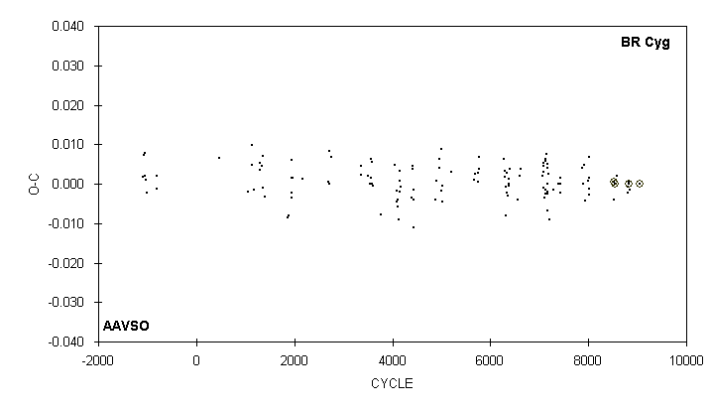

JD(min) STANDARD
HEL. CYCLE O-C N OBSERVER ERROR
2400000 +
52883.580 8513 -0.004 13 C. Stephan
52899.5754 8525 0.0006 46 G. Samolyk (CCD) 0.0002
52931.5563 8549 0.0000 18 B. Manske (CCD) 0.0009
52975.533 8582 0.002 12 R. Hays
53264.695 8799 -0.002 16 S. Cook (CCD)
53284.685 8814 -0.001 14 R. Hays
53288.6835 8817 0.0000 51 G. Samolyk (CCD) 0.0001
53288.684 8817 0.000 10 C. Stephan
53340.652 8856 -0.002 19 S. Cook (CCD)
53589.8430 9043 0.0000 67 G. Samolyk (CCD) 0.0001

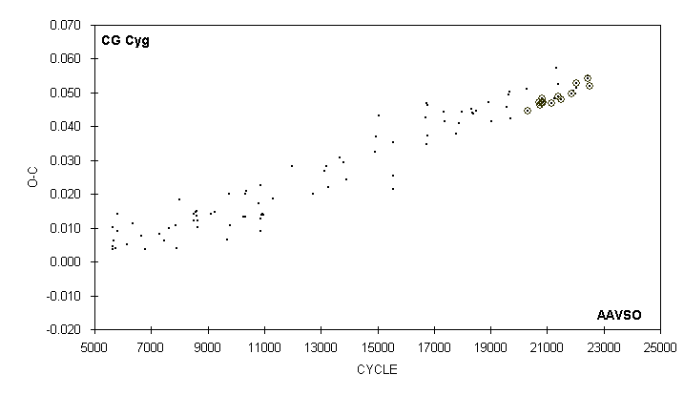

JD(min) STANDARD
HEL. CYCLE O-C N OBSERVER ERROR
2400000 +
52833.761 21245 0.048 11 D. Williams
52883.630 21324 0.057 14 C. Stephan
52931.5884 21400 0.0489 22 S. Dvorak (CCD) 0.0001
52931.592 21400 0.052 13 D. Williams
52986.4968 21487 0.0480 58 S. Dvorak (CCD) 0.0001
53232.6435 21877 0.0497 44 H. Gerner (CCD) 0.0003
53275.562 21945 0.051 14 G. Chaple
53302.700 21988 0.050 22 S. Cook (CCD)
53321.636 22018 0.051 26 S. Cook (CCD)
53335.5224 22040 0.0527 104 S. Dvorak (CCD) 0.0001
53581.6689 22430 0.0542 82 G. Samolyk (CCD) 0.0001
53591.768 22446 0.055 13 C. Stephan
53624.5844 22498 0.0521 38 H. Gerner (CCD) 0.0002

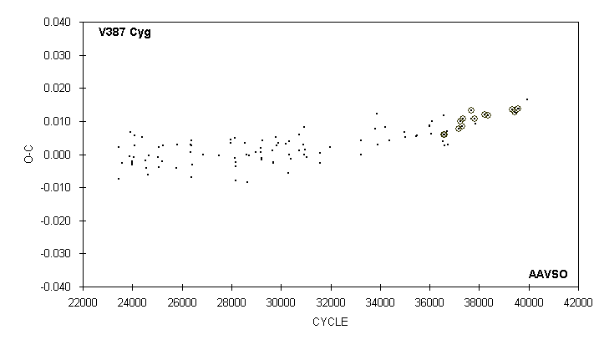

JD(min) STANDARD
HEL. CYCLE O-C N OBSERVER ERROR
2400000 +
52469.7080 38221 0.0120 112 C. Hesseltine (CCD) 0.0001
52562.5943 38366 0.0118 61 G. Samolyk (CCD) 0.0003
53175.6467 39323 0.0135 32 G. Samolyk (CCD) 0.0004
53253.800 39445 0.014 29 C. Stephan
53257.6423 39451 0.0127 26 S. Cook (CCD)
53289.672 39501 0.013 15 C. Stephan
53341.5615 39582 0.0138 51 G. Samolyk (CCD) 0.0001
53348.608 39593 0.014 23 S. Cook (CCD)
53565.773 39932 0.017 15 C. Stephan

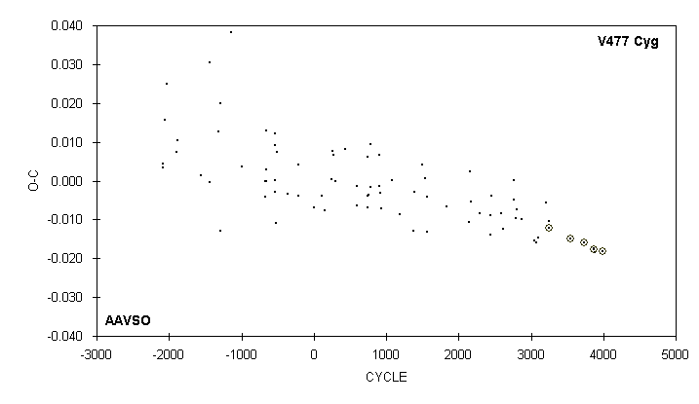

JD(min) STANDARD
HEL. CYCLE O-C N OBSERVER ERROR
2400000 +
51734.833 3215 -0.006 12 D. Williams
51814.6242 3249 -0.0122 J. A. Howell (CCD) 0.0001
51814.626 3249 -0.010 9 R. Berg
52525.7596 3552 -0.0149 66 G. Samolyk (CCD) 0.0002
52950.5638 3733 -0.0160 66 G. Samolyk (CCD) 0.0001
53255.6708 3863 -0.0178 75 J. Bialozynski (CCD) 0.0004
53269.753 3869 -0.018 19 S. Cook (CCD)
53302.610 3883 -0.018 18 S. Cook (CCD)
53553.7383 3990 -0.0181 71 J. Bialozynski (CCD) 0.0003

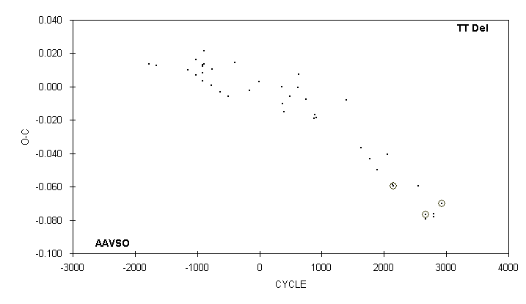

JD(min) STANDARD
HEL. CYCLE O-C N OBSERVER ERROR
2400000 +
50305.643 1767 -0.043 13 M. Baldwin
50661.655 1891 -0.050 10 M. Baldwin
51132.528 2055 -0.041 9 M. Baldwin
51370.813 2138 -0.058 10 D. Williams
51419.621 2155 -0.059 J. A. Howell (CCD) 0.0031
52556.584 2551 -0.060 18 C. Stephan
52881.0034 2664 -0.0766 N. Butterworth (CCD) 0.0003
52909.712 2674 -0.079 14 R. Hill
53265.732 2798 -0.078 14 S. Cook (CCD)
53268.605 2799 -0.076 11 D. Williams
53644.7278 2930 -0.0699 109 C. Hesseltine (CCD) 0.0002

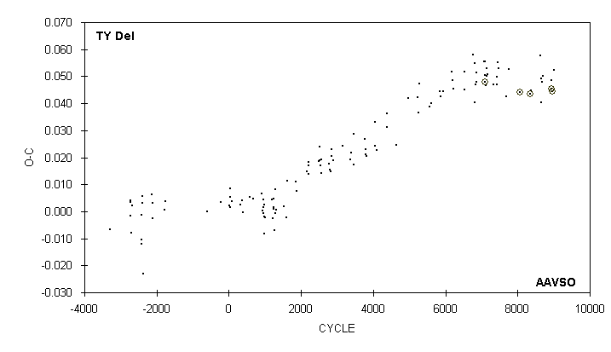

JD(min) STANDARD
HEL. CYCLE O-C N OBSERVER ERROR
2400000 +
52557.5896 8058 0.0441 56 G. Samolyk (CCD) 0.0002
52908.9715 8353 0.0436 N Butterworth (CCD) 0.0001
52931.604 8372 0.045 12 D. Williams
53249.648 8639 0.058 13 R. Hays
53262.733 8650 0.040 23 R. Hill
53274.653 8660 0.049 14 D. Williams
53286.563 8670 0.048 22 G. Chaple
53311.579 8691 0.050 20 G. Chaple
53617.6938 8948 0.0454 44 G. Samolyk (CCD) 0.0001
53617.697 8948 0.049 16 D. Williams
53623.6486 8953 0.0446 34 S. Cook (CCD)
53685.595 9005 0.052 13 R. Hays

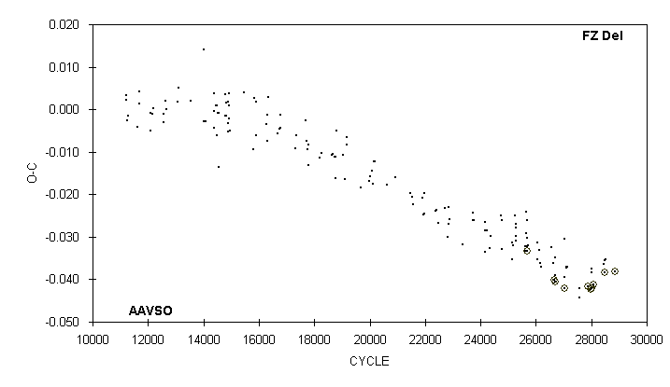

JD(min) STANDARD
HEL. CYCLE O-C N OBSERVER ERROR
2400000 +
52931.554 27588 -0.044 10 D. Williams
52931.556 27588 -0.042 10 M. Baldwin
53168.8700 27891 -0.0416 66 S. Dvorak (CCD) 0.0001
53246.4074 27990 -0.0423 60 R. Papini (CCD) 0.0006
53256.5893 28003 -0.0421 34 G. Samolyk (CCD) 0.0002
53256.594 28003 -0.037 11 R. Hays
53259.726 28007 -0.038 14 D. Williams
53263.6384 28012 -0.0420 38 S. Cook (CCD)
53314.5480 28077 -0.0412 44 G. Samolyk (CCD) 0.0001
53617.656 28464 -0.036 11 D. Williams
53617.656 28464 -0.036 14 R. Hays
53621.573 28469 -0.036 12 G. Chaple
53624.7029 28473 -0.0385 62 H. Gerner (CCD) 0.0001
53653.685 28510 -0.035 19 C. Stephan
53931.7226 28865 -0.0381 48 G. Samolyk (CCD) 0.0001

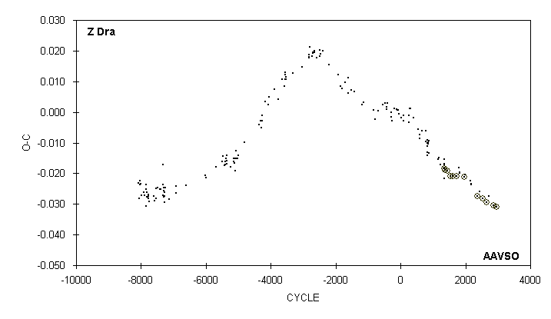

JD(min) STANDARD
HEL. CYCLE O-C N OBSERVER ERROR
2400000 +
52556.537 1998 -0.021 18 G. Chaple
52758.793 2147 -0.022 23 R. Hill
52792.728 2172 -0.023 12 R. Hill
52796.800 2175 -0.024 17 R. Hill
53050.6368 2362 -0.0273 52 G. Samolyk (CCD) 0.0001
53149.731 2435 -0.026 20 R. Hill
53274.6128 2527 -0.0282 65 G. Samolyk (CCD) 0.0001
53445.6484 2653 -0.0295 75 J. Bialozynski (CCD) 0.0001
53540.671 2723 -0.027 14 D. Williams
53722.5643 2857 -0.0305 65 G. Samolyk (CCD) 0.0001
53844.7331 2947 -0.0309 93 R. Poklar (CCD) 0.0001

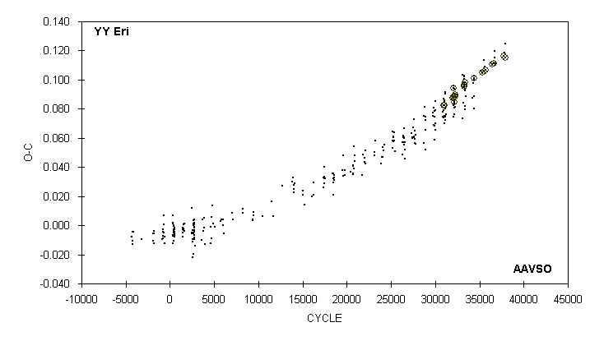

JD(min) STANDARD
HEL. CYCLE O-C N OBSERVER ERROR
2400000 +
53288.7832 36414.5 0.1105 39 G. Samolyk (CCD) 0.0003
53365.6212 36653.5 0.1114 25 C. Norris (CCD) 0.0015
53366.5858 36656.5 0.1115 110 S. Dvorak (CCD) 0.0001
53373.667 36678.5 0.120 15 C. Stephan
53391.666 36734.5 0.115 16 C. Stephan
53414.649 36806 0.111 32 S. Cook (CCD)
53725.6993 37773.5 0.1160 46 R. Poklar (CCD) 0.0002
53758.655 37876 0.119 16 C. Stephan
53761.5449 37885 0.1150 54 G. Samolyk (CCD) 0.0004
53776.665 37932 0.125 16 C. Stephan

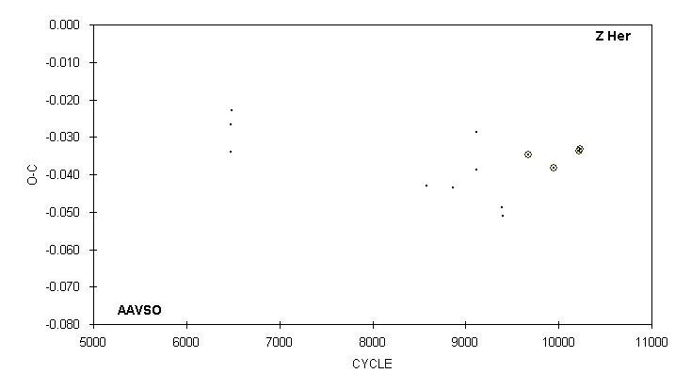

JD(min) STANDARD
HEL. CYCLE O-C N OBSERVER ERROR
2400000 +
47332.603 4) 8577 -0.043 40 G. Samolyk
48486.524 8866 -0.044 9 A. Filho
49480.748 9115 -0.029 25 G. Samolyk
49500.702 9120 -0.039 16 G. Samolyk
50578.750 9390 -0.049 25 G. Samolyk
50634.647 5) 9404 -0.051 13 S. Cook (CCD)
51732.6854 6) 9679 -0.0348 120 G. Samolyk (CCD) 0.0007
52810.7401 9949 -0.0382 52 G. Samolyk (CCD) 0.0008
53884.8099 10218 -0.0337 110 G. Samolyk (CCD) 0.0003
53932.7240 10230 -0.0333 81 G. Samolyk (CCD) 0.0002

4) Observations combined From 47276 to 47391
5) Observations combined from 50602 to 50666
6) Observations combined from 51720 to 51748

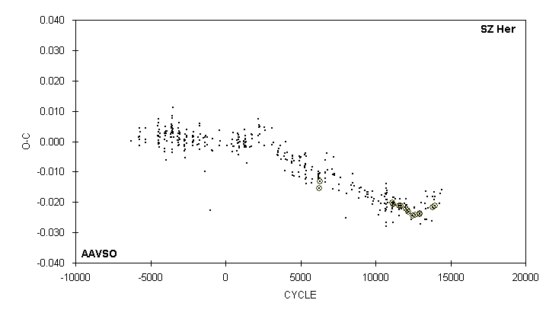

JD(min)
HEL. CYCLE O-C N OBSERVER
2400000 +
53109.858 13746 -0.026 13 R. Hays
53200.671 13857 -0.022 13 R. Hays
53259.577 13929 -0.019 20 G. Chaple
53263.670 13934 -0.017 10 R. Hill
53268.577 13940 -0.018 13 D. Williams
53272.6644 13945 -0.0213 49 S. Cook (CCD)
53528.730 14258 -0.020 13 R. Hays
53560.639 14297 -0.017 11 D. Williams
53673.538 14435 -0.016 11 R. Hays

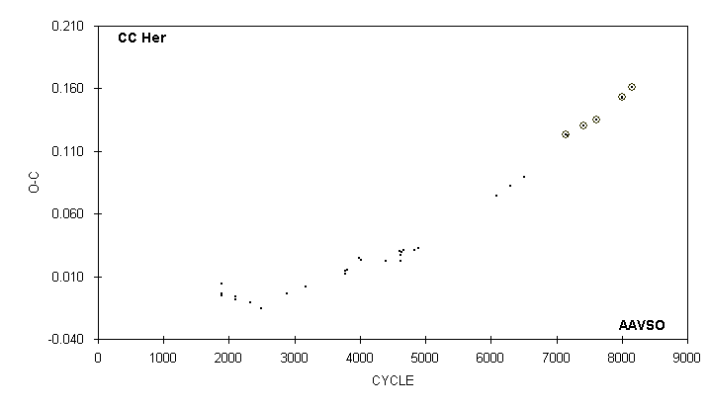

JD(min) STANDARD
HEL. CYCLE O-C N OBSERVER ERROR
2400000 +
50578.789 6292 0.083 21 G. Samolyk
50963.745 6514 0.089 22 G. Samolyk
52059.6706 7146 0.1232 68 G. Samolyk (CCD) 0.0001
52104.754 7172 0.122 17 G. Samolyk
52529.5934 7417 0.1304 39 G. Samolyk (CCD) 0.0001
52874.6654 7616 0.1352 88 C. Hesseltine (CCD) 0.0001
53545.7433 8003 0.1529 65 J. Bialozynski (CCD) 0.0001
53552.679 8007 0.153 28 S. Cook (CCD)
53798.9162 8149 0.1609 65 G. Samolyk (CCD) 0.0001

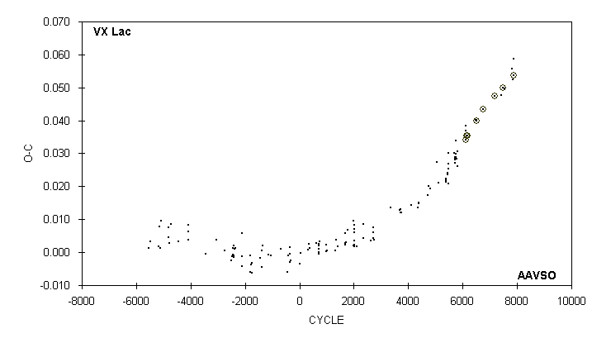

JD(min) STANDARD
HEL. CYCLE O-C N OBSERVER ERROR
2400000 +
52529.6117 6767 0.0434 55 G. Samolyk (CCD) 0.0003
52975.5307 7182 0.0474 32 G. Samolyk (CCD) 0.0002
53238.782 7427 0.048 14 R. Hays
53281.7641 7467 0.0499 56 G. Samolyk (CCD) 0.0001
53351.606 7532 0.050 32 S. Cook (CCD)
53640.651 7801 0.056 13 R. Hays
53682.553 7840 0.052 13 R. Hays
53711.5656 7867 0.0537 71 G. Samolyk (CCD) 0.0002
53725.539 7880 0.059 13 R. Hays

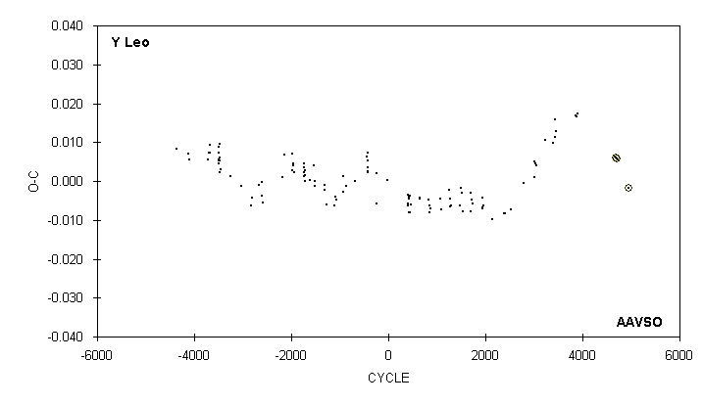

JD(min) STANDARD
HEL. CYCLE O-C N OBSERVER ERROR
2400000 +
51231.595 3437 0.011 11 M. Baldwin
51273.749 3462 0.013 16 M. Baldwin
51951.566 3864 0.017 14 G. Samolyk
51988.660 3886 0.017 16 R. Hill
51993.719 3889 0.017 14 D. Williams
53335.8450 4685 0.0061 175 S. Dvorak (CCD) 0.0001
53367.8805 4704 0.0057 92 S. Dvorak (CCD) 0.0001
53792.7707 4956 -0.0018 116 G. Samolyk (CCD) 0.0001

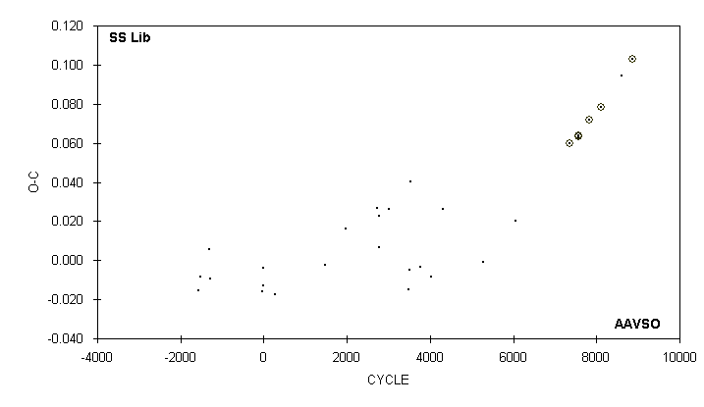

JD(min) STANDARD
HEL. CYCLE O-C N OBSERVER ERROR
2400000 +
51720.6931 7347 0.0596 J. A. Howell (CCD) 0.0003
52042.808 7571 0.063 18 D. Williams
52042.8089 7571 0.0638 112 G. Samolyk (CCD) 0.0003
52045.6844 7573 0.0633 J. A. Howell (CCD) 0.0004
52426.7623 7838 0.0716 94 G. Samolyk (CCD) 0.0002
52810.7147 8105 0.0785 59 G. Samolyk (CCD) 0.0004
53529.730 8605 0.095 12 S. Cook (CCD)
53890.676 8856 0.1031 108 G. Samolyk (CCD) 0.0002

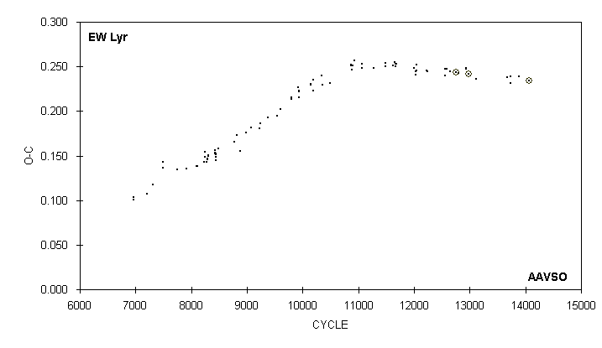

JD(min) STANDARD
HEL. CYCLE O-C N OBSERVER ERROR
2400000 +
51363.6975 12759 0.2437 J. A. Howell (CCD) 0.0009
51439.697 12798 0.243 16 M. Baldwin
51706.676 12935 0.247 24 P. Guilbault
51706.677 12935 0.248 24 T. Hager
51784.6192 12975 0.2413 J. A. Howell (CCD) 0.0002
52045.743 13109 0.236 12 R. Hill
53148.722 13675 0.238 17 R. Hill
53263.690 13734 0.231 11 R. Hill
53267.595 13736 0.239 12 D. Williams
53567.698 13890 0.239 22 S. Cook (CCD)
53910.6686 14066 0.2339 70 G. Samolyk (CCD) 0.0001

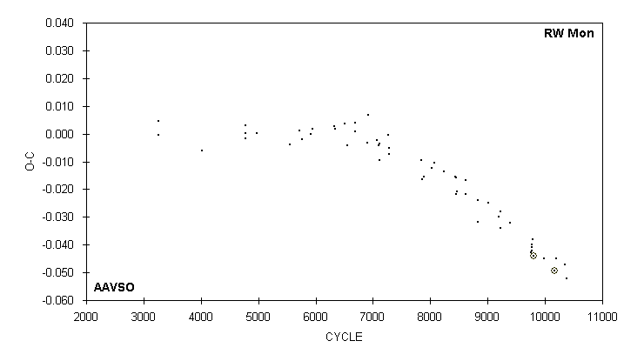

JD(min) STANDARD
HEL. CYCLE O-C N OBSERVER ERROR
2400000 +
52287.696 9762 -0.043 21 G. Samolyk
52310.570 9774 -0.042 18 C. Stephan
52310.571 9774 -0.041 15 R. Hays
52310.572 : 9774 -0.040 11 M. Baldwin
52329.635 9784 -0.038 11 D. Williams
52371.5629 9806 -0.0441 42 S. Dvorak (CCD) 0.0001
52695.598 9976 -0.045 16 R. Hays
53061.5638 10168 -0.0493 56 G. Samolyk (CCD) 0.0001
53101.596 10189 -0.045 12 R. Hays
53406.569 10349 -0.047 16 R. Hays
53465.653 10380 -0.052 13 R. Hays

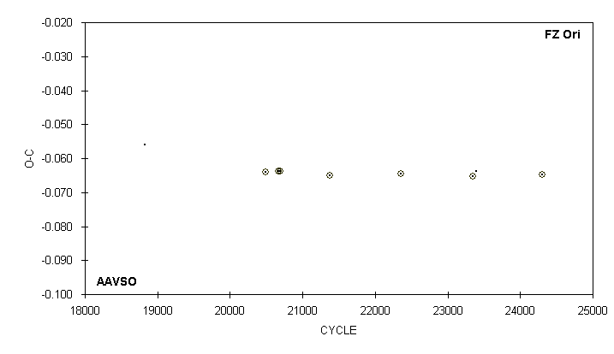

JD(min) STANDARD
HEL. CYCLE O-C N OBSERVER ERROR
2400000 +
51554.550 18826 -0.056 12 S. Cook (CCD)
52220.7196 20491.5 -0.0641 66 S. Dvorak (CCD) 0.0002
52291.5176 20668.5 -0.0637 33 S. Dvorak (CCD) 0.0002
52299.5172 20688.5 -0.0639 29 S. Dvorak (CCD) 0.0003
52575.9068 21379.5 -0.0650 17 S. Dvorak (CCD) 0.0006
52965.8942 22354.5 -0.0645 23 S. Dvorak (CCD) 0.0005
53363.6802 23349 -0.0652 53 G. Samolyk (CCD) 0.0004
53381.681 23394 -0.064 10 S. Cook (CCD)
53745.6679 24304 -0.0647 73 R. Poklar (CCD) 0.0002

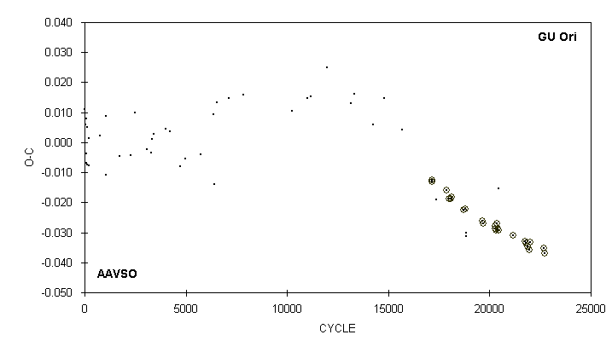

JD(min) STANDARD
HEL. CYCLE O-C N OBSERVER ERROR
2400000 +
52694.608 20448.5 -0.015 19 C. Stephan
53035.6009 21173 -0.0309 92 G. Samolyk (CCD) 0.0004
53314.9481 21766.5 -0.0329 40 G. Samolyk (CCD) 0.0005
53323.8904 21785.5 -0.0335 76 G. Samolyk (CCD) 0.0005
53368.6039 21880.5 -0.0347 14 S. Dvorak (CCD) 0.0004
53413.7883 21976.5 -0.0357 67 G. Samolyk (CCD) 0.0004
53435.6774 22023 -0.0333 89 G. Samolyk (CCD) 0.0005
53735.7347 22660.5 -0.0351 63 R. Poklar (CCD) 0.0004
53763.7384 22720 -0.0369 86 G. Samolyk (CCD) 0.0003

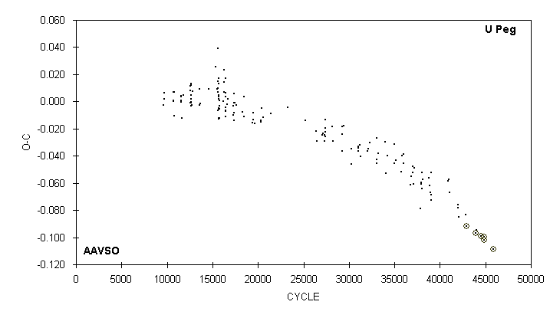

JD(min) STANDARD
HEL. CYCLE O-C N OBSERVER ERROR
2400000 +
52568.721 42844 -0.083 6 G. Sarty
52585.5777 42889 -0.0917 50 J. A. Howell (CCD) 0.0001
52968.5993 43911 -0.0967 52 J. Bialozynski (CCD) 0.0003
52998.584 43991 -0.095 16 G. Samolyk
53197.7758 44522.5 -0.0990 33 B. Manske (CCD) 0.0002
53314.7069 44834.5 -0.0998 70 G. Samolyk (CCD) 0.0002
53315.6414 44837 -0.1022 37 S. Dvorak (CCD) 0.0003
53709.5302 45888 -0.1087 65 G. Samolyk (CCD) 0.0002

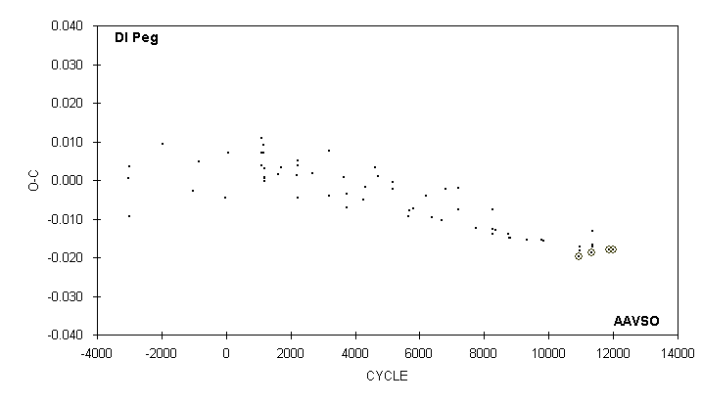

JD(min) STANDARD
HEL. CYCLE O-C N OBSERVER ERROR
2400000 +
52986.5913 10944 -0.0198 47 S. Dvorak (CCD) 0.0001
52993.711 10954 -0.018 15 G. Samolyk
53001.542 10965 -0.017 13 D. Williams
53267.7599 11339 -0.0188 28 G. Samolyk (CCD) 0.0001
53285.557 11364 -0.017 15 G. Chaple
53290.540 11371 -0.017 15 G. Chaple
53292.679 11374 -0.013 12 C. Stephan
53645.7354 11870 -0.0180 52 G. Samolyk (CCD) 0.0001
53728.3061 11986 -0.0181 66 J. Coloma (CCD) 0.0001

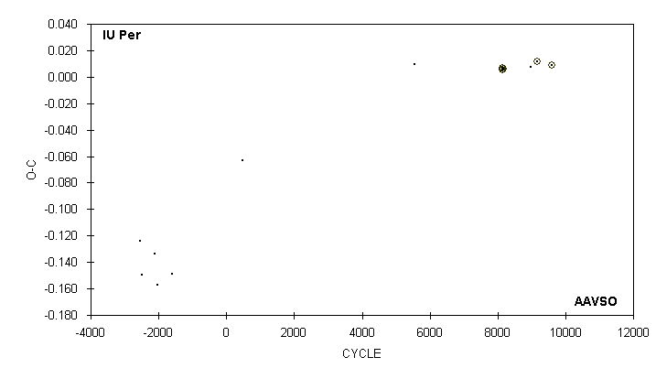

JD(min) STANDARD
HEL. CYCLE O-C N OBSERVER ERROR
2400000 +
43420.756 -2556 -0.124 7 G. Samolyk
43469.581 -2499 -0.149 9 G. Samolyk
43798.694 -2115 -0.134 11 G. Samolyk
43876.660 -2024 -0.157 11 G. Samolyk
44236.619 -1604 -0.149 11 G. Samolyk
46028.744 487 -0.063 17 G. Samolyk
50369.649 5552 0.010 12 S. Cook (CCD)
52586.7698 7) 8139 0.0065 35 S. Dvorak (CCD) 0.0002
52591.9106 8145 0.0052 T. Shoup (CCD) 0.0003
52611.6230 8168 0.0060 76 J. A. Howell (CCD) 0.0001
53312.671 8986 0.007 27 S. Cook (CCD)
53456.6554 9154 0.0116 85 C. Hesseltine (CCD) 0.0005
53834.6009 9595 0.0091 59 C. Hesseltine (CCD) 0.0003

7) Observations combined from 52586 and 52611

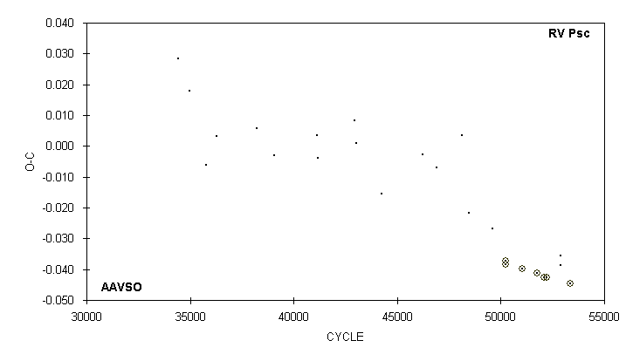

JD(min) STANDARD
HEL. CYCLE O-C N OBSERVER ERROR
2400000 +
51870.509 49620 -0.027 10 G. Samolyk
52204.5542 50223 -0.0384 52 G. Samolyk (CCD) 0.0005
52220.6211 50252 -0.0372 33 S. Dvorak (CCD) 0.0002
52645.5301 51019 -0.0397 45 S. Dvorak (CCD) 0.0002
53061.5762 51770 -0.0412 40 G. Samolyk (CCD) 0.0004
53238.8520 52090 -0.0426 47 G. Samolyk (CCD) 0.0002
53303.6691 52207 -0.0425 38 J. Bialozynski (CCD) 0.0004
53683.711 52893 -0.039 16 C. Stephan
53693.686 52911 -0.036 17 C. Stephan
53945.7430 53366 -0.0447 40 G. Samolyk (CCD) 0.0003

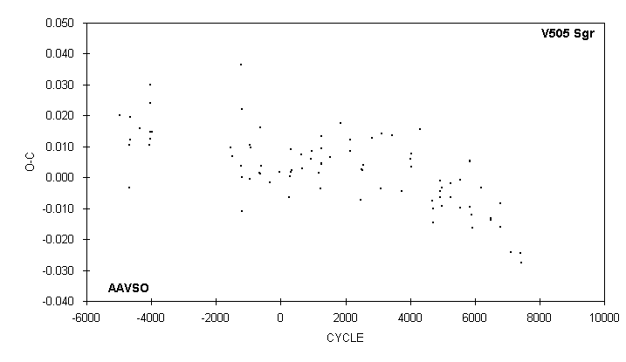

JD(min)
HEL. CYCLE O-C N OBSERVER
2400000 +
51777.648 6185 -0.003 14 G. Samolyk
52133.682 6486 -0.014 14 D. Williams
52146.694 6497 -0.013 18 G. Samolyk
52489.724 6787 -0.016 18 G. Samolyk
52495.646 6792 -0.008 14 G. Samolyk
52883.612 7120 -0.024 16 C. Stephan
53239.656 7421 -0.025 19 G. Samolyk
53265.676 7443 -0.028 18 G. Samolyk

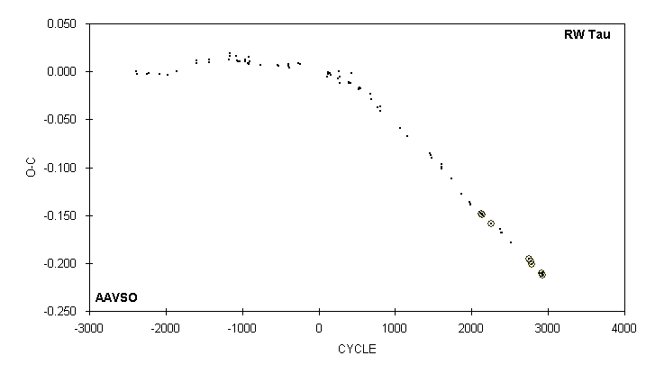

JD(min) STANDARD
HEL. CYCLE O-C N OBSERVER ERROR
2400000 +
51930.5387 2256 -0.1584 75 G. Samolyk (CCD) 0.0001
52265.562 2377 -0.164 17 C. Stephan
52287.709 2385 -0.168 22 G. Samolyk
52312.628 2394 -0.168 27 G. Samolyk
52636.572 2511 -0.178 20 G. Chaple
53314.9196 2756 -0.1953 82 G. Samolyk (CCD) 0.0003
53353.6804 2770 -0.1982 40 S. Cook (CCD)
53414.5923 2792 -0.2007 63 J. Bialozynski (CCD) 0.0003
53699.773 2895 -0.210 22 R. Hays
53741.3048 2910 -0.2108 20 R. Papini (CCD) 0.0003
53774.531 2922 -0.211 20 G. Chaple
53785.604 2926 -0.213 22 R. Hays
53785.6047 2926 -0.2123 80 G. Samolyk (CCD) 0.0001

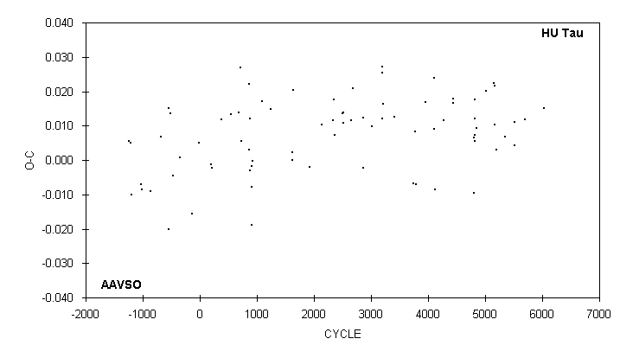

JD(min)
HEL. CYCLE O-C N OBSERVER
2400000 +
51867.344 5151 0.022 9 S. Foglia
51902.289 5168 0.010 12 S. Foglia
51912.582 5173 0.022 22 G. Samolyk
51951.633 5192 0.003 22 G. Samolyk
52268.307 5346 0.007 10 S. Foglia
52609.657 5512 0.011 20 G. Samolyk
52615.819 5515 0.004 19 G. Samolyk
52975.679 5690 0.012 24 G. Samolyk
53672.768 6029 0.015 25 G. Samolyk

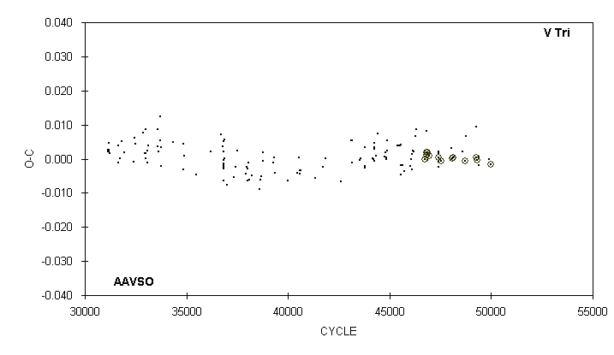

JD(min) STANDARD
HEL. CYCLE O-C N OBSERVER ERROR
2400000 +
52900.674 48575 0.002 14 M. Baldwin
52986.6965 48722 -0.0006 46 G. Samolyk (CCD) 0.0002
53001.334 48747 0.007 8 M. Csukas
53315.5830 49284 0.0003 50 G. Samolyk (CCD) 0.0001
53315.592 49284 0.009 24 G. Chaple
53339.5759 49325 -0.0003 79 S. Dvorak (CCD) 0.0001
53374.689 49385 0.001 19 C. Stephan
53384.635 49402 -0.002 16 S. Cook (CCD)
53683.677 49913 0.000 17 C. Stephan
53714.6914 49966 -0.0016 40 G. Samolyk (CCD) 0.0003

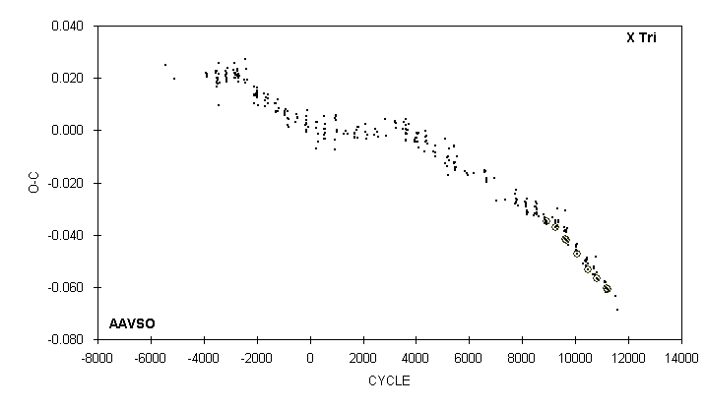

JD(min) STANDARD
HEL. CYCLE O-C N OBSERVER ERROR
2400000 +
52675.615 10471 -0.051 11 R. Hays
53288.647 11102 -0.058 12 D. Williams
53289.618 11103 -0.058 12 R. Hays
53323.622 11138 -0.058 24 G. Samolyk
53324.591 11139 -0.061 24 G. Chaple
53330.419 11145 -0.062 35 I. Megson
53357.6232 11173 -0.0606 C. Haza (CCD) 0.0001
53359.5663 11175 -0.0606 C. Haza (CCD) 0.0001
53392.597 11209 -0.062 36 S. Cook (CCD)
53393.5696 11210 -0.0610 52 G. Samolyk (CCD) 0.0001
53696.686 11522 -0.064 14 R. Hays
53767.603 11595 -0.069 14 R. Hays

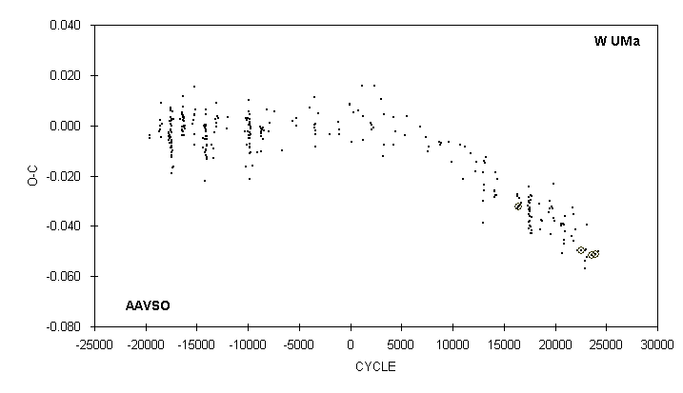

JD(min) STANDARD
HEL. CYCLE O-C N OBSERVER ERROR
2400000 +
53304.8951 22597 -0.0498 88 S. Dvorak (CCD) 0.0001
53411.652 22917 -0.057 11 S. Cook (CCD)
53414.491 22925.5 -0.054 11 S. Cook (CCD)
53417.331 22934 -0.050 35 I. Megson
53451.696 23037 -0.049 27 S. Cook (CCD)
53463.717 23073 -0.039 15 D. Williams
53472.712 23100 -0.053 24 S. Cook (CCD)
53645.8709 23619 -0.0515 30 G. Samolyk (CCD) 0.0003
53753.6362 23942 -0.0511 46 R. Poklar (CCD) 0.0006
53847.723 24224 -0.050 16 C. Stephan

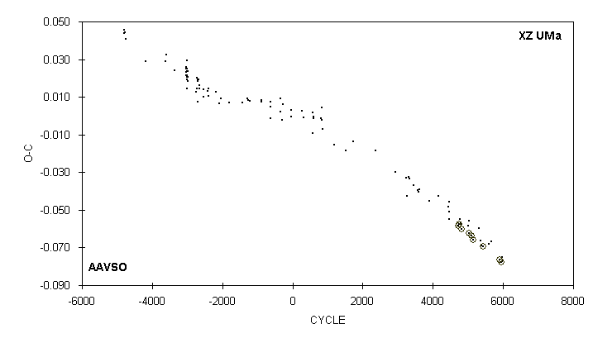

JD(min) STANDARD
HEL. CYCLE O-C N OBSERVER ERROR
2400000 +
52723.662 5363 -0.066 18 C. Stephan
52756.662 5390 -0.069 13 D. Williams
53002.349 5591 -0.068 14 J. Virtanen
53080.579 5655 -0.067 18 G. Chaple
53394.7053 5912 -0.0765 191 S. Dvorak (CCD) 0.0001
53421.595 5934 -0.078 19 G. Chaple
53432.5961 5943 -0.0777 62 G. Samolyk (CCD) 0.0002
53460.710 5966 -0.077 26 S. Cook (CCD)
53471.713 : 5975 -0.075 15 R. Hill

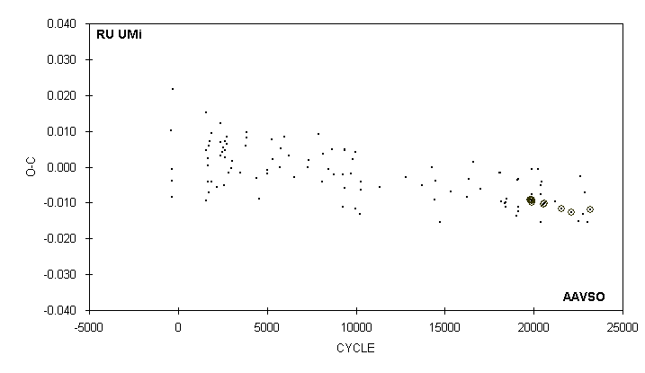

JD(min) STANDARD
HEL. CYCLE O-C N OBSERVER ERROR
2400000 +
52723.712 21198 -0.010 15 C. Stephan
52920.5572 21573 -0.0118 50 G. Samolyk (CCD) 0.0002
53195.6176 22097 -0.0127 32 G. Samolyk (CCD) 0.0003
53430.782 22545 -0.015 15 S. Cook (CCD)
53463.865 22608 -0.003 13 D. Williams
53544.693 22762 -0.013 39 S. Cook (CCD)
53616.614 22899 -0.007 20 G. Chaple
53691.670 23042 -0.016 14 C. Stephan
53765.6883 23183 -0.0118 86 R. Poklar (CCD) 0.0002

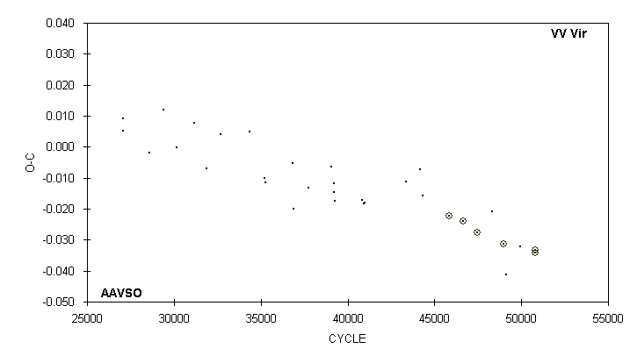

JD(min) STANDARD
HEL. CYCLE O-C N OBSERVER ERROR
2400000 +
50572.792 43376 -0.011 18 G. Samolyk
50921.674 44158 -0.007 15 G. Samolyk
50991.709 44315 -0.016 11 R. Hill
51679.6436 45857 -0.0224 31 G. Samolyk (CCD) 0.0003
52042.7965 46671 -0.0240 43 G. Samolyk (CCD) 0.0002
52398.8091 47469 -0.0278 36 G. Samolyk (CCD) 0.0002
52779.816 48323 -0.021 26 R. Hill
53077.8242 48991 -0.0313 42 G. Samolyk (CCD) 0.0002
53148.750 49150 -0.041 17 R. Hill
53500.760 49939 -0.032 16 R. Hill
53882.6510 50795 -0.0334 65 G. Samolyk (CCD) 0.0003
53890.6806 50813 -0.0343 50 C. Hesseltine (CCD) 0.0002

