OBSERVED MINIMA TIMINGS
OF ECLIPSING BINARIES

NUMBER 10

Prepared by:

Marvin E. Baldwin
Chairman, AAVSO
Eclipsing Binary
Committee

Gerard Samolyk
AAVSO Eclipsing
Binary Committee

October 2005

Funds for publication were provided by
The Harold S. Martin Fund.

ISBN 1-878174-69-X

COPYRIGHT 2005
The American Association of Variable Star Observers
25 Birch Street
Cambridge, MA 02138
USA

All rights reserved. No part of this book may be reproduced by any mechanical, photographic, or electronic process, nor may it be stored on an information retrieval system, transmitted, or otherwise copied for public or private use, without the written permission of the American Association of Variable Star Observers.

TABLE OF CONTENTS

Introduction v

Errata to Earlier Numbers vi

References vii

Table 1. Publications Containing Previous AAVSO Minima for Each Star in this Monograph viii

Table 2. Information on O-C Minima and Linear Elements ix

Table 3. Observers Contributing to this Monograph x

Compilation of Times of Minima and O-C Diagrams 1

INTRODUCTION

This compilation contains 660 minima timings of 50 eclipsing binary stars. It represents a portion of the stars observed by participants in the AAVSO's eclipsing binary program since 1976, and continues the listing of minima published in Observed Minima Timings of Eclipsing Binaries Nos. 1 through 9. Except where otherwise specified, all minima are determined from visual observations reduced by the authors using a computerized tracing paper method. Ron Baldwin and Gerard Samolyk wrote the tracing paper software specifically for this purpose.

Most CCD observations were reduced by the observers using the method of Kwee and Van Worden (1957). The standard error is included in each of these cases.

In instances where fragments of eclipses are observed during different cycles, the data points are reduced to heliocentric phase and combined into a single light curve for the tracing paper process. In these cases, the listed time of minimum is the eclipse nearest to the midpoint of the observing interval that corresponds to the calculated phase of minimum light. A footnote is added to these listings indicating the observing interval in JD.

With the exception of V1315 Aql, DV Cep, and EF Ori, the linear elements in the 1985 General Catalogue of Variable Stars (Kohlopov et al. 1985) (GCVS) were used to compute the O-C values.

In the case of V1315 Aql, no period has been established in the 1985 GCVS. Lewis Cook observed this star intensely for two months to obtain the times of minima listed in this document. The following light elements have been calculated for this star by applying a linear regression to these observed times of minima.

JDmin = 2453199.9643 + 0.1396907 E

No linear elements for DV Cep are listed in the 1985 GCVS. For this publication the linear elements by Frank and Lichtenknecker (1987) are used.

It has been determined that the period listed in the 1985 GCVS for EF Ori (3.7012d) is not valid. The light elements used in this publication were calculated using the observed times of primary minima listed in this publication.

JDmin = 2452350.592 + 1.6194474 E

All elements used in this publication are listed in Table 2. The number of observations used for determination of each time of minimum is given under N. This work is sponsored by the AAVSO, with Marvin Baldwin acting as program coordinator.

The O-C diagrams accompanying the minima listings represent not only the minima tabulated here but also all previously published minima associated with the AAVSO program. Times of minimum obtained electronically that have four-place accuracy are circled on the O-C diagrams. The years spanned by these diagrams are listed by star in Table 2, with the second column giving the year of the earliest observation appearing in the diagram and the third and fourth columns listing the earliest and latest year of the minima tabulated in this publication.

The material in this monograph may be accessed electronically via the AAVSO web site home page (http://www.aavso.org) or the AAVSO ftp site (ftp://ftp.aavso.org/monographs/eb/).

Observers contributing data used in this publication are listed in Table 3. Their dedicated efforts are greatly appreciated.

Marvin E. Baldwin Gerard Samolyk
8655 N Co. Rd. 775E 9504 W Barnard Ave.
Butlerville, IN 47223 Greenfield, WI 53228
USA USA

ERRATA

In Observed Minima Timings of Eclipsing Binaries, Number 8, page ii:
IBVS number should read 1-878174-67-3

In Observed Minima Timings of Eclipsing Binaries, Number 9, page ii:
IBVS number should read 1-878174-68-1

REFERENCES

1 Ashbrook, J. 1964, Sky & Telescope, 27, 5, 317.
2 Ashbrook, J. 1965, Sky & Telescope, 29, 4, 254.
3 Robinson, L. J. 1965, Inf. Bull. Var. Stars, No. 111.
4 Robinson, L. J. 1965, Inf. Bull. Var. Stars, No. 114.
5 Robinson, L. J. 1965, Inf. Bull. Var. Stars, No. 119.
6 Robinson, L. J. 1966, Inf. Bull. Var. Stars, No. 129.
7 Robinson, L. J. 1966, Inf. Bull. Var. Stars, No. 154.
8 Robinson, L. J. 1967, Inf. Bull. Var. Stars, No. 180.
9 Robinson, L. J. 1967, Inf. Bull. Var. Stars, No. 221.
10 Robinson, L. J., and Ashbrook, J. 1968, Inf. Bull. Var. Stars, No. 247.
11 Baldwin, M. E. 1973, Inf. Bull. Var. Stars, No. 795.
12 Baldwin, M. E. 1974, J. Amer. Assoc. Var. Star Obs., 3, 60.
13 Baldwin, M. E. 1975, J. Amer. Assoc. Var. Star Obs., 4, 86.
14 Baldwin, M. E. 1976, J. Amer. Assoc. Var. Star Obs., 5, 29.
15 Baldwin, M. E. 1976, J. Amer. Assoc. Var. Star Obs., 5, 84.
16 Baldwin, M. E. 1977, J. Amer. Assoc. Var. Star Obs., 6, 24.
17 Baldwin, M. E. 1978, J. Amer. Assoc. Var. Star Obs., 7, 28.
18 Samolyk, G. 1992, J. Amer. Assoc. Var. Star Obs., 21, 34.
19 Samolyk, G. 1992, J. Amer. Assoc. Var. Star Obs., 21, 111.
20 Baldwin, M. E., and Samolyk, G. 1993, Observed Minima Timings of Eclipsing Binaries No. 1,
AAVSO, Cambridge, MA.
21 Baldwin, M. E., and Samolyk, G. 1995, Observed Minima Timings of Eclipsing Binaries No. 2,
AAVSO, Cambridge, MA.
22 Baldwin, M. E., and Samolyk, G. 1996, Observed Minima Timings of Eclipsing Binaries No. 3,
AAVSO, Cambridge, MA.
23 Baldwin, M. E., and Samolyk, G. 1997, Observed Minima Timings of Eclipsing Binaries No. 4,
AAVSO, Cambridge, MA.
24 Baldwin, M. E., and Samolyk, G. 1999, Observed Minima Timings of Eclipsing Binaries No. 5,
AAVSO, Cambridge, MA.
25 Baldwin, M. E., and Samolyk, G. 2000, Observed Minima Timings of Eclipsing Binaries No. 6,
AAVSO, Cambridge, MA.
26 Baldwin, M. E., and Samolyk, G. 2002, Observed Minima Timings of Eclipsing Binaries No. 7,
AAVSO, Cambridge, MA.
27 Baldwin, M. E., and Samolyk, G. 2003, Observed Minima Timings of Eclipsing Binaries No. 8,
AAVSO, Cambridge, MA.
28 Frank, P., and Lichtenknecker, D. 1987, BAV Mitt. #47.
29 Kholopov, P. N., et al. 1985, General Catalogue of Variable Stars, Fourth Edition, Moscow.
30 Kwee K. K., and Van Worden, H. 1957, Bull. Astron. Inst. Netherlands, 12, 327.

TABLE 1

1 2 3 4 5 6 7 8 9 10 11 12 13 14 15 16 17 18 19 20 21 22 23 24 25 26 27
AB And X X X X X X X X X X X X X X X X
RY Aqr X X X X X X
CX Aqr X X X X X X X X X X X X X X
V343 Aql X X
V1315 Aql
SS Ari X X X
TT Aur X X
Y Cam X X X X X X X X X X
AL Cam X X X X X X X X
AM CMi
CW Cas X X X
IV Cas X X X X
V364 Cas X
U Cep X X X X X X X X X X X X X
DV Cep X
TW Cet X
RW Com X X X X
RZ Com X X X X
CC Com X X X
U CrB X X X X X X
V Crt X X
KV Cyg
V456 Cyg X
V1034 Cyg
BH Dra X X
TX Gem X
WW Gem
UX Her X X X X
SW Lac X X X X X X X X X X X X X X X X X X X
AW Lac
V508 Oph
V839 Oph
EF Ori
ET Ori X
Z Per X X X
RT Per X X X X X X X X X X X X X X X X
BETA Per X X X X X X X X X X X X X X X
RZ Tau X X
WY Tau X
AM Tau
EQ Tau X X X X
TY UMa X X X
UX UMa X X X
VV UMa X X X X X X X X X
AF UMa
BH Vir X
BE Vul X
BS Vul X X
BU Vul X X X X X X X X X X X X X
CD Vul X

This table identifies publications in which previous AAVSO minima for each star have been published. The numbers across the top of the table correspond to those given at the beginning of each entry in the References.

TABLE 2

Earliest Earliest Latest Epoch Period
Minimum Listing Listing 2400000 + (Days)
AB And 1966 2002 2005 36109.57928 0.33189215
RY Aqr 1969 1991 2004 40824.414 1.966594
CX Aqr 1964 2002 2005 36453.555 0.5559862
V343 Aql 1968 1995 2005 28443.417 1.844603
V1315 Aql 2004 2004 2004 53199.9643 0.1396907
SS Ari 1976 2002 2004 39028.395 0.4059936
TT Aur 1974 2000 2004 21242.25640 1.332735
Y Cam 1965 1996 2005 42961.92757 3.3056244
AL Cam 1966 1996 2005 26411.523 1.32833335
AM CMi 1976 1976 2005 25244.653 1.019186
CW Cas 1977 2003 2005 41649.40322 0.3188449
IV Cas 1968 1999 2005 40854.597 0.9985245
V364 Cas 1977 1998 2005 34333.298 1.543068
U Cep 1964 2002 2005 44541.6031 2.4930475
DV Cep 1977 1998 2005 46763.353 1.1619748
TW Cet 1997 2002 2004 42373.378 0.3168519
RW Com 1974 2002 2005 40022.4163 0.2373459
RZ Com 1969 2002 2005 34837.4198 0.33850604
CC Com 1977 2002 2005 39533.583 0.22068628
U CrB 1965 1995 2005 16747.9718 3.45220133
V Crt 1974 1996 2005 41397.3323 0.7020361
KV Cyg 1977 1977 2005 29468.389 2.8389936
V456 Cyg 1976 1998 2005 44911.3530 0.8911922
V1034 Cyg 1977 1977 2005 42938.459 0.976931
BH Dra 1975 1997 2005 40019.7982 1.81723857
TX Gem 1975 1979 2005 19848.412 2.800014
WW Gem 1977 1977 2005 25984.257 1.237811
UX Her 1967 1996 2005 39672.37853 1.5488479
SW Lac 1965 2003 2005 45275.3477 0.3207209
AW Lac 1976 1976 2005 26624.222 1.1428498
V508 Oph 1985 1985 2005 45082.543 0.344792129
V839 Oph 1985 1985 2005 40448.4129 0.40899532
EF Ori 1998 1998 2005 52350.592 1.6194474
ET Ori 1976 1996 2005 26684.283 0.9509356
Z Per 1967 1997 2004 45659.245 3.0563066
RT Per 1965 2001 2004 33376.0583 0.84940032
BETA Per 1963 2002 2005 45641.5135 2.8673043
RZ Tau 1976 2003 2005 37676.567 0.4156747
WY Tau 1976 2000 2005 37402.258 0.6927584
AM Tau 1976 1976 2005 45253.417 2.043926
EQ Tau 1976 2002 2005 40213.325 0.34134848
TY UMa 1976 2002 2005 39532.4965 0.354538609
UX UMa 1976 2002 2005 37432.8204 0.19667128
VV UMa 1969 2002 2005 45815.3365 0.68738
AF UMa 1976 1976 2005 26796.4 5.257555
BH Vir 1977 1996 2005 43230.609 0.81687161
BE Vul 1976 1997 2005 40111.381 1.552044
BS Vul 1976 2001 2005 43271.578 0.47597147
BU Vul 1966 2002 2005 33533.683 0.568993
CD Vul 1976 1998 2005 46298.505 0.683745

The O-C diagrams for each star contain the minima spanning the years in columns two and four. The listing of new minima spans the years in columns three and four. The fifth and sixth columns contain the linear elements used to calculate the O-C values in this publication. All of these elements are from the General Catalogue of Variable Stars (Kholopov et al. 1985) except for V1315 Aql, DV Cep, and EF Ori (see the introduction).

TABLE 3

P. Atwood 9 C. Limbach (CCD) 2
M. Baldwin 26 G. Lubcke (CCD) 8
R. Berg 1 B. Manske 4
J. Bialozynski (CCD) 11 B. Manske (CCD) 2
S. Brady (CCD) 20 C. Norris (CCD) 2
R. Casas (CCD) 1 R. Poklar (CCD) 5
G. Chaple 4 D. Ruokonen 1
J. Coloma (CCD) 7 G. Samolyk 90
Lew Cook (CCD) 44 G. Samolyk (CCD) 146
S. Cook (CCD) 40 G. Sarty 2
M. Csukas 1 R. Schmude 1
S. Dvorak (CCD) 63 N. Simmons 1
S. Foglia 3 N. Simmons (CCD) 5
H. Gerner (CCD) 6 M. Simonsen 1
G. Hanson 2 M. Spearman (CCD) 1
R. Hays 6 C. Stephan 53
C. Hesseltine (CCD) 15 P. Sullivan (CCD) 1
R. Hill 18 J. Virtanen 1
J. A. Howell (CCD) 6 G. Wedemayer 2
S. Jamieson (CCD) 3 D. Weier 1
V. Jani 1 D. Williams 41
S. Kracenicki 3

40 Observers Total 660

This table lists the observers and the number of minima contributed by each. CCD stands for Charge-Coupled Device.

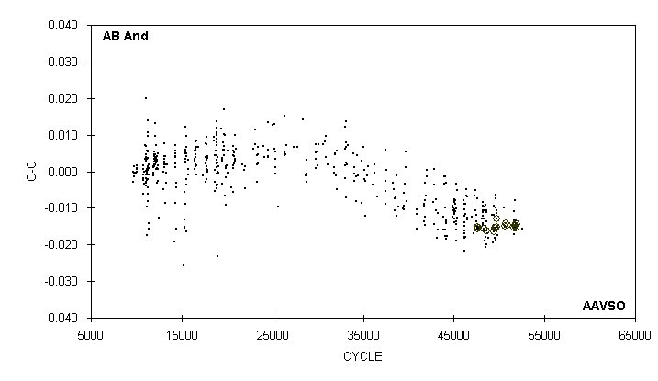

JD(min) STANDARD
HEL. CYCLE O-C N OBSERVER ERROR
2400000 +
52585.694 49643 -0.007 16 R. Hill
52875.765 50517 -0.010 10 D. Williams
52913.5959 50631 -0.0149 54 G. Samolyk (CCD) 0.0001
52918.5741 50646 -0.0150 50 J. Bialozynski (CCD) 0.0002
52930.688 50682.5 -0.015 17 C. Stephan
52936.6630 50700.5 -0.0143 22 R. Poklar (CCD) 0.0005
52966.698 50791 -0.015 23 C. Stephan
53001.5475 50896 -0.0146 75 S. Dvorak (CCD) 0.0001
53250.630 51646.5 -0.017 13 S. Cook (CCD)
53253.787 51656 -0.013 21 C. Stephan
53254.785 51659 -0.011 23 C. Stephan
53260.589 51676.5 -0.015 33 H. Gerner (CCD) 0.0001
53274.696 51719 -0.013 12 D. Williams
53282.667 51743 -0.008 12 C. Stephan
53284.6512 51749 -0.0150 47 S. Brady (CCD) 0.0004
53286.642 51755 -0.016 33 S. Cook (CCD)
53286.6428 51755 -0.0147 45 S. Brady (CCD) 0.0004
53292.286 51772 -0.014 16 V. Jani
53309.7087 51824.5 -0.0153 31 S. Dvorak (CCD) 0.0002
53315.6839 51842.5 -0.0142 20 S. Brady (CCD) 0.0011
53336.5929 51905.5 -0.0144 28 S. Brady (CCD) 0.0006
53553.815 52560 -0.016 10 D. Williams

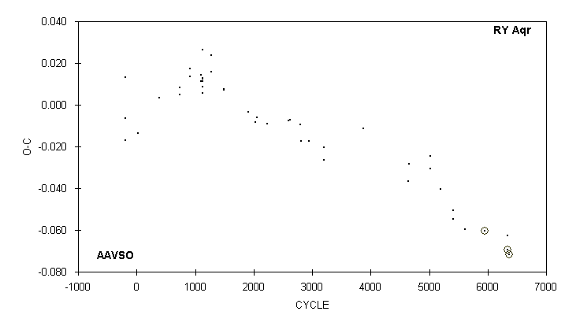

JD(min) STANDARD
HEL. CYCLE O-C N OBSERVER ERROR
2400000 +
48454.787 3880 -0.011 7 M. Baldwin
49961.173: 1) 4646 -0.037 15 S. Cook (CCD)
50692.752 5018 -0.031 12 G. Samolyk
50698.658 5021 -0.024 14 G. Samolyk
51048.696 5199 -0.040 10 D. Williams
51463.637 5410 -0.051 16 D. Williams
51467.566 5412 -0.055 15 D. Williams
51874.646 5619 -0.060 9 R. Hill
52525.5879 5950 -0.0604 38 G. Samolyk (CCD) 0.0005
53288.6173 6338 -0.0695 91 G. Samolyk (CCD) 0.0001
53288.624 6338 -0.063 12 D. Williams
53353.5125 6371 -0.0719 28 G. Samolyk (CCD) 0.0010

1) Observations combined from 49933 to 49988

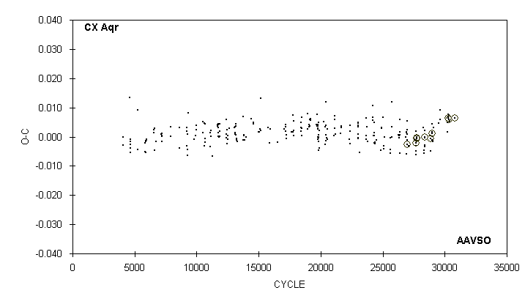

JD(min) STANDARD
HEL. CYCLE O-C N OBSERVER ERROR
2400000 +
52493.752 28850 -0.005 15 R. Hays
52494.8681 28852 -0.0007 25 S. Dvorak (CCD) 0.0001
52556.585 28963 0.002 16 C. Stephan
52561.5883 28972 0.0011 50 G. Samolyk (CCD) 0.0001
52566.590 28981 -0.001 18 C. Stephan
52581.607 29008 0.004 10 C. Stephan
52586.605 29017 -0.002 15 C. Stephan
52615.521 29069 0.003 11 R. Hays
52875.724 29537 0.005 12 D. Williams
52930.768 29636 0.006 14 C. Stephan
52939.667 29652 0.009 17 C. Stephan
53238.780 30190 0.002 14 R. Hays
53253.795 30217 0.005 20 C. Stephan
53281.5956 30267 0.0063 58 G. Samolyk (CCD) 0.0001
53282.709 30269 0.008 16 C. Stephan
53287.712 30278 0.007 15 R. Hill
53306.616 30312 0.007 22 S. Cook (CCD)
53330.5220 30355 0.0059 30 S. Dvorak (CCD) 0.0001
53341.641 30375 0.005 27 S. Cook (CCD)
53581.8283 30807 0.0064 75 G. Samolyk (CCD) 0.0001

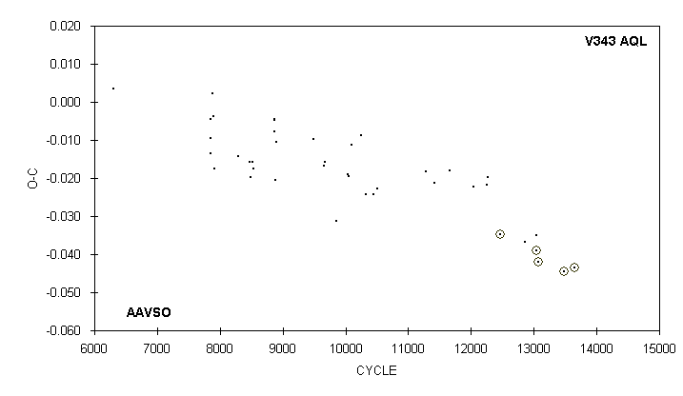

JD(min) STANDARD
HEL. CYCLE O-C N OBSERVER ERROR
2400000 +
49960.693 11665 -0.018 10 M. Baldwin
50661.638 12045 -0.022 11 S. Cook (CCD)
51039.782 12250 -0.022 11 P. Sullivan (CCD)
51076.676 12270 -0.020 14 G. Samolyk
51445.5817 12470 -0.0347 J. A. Howell (CCD) 0.0006
52168.664 12862 -0.037 15 D. Williams
52489.6228 13036 -0.0389 25 N. Simmons (CCD) 0.0005
52511.762 13048 -0.035 10 M. Simonsen
52561.5593 13075 -0.0419 51 G. Samolyk (CCD) 0.0003
53321.5331 13487 -0.0446 50 G. Samolyk (CCD) 0.0002
53616.6706 13647 -0.0435 70 G. Samolyk (CCD) 0.0003

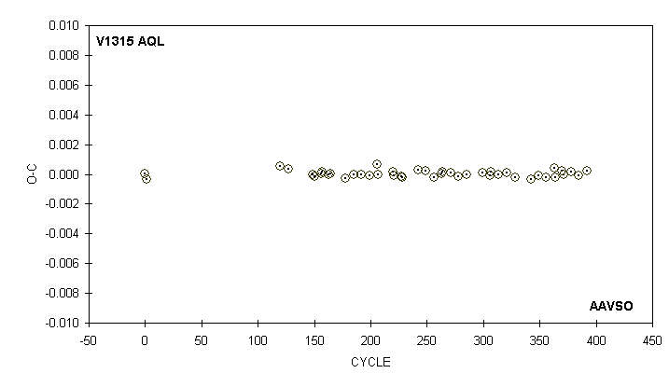

JD(min) STANDARD
HEL. CYCLE O-C OBSERVER ERROR
2400000 +
53199.9643 0 0.0000 Lew Cook (CCD) 0.0001
53200.1036 1 -0.0004 Lew Cook (CCD) 0.0001
53216.7277 120 0.0005 Lew Cook (CCD) 0.0001
53217.7053 127 0.0003 Lew Cook (CCD) 0.0001
53220.7782 149 0.0000 Lew Cook (CCD) 0.0002
53220.9178 150 -0.0001 Lew Cook (CCD) 0.0001
53221.7561 156 0.0000 Lew Cook (CCD) 0.0001
53221.8959 157 0.0002 Lew Cook (CCD) 0.0001
53222.7339 163 0.0000 Lew Cook (CCD) 0.0001
53222.8736 164 0.0000 Lew Cook (CCD) 0.0001
53224.8290 178 -0.0003 Lew Cook (CCD) 0.0001
53225.8070 185 0.0000 Lew Cook (CCD) 0.0001
53226.7849 192 0.0000 Lew Cook (CCD) 0.0001
53227.7627 199 -0.0001 Lew Cook (CCD) 0.0001
53228.7413 206 0.0007 Lew Cook (CCD) 0.0001
53228.8803 207 0.0000 Lew Cook (CCD) 0.0001
53230.6964 220 0.0002 Lew Cook (CCD) 0.0001
53230.8359 221 -0.0001 Lew Cook (CCD) 0.0001
53231.6739 227 -0.0002 Lew Cook (CCD) 0.0001
53231.8135 228 -0.0002 Lew Cook (CCD) 0.0001
53233.7697 242 0.0003 Lew Cook (CCD) 0.0001

V1315 Aql continued on the next page

V1315 Aql continued

JD(min) STANDARD
HEL. CYCLE O-C OBSERVER ERROR
2400000 +
53234.7475 249 0.0002 Lew Cook (CCD) 0.0001
53235.7249 256 -0.0002 Lew Cook (CCD) 0.0001
53236.7030 263 0.0000 Lew Cook (CCD) 0.0001
53236.8428 264 0.0001 Lew Cook (CCD) 0.0001
53237.8206 271 0.0001 Lew Cook (CCD) 0.0001
53238.7982 278 -0.0001 Lew Cook (CCD) 0.0001
53239.7761 285 -0.0001 Lew Cook (CCD) 0.0001
53241.7319 299 0.0001 Lew Cook (CCD) 0.0001
53242.7096 306 -0.0001 Lew Cook (CCD) 0.0001
53242.8495 307 0.0002 Lew Cook (CCD) 0.0001
53243.6875 313 0.0000 Lew Cook (CCD) 0.0001
53244.8051 321 0.0001 Lew Cook (CCD) 0.0001
53245.7826 328 -0.0002 Lew Cook (CCD) 0.0001
53247.7382 342 -0.0003 Lew Cook (CCD) 0.0001
53248.7162 349 -0.0001 Lew Cook (CCD) 0.0001
53249.6940 356 -0.0002 Lew Cook (CCD) 0.0001
53250.6724 363 0.0004 Lew Cook (CCD) 0.0001
53250.8115 364 -0.0002 Lew Cook (CCD) 0.0001
53251.6501 370 0.0002 Lew Cook (CCD) 0.0002
53251.7895 371 0.0000 Lew Cook (CCD) 0.0001
53252.7676 378 0.0002 Lew Cook (CCD) 0.0001
53253.7451 385 -0.0001 Lew Cook (CCD) 0.0001
53254.7233 392 0.0002 Lew Cook (CCD) 0.0001

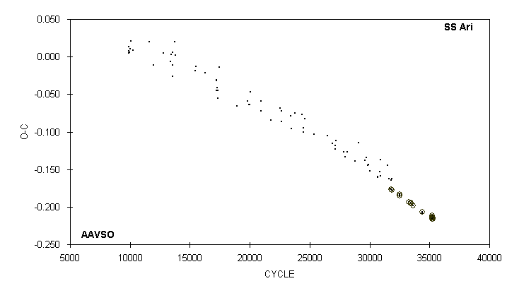

JD(min) STANDARD
HEL. CYCLE O-C N OBSERVER ERROR
2400000 +
52524.8501 33243.5 -0.1931 46 G. Samolyk (CCD) 0.0004
52609.7003 33452.5 -0.1956 47 G. Samolyk (CCD) 0.0002
52612.5432 33459.5 -0.1947 69 S. Dvorak (CCD) 0.0001
52683.5889 33634.5 -0.1978 61 G. Samolyk (CCD) 0.0003
52979.5498 34363.5 -0.2063 51 J. Bialozynski (CCD) 0.0005
52999.644 34413 -0.209 20 B. Manske
53309.8163 35177 -0.2156 25 S. Dvorak (CCD) 0.0002
53315.7070 35191.5 -0.2118 23 S. Brady (CCD) 0.0008
53322.6048 35208.5 -0.2159 61 G. Samolyk (CCD) 0.0001
53329.5095 35225.5 -0.2131 26 S. Brady (CCD) 0.0002
53332.7567 35233.5 -0.2138 26 S. Brady (CCD) 0.0003
53345.5448 35265 -0.2145 23 S. Brady (CCD) 0.0005
53357.5197 35294.5 -0.2164 19 S. Brady (CCD) 0.0007

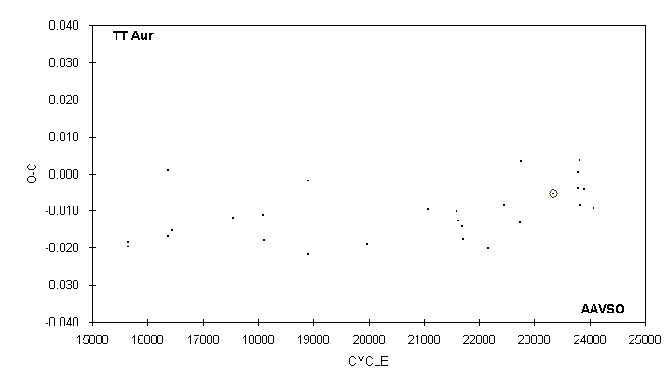

JD(min) STANDARD
HEL. CYCLE O-C N OBSERVER ERROR
2400000 +
51544.639 22737 -0.013 24 G. Samolyk
51576.641 22761 0.003 19 G. Samolyk
52353.6169 23344 -0.0053 66 S. Dvorak (CCD) 0.0004
52947.356 23789.5 0.000 11 S. Foglia
52949.351 : 23791 -0.004 7 S. Foglia
52986.675 23819 0.004 35 G. Samolyk
53001.323 : 23830 -0.008 8 M. Csukas
53098.617 : 23903 -0.004 6 D. Weier
53098.617 23903 -0.004 7 B. Manske
53323.844 24072 -0.009 23 G. Samolyk

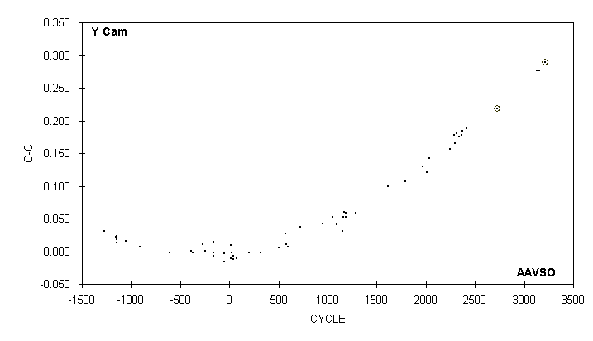

JD(min) STANDARD
HEL. CYCLE O-C N OBSERVER ERROR
2400000 +
50376.599 2243 0.156 21 G. Samolyk
50518.763 2286 0.178 23 M. Baldwin
50541.889 2293 0.165 14 M. Baldwin
50614.628 2315 0.180 6 M. Baldwin
50690.653 2338 0.176 13 M. Baldwin
50776.602 2364 0.178 13 M. Baldwin
50809.664 2374 0.184 9 S. Cook (CCD)
50928.670 2410 0.188 19 M. Baldwin
51976.5834 2727 0.2181 55 S. Dvorak (CCD) 0.0007
53298.892 3127 0.277 15 S. Cook (CCD)
53394.755 3156 0.277 26 S. Cook (CCD)
53589.7988 3215 0.2888 116 G. Samolyk (CCD) 0.0002

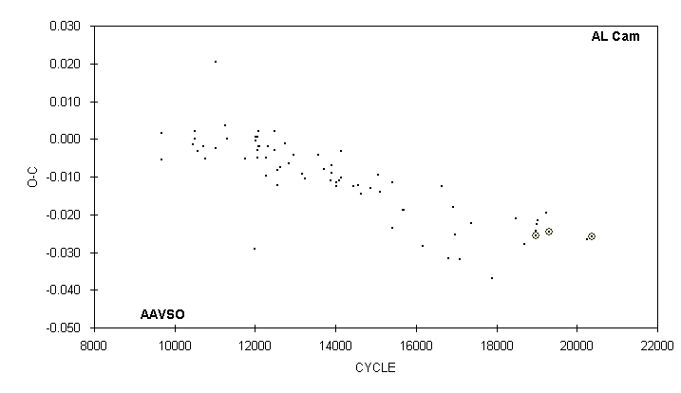

JD(min) STANDARD
HEL. CYCLE O-C N OBSERVER ERROR
2400000 +
50188.653 : 17900 -0.037 7 R. Hill
50965.744 18485 -0.021 16 R. Hill
51256.642 18704 -0.028 15 G. Samolyk
51608.6527 18969 -0.0256 110 G. Lubcke (CCD) 0.0002
51608.654 18969 -0.024 16 D. Williams
51657.804 19006 -0.023 16 D. Williams
51693.670 19033 -0.022 21 C. Stephan
51960.667 19234 -0.020 20 C. Stephan
52057.6304 19307 -0.0246 95 S. Dvorak (CCD) 0.0001
53303.605 20245 -0.027 19 S. Cook (CCD)
53469.6476 20370 -0.0257 79 G. Samolyk (CCD) 0.0002

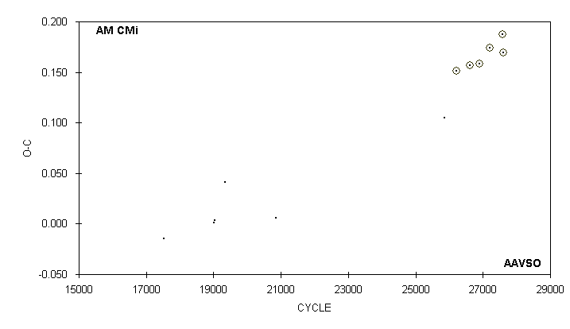

JD(min) STANDARD
HEL. CYCLE O-C N OBSERVER ERROR
2400000 +
43100.777 17520 -0.015 10 G. Samolyk
44634.668 19025 0.001 16 G. Samolyk
44635.689 19026 0.003 18 G. Samolyk
44957.790 19342 0.041 15 G. Samolyk
46494.687 20850 0.006 6 P. Atwood
51589.697 25849 0.105 10 S. Cook (CCD)
51960.7270 26213 0.1514 133 S. Dvorak (CCD) 0.0020
52380.6369 26625 0.1567 47 G. Samolyk (CCD) 0.0009
52650.7227 26890 0.1582 66 G. Samolyk (CCD) 0.0009
52980.9550 27214 0.1742 21 S. Dvorak (CCD) 0.0010
53363.6729 27589.5 0.1878 49 G. Samolyk (CCD) 0.0010
53392.7010 27618 0.1691 47 S. Dvorak (CCD) 0.0010

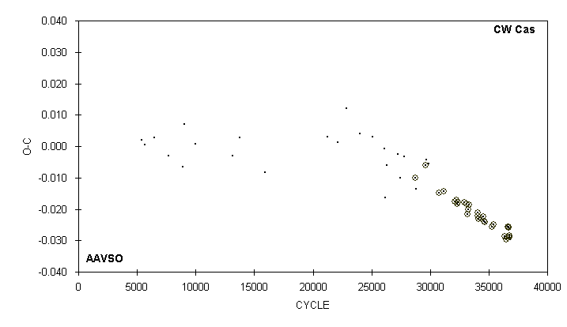

JD(min) STANDARD
HEL. CYCLE O-C N OBSERVER ERROR
2400000 +
52883.7573 35286.5 -0.0258 37 G. Samolyk (CCD) 0.0002
52930.6313 35433.5 -0.0248 23 S. Dvorak (CCD) 0.0006
53223.6635 36352.5 -0.0287 47 G. Samolyk (CCD) 0.0003
53274.6807 36512.5 -0.0298 42 G. Samolyk (CCD) 0.0004
53303.5384 36603 -0.0293 48 J. Bialozynski (CCD) 0.0002
53315.6588 36641 -0.0257 20 S. Brady (CCD) 0.0008
53329.5294 36684.5 -0.0257 19 S. Brady (CCD) 0.0011
53332.7177 36694.5 -0.0260 26 S. Brady (CCD) 0.0005
53345.6289 36735 -0.0288 20 S. Brady (CCD) 0.0003
53355.6736 36766.5 -0.0283 20 S. Brady (CCD) 0.0006
53357.5862 36772.5 -0.0289 22 S. Brady (CCD) 0.0009
53373.688 36823 -0.030 16 C. Stephan

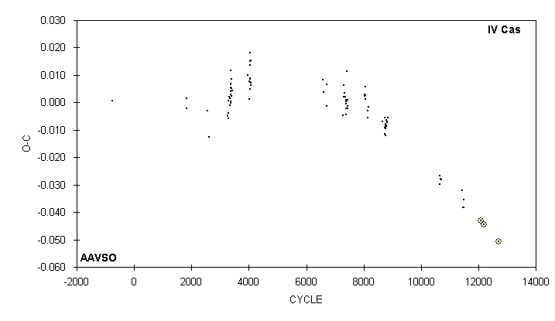

JD(min) STANDARD
HEL. CYCLE O-C N OBSERVER ERROR
2400000 +
51497.843 10659 -0.027 20 M. Baldwin
51501.834 10663 -0.030 20 M. Baldwin
51520.808 10682 -0.028 18 M. Baldwin
51542.775 10704 -0.028 15 M. Baldwin
52278.684 11441 -0.032 15 M. Baldwin
52313.626 11476 -0.038 14 M. Baldwin
52319.620 11482 -0.035 13 M. Baldwin
52323.611 11486 -0.038 13 M. Baldwin
52931.7078 12095 -0.0430 58 G. Samolyk (CCD) 0.0002
53035.5529 12199 -0.0445 53 G. Samolyk (CCD) 0.0003
53539.8015 12704 -0.0507 93 G. Samolyk (CCD) 0.0002

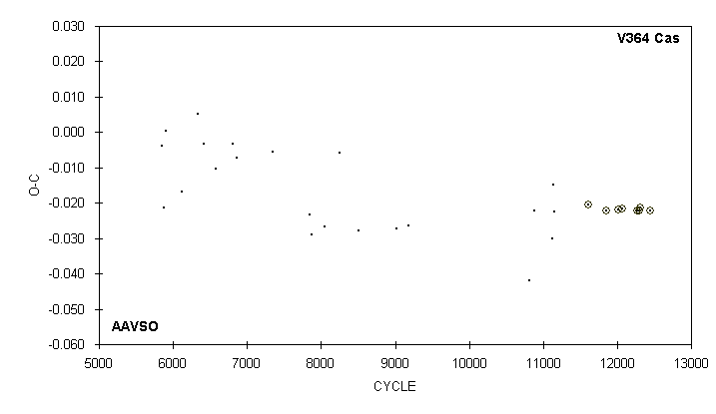

JD(min) STANDARD
HEL. CYCLE O-C N OBSERVER ERROR
2400000 +
51020.765 10814.5 -0.042 18 G. Samolyk
51129.571 10885 -0.022 14 G. Samolyk
51490.641 11119 -0.030 19 G. Samolyk
51510.716 11132 -0.015 19 G. Samolyk
51544.656 11154 -0.022 21 G. Samolyk
52250.6116 11611.5 -0.0205 47 S. Dvorak (CCD) 0.0004
52625.5754 11854.5 -0.0222 26 S. Dvorak (CCD) 0.0003
52881.7250 12020.5 -0.0219 56 G. Samolyk (CCD) 0.0003
52952.7064 12066.5 -0.0216 61 G. Samolyk (CCD) 0.0002
53259.7764 12265.5 -0.0222 54 G. Samolyk (CCD) 0.0003
53314.5553 12301 -0.0222 49 G. Samolyk (CCD) 0.0003
53341.5599 12318.5 -0.0213 58 G. Samolyk (CCD) 0.0002
53539.8433 12447 -0.0221 52 G. Samolyk (CCD) 0.0003

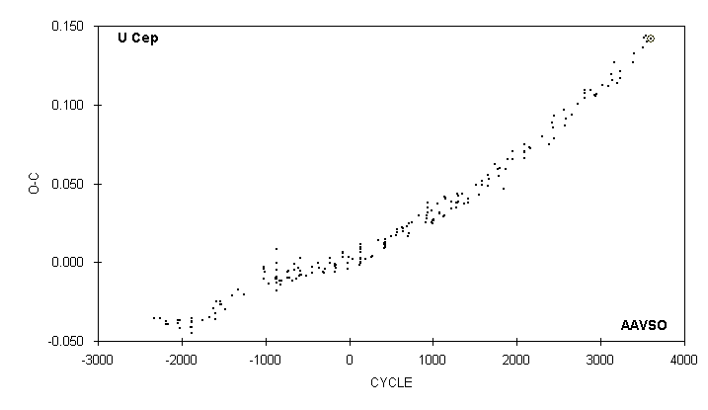

JD(min) STANDARD
HEL. CYCLE O-C N OBSERVER ERROR
2400000 +
52342.468 3129 0.119 11 S. Kracenicki
52372.381 3141 0.116 8 S. Kracenicki
52434.718 3166 0.127 13 D. Williams
52529.441 3204 0.114 11 S. Kracenicki
52616.701 3239 0.117 26 G. Samolyk
52616.705 3239 0.121 16 D. Williams
52995.654 3391 0.127 28 G. Samolyk
53005.632 3395 0.133 19 D. Williams
53274.885 3503 0.137 16 D. Williams
53314.780 3519 0.143 33 G. Samolyk
53354.670 3535 0.144 33 G. Samolyk
53399.541 3553 0.140 31 G. Chaple
53511.7301 3598 0.1421 135 G. Samolyk (CCD) 0.0001

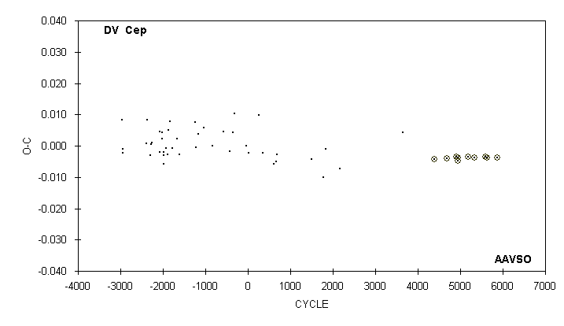

JD(min) STANDARD
HEL. CYCLE O-C N OBSERVER ERROR
2400000 +
51012.699 3657 0.004 16 G. Samolyk
51873.7140 4398 -0.0042 21 G. Samolyk (CCD) 0.0004
52210.6869 4688 -0.0040 72 G. Samolyk (CCD) 0.0001
52468.6458 4910 -0.0035 48 G. Samolyk (CCD) 0.0003
52504.6656 4941 -0.0049 17 G. Samolyk (CCD) 0.0010
52518.6103 4953 -0.0039 49 G. Samolyk (CCD) 0.0003
52791.6747 5188 -0.0036 52 H. Gerner (CCD) 0.0004
52963.6467 5336 -0.0038 71 J. Bialozynski (CCD) 0.0002
53265.7604 5596 -0.0036 84 G. Samolyk (CCD) 0.0002
53314.5631 5638 -0.0038 53 G. Samolyk (CCD) 0.0002
53581.8173 5868 -0.0038 92 G. Samolyk (CCD) 0.0001

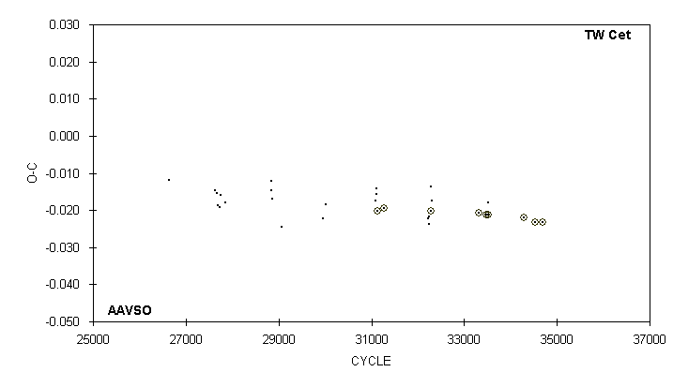

JD(min) STANDARD
HEL. CYCLE O-C N OBSERVER ERROR
2400000 +
52586.760 32234 -0.022 14 C. Stephan
52587.711 32237 -0.022 13 C. Stephan
52589.610 32243 -0.024 14 C. Stephan
52601.6540 32281 -0.0202 20 S. Dvorak (CCD) 0.0002
52602.611 32284 -0.014 17 C. Stephan
52609.578 32306 -0.017 18 C. Stephan
52931.8131 33323 -0.0208 33 B. Manske (CCD) 0.0004
52979.6573 33474 -0.0212 34 G. Samolyk (CCD) 0.0002
52991.701 33512 -0.018 14 C. Stephan
52993.5988 33518 -0.0212 37 S. Dvorak (CCD) 0.0001
53238.8414 34292 -0.0220 46 G. Samolyk (CCD) 0.0004
53316.6273 34537.5 -0.0232 42 G. Samolyk (CCD) 0.0001
53363.5213 34685.5 -0.0233 58 G. Samolyk (CCD) 0.0001

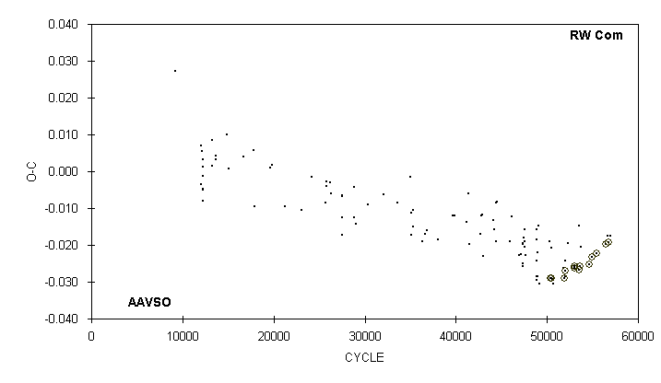

JD(min) STANDARD
HEL. CYCLE O-C N OBSERVER ERROR
2400000 +
52426.687 52262.5 -0.019 13 G. Samolyk
52597.9257 52984 -0.0258 40 G. Samolyk (CCD) 0.0005
52611.9286 53043 -0.0263 32 S. Dvorak (CCD) 0.0001
52735.7040 53564.5 -0.0268 22 S. Dvorak (CCD) 0.0005
52735.716 53564.5 -0.015 15 C. Stephan
52739.6212 53581 -0.0258 35 G. Samolyk (CCD) 0.0003
52762.649 53678 -0.021 17 C. Stephan
52993.9379 54652.5 -0.0252 35 S. Dvorak (CCD) 0.0001
53050.7841 54892 -0.0233 32 G. Samolyk (CCD) 0.0003
53179.6640 55435 -0.0223 36 G. Samolyk (CCD) 0.0002
53413.6895 56421 -0.0198 29 G. Samolyk (CCD) 0.0003
53466.620 56644 -0.017 15 S. Cook (CCD)
53489.4035 56740 -0.0192 J. Coloma (CCD) 0.0007
53530.822 56914.5 -0.018 21 C. Stephan

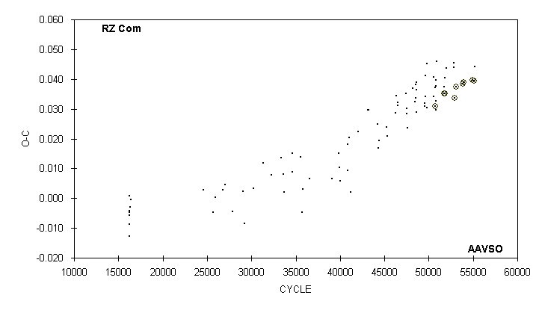

JD(min) STANDARD
HEL. CYCLE O-C N OBSERVER ERROR
2400000 +
52374.6067 51807.5 0.0353 57 G. Lubcke (CCD) 0.0001
52426.745 51961.5 0.044 13 G. Samolyk
52734.618 52871 0.045 16 C. Stephan
52735.632 52874 0.044 12 C. Stephan
52747.8080 52910 0.0336 17 S. Dvorak (CCD) 0.0010
52804.6808 53078 0.0374 41 G. Samolyk (CCD) 0.0003
53057.7152 53825.5 0.0385 42 G. Samolyk (CCD) 0.0002
53092.7509 53929 0.0389 62 S. Dvorak (CCD) 0.0001
53442.7670 54963 0.0397 41 H. Gerner (CCD) 0.0005
53488.6343 55098.5 0.0395 73 S. Dvorak (CCD) 0.0001
53530.783 55223 0.044 18 C. Stephan

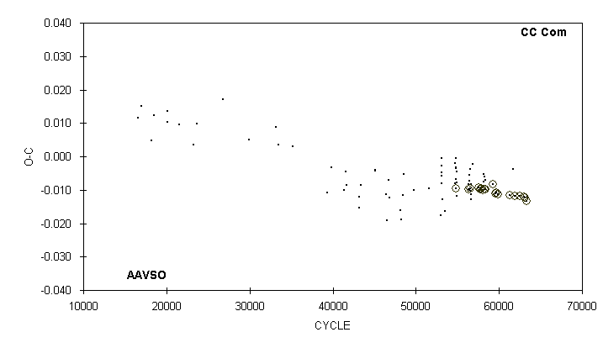

JD(min) STANDARD
HEL. CYCLE O-C N OBSERVER ERROR
2400000 +
52380.6044 58214 -0.0097 25 G. Lubcke (CCD) 0.0002
52405.655 58327.5 -0.007 9 C. Stephan
52624.9054 59321 -0.0084 28 S. Dvorak (CCD) 0.0001
52683.9363 59588.5 -0.0111 26 S. Dvorak (CCD) 0.0002
52707.7708 59696.5 -0.0107 32 G. Samolyk (CCD) 0.0002
52739.7698 59841.5 -0.0112 37 G. Samolyk (CCD) 0.0002
53064.9507 61315 -0.0116 18 S. Dvorak (CCD) 0.0002
53149.702 61699 -0.004 20 R. Hill
53189.6382 61880 -0.0118 37 G. Samolyk (CCD) 0.0002
53339.9256 62561 -0.0118 40 S. Dvorak (CCD) 0.0001
53442.8755 63027.5 -0.0120 39 G. Samolyk (CCD) 0.0001
53470.7920 63154 -0.0123 19 S. Dvorak (CCD) 0.0002
53509.4112 63329 -0.0132 J. Coloma (CCD) 0.0002
53530.819 63426 -0.012 21 C. Stephan

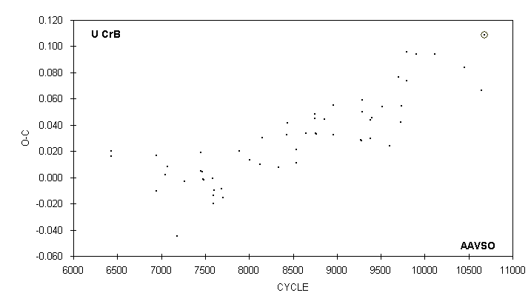

JD(min) STANDARD
HEL. CYCLE O-C N OBSERVER ERROR
2400000 +
49878.772 9597 0.024 7 R. Hill
50230.949 2) 9699 0.077 16 S. Cook (CCD)
50320.672 9725 0.042 12 N. Simmons
50365.563 : 9738 0.055 10 R. Schmude
50572.714 9798 0.074 22 G. Samolyk
50572.736 9798 0.096 15 S. Cook (CCD)
50938.668 9904 0.094 13 R. Berg
51663.630 10114 0.094 21 C. Stephan
52816.655 10448 0.084 24 C. Stephan
53503.626 10647 0.067 28 S. Cook (CCD)
53610.6863 10678 0.1087 64 G. Samolyk (CCD) 0.0009

2) Observations combined from 50213 to 50251

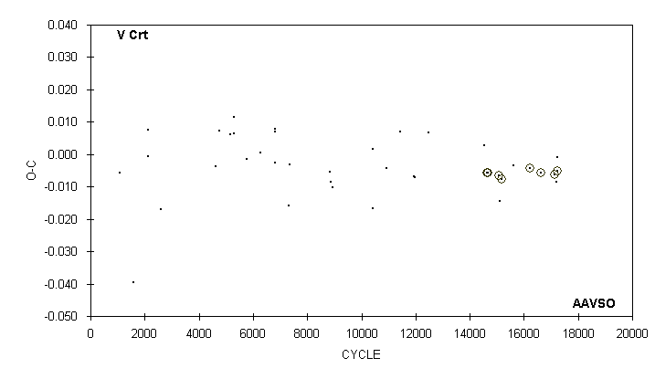

JD(min) STANDARD
HEL. CYCLE O-C N OBSERVER ERROR
2400000 +
50165.770 12490 0.007 10 M. Baldwin
51607.748 14544 0.003 15 C. Stephan
51664.6045 14625 -0.0058 26 S. Dvorak (CCD)
51685.6657 14655 -0.0056 34 G. Samolyk (CCD) 0.0004
51989.6464 15088 -0.0066 59 G. Samolyk (CCD) 0.0003
52015.614 15125 -0.014 21 C. Stephan
52041.5960 15162 -0.0076 59 S. Dvorak (CCD) 0.0004
52349.794 15601 -0.003 12 C. Stephan
52783.6515 16219 -0.0043 43 H. Gerner (CCD) 0.0008
53077.8032 16638 -0.0057 52 G. Samolyk (CCD) 0.0008
53435.8411 17148 -0.0062 38 G. Samolyk (CCD) 0.0006
53478.663 17209 -0.009 21 S. Cook (CCD)
53485.6868 17219 -0.0051 78 J. Bialozynski (CCD) 0.0005
53504.646 17246 -0.001 20 S. Cook (CCD)

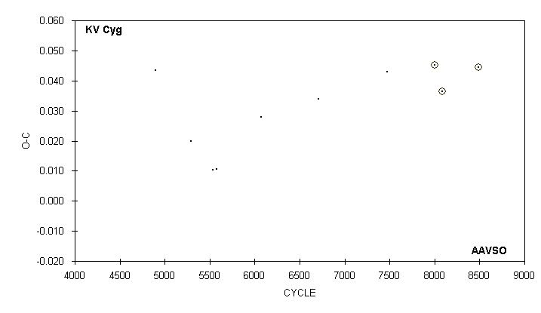

JD(min) STANDARD
HEL. CYCLE O-C N OBSERVER ERROR
2400000 +
43373.823 4898 0.043 19 D. Ruokonen
44486.685 5290 0.020 19 G. Hanson
45173.712 5532 0.010 15 G. Samolyk
45298.628 5576 0.011 16 G. Samolyk
46709.625 6073 0.028 20 G. Samolyk
48506.714 6706 0.034 26 G. Samolyk
50692.748 7476 0.043 23 G. Samolyk
52174.7050 7998 0.0452 100 C. Hesseltine (CCD) 0.0009
52418.8498 8084 0.0365 38 S. Dvorak (CCD) 0.0003
53565.8111 8488 0.0444 94 G. Samolyk (CCD) 0.0005

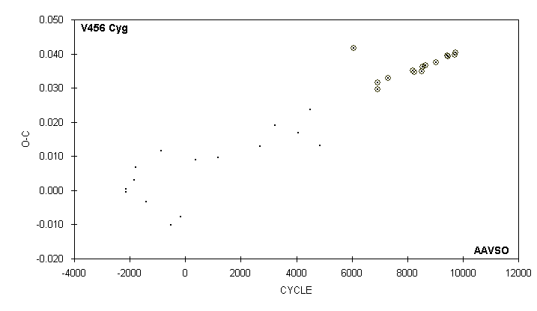

JD(min) STANDARD
HEL. CYCLE O-C N OBSERVER ERROR
2400000 +
51084.6730 6927 0.0316 53 G. Samolyk (CCD) 0.0007
51085.5621 6928 0.0295 58 G. Samolyk (CCD) 0.0002
51411.7417 7294 0.0328 42 C. Hesseltine (CCD) 0.0005
52220.5010 8201.5 0.0352 41 S. Dvorak (CCD) 0.0080
52261.4954 8247.5 0.0347 24 S. Dvorak (CCD) 0.0004
52504.7909 8520.5 0.0348 20 S. Dvorak (CCD) 0.0003
52534.6473 8554 0.0363 33 G. Lubcke (CCD) 0.0001
52616.6373 8646 0.0365 35 G. Samolyk (CCD) 0.0002
52951.7265 9022 0.0375 48 G. Samolyk (CCD) 0.0002
53321.5733 9437 0.0395 54 G. Samolyk (CCD) 0.0001
53338.5058 9456 0.0394 28 S. Dvorak (CCD) 0.0002
53557.7394 9702 0.0397 71 G. Samolyk (CCD) 0.0002
53590.7141 9739 0.0403 61 R. Poklar (CCD) 0.0002

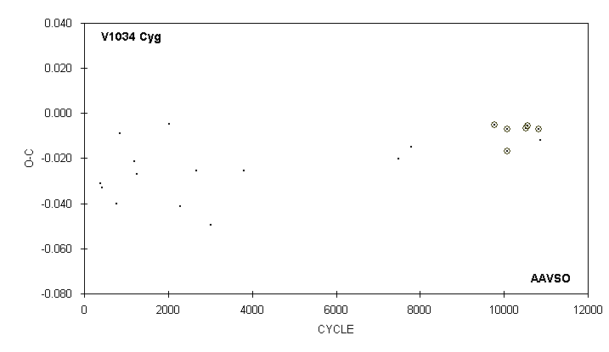

JD(min) STANDARD
HEL. CYCLE O-C N OBSERVER ERROR
2400000 +
43304.777 375 -0.031 13 G. Samolyk
43347.760 419 -0.033 11 G. Samolyk
43687.725 767 -0.040 15 G. Samolyk
43777.634 859 -0.009 12 G. Samolyk
44111.732 1201 -0.021 12 G. Samolyk
44156.665 1247 -0.027 13 G. Samolyk
44921.624 2030 -0.005 19 G. Samolyk
45171.682 2286 -0.041 12 G. Samolyk
45552.701 2676 -0.025 16 G. Samolyk
45888.741 3020 -0.050 15 G. Samolyk
46654.679 3804 -0.026 12 G. Samolyk
50255.652 : 7490 -0.020 12 S. Cook (CCD)
50540.921 7782 -0.015 9 S. Cook (CCD)
52495.7698 9783 -0.0052 74 C. Hesseltine (CCD) 0.0006
52791.7779 10086 -0.0072 40 N. Simmons (CCD) 0.0007
52792.7453 10087 -0.0167 82 C. Limbach (CCD) 0.0004
53218.6974 10523 -0.0065 100 C. Hesseltine (CCD) 0.0005
53265.5909 10571 -0.0057 49 G. Samolyk (CCD) 0.0003
53511.7762 10823 -0.0070 94 G. Samolyk (CCD) 0.0004
53557.687 : 10870 -0.012 15 S. Cook (CCD)

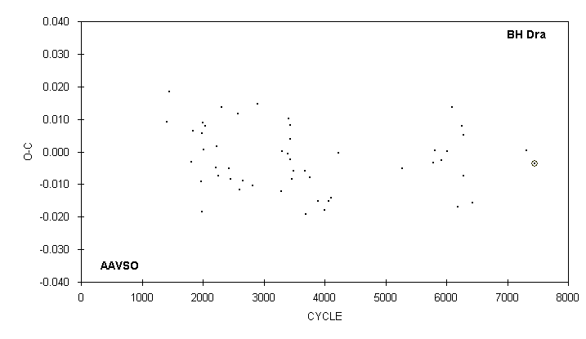

JD(min) STANDARD
HEL. CYCLE O-C N OBSERVER ERROR
2400000 +
50539.789 5789 -0.003 16 M. Baldwin
50579.772 5811 0.000 12 M. Baldwin
50770.579 5916 -0.003 17 G. Samolyk
50948.671 6014 0.000 14 M. Baldwin
51088.612 6091 0.014 20 G. Samolyk
51275.757 6194 -0.017 15 M. Baldwin
51384.816 6254 0.008 17 G. Samolyk
51424.780 6276 -0.007 21 M. Baldwin
51435.696 6282 0.005 23 M. Baldwin
51693.723 6424 -0.016 18 G. Samolyk
53314.716 7316 0.000 24 G. Samolyk
53563.6736 7453 -0.0037 44 G. Samolyk (CCD) 0.0003

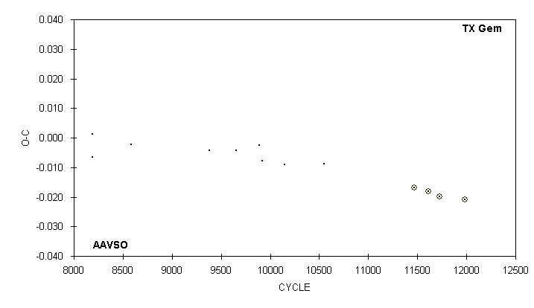

JD(min) STANDARD
HEL. CYCLE O-C N OBSERVER ERROR
2400000 +
43883.730 8584 -0.002 22 G. Samolyk
46123.739 9384 -0.004 13 P. Atwood
46879.743 9654 -0.004 13 P. Atwood
47540.548 9890 -0.002 13 G. Samolyk
47621.743 9919 -0.008 16 R. Hill
48251.745 10144 -0.009 29 G. Samolyk
49388.551 10550 -0.009 10 G. Samolyk
51950.5557 11465 -0.0168 48 S. Dvorak (CCD) 0.0002
52356.5565 11610 -0.0180 43 S. Dvorak (CCD) 0.0002
52678.5564 11725 -0.0197 66 G. Samolyk (CCD) 0.0002
53406.5589 11985 -0.0209 65 G. Samolyk (CCD) 0.0002

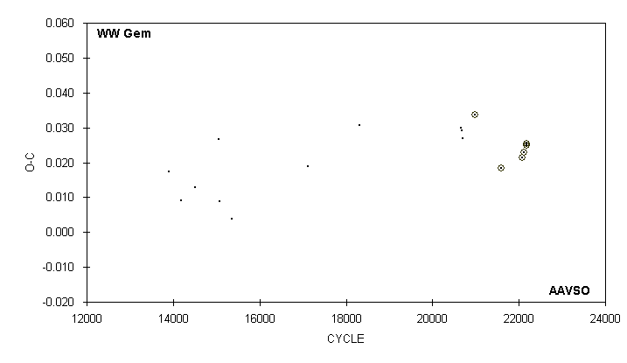

JD(min) STANDARD
HEL. CYCLE O-C N OBSERVER ERROR
2400000 +
43204.701 13912 0.017 17 G. Samolyk
43537.664 14181 0.009 14 G. Samolyk
43948.621 14513 0.013 17 G. Samolyk
44614.577 15051 0.027 15 G. Samolyk
44635.602 15068 0.009 17 G. Samolyk
44989.611 15354 0.004 12 G. Samolyk
47170.649 17116 0.019 15 G. Samolyk
48654.796 18315 0.031 16 G. Samolyk
51558.700 20661 0.030 15 S. Cook (CCD)
51579.742 20678 0.029 17 G. Samolyk
51610.685 20703 0.027 17 M. Baldwin
51969.6569 20993 0.0336 57 S. Dvorak (CCD) 0.0004
52713.5661 21594 0.0184 34 G. Samolyk (CCD) 0.0007
53323.8100 22087 0.0214 80 G. Samolyk (CCD) 0.0003
53354.7566 22112 0.0228 48 J. Bialozynski (CCD) 0.0009
53442.6434 22183 0.0250 72 H. Gerner (CCD) 0.0007
53442.6438 22183 0.0254 77 C. Hesseltine (CCD) 0.0002

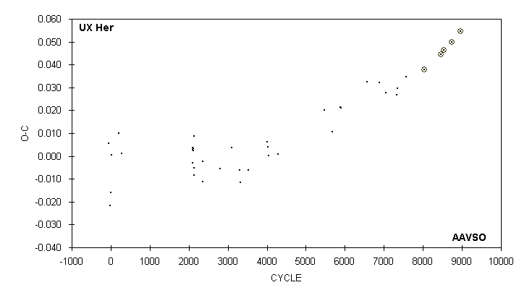

JD(min) STANDARD
HEL. CYCLE O-C N OBSERVER ERROR
2400000 +
50320.740 6875 0.032 19 G. Samolyk
50602.626 7057 0.028 12 S. Cook (CCD)
51020.814 7327 0.027 16 G. Samolyk
51048.696 7345 0.030 19 D. Williams
51384.801 7562 0.035 16 G. Samolyk
52126.7022 8041 0.0377 86 G. Samolyk (CCD) 0.0001
52775.6764 8460 0.0446 33 R. Poklar (CCD) 0.0004
52902.6836 8542 0.0463 62 C. Hesseltine (CCD) 0.0001
53204.7125 8737 0.0499 59 B. Manske (CCD) 0.0002
53540.8171 8954 0.0545 82 G. Samolyk (CCD) 0.0001

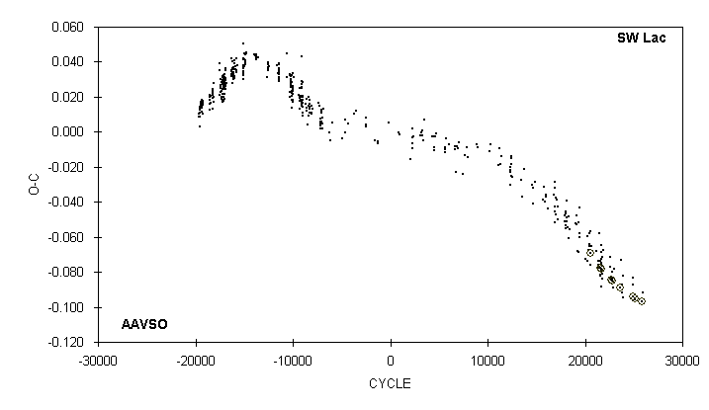

JD(min) STANDARD
HEL. CYCLE O-C N OBSERVER ERROR
2400000 +
52860.7891 23651.5 -0.0890 39 G. Samolyk (CCD) 0.0002
52883.576 23722.5 -0.073 10 C. Stephan
52897.669 23766.5 -0.092 16 C. Stephan
52918.681 23832 -0.087 11 C. Stephan
52930.713 23869.5 -0.082 13 C. Stephan
52939.681 23897.5 -0.094 14 C. Stephan
53257.687 24889 -0.083 21 B. Manske
53274.681 24942 -0.087 13 D. Williams
53281.7301 24964 -0.0941 53 G. Samolyk (CCD) 0.0001
53328.714 25110.5 -0.096 19 S. Cook (CCD)
53333.3654 25125 -0.0949 J. Coloma (CCD) 0.0001
53344.5905 25160 -0.0950 36 G. Samolyk (CCD) 0.0001
53557.8683 25825 -0.0966 42 G. Samolyk (CCD) 0.0004
53585.776 25912 -0.092 16 C. Stephan

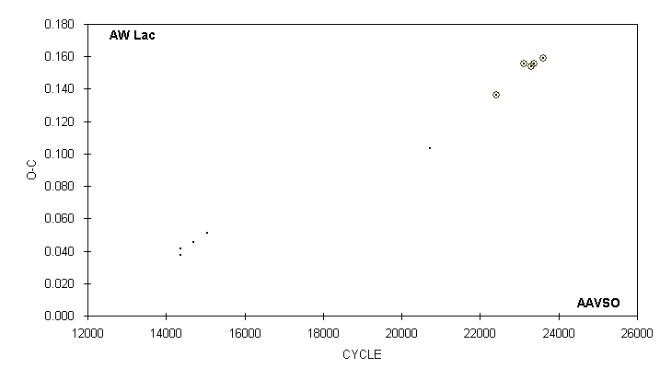

JD(min) STANDARD
HEL. CYCLE O-C N OBSERVER ERROR
2400000 +
43045.868 14369 0.037 14 G. Wedemayer
43045.872 14369 0.041 15 G. Samolyk
43420.731 14697 0.045 28 G. Samolyk
43820.734 15047 0.051 26 G. Samolyk
50304.173 3) 20720 0.103 19 S. Cook (CCD)
52235.6224 22410 0.1364 85 C. Hesseltine (CCD) 0.0008
53035.6367 23110 0.1558 90 C. Hesseltine (CCD) 0.0008
53251.6335 23299 0.1540 63 G. Samolyk (CCD) 0.0003
53323.6345 23362 0.1555 148 C. Hesseltine (CCD) 0.0001
53603.6362 23607 0.1590 82 G. Samolyk (CCD) 0.0002

3) Observations combined from 50300 to 50308

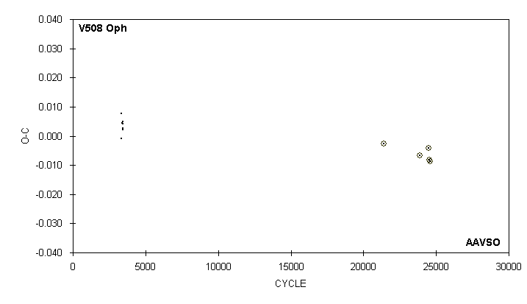

JD(min) STANDARD
HEL. CYCLE O-C N OBSERVER ERROR
2400000 +
46239.673 3356 0.008 10 D. Williams
46240.699 3359 -0.001 14 D. Williams
46246.738 3376.5 0.004 10 D. Williams
46264.665 3428.5 0.002 10 D. Williams
46265.702 3431.5 0.005 10 D. Williams
46269.665 3443 0.003 12 D. Williams
46274.666 3457.5 0.004 10 D. Williams
52466.6085 21416 -0.0027 29 S. Dvorak (CCD) 0.0001
53316.5172 23881 -0.0066 41 G. Samolyk (CCD) 0.0002
53524.4294 24484 -0.0041 J. Coloma (CCD) 0.0002
53541.6649 24534 -0.0082 47 R. Poklar (CCD) 0.0001
53561.6623 24592 -0.0087 40 C. Hesseltine (CCD) 0.0001

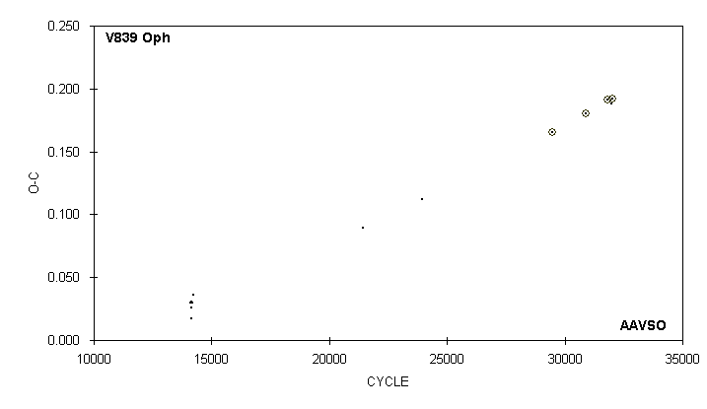

JD(min) STANDARD
HEL. CYCLE O-C N OBSERVER ERROR
2400000 +
46217.731 14106 0.030 14 D. Williams
46225.702 14125.5 0.026 14 D. Williams
46233.682 14145 0.030 14 D. Williams
46237.759 14155 0.017 13 D. Williams
46246.769 14177 0.029 12 D. Williams
46269.679 14233 0.036 14 D. Williams
49213.681 21431 0.089 12 D. Williams
50237.010 4) 23933 0.112 22 S. Cook (CCD)
52508.6235 29487 0.1656 61 S. Dvorak (CCD) 0.0001
53092.8878 30915.5 0.1801 95 S. Dvorak (CCD) 0.0002
53469.7881 31837 0.1912 62 G. Samolyk (CCD) 0.0001
53538.701 32005.5 0.188 15 S. Cook (CCD)
53539.7271 32008 0.1920 88 C. Hesseltine (CCD) 0.0001

4) Observations combined from 50226 to 50248

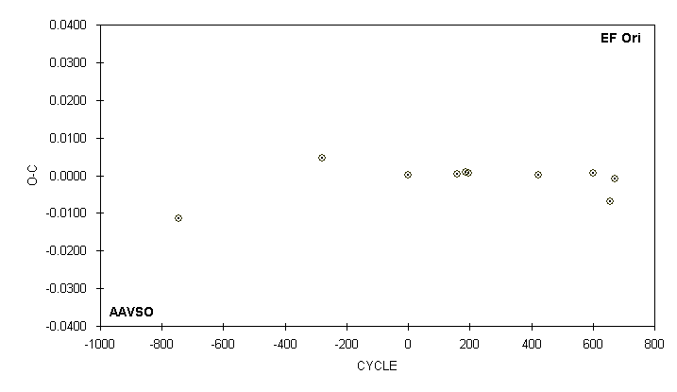

JD(min) STANDARD
HEL. CYCLE O-C N OBSERVER ERROR
2400000 +
51144.9020 -744.5 -0.0114 78 G. Samolyk (CCD) 0.0007
51896.3417 5) -280.5 0.0047 104 G. Samolyk (CCD) 0.0007
52350.5921 0 0.0001 57 G. Samolyk (CCD) 0.0003
52609.7039 160 0.0003 67 G. Samolyk (CCD) 0.0004
52651.8100 186 0.0008 65 G. Samolyk (CCD) 0.0003
52669.6237 197 0.0006 50 G. Samolyk (CCD) 0.0004
53035.6184 423 0.0001 102 G. Samolyk (CCD) 0.0005
53323.8804 601 0.0005 92 G. Samolyk (CCD) 0.0003
53413.7522 656.5 -0.0070 74 G. Samolyk (CCD) 0.0010
53435.6210 670 -0.0008 91 G. Samolyk (CCD) 0.0006

5) Observations combined from 51881 to 52312

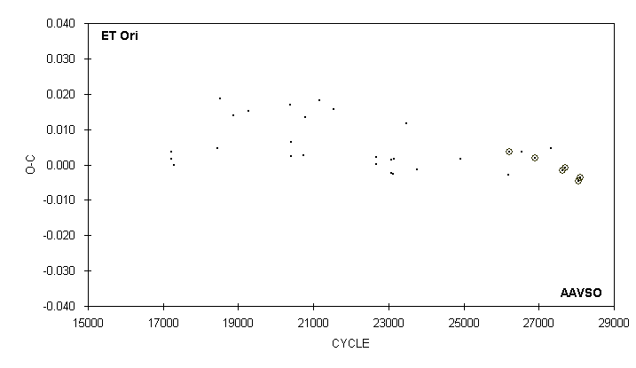

JD(min) STANDARD
HEL. CYCLE O-C N OBSERVER ERROR
2400000 +
50376.845 24915 0.002 17 G. Samolyk
51582.627 26183 -0.003 20 G. Samolyk
51602.6031 26204 0.0036 41 G. Lubcke (CCD) 0.0001
51930.676 26549 0.004 13 R. Hill
52261.5997 26897 0.0019 51 S. Dvorak (CCD) 0.0001
52667.652 27324 0.005 15 R. Hill
52956.7302 27628 -0.0016 24 S. Dvorak (CCD) 0.0002
53018.5418 27693 -0.0008 42 G. Samolyk (CCD) 0.0003
53369.4331 28062 -0.0047 J. Coloma (CCD)
53405.5696 28100 -0.0038 69 G. Samolyk (CCD) 0.0002

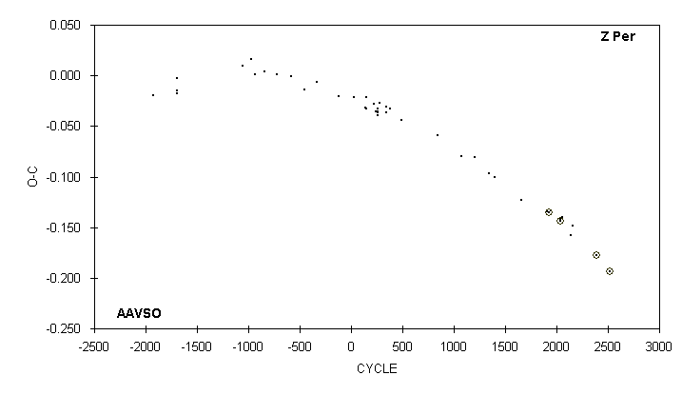

JD(min) STANDARD
HEL. CYCLE O-C N OBSERVER ERROR
2400000 +
50735.647 1661 -0.123 16 S. Cook (CCD)
51496.656 1910 -0.135 26 M. Baldwin
51551.6692 1928 -0.1349 J. A. Howell (CCD) 0.0003
51606.684 1946 -0.134 18 R. Hill
51872.5728 2033 -0.1435 J. A. Howell (CCD) 0.0001
51878.687 2035 -0.142 25 R. Hill
51930.646 2052 -0.140 28 G. Samolyk
52208.752 6) 2143 -0.158 37 R. Hill
52254.606 2158 -0.149 21 G. Samolyk
52957.5272 2388 -0.1780 49 G. Samolyk (CCD) 0.0007
53354.8319 2518 -0.1931 88 G. Samolyk (CCD) 0.0005

6) Observations combined from 52205 to 52211

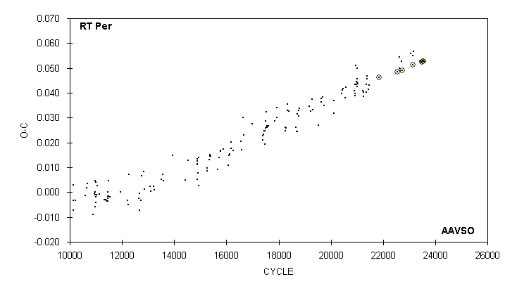

JD(min) STANDARD
HEL. CYCLE O-C N OBSERVER ERROR
2400000 +
51940.5978 21856 0.0461 J. A. Howell (CCD) 0.0001
52525.8369 22545 0.0484 56 G. Samolyk (CCD) 0.0002
52589.548 22620 0.054 12 C. Stephan
52605.682 22639 0.050 12 R. Hays
52616.723 22652 0.049 11 D. Williams
52667.691 22712 0.053 12 R. Hill
52684.6753 22732 0.0489 47 S. Jamieson (CCD) 0.0001
52966.683 23064 0.056 12 C. Stephan
53023.592 23131 0.055 12 R. Hays
53029.5343 23138 0.0514 46 G. Samolyk (CCD) 0.0002
53051.624 23164 0.057 13 R. Hays
53259.723 23409 0.053 12 D. Williams
53321.730 23482 0.053 23 S. Cook (CCD)
53322.5784 23483 0.0524 54 G. Samolyk (CCD) 0.0001
53340.4159 23504 0.0525 J. Coloma (CCD) 0.0002
53350.6089 23516 0.0527 27 C. Norris (CCD) 0.0005
53367.5971 23536 0.0529 27 C. Norris (CCD) 0.0007

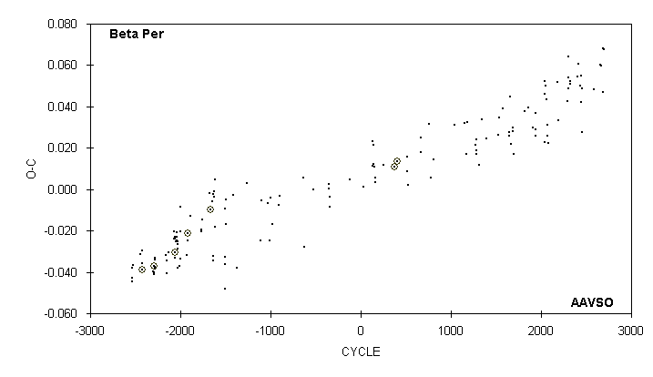

JD(min)
HEL. CYCLE O-C N OBSERVER
2400000 +
52531.700 2403 0.054 7 G. Sarty
52574.716 2418 0.061 23 G. Chaple
52617.715 2433 0.050 10 G. Sarty
52640.658 2441 0.055 24 G. Samolyk
52663.584 2449 0.042 19 G. Samolyk
52669.325 2451 0.049 23 J. Virtanen
52689.375 2458 0.028 11 S. Foglia
53050.676 2584 0.048 23 G. Samolyk
53265.736 2659 0.060 29 G. Samolyk
53288.674 2667 0.060 27 G. Samolyk
53354.609 2690 0.047 20 G. Chaple
53354.630 2690 0.068 30 G. Samolyk
53374.701 2697 0.068 20 C. Stephan

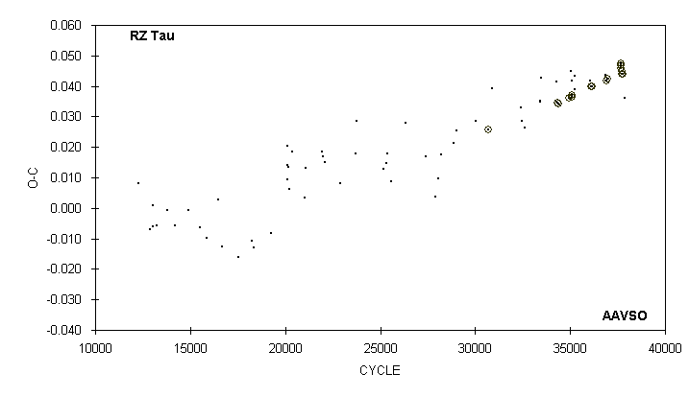

JD(min) STANDARD
HEL. CYCLE O-C N OBSERVER ERROR
2400000 +
52671.658 36074 0.042 16 C. Stephan
52678.7224 36091 0.0398 55 G. Samolyk (CCD) 0.0002
52713.6390 36175 0.0397 41 G. Samolyk (CCD) 0.0001
52999.627 36863 0.044 14 B. Manske
53024.5656 36923 0.0417 52 J. Bialozynski (CCD) 0.0002
53048.6754 36981 0.0423 55 J. Bialozynski (CCD) 0.0002
53329.6761 37657 0.0469 28 S. Brady (CCD) 0.0004
53332.7942 37664.5 0.0475 32 S. Brady (CCD) 0.0002
53345.6784 37695.5 0.0457 26 S. Brady (CCD) 0.0003
53357.5234 37724 0.0440 23 S. Brady (CCD) 0.0021
53357.7321 37724.5 0.0449 24 S. Brady (CCD) 0.0005
53371.6564 37758 0.0441 31 C. Limbach (CCD) 0.0002
53410.722 37852 0.036 22 S. Cook (CCD)

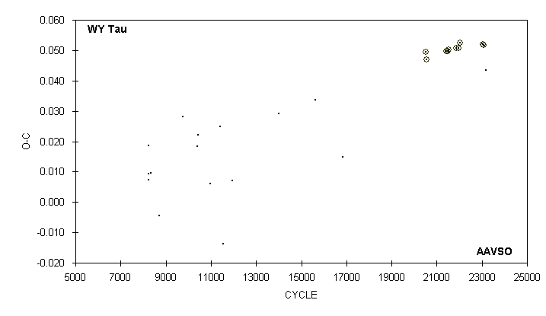

JD(min) STANDARD
HEL. CYCLE O-C N OBSERVER ERROR
2400000 +
51608.7039 20507 0.0494 44 C. Hesseltine (CCD) 0.0002
51633.6408 20543 0.0470 92 G. Samolyk (CCD) 0.0002
52235.6507 21412 0.0498 87 G. Samolyk (CCD) 0.0004
52282.7582 21480 0.0498 71 S. Dvorak (CCD) 0.0005
52307.6979 21516 0.0502 49 S. Dvorak (CCD) 0.0002
52559.8624 21880 0.0506 53 G. Samolyk (CCD) 0.0003
52616.6688 21962 0.0508 58 G. Samolyk (CCD) 0.0002
52659.6214 22024 0.0524 25 S. Dvorak (CCD) 0.0004
53360.6925 23036 0.0520 23 S. Dvorak (CCD) 0.0002
53398.7940 23091 0.0518 60 J. Bialozynski (CCD) 0.0002
53466.676 : 23189 0.043 6 S. Cook (CCD)

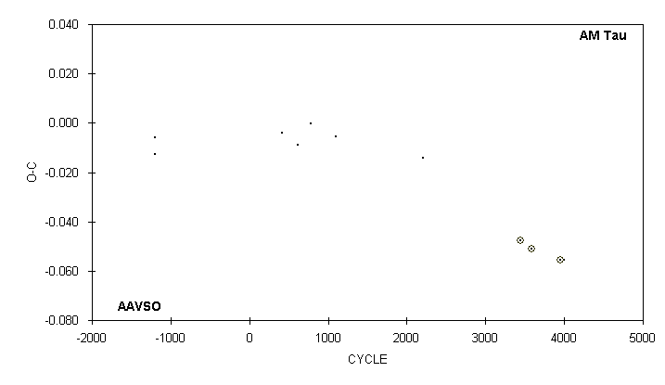

JD(min) STANDARD
HEL. CYCLE O-C N OBSERVER ERROR
2400000 +
42802.744 -1199 -0.006 16 P. Atwood
42804.781 -1198 -0.013 13 P. Atwood
46105.730 417 -0.004 10 P. Atwood
46522.686 621 -0.009 9 P. Atwood
46849.723 781 0.000 14 P. Atwood
47505.818 1102 -0.005 15 P. Atwood
49774.567 2212 -0.014 9 M. Baldwin
52290.6065 3443 -0.0477 54 S. Dvorak (CCD) 0.0001
52580.8408 3585 -0.0509 24 S. Dvorak (CCD) 0.0002
53322.7814 3948 -0.0554 80 G. Samolyk (CCD) 0.0001
53414.758 3993 -0.056 30 S. Cook (CCD)

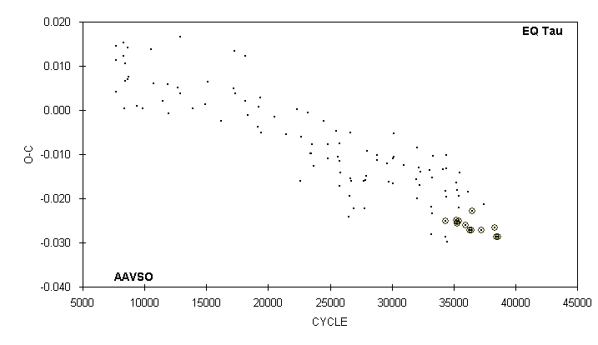

JD(min) STANDARD
HEL. CYCLE O-C N OBSERVER ERROR
2400000 +
52310.5194 35439.5 -0.0251 20 S. Dvorak (CCD) 0.0002
52496.8946 35985.5 -0.0261 39 S. Dvorak (CCD) 0.0001
52558.857 36167 -0.018 13 G. Samolyk
52606.6370 36307 -0.0273 30 G. Samolyk (CCD) 0.0003
52645.5508 36421 -0.0272 83 J. A. Howell (CCD) 0.0001
52672.6923 36500.5 -0.0229 39 M. Spearman (CCD) 0.0005
52928.6994 37250.5 -0.0272 34 S. Dvorak (CCD) 0.0002
52991.684 37435 -0.021 13 C. Stephan
53302.8178 38346.5 -0.0267 43 S. Dvorak (CCD) 0.0001
53341.5589 38460 -0.0286 52 G. Samolyk (CCD) 0.0003
53392.4197 38609 -0.0288 J. Coloma (CCD) 0.0005

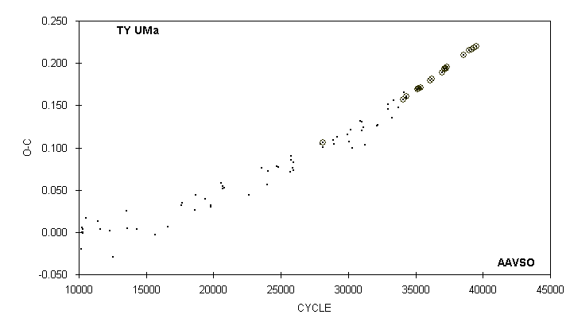

JD(min) STANDARD
HEL. CYCLE O-C N OBSERVER ERROR
2400000 +
52370.6980 36210.5 0.1815 60 G. Lubcke (CCD) 0.0001
52645.8274 36986.5 0.1890 36 S. Dvorak (CCD) 0.0001
52696.7077 37130 0.1930 40 S. Jamieson (CCD) 0.0001
52712.6627 37175 0.1937 65 S. Jamieson (CCD) 0.0002
52739.7847 37251.5 0.1935 51 G. Samolyk (CCD) 0.0002
52756.6274 37299 0.1957 19 S. Dvorak (CCD) 0.0003
53197.6877 38543 0.2099 54 G. Samolyk (CCD) 0.0001
53342.8764 38952.5 0.2151 21 S. Dvorak (CCD) 0.0001
53406.6947 39132.5 0.2164 42 N. Simmons (CCD) 0.0002
53467.674 39304.5 0.215 14 S. Cook (CCD)
53469.8042 39310.5 0.2181 79 G. Samolyk (CCD) 0.0002
53539.6504 39507.5 0.2202 70 G. Samolyk (CCD) 0.0001

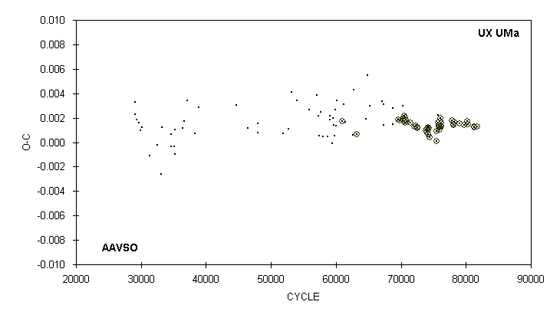

JD(min) STANDARD
HEL. CYCLE O-C N OBSERVER ERROR
2400000 +
52327.722 75735 0.002 7 R. Hill
52370.5954 75953 0.0013 12 G. Lubcke (CCD) 0.0008
52735.8145 77810 0.0018 27 G. Samolyk (CCD) 0.0001
52781.6385 78043 0.0014 30 G. Samolyk (CCD) 0.0001
52791.6688 78094 0.0015 30 G. Samolyk (CCD) 0.0002
52804.6493 78160 0.0017 21 G. Samolyk (CCD) 0.0001
52976.9332 79036 0.0015 23 S. Dvorak (CCD) 0.0003
53113.8163 79732 0.0014 33 S. Dvorak (CCD) 0.0002
53195.6319 80148 0.0018 30 G. Samolyk (CCD) 0.0001
53232.6058 80336 0.0014 31 G. Samolyk (CCD) 0.0001
53406.6597 81221 0.0013 33 G. Samolyk (CCD) 0.0002
53416.4932 81271 0.0012 R. Casas (CCD) 0.0001
53511.6822 81755 0.0013 28 G. Samolyk (CCD) 0.0001

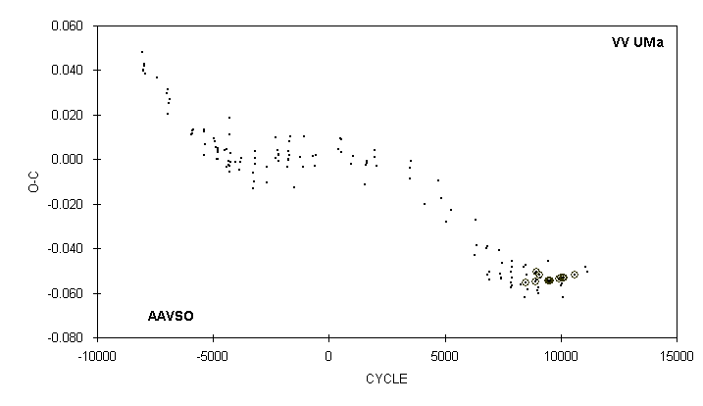

JD(min) STANDARD
HEL. CYCLE O-C N OBSERVER ERROR
2400000 +
52318.5842 9461 -0.0545 131 G. Lubcke (CCD) 0.0001
52638.9041 9927 -0.0537 25 S. Dvorak (CCD) 0.0001
52694.579 10008 -0.057 12 C. Stephan
52696.6445 10011 -0.0532 41 J. A. Howell (CCD) 0.0003
52727.574 10056 -0.056 8 C. Stephan
52740.6369 10075 -0.0531 43 G. Samolyk (CCD) 0.0001
52762.624 10107 -0.062 20 C. Stephan
52773.6309 10123 -0.0533 46 G. Samolyk (CCD) 0.0001
53098.7630 10596 -0.0520 70 G. Samolyk (CCD) 0.0001
53435.583 11086 -0.048 16 G. Chaple
53472.699 11140 -0.051 21 S. Cook (CCD)

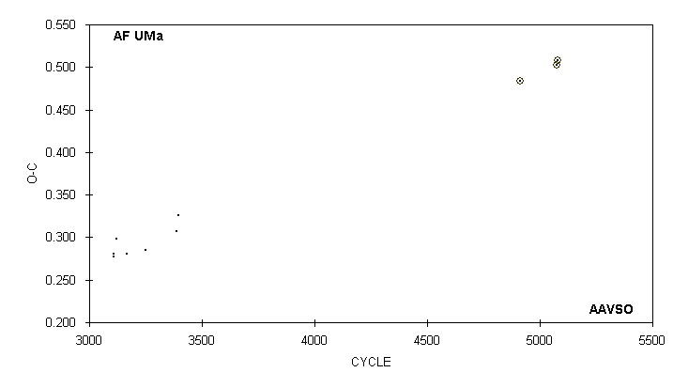

JD(min) STANDARD
HEL. CYCLE O-C N OBSERVER ERROR
2400000 +
43131.901 3107 0.278 10 G. Wedemayer
43131.904 3107 0.281 23 G. Samolyk
43210.785 3122 0.298 25 G. Samolyk
43436.842 3165 0.280 23 G. Samolyk
43883.739 3250 0.285 31 G. Samolyk
44598.788 3386 0.307 31 G. Samolyk
44640.867 3394 0.325 30 G. Hanson
52616.7361 4911 0.4835 12 G. Samolyk (CCD) 0.0020
53473.7361 5074 0.5020 90 G. Samolyk (CCD) 0.0004
53505.287 7) 5080 0.5076 31 S. Cook (CCD) 0.002

7) Observations combined from 53473 to 53531

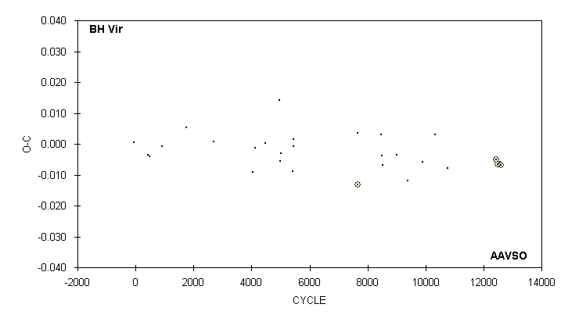

JD(min) STANDARD
HEL. CYCLE O-C N OBSERVER ERROR
2400000 +
50166.662 : 8491 -0.004 6 S. Cook (CCD)
50197.700 8529 -0.007 14 S. Cook (CCD)
50581.633 8999 -0.004 15 S. Cook (CCD)
50897.754 9386 -0.012 21 C. Stephan
51315.590 : 9897.5 -0.006 15 C. Stephan
51663.586 : 10323.5 0.003 12 C. Stephan
52015.647 : 10754.5 -0.008 21 C. Stephan
53394.9374 12443 -0.0050 76 S. Dvorak (CCD) 0.0001
53435.7795 12493 -0.0065 80 G. Samolyk (CCD) 0.0001
53507.665 12581 -0.006 21 S. Cook (CCD)
53511.7483 12586 -0.0068 100 C. Hesseltine (CCD) 0.0002

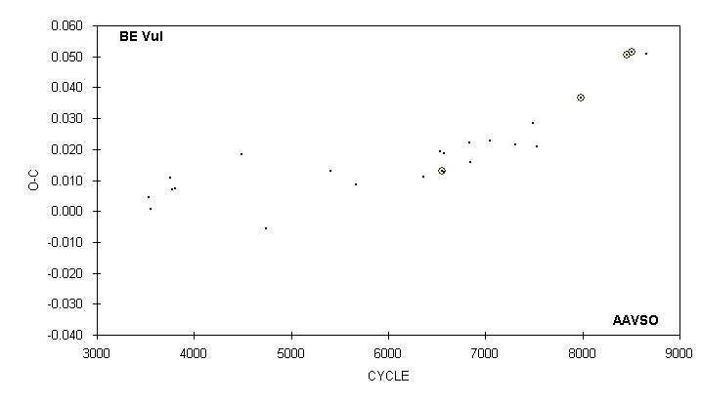

JD(min) STANDARD
HEL. CYCLE O-C N OBSERVER ERROR
2400000 +
50719.624 6835 0.022 16 D. Williams
50733.586 6844 0.016 16 D. Williams
51048.658 7047 0.023 15 D. Williams
51453.740 7308 0.021 14 R. Hill
51734.667 7489 0.028 14 D. Williams
51793.637 7527 0.021 15 G. Samolyk
52496.7289 7980 0.0368 55 G. Samolyk (CCD) 0.0003
53238.6197 8458 0.0505 48 G. Samolyk (CCD) 0.0001
53314.6708 8507 0.0515 60 G. Samolyk (CCD) 0.0001
53553.685 8661 0.051 13 D. Williams

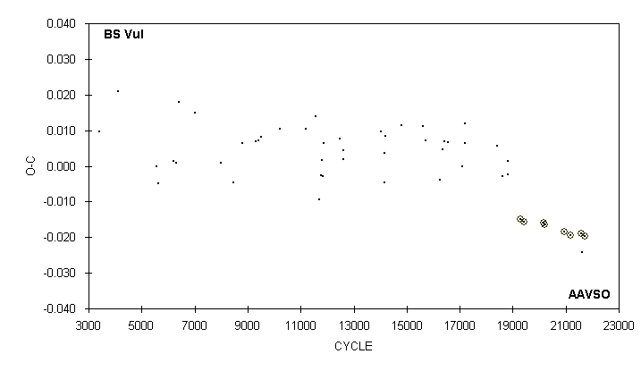

JD(min) STANDARD
HEL. CYCLE O-C N OBSERVER ERROR
2400000 +
52042.786 18428 0.006 12 G. Samolyk
52133.688 18619 -0.003 15 G. Samolyk
52225.551 18812 -0.002 16 G. Samolyk
52235.550 18833 0.001 16 G. Samolyk
52448.7690 19281 -0.0149 49 G. Samolyk (CCD) 0.0001
52521.5919 19434 -0.0156 34 G. Samolyk (CCD) 0.0003
52876.6663 20180 -0.0160 61 R. Poklar (CCD) 0.0003
52886.6613 20201 -0.0164 34 G. Samolyk (CCD) 0.0002
53233.6424 20930 -0.0185 63 J. Bialozynski (CCD) 0.0003
53344.5428 21163 -0.0194 46 G. Samolyk (CCD) 0.0001
53539.6916 21573 -0.0189 48 H. Gerner (CCD) 0.0001
53559.677 21615 -0.024 21 S. Cook (CCD)
53610.6106 21722 -0.0197 42 N. Simmons (CCD) 0.0001

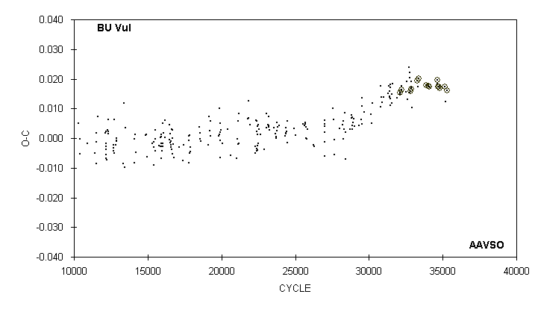

JD(min) STANDARD
HEL. CYCLE O-C N OBSERVER ERROR
2400000 +
52469.7893 33280 0.0193 44 G. Samolyk (CCD) 0.0002
52497.668 33329 0.017 12 D. Williams
52518.7235 33366 0.0201 22 G. Samolyk (CCD) 0.0009
52811.7527 33881 0.0179 47 G. Samolyk (CCD) 0.0001
52902.7913 34041 0.0176 45 G. Samolyk (CCD) 0.0003
52934.6548 34097 0.0175 17 S. Dvorak (CCD) 0.0006
53239.636 34633 0.018 10 D. Williams
53239.6371 34633 0.0195 56 J. Bialozynski (CCD) 0.0004
53265.8087 34679 0.0175 39 G. Samolyk (CCD) 0.0001
53309.6210 34756 0.0173 59 S. Dvorak (CCD) 0.0001
53321.5695 34777 0.0169 54 G. Samolyk (CCD) 0.0001
53342.623 34814 0.018 12 S. Cook (CCD)
53540.6323 35162 0.0174 42 G. Samolyk (CCD) 0.0002
53553.714 35185 0.012 12 D. Williams
53603.7893 35273 0.0162 56 G. Samolyk (CCD) 0.0002

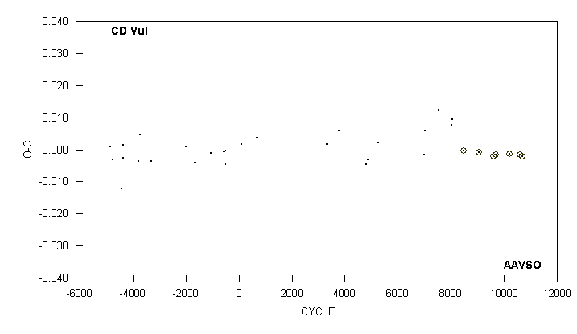

JD(min) STANDARD
HEL. CYCLE O-C N OBSERVER ERROR
2400000 +
51069.676 6978 -0.002 25 G. Samolyk
51097.717 7019 0.006 18 R. Hill
51452.587 7538 0.012 17 G. Samolyk
51791.720 8034 0.008 17 R. Hill
51804.713 8053 0.010 14 G. Samolyk
52096.6623 8480 -0.0003 78 C. Hesseltine (CCD) 0.0002
52496.6525 9065 -0.0009 18 S. Dvorak (CCD) 0.0002
52861.7711 9599 -0.0022 47 G. Samolyk (CCD) 0.0003
52920.5736 9685 -0.0017 59 G. Samolyk (CCD) 0.0002
53274.7538 10203 -0.0014 66 G. Samolyk (CCD) 0.0001
53540.7305 10592 -0.0015 125 C. Hesseltine (CCD) 0.0001
53616.6257 10703 -0.0020 43 N. Simmons (CCD) 0.0002

