VPhot VIII Choice Course
Week 1 Quiz – Steve Boerner
1a. Provide a screen shot showing the top portion (including the appropriate pull down option boxes filled in) of the VPhot Available Images window displaying only the V band images of WX CMi.
(Name the file screenshot Q1. WX CMI for clarity).
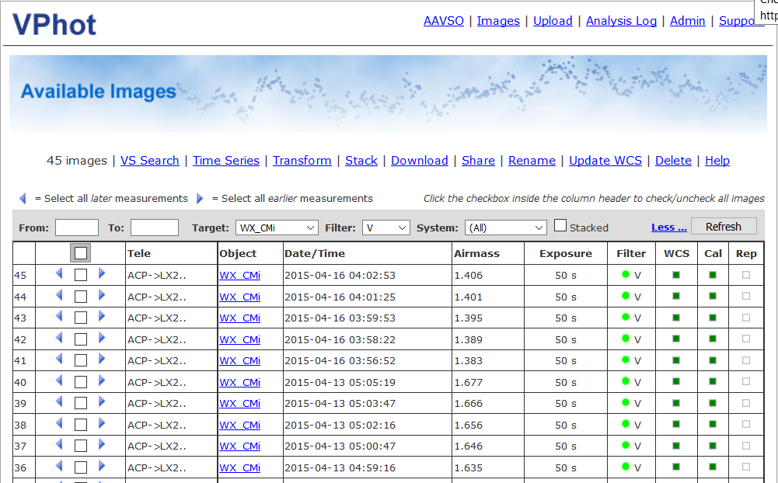
1b. If you were interested in stacking the images in this list collected only on April 16, 2015, explain how would you select these images from this page?
Go to the last April 16, 2015 entry (#41) and click the left arrow to highlight that image and all above it (#41-45)
2a. Provide a screen shot of an I Band S Lyn image with the AAVSO comps and S Lyn displayed/identified. (Name the file screenshot Q1. S Lyn for clarity).
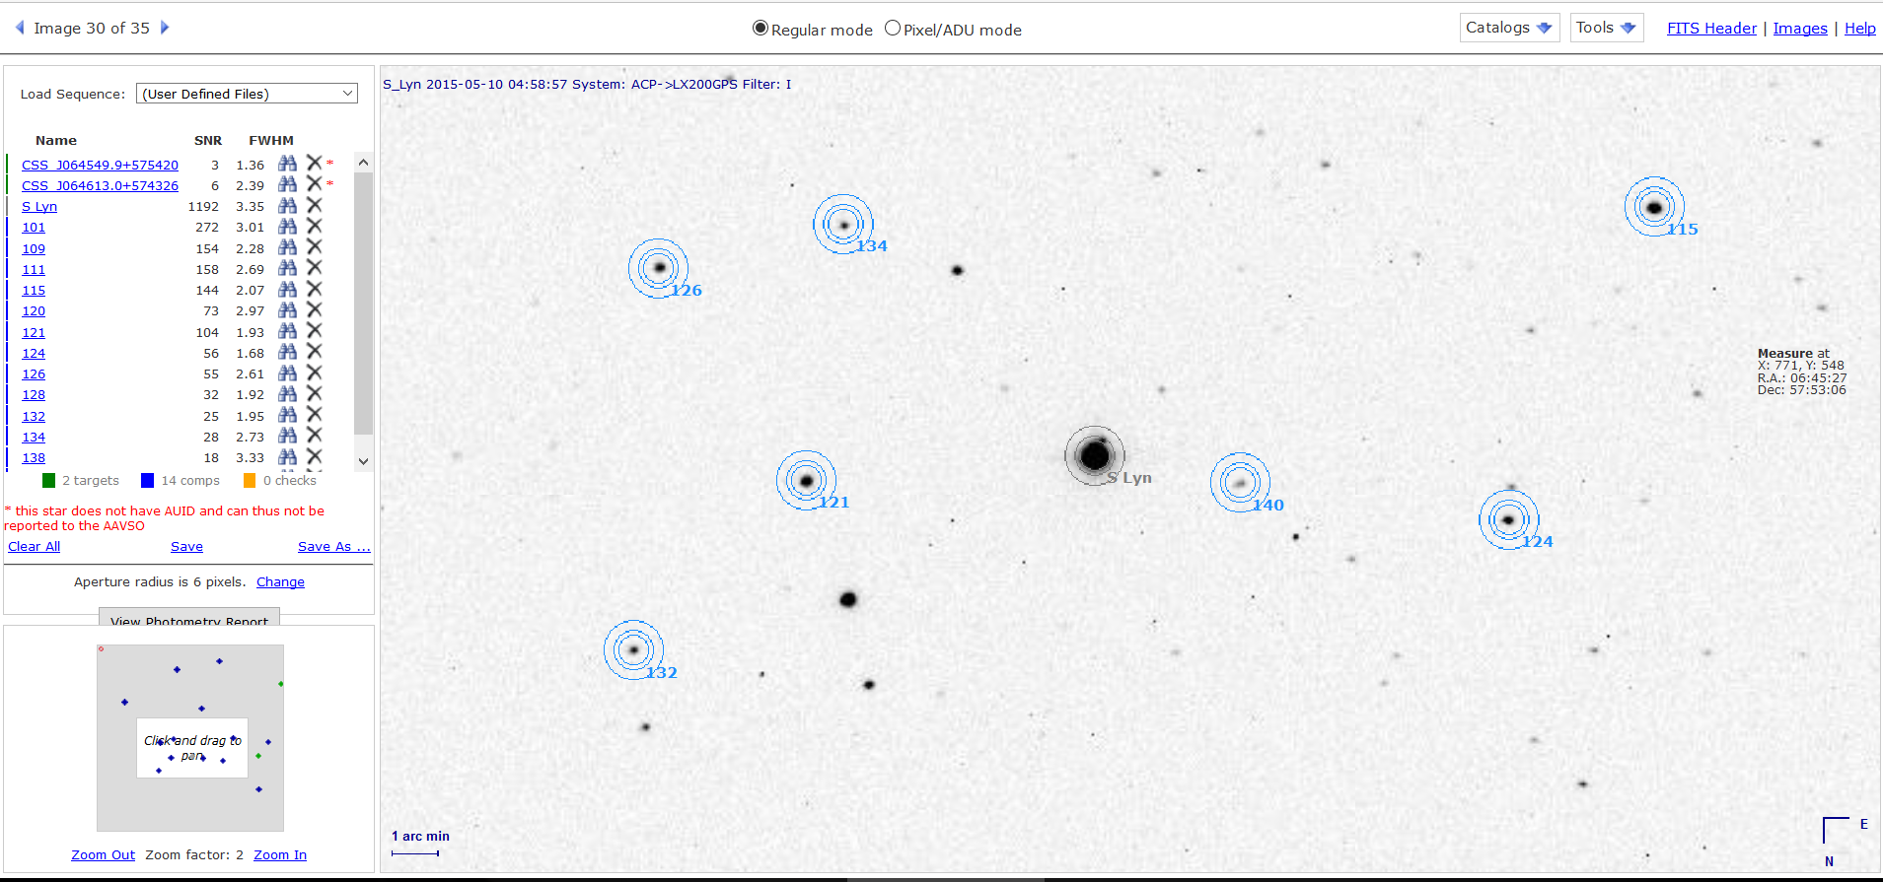
2b. Describe the color of the target aperture. Gray
2c. What is the SNR of the target? 1192 (image #30)
2d. What does this mean and what does it imply might be true of the photometric results?
The ADU values too high with saturation possible. At the very least, they are about the linear portion of the CCD’s response curve. Photometric results will be unreliable.
3a. Provide a screen shot of a V Band R CrB image zoomed out to display both R CrB and TT CrB with no other variables or unclassified objects displayed. Make sure to include the list of objects to the left of the image. (Name the file screenshot Q3. R CrB for clarity).
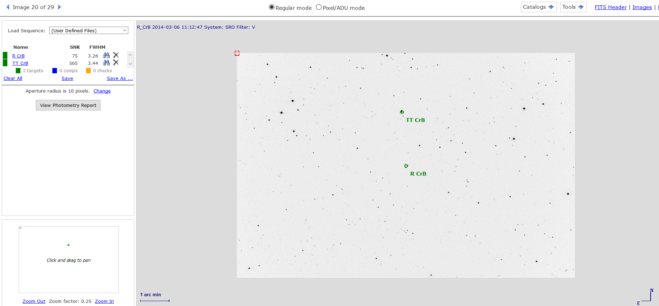
3b. What is the FWHM of TT CrB? Image #20 is 3.44
4a. Explain how you would select all the R CrB B band images between/including March 1, 2014 and March 12, 2014?
One way is to use the From: (140301) and To: (140312) filters with refresh. A second way would be to use the right arrow by the first entry in the time range March 12, 2017--#26 and then the right arrow with the first entry after March 1, 2014--#16.
FWIW the first way generates new numbers for the images while the second preserves the numbers.
4b. Describe the format of the dates you would need to filter by date? Give an example.
140301 – 2014-03-01= March, 01, 2014
4c. How many images are there between/including these dates? 10
5a. Open a BX Pup image and load AAVSO comps and VSX variables. How many VSX variables are included? 12 variable stars
5b. What are the SNR and FWHM values of BX Pup? Image 133-- SNR is 49, FWHM is 5.34
5c. What is the approximate pixel radius of the maximum SNR of BX Pup? 5 pixels
5d. What is the approximate pixel radius of the point where the BX Pup star profile flattens out? 5 pixels
5e. What would you select as the aperture pixel radius for the stars on this image and why?
I’d go with the 2x FWHM value of 10. The 11.4 comp star is pretty bloated and anything smaller than 10 pixels doesn’t seem to get it all.

